PRACTICAL -5
To design and develop basic frontend website pages
Login/Signup:
This page allows users to log in to LifeOS using their email and password. It acts as the entry point to access personalized features and user data. A sign-in button and sign-up link are provided for authentication and new user registration.
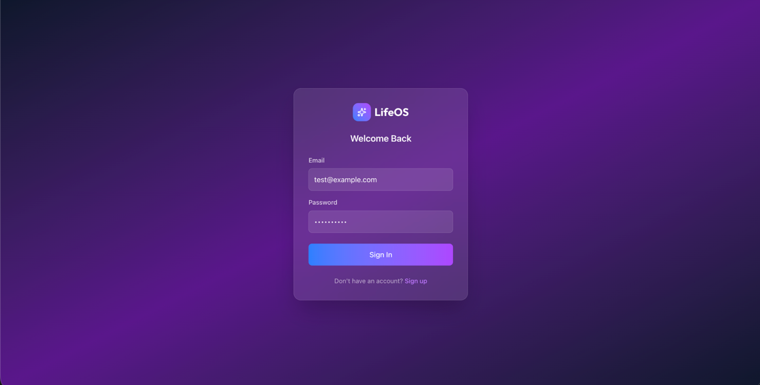
Dashboard:
This page provides a daily overview of the user’s activities and progress across different modules. It displays key summaries for wellness, productivity, study focus, meals, and shopping in a single view. The sidebar allows quick navigation to different sections of the application for managing tasks and routines.
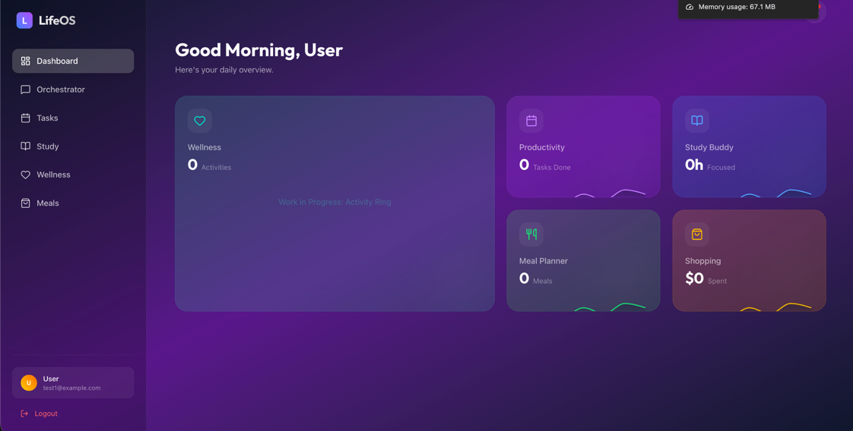

Productivity Page:
This page helps users manage tasks and improve focus. It includes a Pomodoro-based focus timer and a priority matrix to organize tasks by urgency and importance. Users can create, track, and move tasks across different stages of completion.
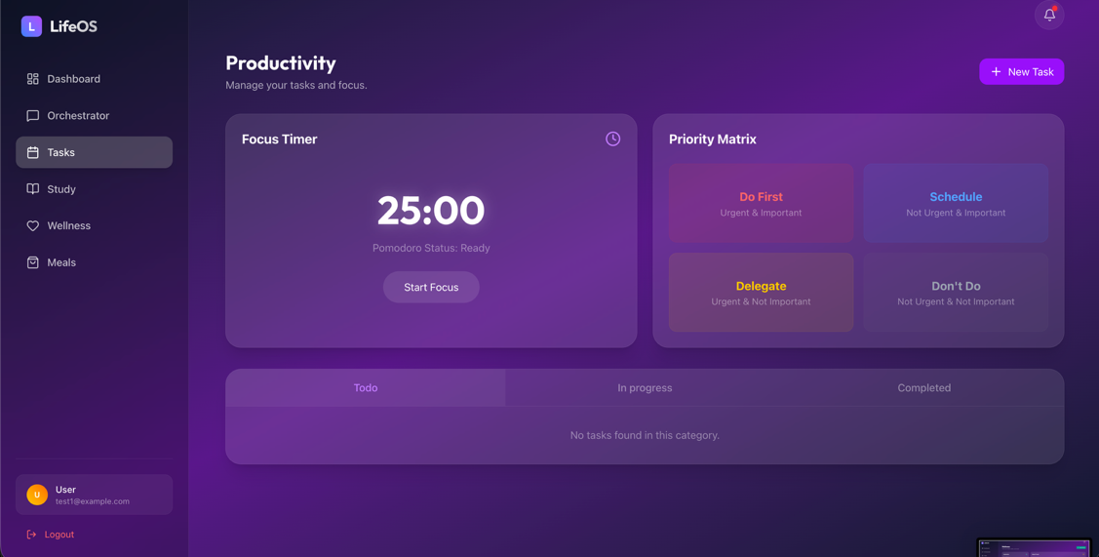
Wellness Page:
This page helps users track their health-related habits and daily wellness activities. It shows hydration progress, mood trends over time, and a list of recent activities. Users can log new wellness activities to monitor and improve their overall well-being.
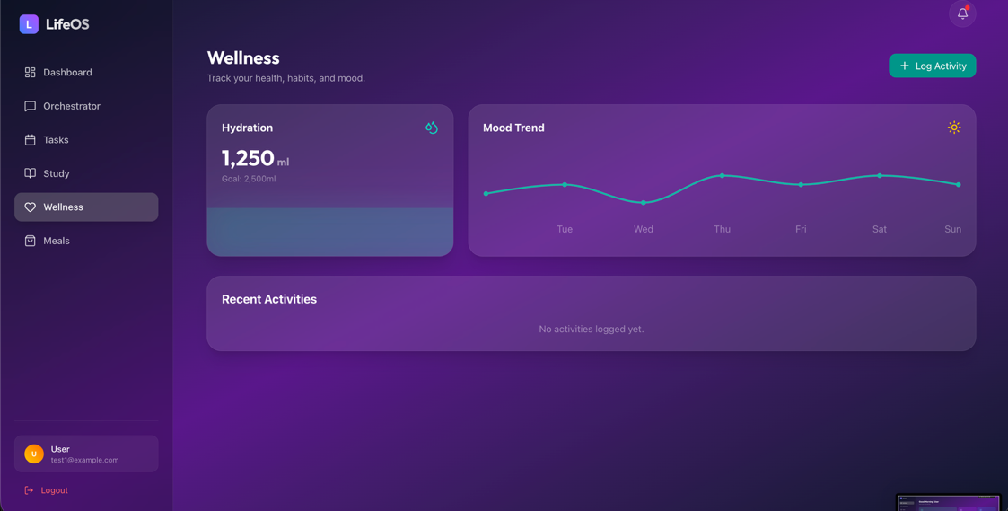

Meal Planner Page:
This page allows users to plan meals for the entire week in a structured schedule. It provides options to add meals and view suggested recipes for healthier choices. An auto-grocery feature helps generate shopping needs based on the planned meals.
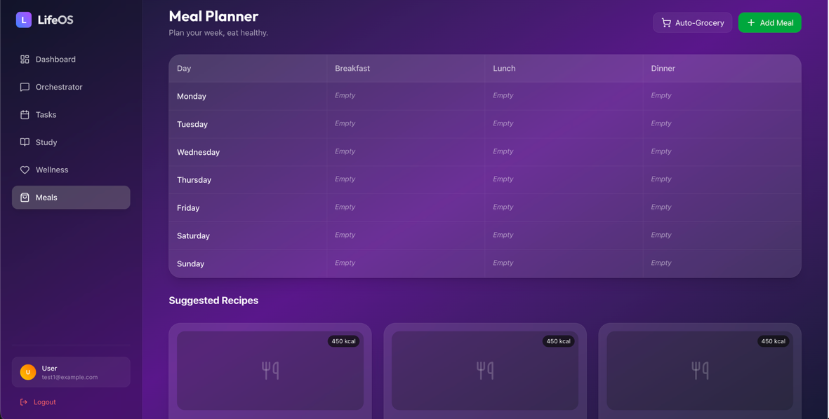
Study Buddy Page:
This page helps users log and track their study sessions. It shows subject-wise time distribution and supports active recall through quick revision prompts. Users can review recent sessions and monitor their overall study focus.
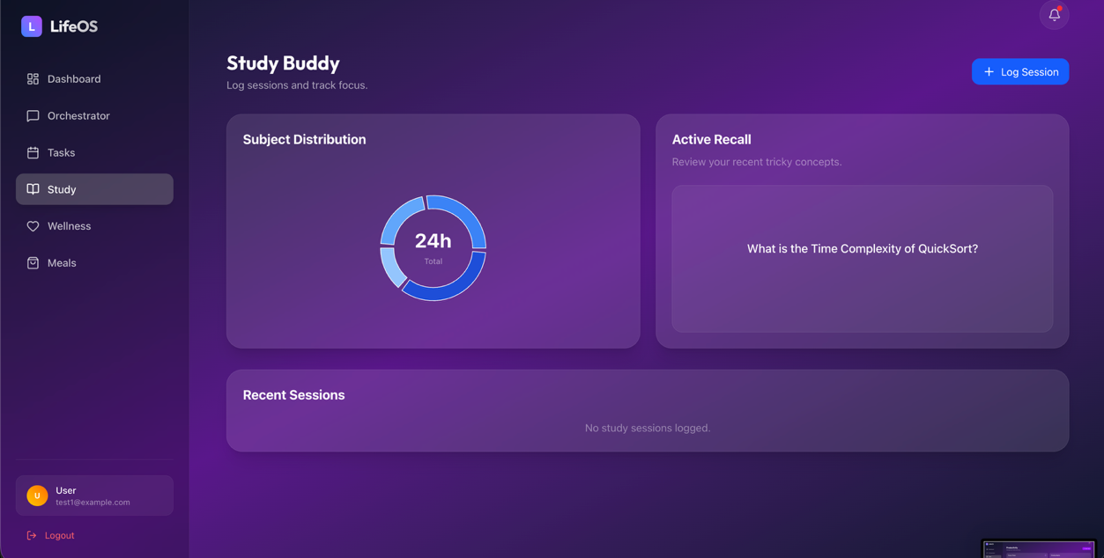

Shopping Page:
This page helps users manage their wishlist and track monthly expenses. It shows budget status and spending by category for better financial awareness. Users can add items, categorize purchases, and mark items as pending or bought.
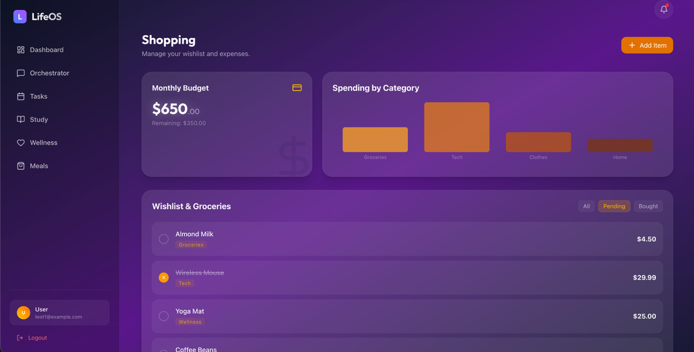
Orchestrator (AI chatbot) Page:
This page serves as the AI command center for interacting with LifeOS agents. Users can chat with the AI to get personalized assistance for tasks like meal planning, shopping, and budgeting. It centralizes smart recommendations and actions in a conversational interface.
