**NIKHIL JAIN ISE-2**

**ROLL NO:B68**

**CODE:**

class invalidNumber(Exception):

pass

def verify_mobile_number(mobile_number):

if not mobile_number.isdigit():

print("---------------------------------------------------------------------------")

raise invalidNumber("\nMobile number should contain only digits.\n")

print("---------------------------------------------------------------------------")

if len(mobile_number) != 10:

print("---------------------------------------------------------------------------")

raise invalidNumber("\nMobile number should be 10 digits long.\n")

print("---------------------------------------------------------------------------")

if mobile_number[0] not in ['9', '8', '7']:

print("---------------------------------------------------------------------------")

raise invalidNumber("\nMobile number should start with 9, 8, or 7.\n")

print("---------------------------------------------------------------------------")

return mobile_number

try:

print("\n*******************************************************************************")

mobile_number = input("Enter your mobile number: ")

mobile_number = verify_mobile_number(mobile_number)

print("---------------------------------------------------------------------------")

print("Mobile number verified:", mobile_number)

print("---------------------------------------------------------------------------")

except invalidNumber as e:

print("Invalid mobile number:", e)

print("---------------------------------------------------------------------------")

print("Welcome to Mobile Number Verification App")

print("---------------------------------------------------------------------------")

print("*****************************************************************************")

**snapshot**:

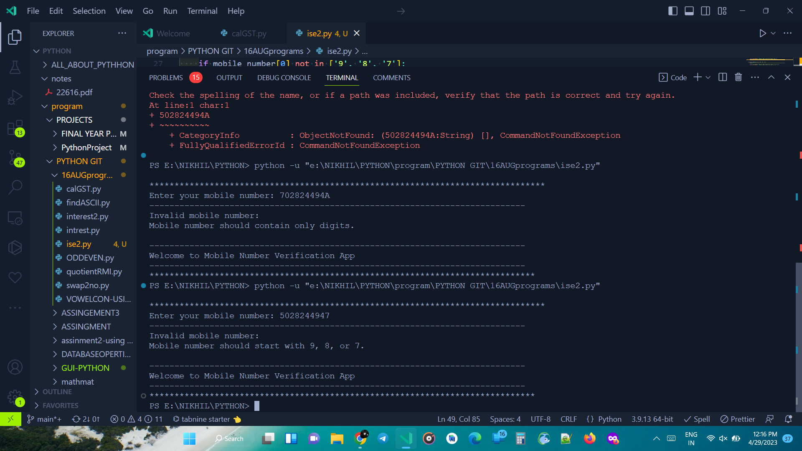

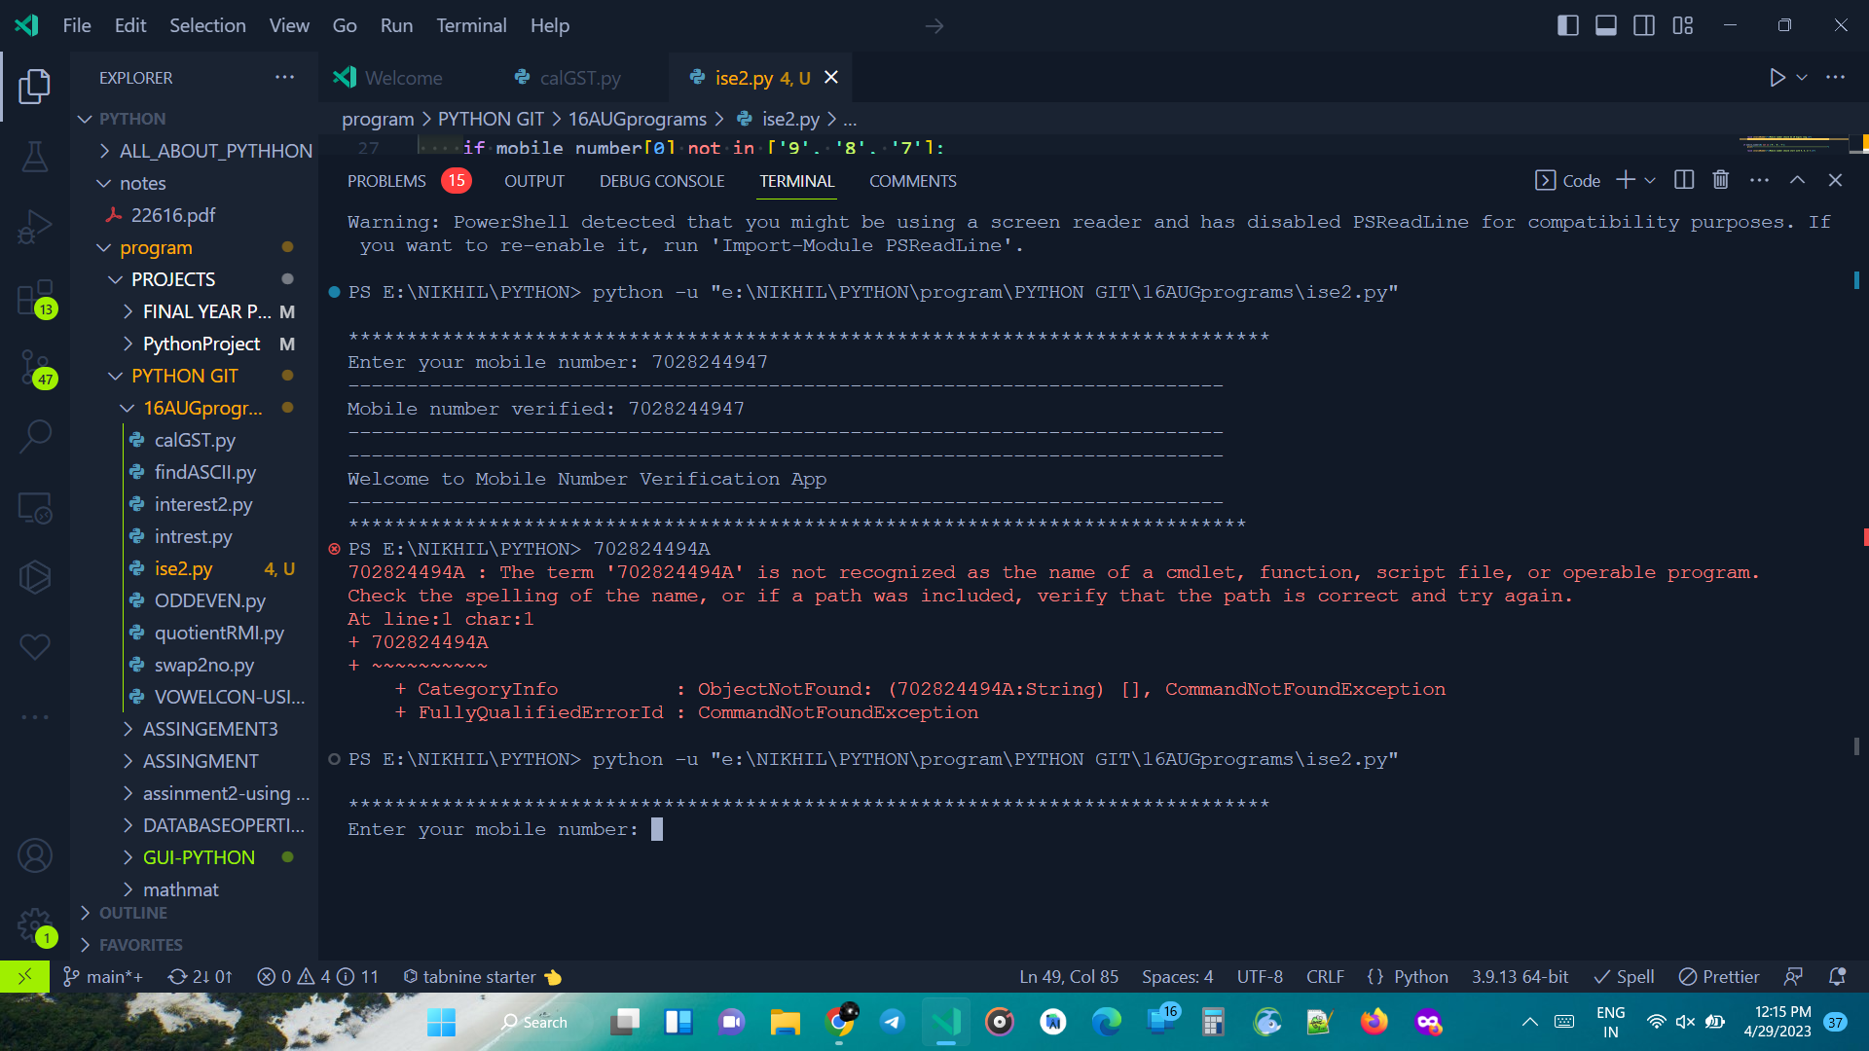

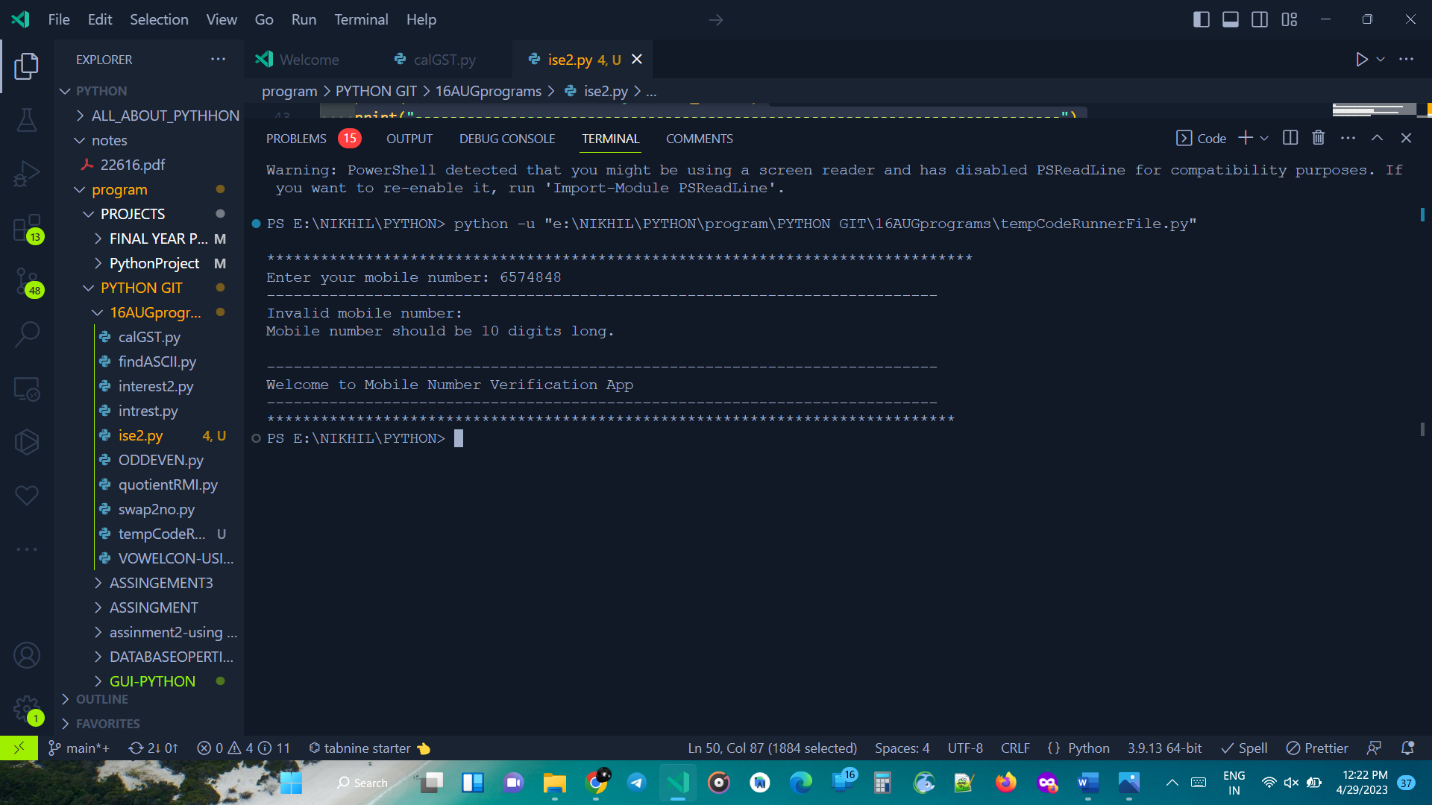



**Q 2**

**CODE:**

a=int (input("Enter a Number :"))

d={}

for i in range (1,a+1):

d[i]=i*i

print(d)

**SNAPSHOT :**

