**Database Programming (CSD 4203_2)**

**Exercises 16-19**

**Name: Sakshi Jain Student ID: c0753352**

**Instruction: Provide FULL Screenshot of your code with the result on SQL Developer**

***Exercise 16 (1.2%)***

**Create procedure called “Add_job” that will insert job_id and job title into jobs table.include two parameters one for job_id and the other for job_tiltle.**

Code:

SET SERVEROUTPUT ON

CREATE OR REPLACE PROCEDURE

ADD_JOB(p_jobid jobs.job_id%TYPE,p_jobtitle jobs.job_title%TYPE)

IS

BEGIN

INSERT INTO jobs (job_id,job_title)

VALUES (p_jobid,p_jobtitle);

COMMIT;

END ADD_JOB;

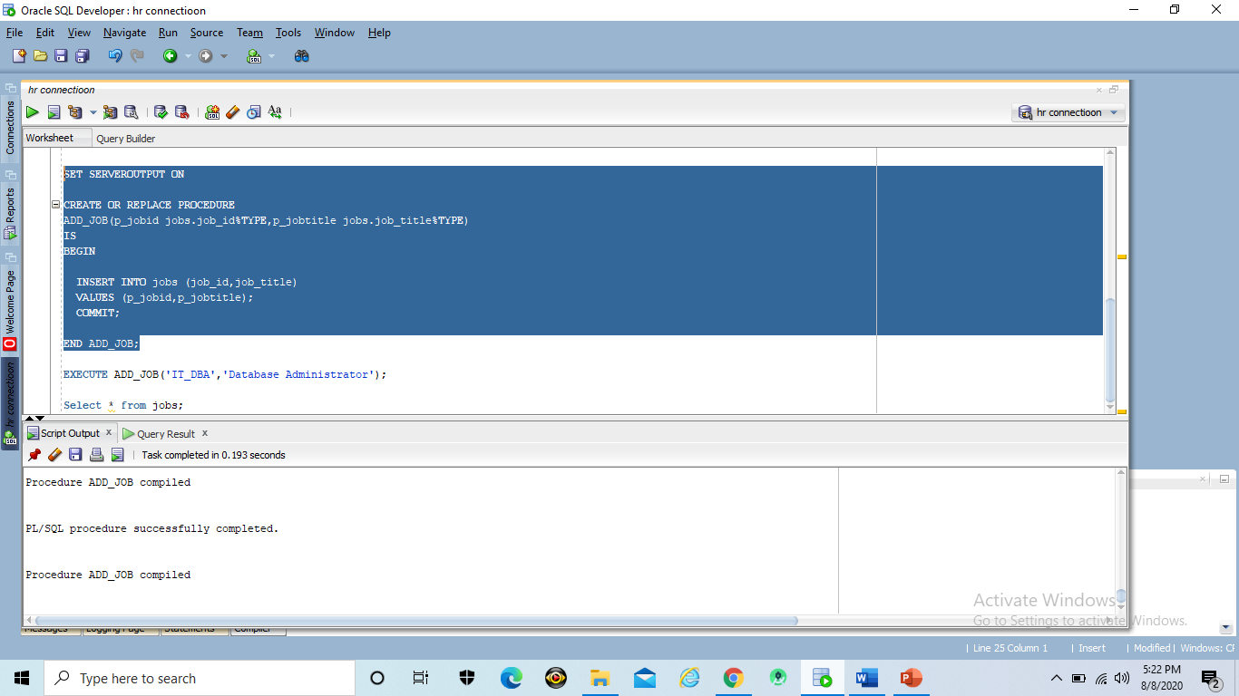

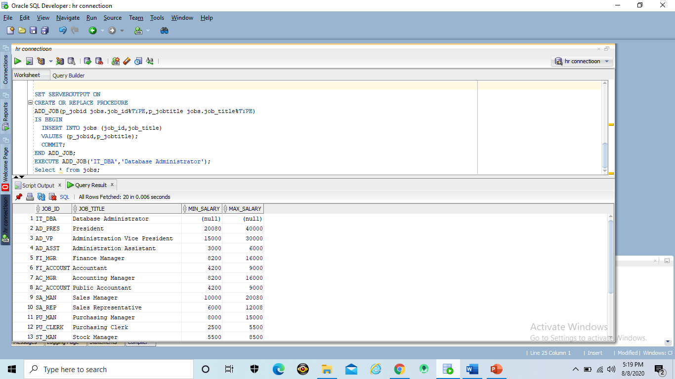

***Exercise 17 (1.2%)***

**Invoke your “Add_job” procedure with proper paramaeter values and display the output. Include screenshot of your output**

Code:

EXECUTE ADD_JOB(‘IT_DBA’,’Database Administrator’);

Select * from jobs;

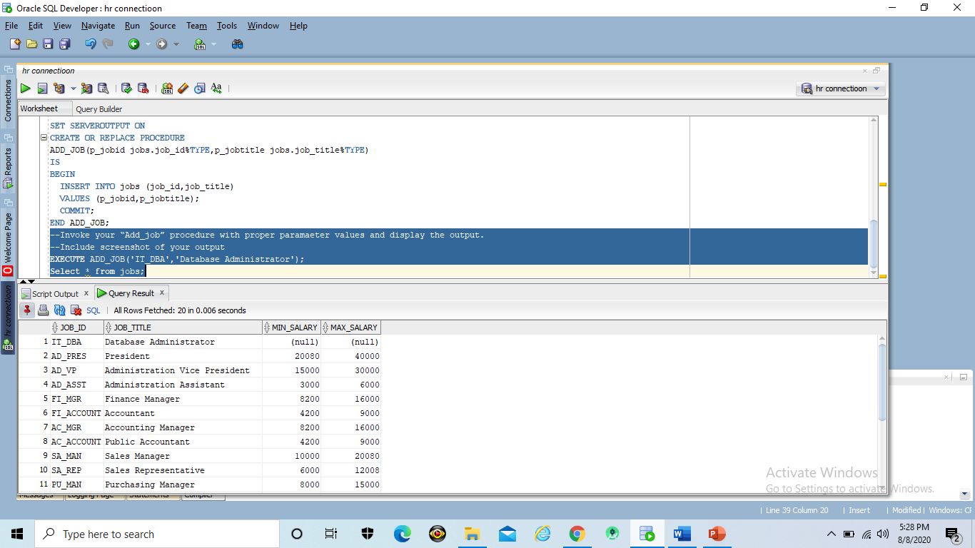

***Exercise 18 (1.2%)***

**Create procedure called “update_job” that will update job_title based on entered job_id. Include two parameters one for job_id and the other for job_tiltle.**

Code:

SET SERVEROUTPUT ON

CREATE OR REPLACE PROCEDURE

Update_Job(p_jobid jobs.job_id%Type, p_jobtitle jobs.job_title%Type)

IS

BEGIN

UPDATE jobs

SET job_title = p_jobtitle

WHERE job_id = p_jobid;

IF SQL%NOTFOUND THEn

Raise_APPLICATION_ERROR(-20202,' Data not updated.!!');

END IF;

END Update_Job;

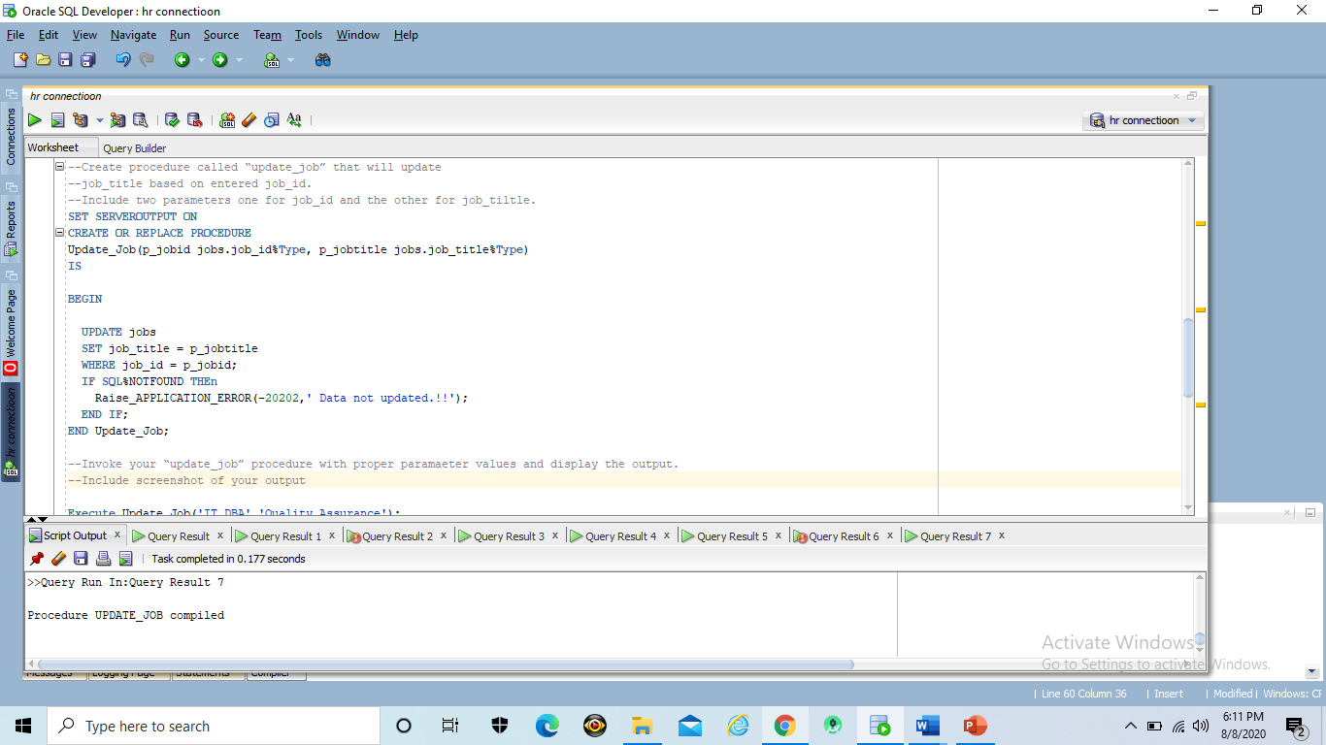

***Exercise 19 (1.2%)***

**Invoke your “update_job” procedure with proper paramaeter values and display the output. Include screenshot of your output**

Code:

Execute Update_Job('IT_DBA','Quality Assurance');

Select * FROM jobs WHERE job_id = 'IT_DBA';

