**Database Programming**

**Exercises 23-25**

**Name: Sakshi Jain Student ID: c0753352**

**Instruction: Provide FULL Screenshot of your code with the result on SQL Developer or SQL Live**

**Exercise 23 (1.2%)**

Create a trigger on employees that will not allow employees to update salary for Accountants. Executes the trigger body before the triggering DML event on a table. As result of your trigger the following message should be displayed , You are not allowed to update accountants salary

Hint: Use when clause

Code:

**SET SERVEROUTPUT ON**

**CREATE OR REPLACE TRIGGER secure_emp**

**Before INSERT OR UPDATE OF SALARY ON employees**

**FOR EACH ROW**

**WHEN (NEW.job_id = 'FI_ACCOUNT')**

**BEGIN**

**RAISE_APPLICATION_ERROR(-20500,'You are not allowed to update accountants salary');**

**END;**

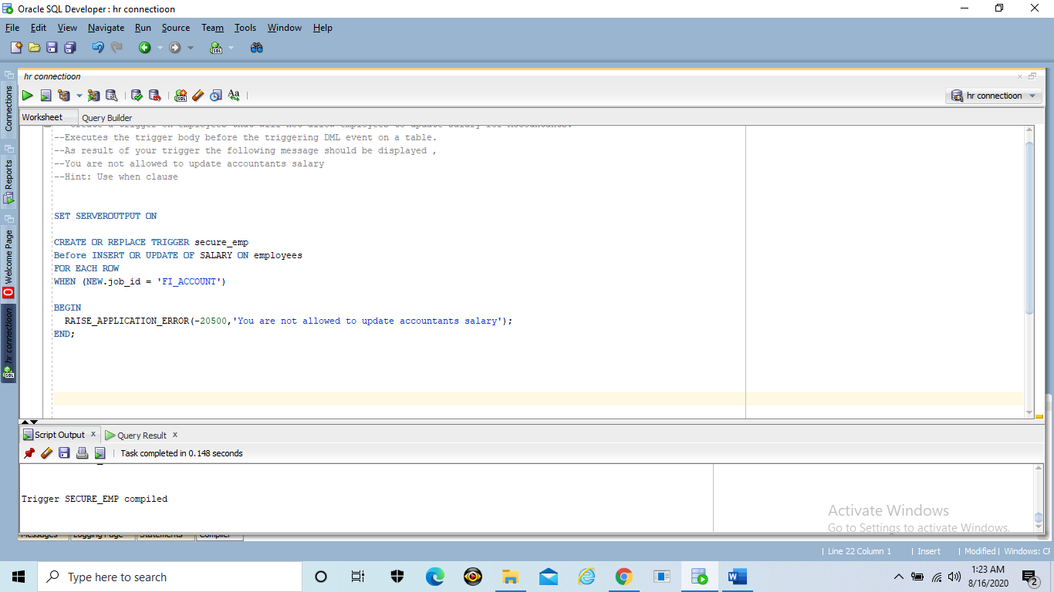

**Exercise 24 (1.2%)**

Test your triggers that you created in exercise 23 by updating accountants salary

Code:

**UPDATE employees**

**SET SALARY=SALARY+1000**

**WHERE employee_id=111;**

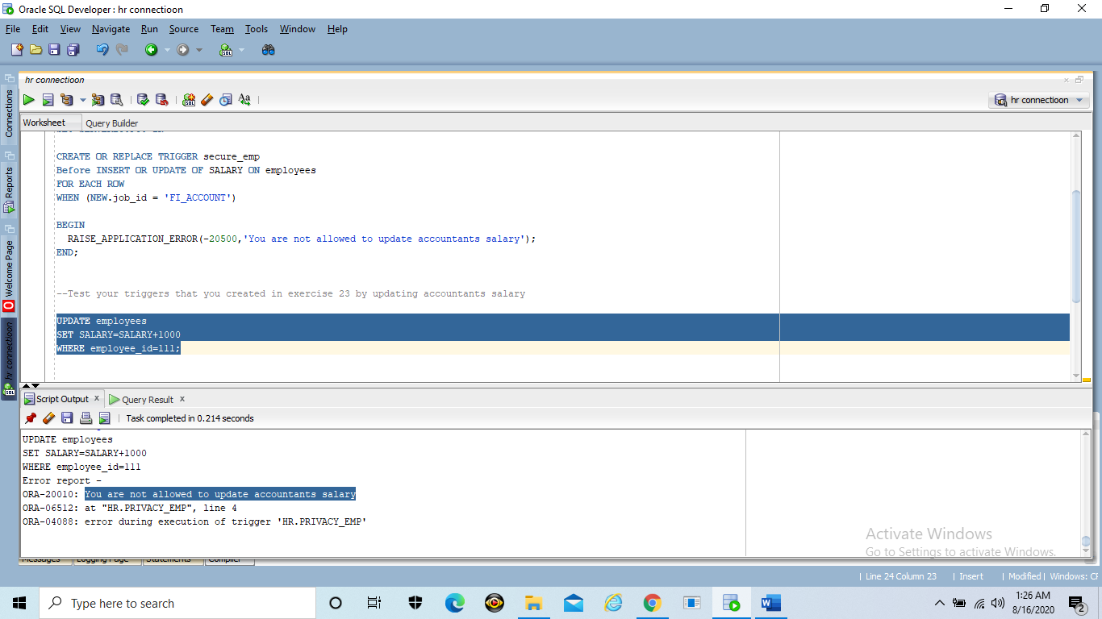

**Exercise 25 (1.2%)**

Display information about your trigger using user_triggers data dictionary view

Code:

**DESCRIBE user_triggers;**

**SELECT trigger_type, trigger_body**

**FROM user_triggers**

**WHERE trigger_name = 'secure_emp';**

