CSE DEPT  MITS GWALIOR  Estd. 1957  Cybersecurity Lab | Intelligent Network Traffic Monitoring System  DDoS Attack Detection & Real-Time Flow Classification Using Stacking Ensemble Learning  Author: Aditi Jain | Department of CSE, Madhav Institute of Technology & Science (MITS) |   SCAN GITHUB REPO

INTRODUCTION  • DDoS Attacks Surge: Malicious traffic floods overwhelm servers, causing critical service downtime.  • Rule-Based Failure: Traditional firewalls fail against dynamic, high-volume multi-vector DDoS.  • Machine Learning Power: Supervised ML learns subtle, multi-dimensional flow behaviors automatically.  ? RESEARCH HYPOTHESIS:  Can Stacking Ensemble minimize False Negatives while keeping 99.9%+ accuracy? | METHODS & EXPERIMENTAL WORKFLOW
  STEP 1: Data Prep  • 17 CIC-DDoS Parquet files  • 426,076 Cleaned records  • Dropped nulls & duplicates  • Labels: BENIGN(0), ATTACK(1) | STEP 2: Features  • 88 -> 30 Features (RF)  • 80/20 train/test split  • StandardScaler on train set  • SMOTE: 530,194 samples | STEP 3: Models  • 5 Models: DT, RF, XGB, Voting, Stacking  • Meta-Learner: Log. Reg.  • 99.94% accuracy test set  • Flask Dashboard demo

RESULTS & SYSTEM PERFORMANCE DEMONSTRATION
OBJECTIVE 1: Flow Feature Selection  Random Forest importance ranking reduced 88 -> 30 features.  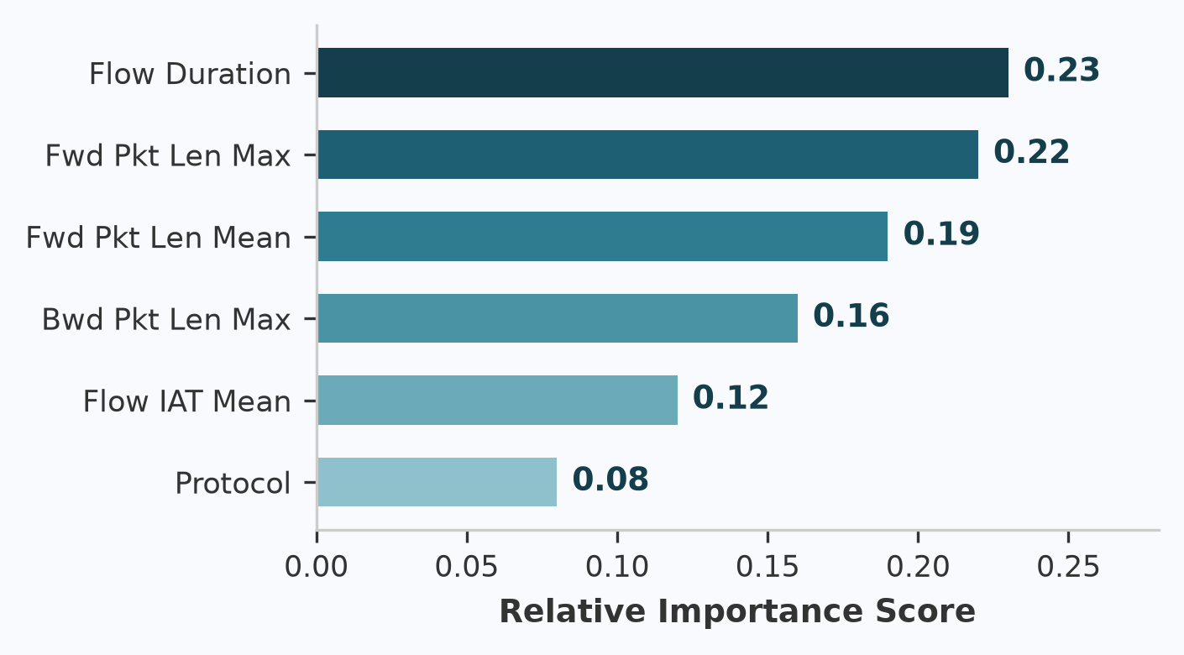  Figure 1. Relative Importance Score (Top 6 Features)  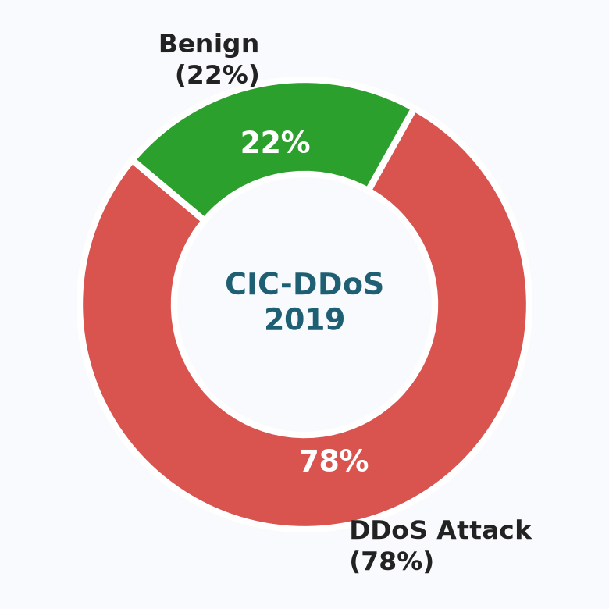  Figure 2. CIC-DDoS2019 Cleaned Traffic Balance  > Concluding Outcome 1:  Selecting top 30 features achieved 66% dimension reduction with zero metric loss. | OBJECTIVE 2: Detection Architecture  Multi-tier ensemble processing & real-time classification.  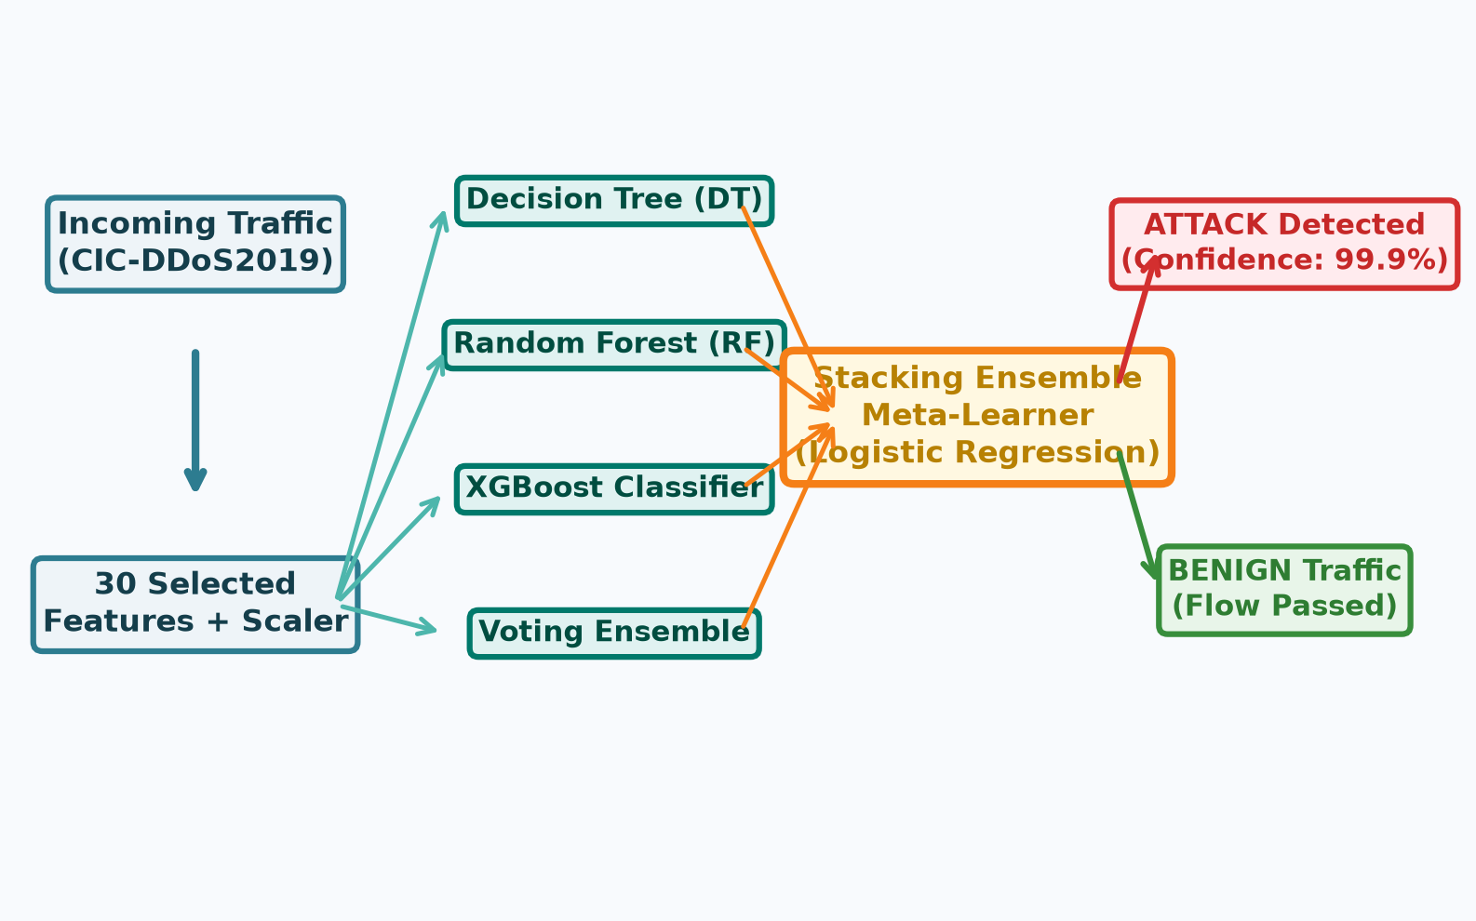  Figure 3. Intelligent Monitoring & Stacking Architecture  • 1. Base Learners: DT, RF, and XGBoost evaluate incoming flows.  • 2. Meta-Learner: Logistic Regression weighs individual models to minimize errors.  • 3. Web Dashboard: Flask serves live prediction with calibrated confidence.  > Concluding Outcome 2:  Stacking meta-learner dynamically resolves edge cases, eliminating single-model bias. | OBJECTIVE 3: Benchmark & Evaluation  Testing across 85,216 unseen held-out network traffic flows.  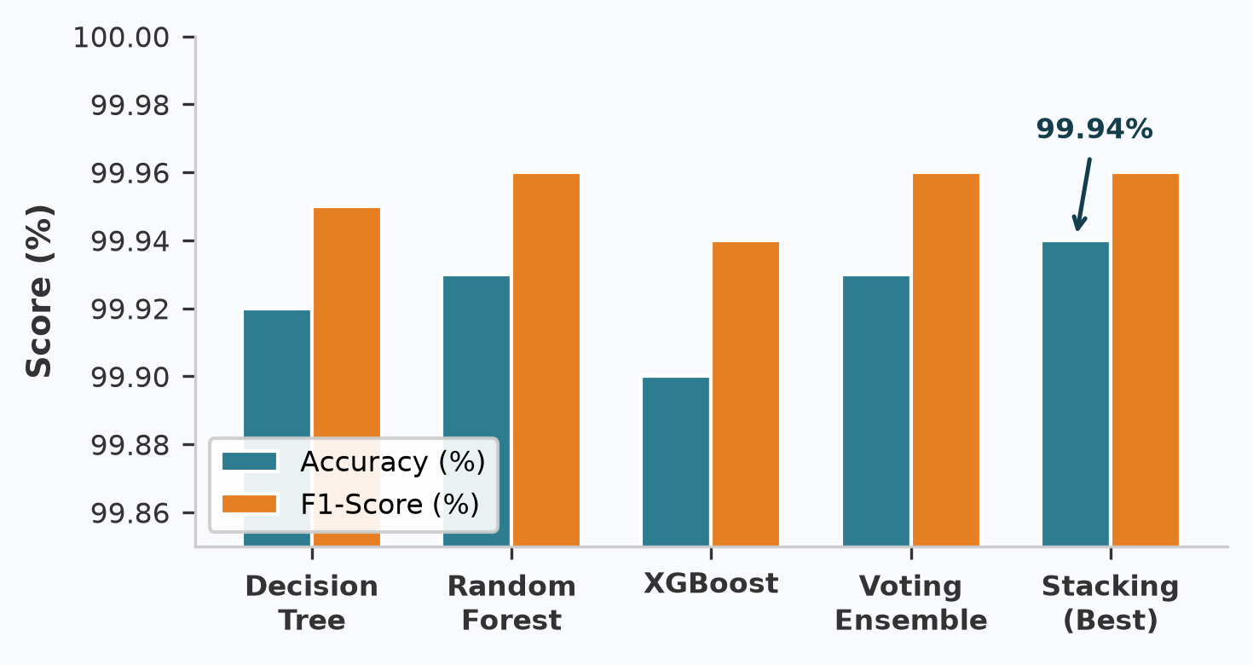  Figure 4. Accuracy & F1-Score Across 5 Models  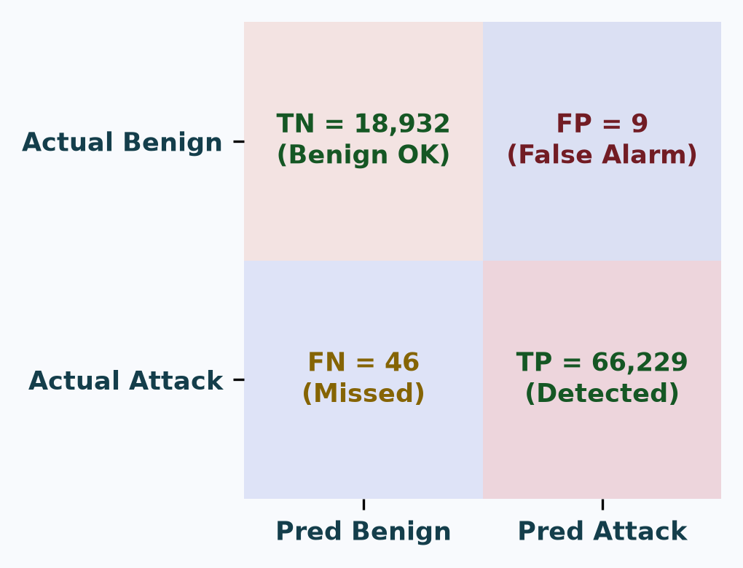  Figure 5. Stacking Confusion Matrix (Test = 85,216 flows)  > Concluding Outcome 3:  Stacking Ensemble achieved lowest False Negatives (FN = 46) and only 9 False Positives.

DISCUSSION & KEY STUDY FINDINGS  [99.94% Accuracy] Highest test accuracy. [FN = 46] Missed rate < 0.07%. [FP = 9] Minimal false alarms.  • Security Interpretation: Minimizing False Negatives is critical: missing an active DDoS flood allows server crashes, while FP=9 avoids blocking legitimate users.  • Limitations: Offline flow analysis (no live packet capture / Scapy hook); binary classification (attack vs benign). | CONCLUSION & REFERENCES  • Summary: Stacking Ensemble outperformed base classifiers; SMOTE fixed 78:22 imbalance.  • Future Directions: Live packet sniffing via Scapy and 11-class multi-label DDoS classification.  TAKE-HOME MESSAGE:  Ensemble meta-learning delivers robust, high-accuracy threat classification suitable for modern network security pipelines.  [1] Sharafaldin et al. (CIC-DDoS2019) | [2] Pedregosa et al. (Scikit-Learn)  [3] GitHub: github.com/JainAditi123/Intelligent-Network-Traffic-Monitoring-System

