**100 WORD STORY APP**

**APP NAME : QUICK STORY**

**Problem Statement:**

* Want to read but don’t have enough time ? Want to enjoy the complete story in your mind in few minutes ,anytime and anywhere
* Need audiobooks to experience music with the story ?
* Or bored of the same old light and dark theme story apps?
* Want to skip the boring fillers in story and enjoy the Thrill of the story?

**Then QUICK STORY app for you .**

**Proposed solution:**

**Well then ,QUICK STORY will solve all the problems for you.**

* QUICK STORY brings to you the top stories which you can read in a little time while imagining the complete content of the story. QUICK STORY can show you how effective 100 words can be.
* The colourful UI of the app will give a totally different experience .
* Don’t forget to check the audiobooks of your favourite stories .
* Enjoy any story on QUICKSTORY : anytime ,anywhere , with the effective 100 words .

**Functionality and concepts used**

1. LiveData

2. ViewBinding

3. Room Database

4. Navigation Library

5. Android Jetpack Libraries

6.ViewModel

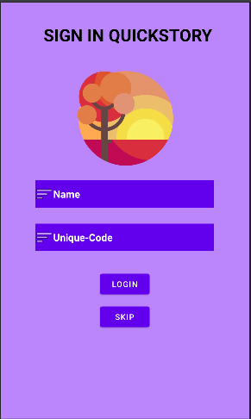 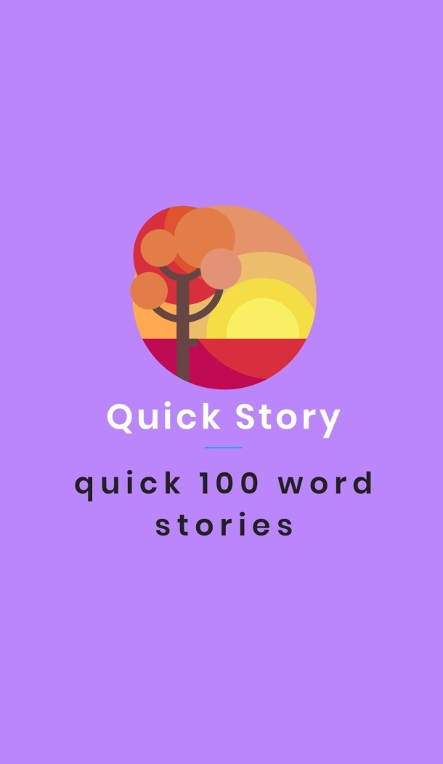

App link on github

https://github.com/JainAyush09/QuickRead

**Future Scope**

* Biographies and Autobiographies of best books in effective points .
* Audioboooks for every book .
* Addition of latest news stories in short for daily updates.
* Opportunity for you to add your Quick Story in this app.

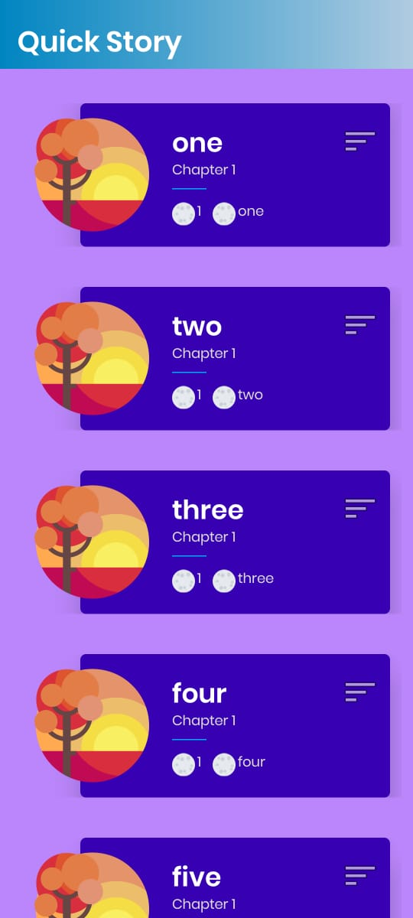 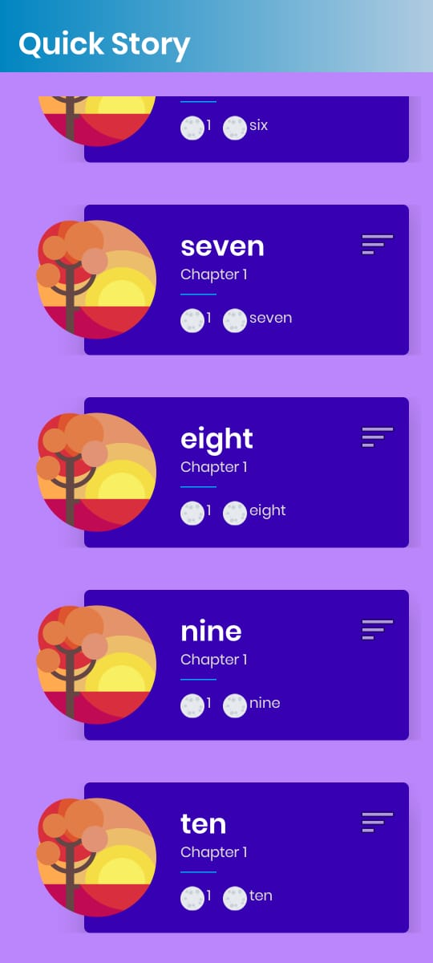

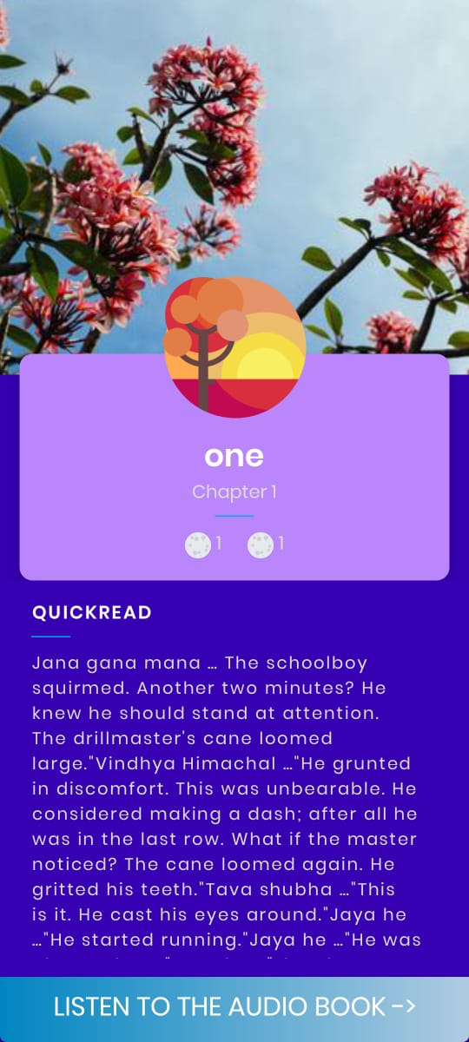 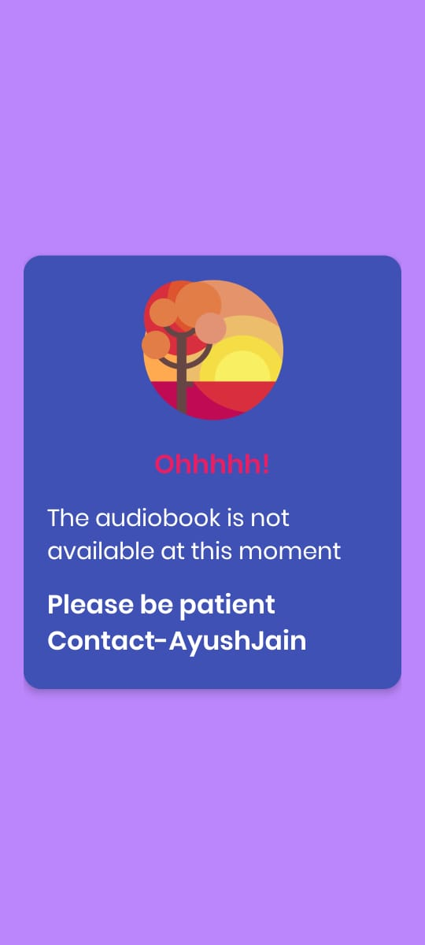

**By –AYUSH JAIN**