RETAILPULSE
Retail Sales & Customer Analytics
POWER BI DASHBOARD PROJECT REPORT

Project | RetailPulse: Retail Sales & Customer Analytics
Platform | Microsoft Power BI; Excel source data
Prepared by | Khushii Vinod Jain
Project / cohort | Team 22

1. Executive Summary and Project Objectives
RetailPulse is a Power BI dashboard project designed to organise retail transaction data into interactive views of sales, order activity, customer contribution, product performance and country-level patterns. The report brings together executive monitoring and more detailed views so a user can move from a high-level question to a more focused investigation using the available visual filters.

Project at a glance
Item | Description
Platform | Microsoft Power BI Desktop
Core transaction table | 2009-2011
Source data | Retail transaction data imported from Excel
Scope | 12 dashboard pages
Primary themes | Sales, order volume, customers, products, countries, seasonality and inventory-risk proxies
Evidence in this draft | Project description plus available Power BI screenshots; all numeric claims should be checked in the PBIX

Business objectives
- Monitor overall sales, order count, customer reach and quantity sold.
- Compare product and country contributions using sales and quantity-based visuals.
- Explore monthly, daily and seasonal patterns in recorded transactions.
- Review customer purchase activity, order frequency and average order value.
- Use demand-related visuals to help prioritise further inventory checks.
- Allow a viewer to explore data using available year, month, country and other report filters.

Scope and evidence approach
Descriptions in this report are intended to explain the purpose and use of the visuals. Where exact results, calculation logic or forecasting-model performance have not been independently confirmed, the report gives interpretation guidance instead of asserting an unverified finding. Screenshots should come from the submitted PBIX file after filters are cleared or clearly documented.

2. Dataset, Model and Preparation
The main transaction table in the project is named CLEANED. Fields used in the analysis include customer, invoice, stock/product, quantity, price, transaction date and country attributes.

Core fields referenced
Field | Analytical use
Customer ID | Customer-level grouping and distinct customer counts
Invoice | Invoice/order identification; use distinct count when counting orders
StockCode / Description | Product identification and product-level summaries
Quantity | Units sold or transaction quantity
Price | Recorded unit price; confirm currency and meaning
TOTAL SALES | Sales amount used in revenue/sales visuals
InvoiceDate / DATE | Time-based slicing and trends
TIME / MONTH / YEAR | Time-of-day and calendar breakdowns
Country | Geographic analysis

Supporting model tables
- RFM Customer Table: customer-level Recency, Frequency, Monetary, Customer Segment and Churn Risk attributes. Validate how each field was calculated before interpreting it.
- Product Demand Summary and Monthly Demand Summary: product and month-level quantity views.
- Product Monthly Demand: StockCode by Year/Month, with Total Quantity and Total Revenue.
- Customer Monthly Sales: customer/month summaries such as order count, sales and quantity.
- Monthly Sales Forecast: currently used as a historical monthly-sales summary in this report. It is not described as a validated future forecast unless future-period predictions are actually present in the PBIX.

Data quality and model validation checks
- Check blank customer, product, country, date, price and quantity values.
- Review negative quantities, cancellations and returns; document the treatment used.
- Confirm date fields have the correct data type and calendar relationships filter the transaction table as intended.
- Verify that order count is based on distinct Invoice IDs and customer count is based on distinct Customer IDs.
- Reconcile sales and quantity totals against the source workbook, including the effect of filters.
- Use cost data before presenting any measure as profit or margin; sales alone are revenue, not profit.

DASHBOARD PAGE 01

Executive Summary
Purpose: Give a concise view of sales performance, order activity, customer reach and sales distribution.

Visuals documented
- KPI cards: Total Sales, Total Customers, Total Orders, Total Quantity and Average Order Value.
- Yearly Sales Trend.
- Top 5 Country by Sales.
- Top 10 Products by Sales.
- Sales by Month.
Filters / interaction: Year, Month and Country slicers are shown in the project screenshot.
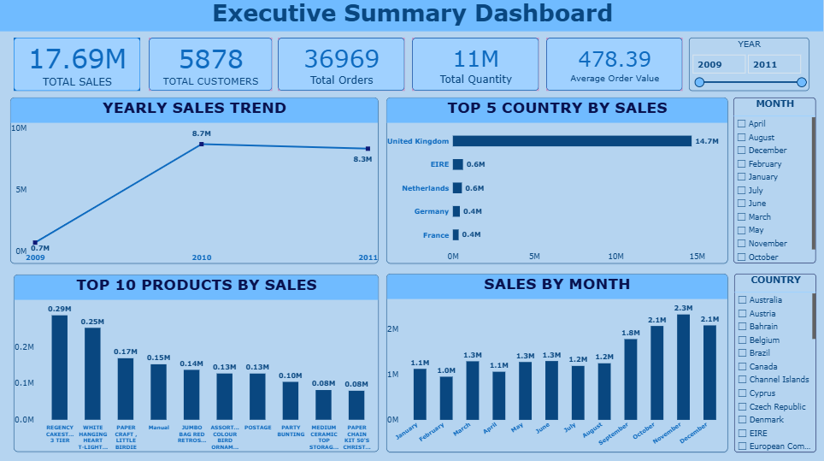
Figure 1. Executive Summary Dashboard .
Interpretation guidance: Read KPI cards together with the current filter context; use the trend and rankings to investigate changes rather than treating them as causal explanations.
Business application: Provide a starting point for routine performance reviews and follow-up analysis.

DASHBOARD PAGE 02

Sales Trend Analysis
Purpose: Examine recorded sales changes over monthly, yearly and daily time views.

Visuals documented
- Monthly Sales Trend.
- Sales by Year.
- Monthly Sales Changes.
- Daily Sales Trend, using transaction date and Total Sales.
Filters / interaction: Year, Month and Country filters are available in the report; verify their effect after selecting a value.
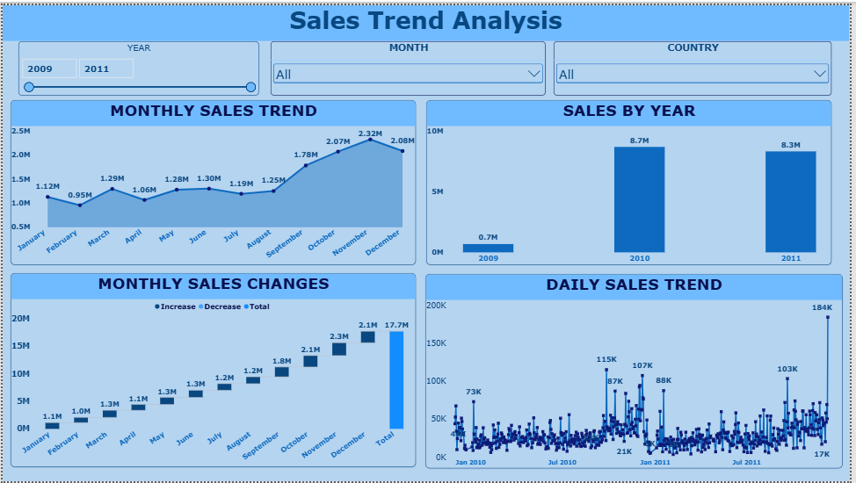
Figure 2. Sales Trend Analysis .
Interpretation guidance: Compare periods using the same date range and ensure the date axis is chronological. Daily values can be volatile, so use monthly/yearly context before drawing conclusions.
Business application: Support time-based reviews and identify periods that merit closer checking.

DASHBOARD PAGE 03

Product Performance
Purpose: Compare product contribution using sales and quantity-based views.

Visuals documented
- Product Sales Contribution treemap.
- Top 10 Products by Quantity Sold.
- Top 10 Products by Revenue.
- Product Sales & Quantity Comparison.
- Product Monthly Demand trend.
Filters / interaction: Year, Month and Country filters are part of the broader report design; confirm which are present on this page in the saved PBIX.
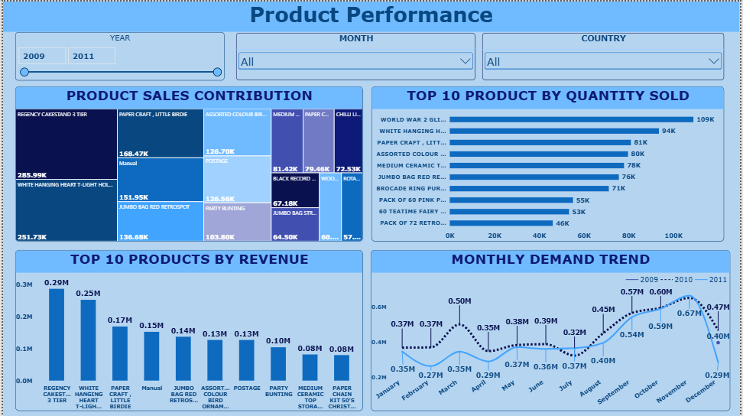
Figure 3. Product Performance .
Interpretation guidance: Revenue ranking and quantity ranking answer different questions. A high quantity does not automatically mean high revenue or high profit.
Business application: Support merchandising review and focus attention on leading or low-volume products.

DASHBOARD PAGE 04

Customer Analytics
Purpose: Review customer contribution, purchase activity and segment distribution.

Visuals documented
- Top 10 Customers by Sales.
- Top 10 Customers by Total Orders.
- Customer Distribution by Country map.
- Customer Segment Distribution from the RFM Customer Table.
Filters / interaction: Country and Year filters are used on this report page; confirm the final saved page.
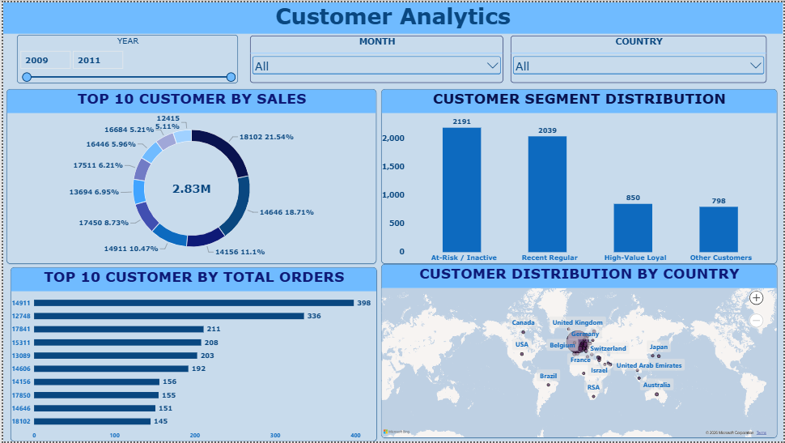
Figure 4. Customer Analytics .
Interpretation guidance: Distinct customer counts and customer sales must be interpreted under the active filters. Treat segment labels as analytical groupings and verify their definitions.
Business application: Help prioritise customer-retention analysis and review whether sales are concentrated among a small group.

DASHBOARD PAGE 05

Country Sales Analysis
Purpose: Compare country-level sales and quantity patterns.

Visuals documented
- Top 10 Countries by Total Sales.
- Monthly Sales Trend by Year.
- Top 10 Countries by Quantity Sold.
- Global Sales Distribution map.
Filters / interaction: Country and date-related filters may narrow the data; record the selected context when taking evidence screenshots.
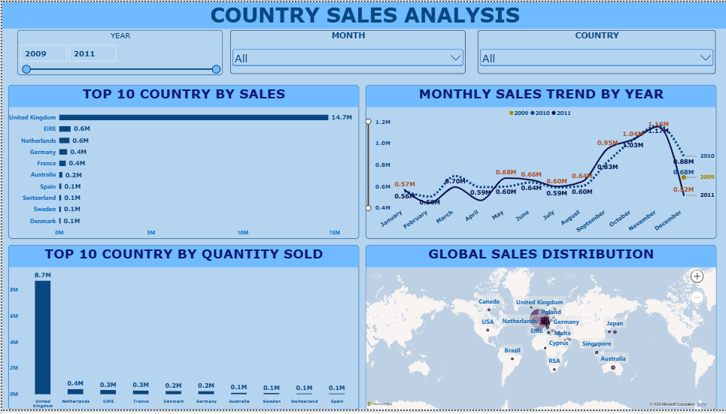
Figure 5. Country Sales Analysis
Interpretation guidance: Compare sales and quantity rankings separately. Map marker sizes and displayed rankings should be validated against the filtered table totals.
Business application: Support geographic comparison and identify markets for further commercial investigation.

DASHBOARD PAGE 06

Monthly & Seasonal Sales Analysis
Purpose: Explore monthly sales, quantity patterns and seasonal differences.

Visuals documented
- Sales Shares by Year.
- Monthly Quantity Sold.
- Seasonal Sales Comparison.
- Monthly Sales Heatmap.
Filters / interaction: Use the Year, Month, Country or other slicers actually present on the final page.
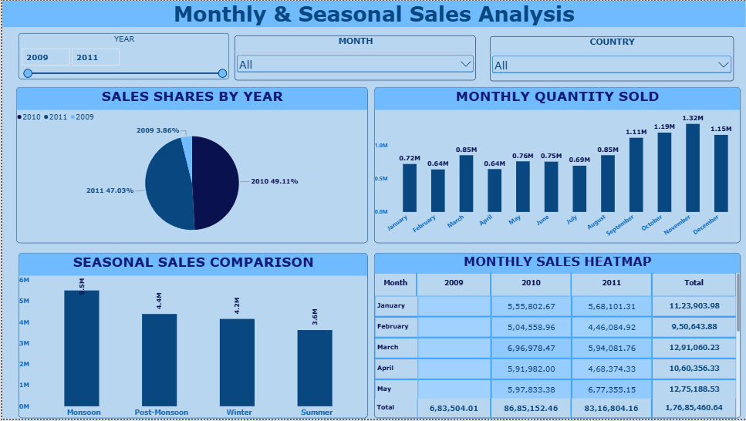
Figure 6. Monthly And Seasonal Sales Analysis
Interpretation guidance: The heatmap and seasonal charts describe patterns in historical data. They do not by themselves prove why a peak occurred or forecast future demand.
Business application: Help frame campaign, staffing and planning questions around observed historical periods.

DASHBOARD PAGE 07

Customer Behaviour Analysis
Purpose: Explore purchase frequency, order size and customer spend patterns.

Visuals documented
- Order Size Distribution.
- Top 10 Customers by Average Order Value.
- Weekly Sales Trend (confirm that the visual uses a true week grouping).
- Customer Sales vs Order Frequency.
Filters / interaction: Use the report filters available on the final page and note the time period before comparing customers.
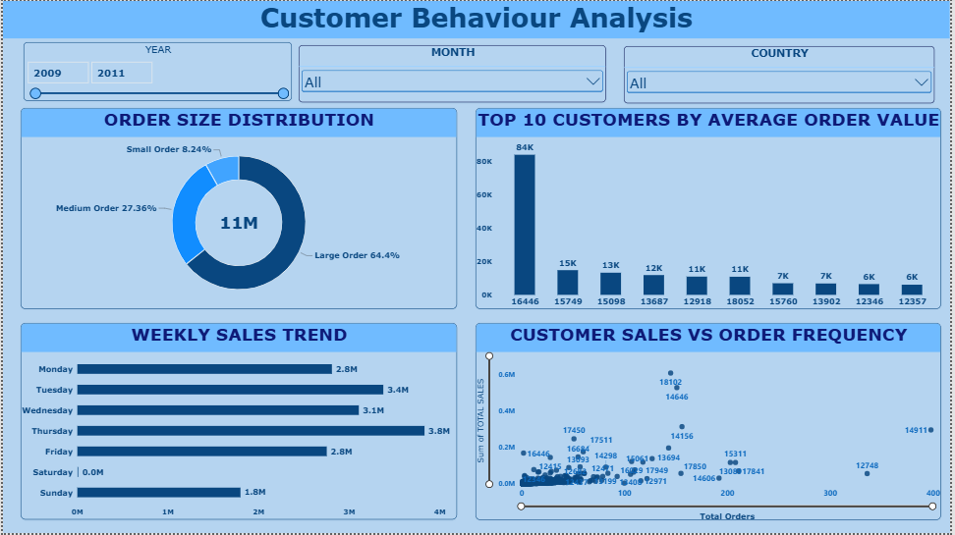
Figure 7. Customer Behaviour Analysis.
Interpretation guidance: Average order value should be defined consistently as sales divided by distinct orders if that is the project measure. A top-10 chart is a subset, not a full customer profile.
Business application: Support customer-behaviour reviews and identify candidates for deeper segmentation.

DASHBOARD PAGE 08

Revenue Analysis
Purpose: Review sales amount across time, products and countries.

Visuals documented
- Monthly Revenue Trend.
- Top 10 Products: Revenue vs Quantity.
- Revenue by Country.
- Revenue Shares by Year.
- Annual Revenue Trend and the page KPI cards.
Filters / interaction: Check Year, Month and Country filters on the saved report.
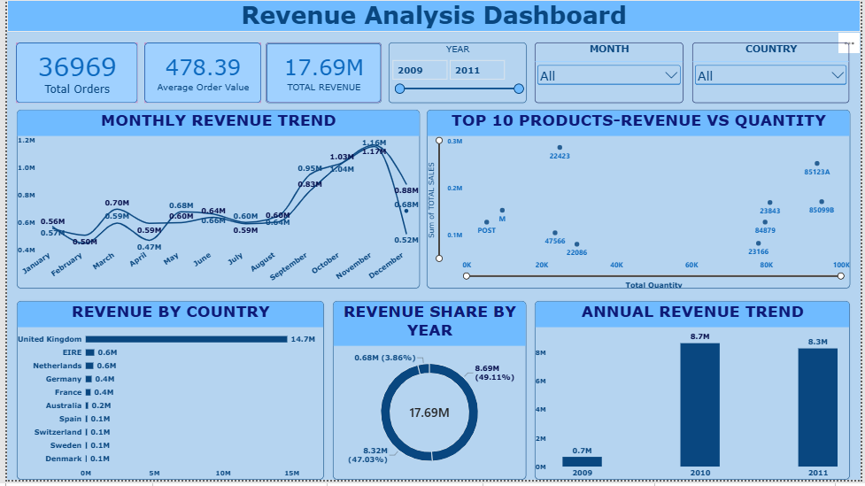
Figure 8. Revenue Analysis
Interpretation guidance: The project uses sales/revenue measures. Do not label them as profit or margin without reliable cost fields and validated calculations.
Business application: Explain the main dimensions contributing to recorded revenue and guide follow-up checks.

DASHBOARD PAGE 09

Inventory Risk
Purpose: Use historical demand patterns as a starting point for inventory review.

Visuals documented
- Monthly Product Demand Trend.
- Top 10 Products by Quantity Sold.
- Bottom 10 Products by Revenue.
Filters / interaction: Use the Year and Country selections actually configured on the final page.
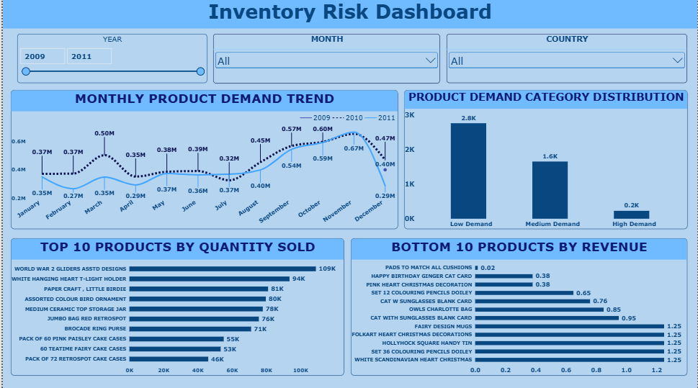
Figure 9. Inventory Risk Dashboard
Interpretation guidance: Sales and quantity are demand proxies only. Without current stock-on-hand, supplier lead time and replenishment rules, the dashboard cannot conclusively identify stockouts or calculate a reorder recommendation.
Business application: Prioritise product-level checks and define what additional inventory data would be required.

DASHBOARD PAGE 10

Order & Transaction Analysis
Purpose: Monitor transaction volume, average order value and order mix over time.

Visuals documented
- Monthly Order Trend.
- Average Order Value by Year.
- Total Orders by Year.
- Quantity Sold by Year.
Filters / interaction: Use the available Year and Country filters; check whether invoice counts use distinct values.
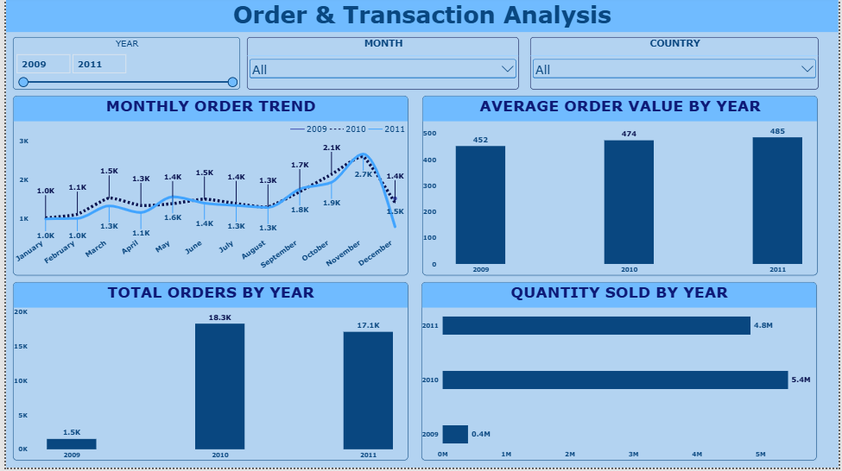
Figure 10. Order And Transaction Analysis
Interpretation guidance: Order totals can be overstated when invoice identifiers are summed rather than counted distinctly. Verify all order measures before submission.
Business application: Support operational workload review and comparisons between periods.

DASHBOARD PAGE 11

Advanced Analytics Dashboard
Purpose: Provide a decomposition-tree view for exploring contributing dimensions.

Visuals documented
- Decomposition Tree visual for exploring sales or the selected measure across explanatory dimensions, as configured in the saved PBIX.
Filters / interaction: Use the visual’s configured Analyze and Explain by fields; verify the actual choices in Power BI.
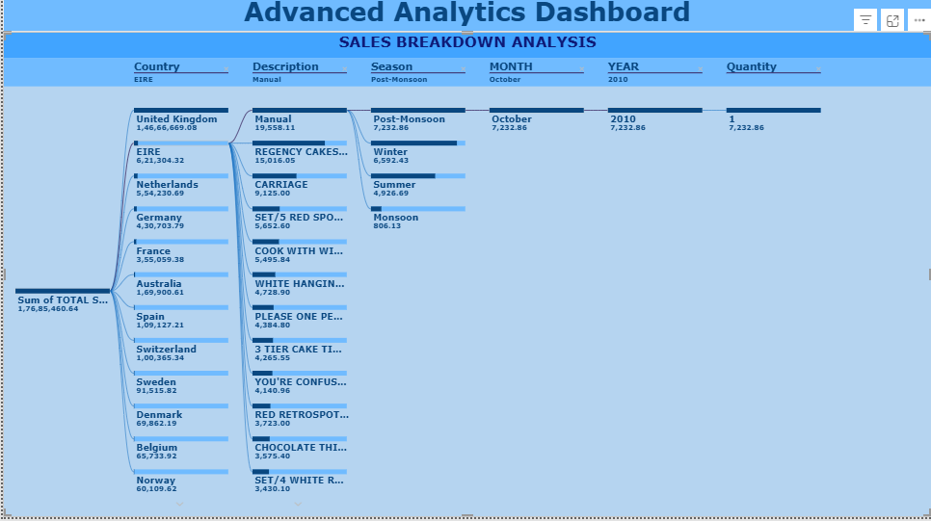
Figure 11. Advanced Analytics Dashboard
Interpretation guidance: A decomposition tree helps explore how a measure breaks down across dimensions. It does not, on its own, establish causation or predict future outcomes.
Business application: Enable a guided drill-down when a headline number needs further investigation.

DASHBOARD PAGE 12

Interactive Filter Dashboard
Purpose: Provide a compact self-service entry point for customer segments and monthly sales.

Visuals documented
- Customer Segment Distribution donut chart using Customer Segment and distinct Customer ID.
- Monthly Sales Trend line chart based on transaction date and Total Sales.
Filters / interaction: Only describe slicers that are present in the saved file. Test whether each filter updates both visuals as expected.
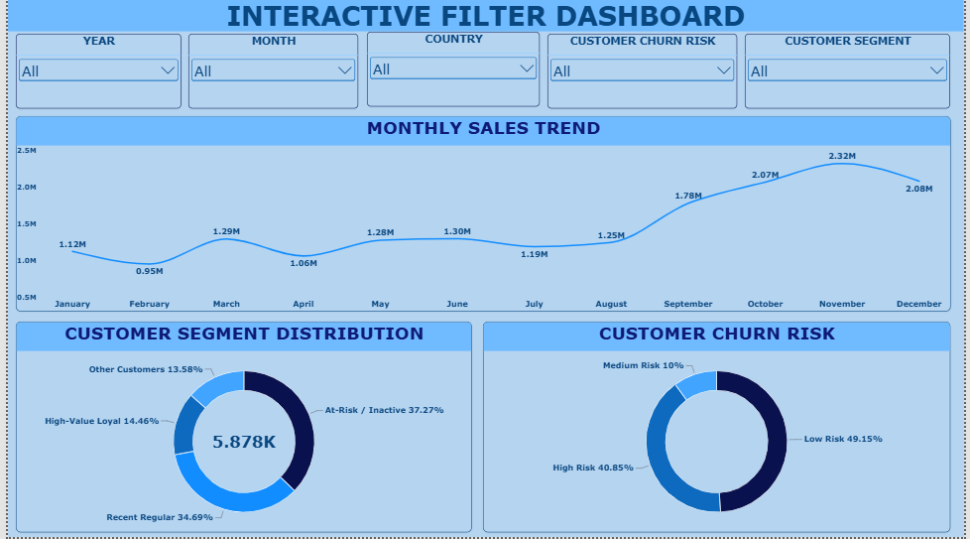
Figure 12. Interactive Filter Dashboard
Interpretation guidance: Check that segment categories are defined, category counts are distinct customers, and the monthly trend follows a real chronological date field.
Business application: Let a viewer compare segment composition with the selected sales period.

15. Project Findings and Conclusion
- The RetailPulse project helped in analysing retail sales, customer behaviour, product performance and country-wise sales using Microsoft Power BI. The dashboard presents the data through different charts, graphs and cards, making it easier to understand and compare business performance.
- The project provides a clear overview of sales and customer activities. The dashboard can help users explore the data and identify important patterns. The accuracy of the results depends on the quality of the data and the correct use of measures.
- Overall, this project helped me understand how Power BI can be used to create interactive dashboards and analyse retail data in a simple and effective way.
- The report layout provides a broad view of retail sales, customers, products, geography, time patterns and transactions. Specific numerical conclusions should be written only after they have been checked against the displayed values in Power BI with the relevant filters recorded.

Findings to validate in Power BI
- Confirm the highest-selling products and countries from the final filtered report.
- Check whether sales and quantity rankings differ, and describe only patterns visibly supported by the visuals.
- Confirm the direction of monthly/yearly sales changes from the displayed trend and exact period labels.
- Review customer segment counts and the definitions behind High-Value Loyal, At-Risk / Inactive, Recent Regular and Other Customers.
- Verify any weekly-sales visual truly groups records by week before calling it a weekly trend.

Limitations
- The screenshot and visual descriptions are not a substitute for validating measure formulas in the PBIX.
- Historical monthly sales charts should not be presented as a validated future forecast. Forecasting claims require actual future-period predictions and documented validation metrics.
- Inventory risk cannot be conclusively assessed from sales alone; on-hand stock and lead-time data are not documented here.
- Profit and margin cannot be reliably reported without cost data.
- Maps and customer/product rankings should be checked with current slicer selections and sensible aggregation.

Conclusion
The RetailPulse project helped me understand how retail data can be analysed using Microsoft Power BI. I created interactive dashboards to present sales, customer behaviour, product performance and country-wise analysis. Different charts and graphs make the data easier to understand. Overall, this project improved my knowledge of data visualisation and helped me learn how to present business data in a clear and organised way.

