How to create Workflow System
First go to Database and select DB.
Goto properties-> Open Filegroups->ADD->Press OK
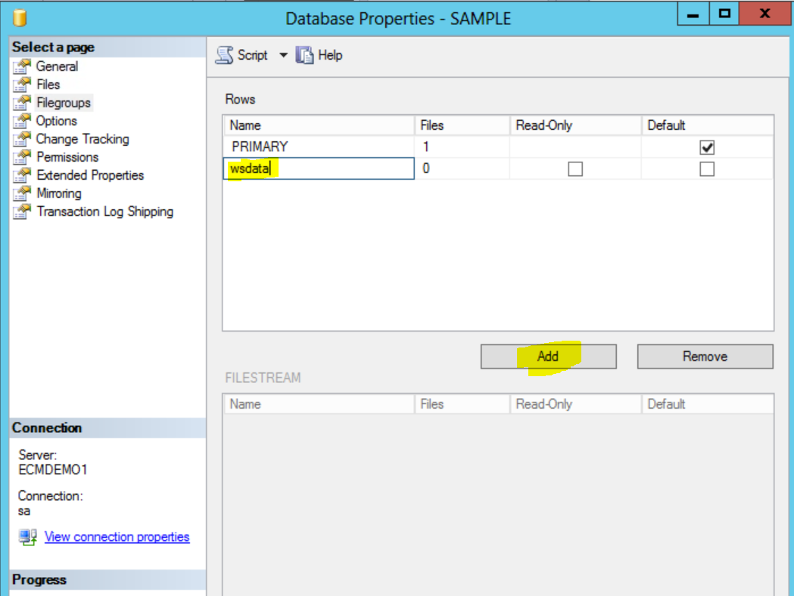
Now go to Files and ADD(please give the size to 50)
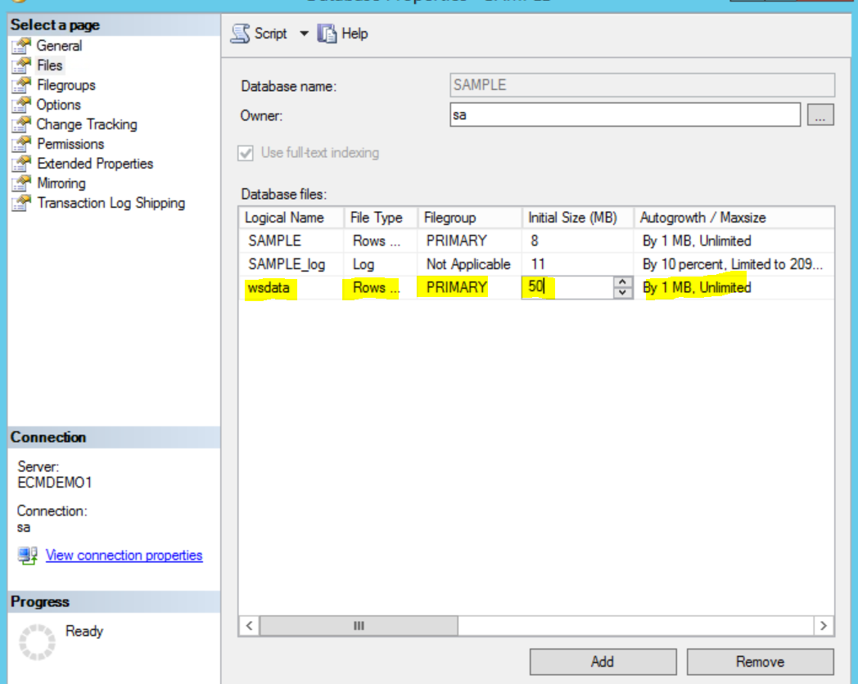
After creation:
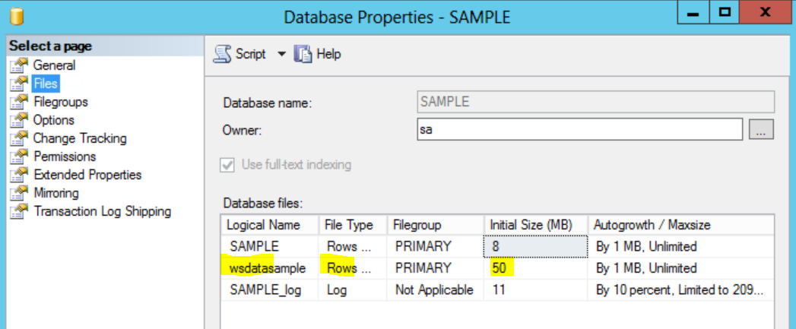
Go to ACCE.
Open Object store ->administrative -> workflow system (right click and press new)
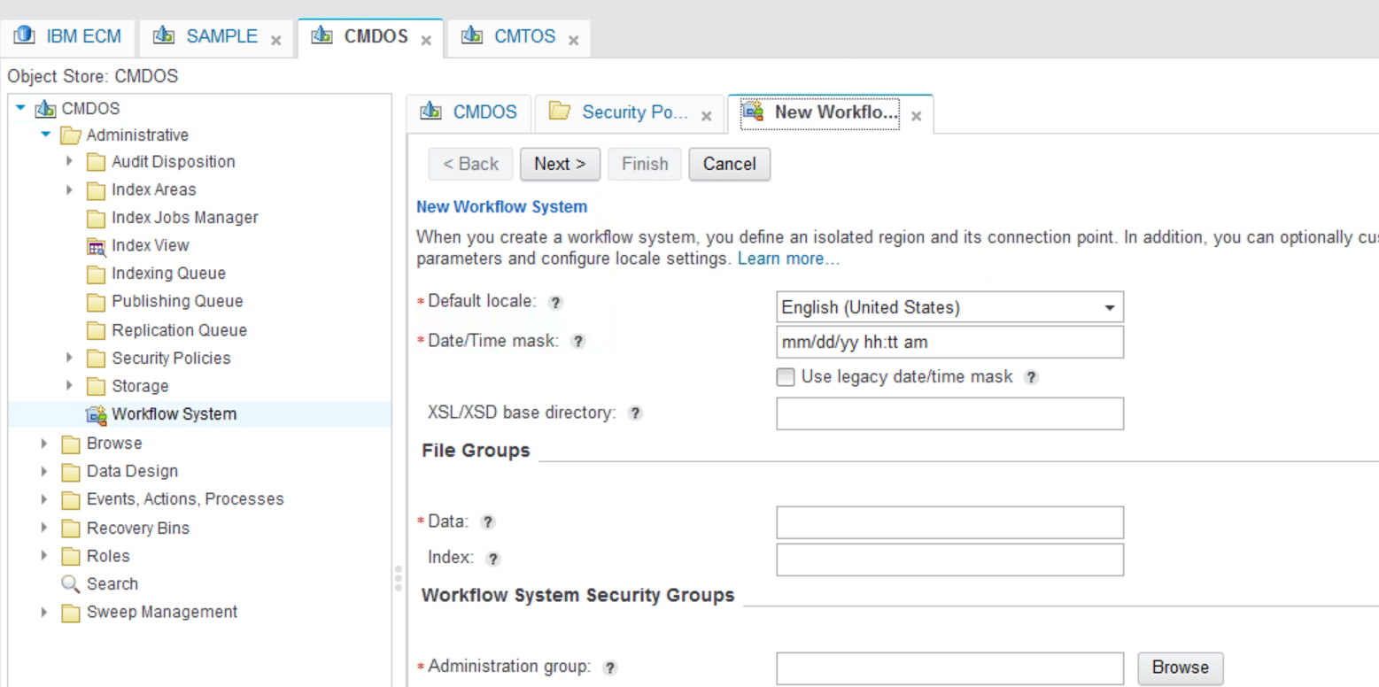

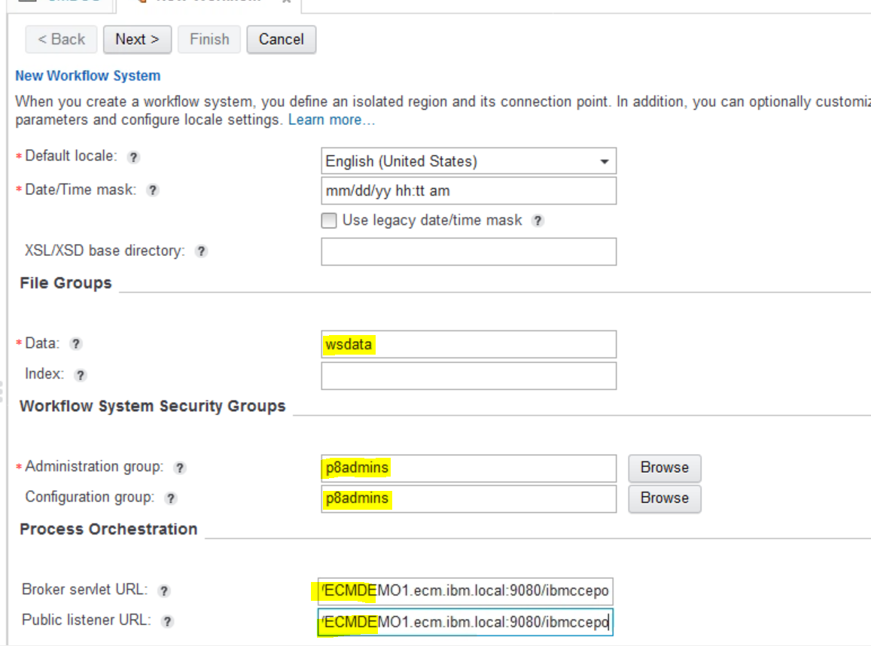
Press next and give connection point name:
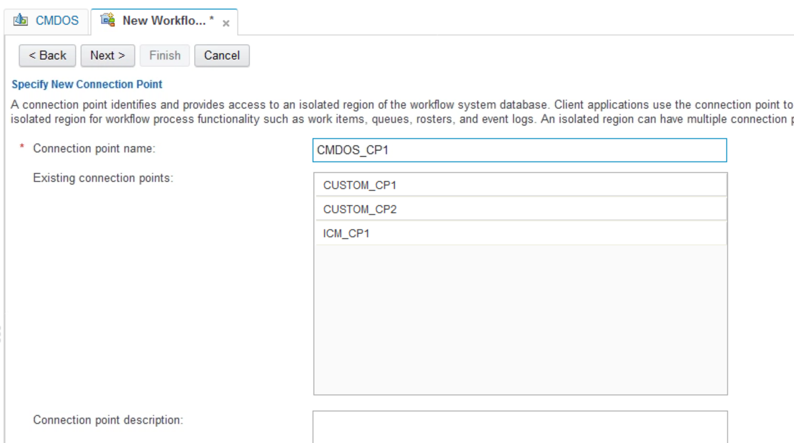
Give Region name, you can choose any number between (0-999).
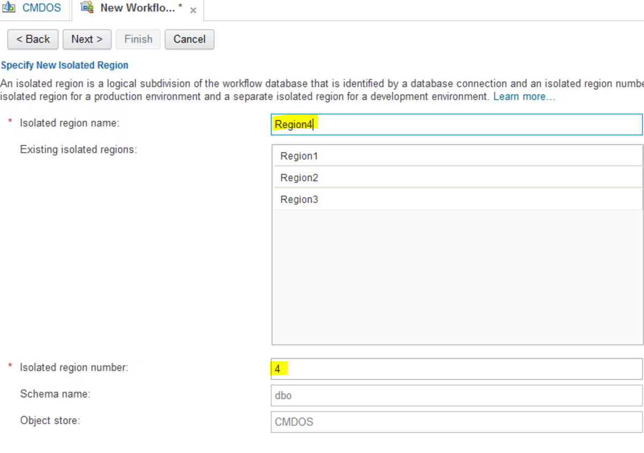
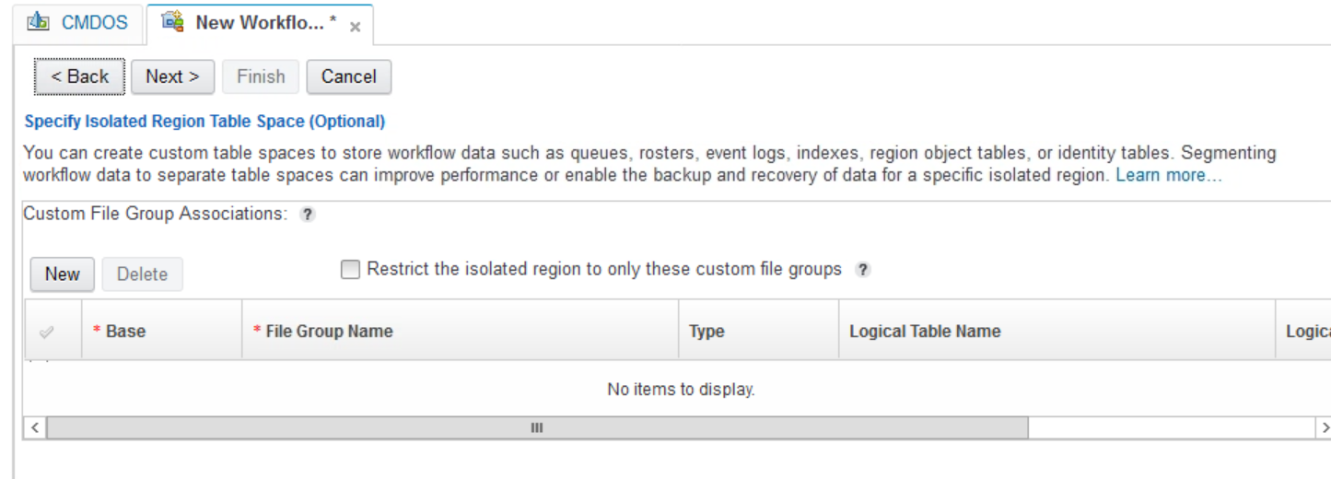
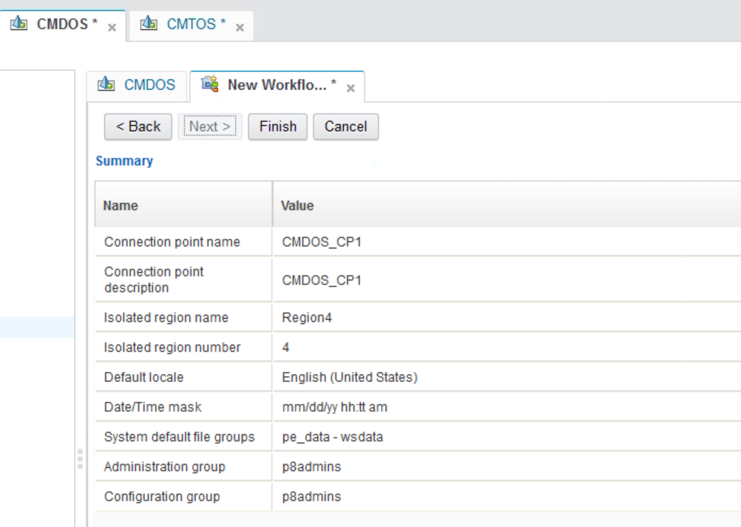

Finish it.

If you want to create new isolated region. You need to create new connection point and at the time of creation , you need to select you want to go for existing region or new region.

