Hive

Program 01:

1. Create a table with the schema as specified below and load the data.

2) Write a query to derive a new column extra_vacation based on the tenure served, the logic is as given below.

1. If tenure < 2, Then 20

2. If tenure is 2-10 then 30 days

3. If tenure > 10 then 40 days

**Problem Statement 02**

1)Create a table “temperature” to store the dataset as mentioned in the schema and load the data

Write a query to calculate the maximum temperature of each state.

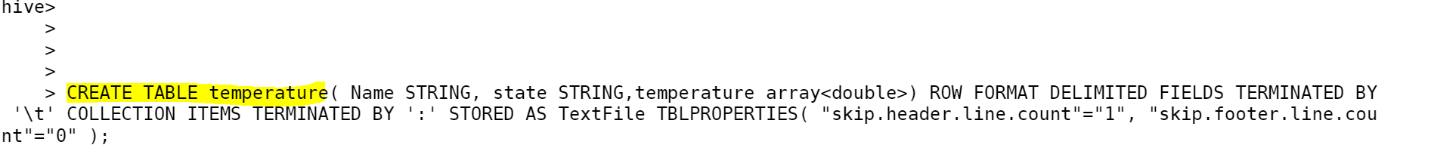

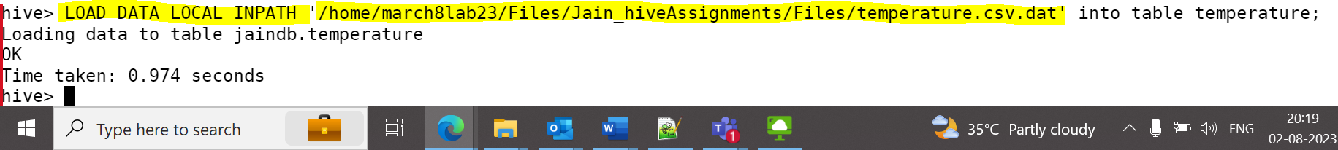

**Problem Statement 03**

Prerequisite :

Create a table 'student_marks' with schema as shown above and load the data into the 'student_marks' table.

1)Write a query to perform below mentioned tasks:

A. Display NAME who have scored more than 90 in subject Maths subject

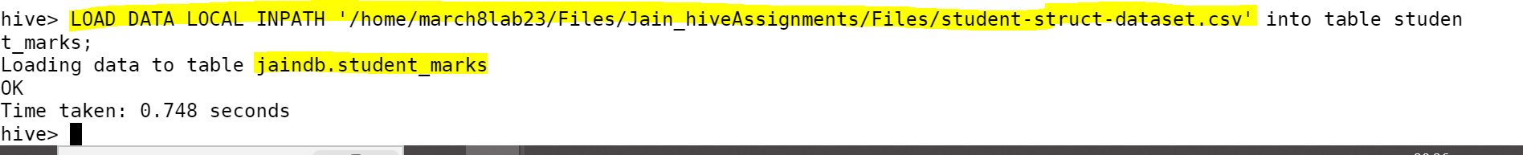

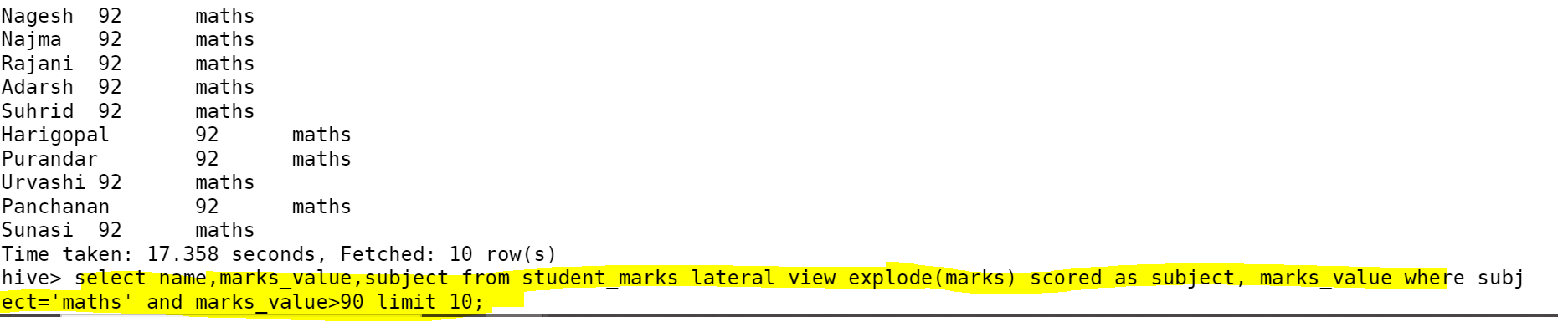

B. Display NAME and marks scored in physics subject.

C.Display NAME and marks scored in physics subject.

D. Display NAME, and <average -Subject-Marks>

**Problem Statement 04**

**Prerequisite :**

Create a table “student_info” with schema as show below and load the data

A. Display all “NAME” who is located in Banashankari

B. Calculate the total count who is staying in pin code 560001

