**NAME:- PATEL SHIV DINESHBHAI**

**ID:- 20IT113**

**CLASS:- IT 2**

**LAB BATCH:- B2**

**SUBJECT:- DATA COMMUNIVCATION AND NETWORKING**

**DATE OF SUBMISSION :- 8/9/2021**

**TASK:-** UNDERSTAND AND IDENTIFY LAYER-2 FUNCTIONALITY

* Layer 2, also known as the Data Link Layer, is the second level in the seven-layer OSI reference model for network protocol design. Layer 2 is equivalent to the link layer (the lowest layer) in the TCP/IP network model. Layer2 is the network layer used to transfer data between adjacent network nodes in a wide area network or between nodes on the same local area network.
* The data link layer is the protocol layer in a program that handles the moving of data into and out of a physical link in a network.
* The data link layer also determines how devices recover from collisions that may occur when nodes attempt to send frames at the same time.
* A frame is a protocol data unit, the smallest unit of bits on a Layer 2 network. Frames are transmitted to and received from devices on the same local area network (LAN).
* At Layer 2, unicast refers to sending frames from one node to a single other node, whereas multicast denotes sending traffic from one node to multiple nodes, and broadcasting refers to the transmission of frames to all nodes in a network.
* Data link layer is the second layer in OSI reference model and lies above the physical layer. The physical layer provides only a raw bitstream service between computers. The data link layer provides data reliability and provides tools to establish, maintain, and release data link connections among the network nodes.
* FUNCTIONALITIES OF DATA LINK LAYER

🡪 Providing a well-defined service interface to the network layer.

🡪 Dealing with transmission error.

🡪 Regulating the flow of the data so that the slow receiver are not swamped by fast senders.

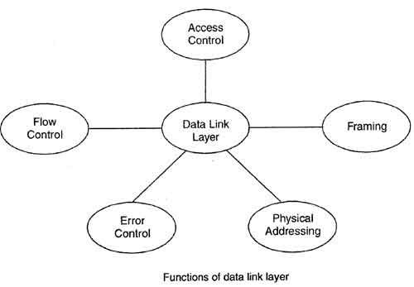

**1) FRAMING:-**

* Divides the stream of bits into manageable data units called as frames.
* Framing is a point-to-point connection between two computers or devices consists of a wire in which data is transmitted as a stream of bits.

**2) PHYSICAL ADDRESSING:-**

* The Data Link layer adds a header to the frame in order to define physical address of the sender or receiver of the frame, if the frames are to be distributed to different systems on the network.This prevents traffic jam at the receiver side.

**3) FLOW CONTROL:-**

* Imposes the flow control mechanism to avoid overwhelming the receiver.
* Flow control in Data Link Layer simply restricts and coordinates number of frames or amount of data sender can send just before it waits for an acknowledgment from receiver.

**4) ERROR CONTROL:-**

* Adds mechanism to detect and retransmit damaged or lost frames.
* [Data-link layer](https://www.geeksforgeeks.org/design-issues-in-data-link-layer/) uses the techniques of error control simply to ensure and confirm that all the data frames or packets, i.e. bit streams of data, are transmitted or transferred from sender to receiver with certain accuracy.

**5) ACCESS CONTROL:-**

* Determine that which device has the control over the link at any given time.