**Name:- PATEL SHIV DINESHBHAI**

**ID:- 20IT113**

**CLASS:- IT 2**

**LAB BATCH:- B2**

**SUBJECT:- DATA COMMUNICATION AND NETWORKING**

**DATE OF SUBMISSION:- 9/9/2021**

**PRACTICAL-2**

**AIM:-** STUDY THE FOLLOWING NETWORK DEVICES IN DETAIL

NIC HUB SWITCH ROUTER

GATEWAY REPEATER BRIDGE BROUTER

**1) NIC:-**

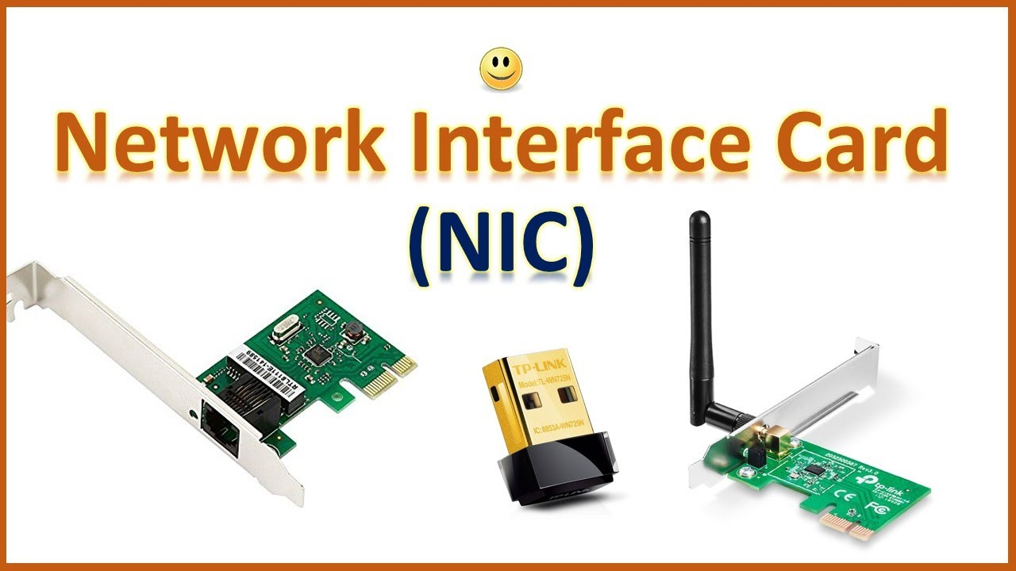

* The full form of the NIC is Network Interface card.
* It is the Network Adapter that is used to Connect Computer to Network.
* It is a circuit board installed in a computer that provides a dedicated network connection to the computer.
* A network interface card (NIC) is a hardware component, typically a circuit board or chip, which is installed on a computer so that it can connect to a network..
* Each card represents a device and can prepare, transmit and control the flow of data on the network
* It can connect to motherboard and also we can Establish the LAN connection.
* The cable acts as the interface Between the Computer and Router or Modem.
* These NIC works on the physical and data link layer.
* NIC allows communications between computers connected via local area network (LAN) as well as communications over large-scale network through Internet Protocol (IP).
* The example of that NIC works on both physical layer and a data link layer device is that it provides the necessary hardware circuitry so that the physical layer processes and some data link layer processes can run on it.

**2) HUB:-**

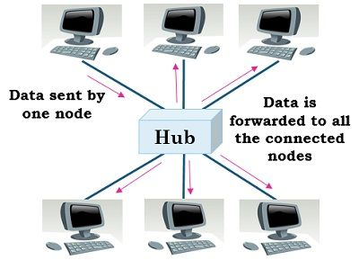

* They are generally used to connect computers in a LAN.
* A hub has many ports in it. A computer which intends to be connected to the network is plugged in to one of these ports.
* It is a MULTI POINT REPEATER.
* In the HUB Frame is the Broadcast.
* It is the Physical Layer Device and Do not check the MAC address(HEXA DECIMAL FORM).
* The HUB cannot create the virtual LAN.
* Collisions may occurs during setup of transmission when more than one computers place data simultaneously in the corresponding ports.
* There are three types of Hubs:-
* Passive hub:-
* It does not have much Intelligency.
* Active hub:-
* Active hub can process and monitor information.
* It has the more intelligency as compare to the passive Hub.
* Intelligency HUB:-
* It is mainly design for the Management Purposes.
* It is used in different kind of business to handle and share the common problem.
* It works only with LAN connection.
* It can detect the problem easily.
* USES:-
* It is used to create the Home networks.
* It is used in organizations to provide the connectivity.

**3) ROUTER:-**

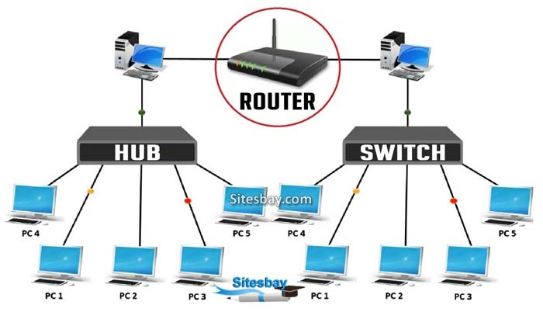

* The Router is three layer devices and it operates at the Network layer.
* A router receives and sends data on computer networks.
* Routers are sometimes confused with network hubs, modems, or network switches.
* Routers can combine the functions of these components, and connect with these devices, to improve Internet access or help create business networks.
* They are responsible for receiving, analysing, and forwarding data packets among the connected computer networks.

**4) SWITCH:-**

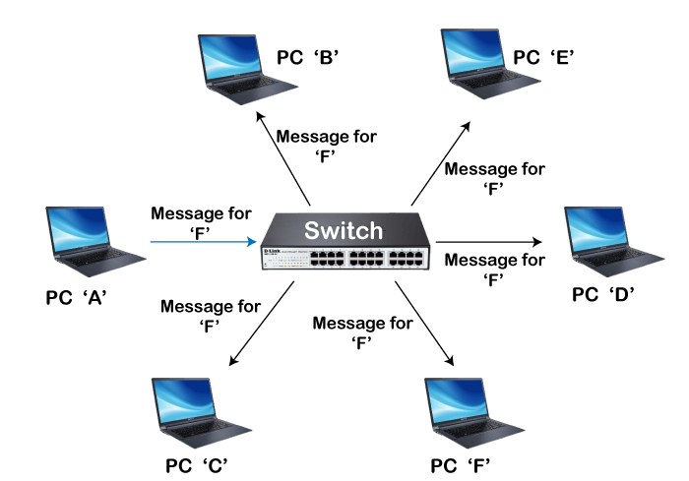

* A switch is a device in a computer network that connects other devices together.
* Multiple data cables are plugged into a switch to enable communication between different networked devices.
* They connect multiple devices, such as computers, wireless access points, printers, and servers on the same network within a building or campus.
* A switch enables connected devices to share information and talk to each other.
* It has the capacity of the buffer and it is also called as Multi port bridge.
* It can perform the error checking.
* A switch is used in a wired network to connect to other devices using Ethernet cables.

**5) GATEWAY:-**

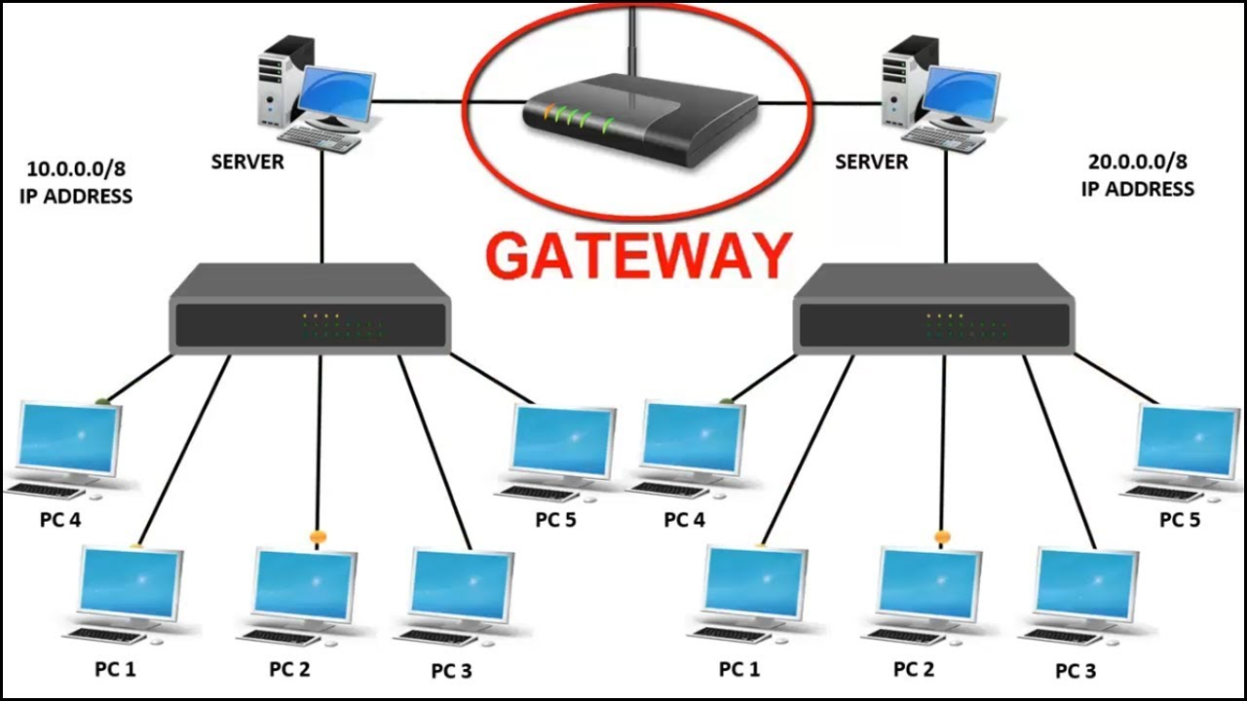

* A computer that sits between different networks or applications.
* The gateway converts information, data or other communications from one protocol or format to another.
* A router may perform some of the functions of a gateway.
* An Internet gateway can transfer communications between an enterprise network and the Internet.
* GATEWAYS ARE ALSO called as protocol converters and can operate at any network layer.
* Gateways are generally more complex than switch or router.
* They basically work as the messenger agents that take data from one system, interpret it and transfer it to another system.

**6) REPEATER:-**

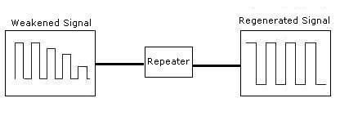

* Repeater operates at the physical layer.
* It can regenerate the signal over same network before signal become weak.
* To extend the length of the network a repeater is used.
* They are incorporated in networks to expand its coverage area. They are also known as signal boosters.

**7) BRIDGE:-**

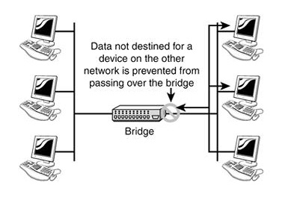

* It operates at the data link layer.
* It is a 2 port device single input and single output device.
* A bridge is a network device that connects multiple LANs (local area networks) together to form a larger LAN.
* A bridge connects the different components so that they appear as parts of a single network.
* Bridges connects two or more different LANs that has a similar protocol and provides communication between the devices (nodes) in them.

**8) BROUTER:-**

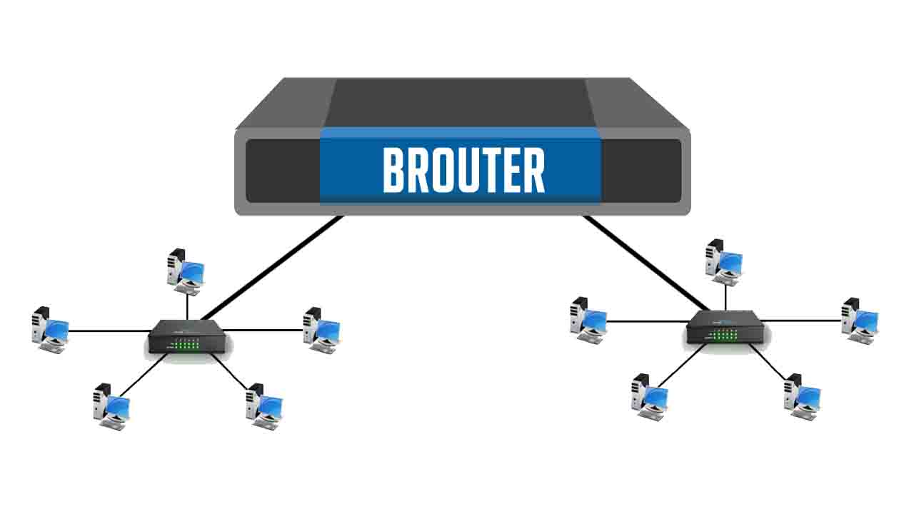

* It is also known as the bridging router is a device that combines features of both bridge and router.
* It can work either at the data link layer or a network layer.
* Brouters are the combination of the Routers and Bridge.
* They take up the functionalities of both networking devices serving as a bridge when forwarding data between networks, and serving as a router when routing data to individual systems.

-------x------------------x-----------------------x-----------------x--------