IT-643 Software Design and Testing

Class Diagram

Team : CodeCatalyst

202412122 : Jainam Vora
202412108 : Jenil Soni
202412090 : Anuj Shah

Class Diagram Image

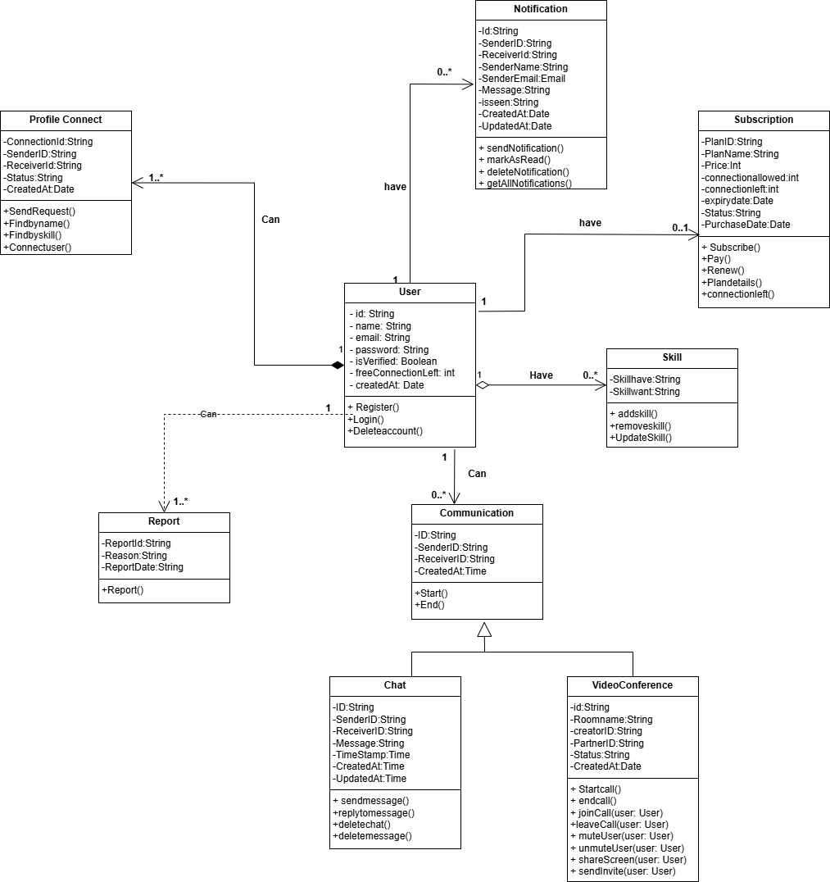

Entities, Attributes, and Behaviors
This section lists each class (entity) from the diagram, detailing its specific attributes (data) and behaviors (methods) in a bullet-point format.

User
- Attributes: id: String, name: String, email: String, password: String, freeConnectionLeft: Int, createdAt: Date, isVerified: Boolean
- Behaviors: Register(), Login(), DeleteAccount()

Profile Connect
- Attributes: connectId: String, senderId: String, receiverId: String, status: String, updatedAt: Date
- Behaviors: SendRequest(), Findbyname(), Findbyskill(), Connectuser()

Report
- Attributes: reportId: String, reason: String, reportDate: String
- Behaviors: Report()

Notification
- Attributes: id: String, receiverId: String, senderId: String, senderName: String, message: String, createdAt: Date, updatedAt: Date, status: String, senderEmail: String, isSeen: Boolean
- Behaviors: sendNotification(), markAsRead(), deleteNotification(), getAllNotifications()

Subscription
- Attributes: planId: String, planName: String, price: Int, connectionAllowed: Int, connectionLeft: Int, expiryDate: Date, purchaseDate: Date, Status: String
- Behaviors: Subscribe(), Pay(), Renew(), PlanDetail(), connectionLeft()

Skill
- Attributes: skilIHave: String, skillWant: String
- Behaviors: addSkill(), removeSkill(), UpdateSkill()

Communication
- Attributes: id: String, senderId: String, receiverId: String, createdAt: Time
- Behaviors: Start(), End()

Chat
- Attributes: id: String, senderId: String, receiverId: String, message: String, timeStamp: Time, createdAt: Date, updatedAt: Date
- Behaviors: sendmessage(), replytomessage(), deletemessage(), deleteChat()

VideoConference
- Attributes: id: String, roomName: String, creatorId: String, partnerID: String, status: String, createdAt: Date
- Behaviors: Startcall(), endcall(), joinCall(User: User), shareScreen(User: User), muteUser(User: User), unmuteUser(User: User), sendinvite(User: User), leaveCall(User: User),

Relationships and Cardinality
This section outlines how the classes are connected, including the type of relationship and the cardinality.
- User and Profile Connect: A User can have 1..* (one or more) Profile Connects, while a Profile Connect is associated with 1 (exactly one) User.
  - Cardinality: One-to-Many
  - Relationship: Composition
- User and Report: A User can have 0..* (zero or more) Reports, while a Report is associated with 1 (exactly one) User.
  - Cardinality: One-to-Many
  - Relationship: Dependency
- User and Notification: A User can have 0..* (zero or more) Notifications, while a Notification is associated with 1 (exactly one) User.
  - Cardinality: One-to-Many
  - Relationship: Association
- User and Subscription: A User can have 0..1 (zero or one) Subscription, while a Subscription is associated with 1 (exactly one) User.
  - Cardinality: One-to-One
  - Relationship: Association
- User and Skill: A User can have 0..* (zero or more) Skills, while a Skill is associated with 1 (exactly one) User.
  - Cardinality: One-to-Many
  - Relationship: Aggregation
- User and Communication: A User can have 0..* (zero or more) Communications, while a Communication is associated with 1 (exactly one) User.
  - Cardinality: One-to-Many
  - Relationship: Association
- Chat and VideoConference Inheritance: Chat and VideoConference are both specialized types of Communication, inheriting its attributes and behaviors.
  - Cardinality: Generalization/Inheritance
  - Relationship: Generalization

