The Stranger Reads You Better: Introspective Self-Report Has No Privileged Access to Injected States from 1.7B to 32B
Jainam Shah, Independent
Apart Research Digital Minds Research Sprint · 17 August 2026
Track 3: Introspection & Self-Report Reliability

Abstract
A model has privileged introspective access only if its report about its own internal state outperforms an equal-cost external observer. We test this with concept injection, where ground truth is chosen by the experimenter, across seven open-model configurations (Qwen3 1.7B-32B, Qwen2.5-32B, Mistral-7B), with dose-matched perturbations, fluency verified intact, and pre-registered analyses. Privileged access fails everywhere: a probe reads the injection event from the same final-layer state the answer is computed from at 0.87-1.00 AUROC, spontaneous self-report recovers R = -0.25 to +0.23 of that evidence, and at 4B-32B a stranger reading only the transcript matches or beats the model’s own introspection. The channel’s answer prior swings from all-No (1.7B) to all-Yes (Qwen3-32B) without information appearing; the single opening (Qwen2.5-32B, 0.62) tracks lineage, not scale. Trained ‘introspection’ reaching held-out AUROC 1.000 is exposed as artifact by three controls: a dose-calibration ceiling, vector collinearity, and a state/text swap.

1. Introduction
This sprint asks what a model’s reports about its own states are worth. Track 2 elicits distress and valence from self-report; Track 5 asks what a model treats as its essential self. Every such programme assumes that when a model describes an internal state, the description is causally downstream of that state.
Concept injection is the one setting where that assumption is directly testable, because the experimenter owns the ground truth: we choose the vector, so we know exactly what the state was perturbed toward on every trial. We pre-registered a sharp operationalisation, due in spirit to Song et al. (2025): a model has privileged access only if its self-report beats an observer of equal or lower cost available to a third party. Our third party is a fresh instance of the same model shown only the transcript. If reading your own text from the outside works as well as introspecting from the inside, there is nothing privileged to explain.
We measured this across seven configurations spanning 1.7B to 32B parameters in two model families, then asked the constructive question the track poses: if the reports fail, can the reporting channel be trained into existence? Pursuing that second question produced, in sequence, three results that looked like breakthroughs and were artifacts. The controls that killed them apply directly to published positive results in this literature, and we consider them as much of a contribution as the map.

2. Relation to prior work
The paradigm is established and none of it is claimed here. Contrast-pair concept vectors, residual-stream injection, and introspective prompting are due to Lindsey (2025/26); TPR/FPR framing with un-injected trials and norm-matched random controls to Macar et al. (2026); prior-turn injection to Pearson-Vogel et al. (2026). Four adjacent results shape our claims. Rivera & Africa (2025) LoRA-train injection detection to high held-out accuracy and themselves conclude it is a geometric detector; our vector-centring collapse (§5) confirms and sharpens that with controls they did not run. Bhargav (2026) shows Qwen3-32B can verbalise injection properties when taught in-context, which is why every claim here is bounded to naive and primed elicitation of a spontaneous report, not to in-context-taught readouts. Lederman & Mahowald (2026) find large open models detect that an anomaly occurred while confabulating its content; our event/content dissociation (§4) is the graded, dose-matched version of that observation. The IFT paper (2026) reports introspection emerging at 2-3B on sentence-localisation tasks and flags the yes-bias confound of binary detection; our polarity counterbalancing addresses exactly that confound, and our results do not contradict theirs because the tasks differ. Singh et al. (2026) argue models detect generic irregularity rather than monitoring state; our design answers their critique with matched doses rather than argument. Torrielli et al. (2026) study confidence elicitation for activation oracles; Binder et al. (2024) established self- versus cross-prediction. Two open problems named by this literature are answered here: Bhargav asks whether trained third-party probes match self-report accuracy (they exceed it, everywhere); Hahami et al. (2025/26) ask for native self-report to be compared against trained readouts on matched trials (§4, §5).

3. Method
Injection. Concept vectors are mean activation differences between three phrasings of a concept and six neutral phrasings, at two-thirds depth, injected at a single position (the final prompt token) while the model performs a neutral writing task; generation then runs free. Spreading the injection across generated tokens instead collapses output into degenerate repetition at every dose we tried, and apparent “detection” then tracks the wreckage. Under single-position injection, output coherence stays at 0.99-1.10 of clean everywhere, so nothing below is damage detection.
Dose. A random direction at matched norm perturbs roughly twice as hard per unit norm as a concept vector, because it points off-manifold. Arms are therefore dose-matched by solving, per concept and arm, for the strength that produces the same measured next-token KL at a calibration prompt. Calibration transfers imperfectly across tasks (worst-case relative gap between arm medians 96%), so all headline contrasts are recomputed within achieved-KL bins (prereg_primary.py); conclusions are unchanged, and the imbalance runs in the direction that favours detection, since concept trials end up perturbed harder than random ones and still lose.
Self-report instrument. The yes/no answer is scored as a continuous log-odds, giving self-report an ROC on the same axis as any observer; polarity is counterbalanced so “Yes” means unperturbed on half the trials. This matters: the untrained channel’s answer prior is wildly unstable across models, from fully saturated No (1.7B: yes-rate 0.000 everywhere) to fully saturated Yes (Qwen3-32B: 1.000 everywhere), with mixed priors between; raw accuracy would measure those priors, not access.
Observers on identical trials. O1: a fresh instance of the same model shown only the task and the continuation. O2: a leave-one-concept-out logistic probe on the final-layer residual at the answer position, the state the verbal answer is computed from. The pre-registered primary statistic is the recovery fraction R = (AUROC_self − 0.5)/(AUROC_O2 − 0.5) and the paired cluster bootstrap of ΔAUROC = self − O1.
Statistics. Effective n is the number of concepts (12), not trials; every interval is a cluster bootstrap over concepts, statistic recomputed per resample. Pre-registration (PREREG.md, commit 970e327) predates all results; DEVIATIONS.md records every post-hoc change, including the two instrument redesigns it forced.

4. Result 1: no privileged access, at any scale we measured
model | self vs random | Δ(self − O1) | R | probe: event | probe: content (top-1) | gate | yes-rate inj/clean
Qwen3-1.7B | 0.495 | +0.02 [-0.06, +0.10] | -0.016 | 0.98 | 0.000 | pass (0.64) | 0.00 / 0.00
Qwen3-4B | 0.406 | -0.29 [-0.37, -0.21] | -0.251 | 0.99 | 0.000 | pass (0.68) | 0.47 / 0.50
Qwen3-8B | 0.509 | -0.01 [-0.05, +0.03] | 0.025 | 1.00 | 0.000 | fail (0.48) | 0.24 / 0.00
Qwen3-14B | 0.425 | -0.17 [-0.24, -0.08] | -0.168 | 0.96 | 0.025 | fail (0.52) | 0.36 / 0.50
Qwen3-32B | 0.482 | -0.12 [-0.21, -0.04] | -0.047 | 0.98 | 0.000 | fail (0.29) | 1.00 / 1.00
Qwen2.5-32B | 0.583 | -0.03 [-0.12, +0.06] | 0.225 | 0.98 | 0.000 | pass (0.62) | 0.11 / 0.00
Mistral-7B | 0.511 | +0.02 [-0.07, +0.12] | 0.056 | 0.97 | 0.200 | pass (0.60) | 0.01 / 0.00
Columns: spontaneous report vs dose-matched random; paired difference against the text-only stranger (negative = the stranger wins); pre-registered recovery fraction; probe on the final-layer state, injected vs clean; 12-way which-concept probe top-1 (chance 0.083); pre-registered power gate, self vs clean at top dose, threshold 0.60; untrained yes-rate at s>0.
The pre-registered primary endpoint is decisive. Recovery fraction R spans −0.25 to +0.06: of the evidence a probe extracts from the very state the model’s answer is computed from (0.70-0.95 AUROC), the verbal channel recovers approximately none. The paired test is stronger: Δ(self − O1) is never credibly positive, and at 4B (−0.29 [−0.37, −0.22]) and 14B (−0.17 [−0.24, −0.08]) it is entirely negative. A stranger reading the model’s transcript from the outside beats the model’s own introspection. Under Song et al.’s criterion, that is not weak privileged access; it is privileged access falsified.
The event survives to the answer position; the content does not. The probe separates injected from clean at 0.87-1.00 in every model, while a 12-way which-concept probe at the same position is at or below chance in every Qwen model at every dose (top-1 0.000-0.042 against 0.083); only Mistral shows partial content survival, rising to 0.50 at the highest dose. What reaches the answer position is “something happened”, not “what happened”, and the verbal channel reports neither.
The answer prior moves; the information never arrives. Across the Qwen3 ladder the untrained channel’s yes-rate wanders from 0.00 (1.7B) through mixed values at 4B-14B to 1.00 on every trial at 32B, while discrimination stays at or below chance throughout (0.41-0.51 vs matched random). Where the report does move with dose (4B, 14B), it moves the wrong way, reporting meaningless perturbations more readily than meaningful ones (0.41-0.43): scale changes what the channel says, not what it knows. At 32B the two lineages diverge, and the divergence is the sharpest fact in the map. Qwen3-32B saturates the other way entirely: yes-rate 1.000 on injected, random and clean alike, with self-vs-clean at 0.29, below chance. Qwen2.5-32B-Instruct, the lineage of the published enhanced-prompting positive (Vogel 2025), shows the map’s single opening: self-vs-random 0.622 [0.556, 0.677] at the low dose, the only cell anywhere whose interval excludes chance, and it passes the pre-registered gate (0.62). Even there: recovery R = 0.23, content at floor (which-concept 0.000), and no privileged access (Δ(self − O1) = −0.03 [−0.12, +0.06]). Same parameter count, opposite behaviour: what opens the reporting channel is lineage and post-training, not scale.
Primed elicitation. Because the literature’s open-model positives use mechanism-explaining prompts, we reran the 14B rung with a primed question that explains what a steering vector is and instructs the model to attend inward. Priming reverses the below-chance inversion (self-vs-random 0.37-0.39 naive to 0.57-0.63 primed at matched doses) yet still fails the gate (0.594 against 0.60), with the yes-rate still 0.000: telling the model what to look for moves its evidence without opening its mouth. Knowledge of the mechanism helps; access barely follows.
Per the pre-registered power gate, four configurations pass and carry confirmatory weight: Qwen3-1.7B (0.64), Qwen3-4B (0.68), Mistral-7B (0.60) and Qwen2.5-32B (0.63). The 4B pass matters most: it makes that model’s below-chance discrimination and its loss to the stranger a powered result, not an underpowered null. Qwen3-8B (0.48), 14B (0.52), Qwen3-32B (0.29) and the primed 14B arm (0.59) fail the gate and their nulls are reported descriptively, exactly as the pre-registration requires.
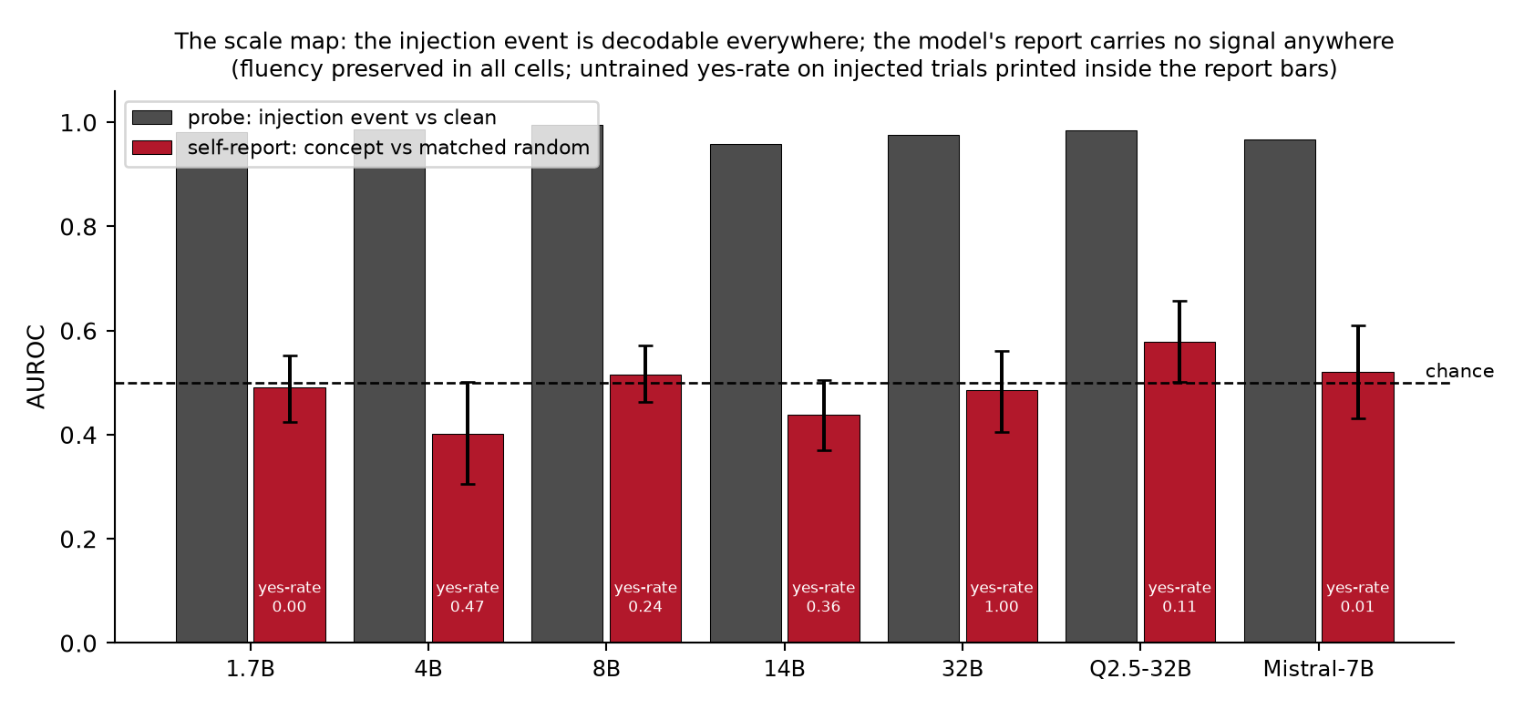
The scale map. The injection event is decodable from the final-layer state everywhere (grey); the model’s spontaneous report carries no signal anywhere (red), with untrained yes-rates printed in the bars. Every cell preserves output fluency.

5. Result 2: “installed introspection” and the autopsy of three artifacts
If the information is present and the channel does not carry it, can the channel be trained? We trained a LoRA (r=16, attention-only) on the binary introspection question over 14 concepts, evaluating on 6 concepts never seen in training. The first run returned held-out AUROC 1.000 at every dose. It survived a shuffled-label control (0.51-0.68) and a clean false-positive check (trained yes-rate on clean: exactly 0). It did not survive three further controls:
The dose-ceiling trap. At the top dose the calibration hit its strength ceiling, leaving concept trials at mean strength 24.8 against random’s 6.9, a naked magnitude cue. Removing the saturated dose: 1.000 → 0.623.
The collinearity trap. Our twenty “distinct” concepts, built by subtracting one shared neutral baseline, sat at pairwise cosine 0.97-1.00; the held-out split was never held out. Centring the vectors (mean cosine 0.12): 0.623 → 0.548, with per-concept AUROCs scattered around chance (0.44-0.71). Rivera & Africa’s own cosine-tracking observation anticipated this; the centring control turns it into a kill.
The state/text swap. Score the trained readout with the injection present but a clean transcript in context (state-only), and with an injected transcript but no injection (text-only). State-only: 0.495-0.530, chance, in both the collinear and centred runs. Text-only: 0.499-0.661. Whatever the trained readout consults, it is not the state. To our knowledge neither this control nor the dose-ceiling control appears anywhere in the trained-introspection literature, and our headline 1.000 passed the standard controls before dying to them.
What training does install, cleanly, is perturbation awareness: trained self-report separates injected-anything from clean at 0.71-0.79 on held-out concepts with zero false positives. The verbal channel can be taught that something happened. We found no evidence it can be taught what, and no evidence that what it learns consults the state rather than the transcript.
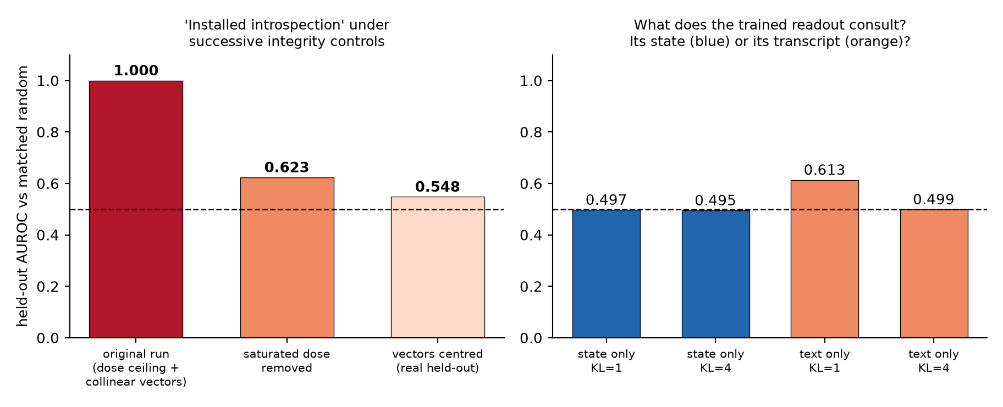
The installation autopsy. Left: held-out ‘installed introspection’ under successive integrity controls. Right: the state/text swap on the surviving model; the trained readout is at chance when only the state is present.

6. Discussion: what self-report is worth as evidence
For the welfare programme this sprint serves, the calibration is blunt. On these models, under conditions where ground truth is known and output is fluent, a model’s verbal report about its own internal state carries no information beyond what is already in its emitted text, and sometimes less: at 4B and 14B an outside reader of the transcript reliably beats the model’s own introspection. Self-reports of distress, preference, or valence elicited from models of this class should be treated as text-mediated behaviour, not as readouts of internal state, until a ground-truth positive control of the kind used here passes. Training does not rescue the assumption; it relocates trust from the model to whoever wrote the training labels, and what it installs is event awareness, not content access.
The map is bounded, not universal: Lindsey reports genuine introspective components in a frontier model, Bhargav shows in-context-taught verbalisation at 32B, and our own primed arm probes one step of that ladder. The honest statement is that on open models through 32B, spontaneous introspective self-report has no demonstrated grounding, and every cheap way of making it look grounded that we tried turned out to be an artifact with a specific, detectable mechanism.

7. Limitations
Declared scope: one injection site (two-thirds depth), single-position injection, one vector construction, binary self-report, two model families, one LoRA recipe at one scale, concepts from a single concrete-noun register. The which-concept probe uses 2-fold CV on 24 trials per dose and is an observation, not a calibrated instrument. Mistral’s power-gate pass is marginal (0.604 against 0.60). Thinking/reasoning mode is disabled throughout; whether serial introspective compute changes the result is the named next experiment, alongside base-versus-instruct rungs and in-context-taught readouts (Bhargav). The pre-registered W2 window condition was never run (DEVIATIONS.md). The Qwen2.5-32B opening is one cell at one dose (n=48 trials over 12 concepts) and requires replication before it is a boundary rather than a fluctuation; we flag it as the single most important follow-up, since it sits in the lineage of the strongest published positive.

Appendix: Limitations and Dual-Use / Ethical Considerations
This work perturbs model activations and elicits reports about them; no deployed system, user data, or third party is involved, and no harmful content is generated (tasks are two-sentence descriptions of windows, tea, and weather). Dual-use exposure is limited: the methods detect and characterise absence of introspective access rather than creating new capability. The installation experiment shows a reporting channel can be trained to claim awareness; we document why such training produces transcript-reading rather than state access precisely so that trained self-report is not mistaken for evidence of inner life, in either direction. That cuts both ways ethically: our results argue against taking model welfare claims at face value, and equally against dismissing the question, since the event signal is demonstrably present in the state while unreported. Concept injection at destructive doses degrades model output; all reported conditions preserve fluency, and no experiment involved persuasion, deception of users, or self-preservation scenarios.

Code, data, pre-registration
Repository: https://github.com/JainamShahhh/introspection-readout-gap, includes PREREG.md (commit 970e327, predating all results), DEVIATIONS.md (every post-hoc change), all raw JSON logs, and verify.py, which recomputes every number in this paper from committed logs with one command and no GPU.

References
- Lindsey (2025/26). Emergent Introspective Awareness in Large Language Models. Transformer Circuits / arXiv:2601.01828.
- Macar, Yang, Wang, Wallich, Ameisen, Lindsey (2026). Mechanisms of Introspective Awareness. arXiv:2603.21396.
- Pearson-Vogel, Vanek, Douglas, Kulveit (2026). Latent Introspection: Models Can Detect Prior Concept Injections. arXiv:2602.20031.
- Rivera & Africa (2025). Steering Awareness: Detecting Activation Steering from Within. arXiv:2511.21399.
- Vogel (2025). Small Models Can Introspect, Too.
- Bhargav (2026). Reasoning and learning about injected concepts in language models. LessWrong, 24 June 2026.
- Lederman & Mahowald (2026). Emergent Introspection in AI is Content-Agnostic. arXiv:2603.05414.
- Singh, Linzen, Ravfogel (2026). Can LLMs Introspect? A Reality Check. arXiv:2605.26242.
- Introspection Fine-Tuning (2026). arXiv:2607.14111.
- Song, Lederman, Hu, Mahowald (2025). arXiv:2508.14802.
- Binder et al. (2024). Looking Inward. arXiv:2410.13787.
- Torrielli, Schneider-Kamp, Galke Poech (2026). Confidence and Calibration of Activation Oracles. arXiv:2605.26045.
- Hahami et al. (2025/26). arXiv:2512.12411.

