Project: Goat Imitator (CSC8503 Coursework)

Student: Jainesh Pathak

Student Email: J.P.Pathak2@newcastle.ac.uk

Student ID: 220639466

**Technical Details:**

**Raycast:**

* Evil Goose inside the maze uses Raycasting towards the player. If raycast node is the goat, then evil goose will move towards the goat, otherwise follow the path.
* Raycast is used on goat to check if it is standing on the ground to avoid jump spam
* Raycast is also used for grapple powerup to fire from camera for the Spring Constraint to work.
* Raycast is also used between camera and goat to avoid camera wall clipping.

**AI:**

* Both NPC Padestrians and Evil Goose use State Machines for path navigation.
* Goat will get extra bonus points when NPC Padestrians knocks any items when running away.
* Evil Goose will try to kill the goat, if it enters the maze. If goat health is 0, it will respawn in the center of map.

**Level:**

* Red Colour Jumppad is an OBB Cube for OBB vs Sphere collision.
* There is a grapple powerup (Black Cube) on top of one of the buildings. Use Jumppad and maybe bridge to get the powerup.
* There is a warehouse with locked door behind the maze with additional items to destroy.
* The key to open the warehouse door is hidden inside the maze (Cyan Cube).

**Grapple Powerup:**

* Goat will get the 30 seconds grapple powerup.
* A crosshair is drawn for aiming.
* It used Spring Constraint (Hooke’s Law).

**Networking:**

* Multiplayer was complex, so I have only added basic client to server packet sending and receiving.

**Controls:**

**Goat:**

* Movement: WASD
* Jump: SPACE
* Fire Grapple (if have grapple powerup): LEFT MOUSE
* Toggle Free-Style/Follow Camera: Q

**Screenshots:**

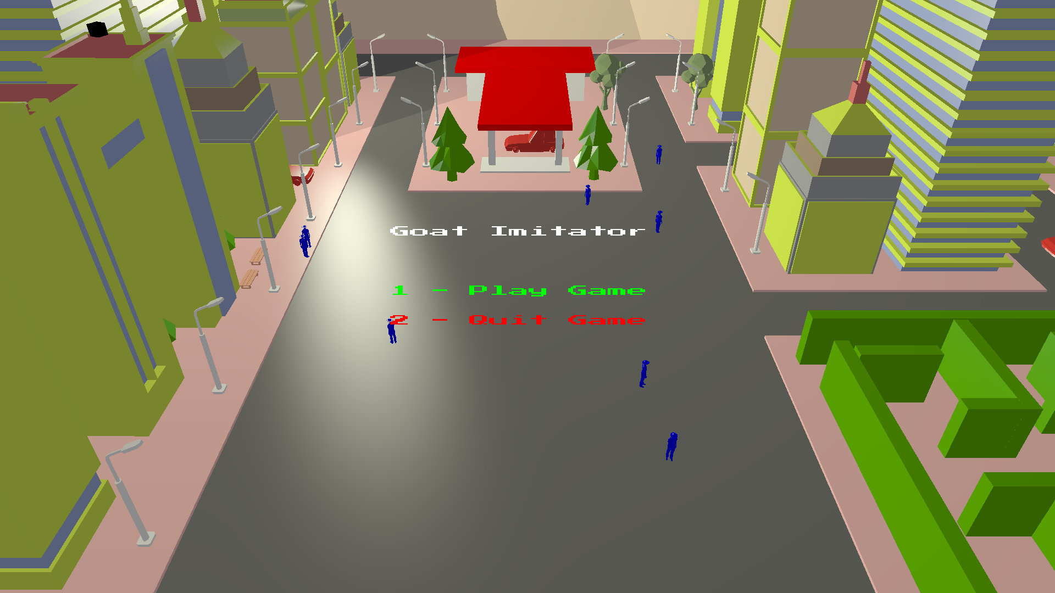

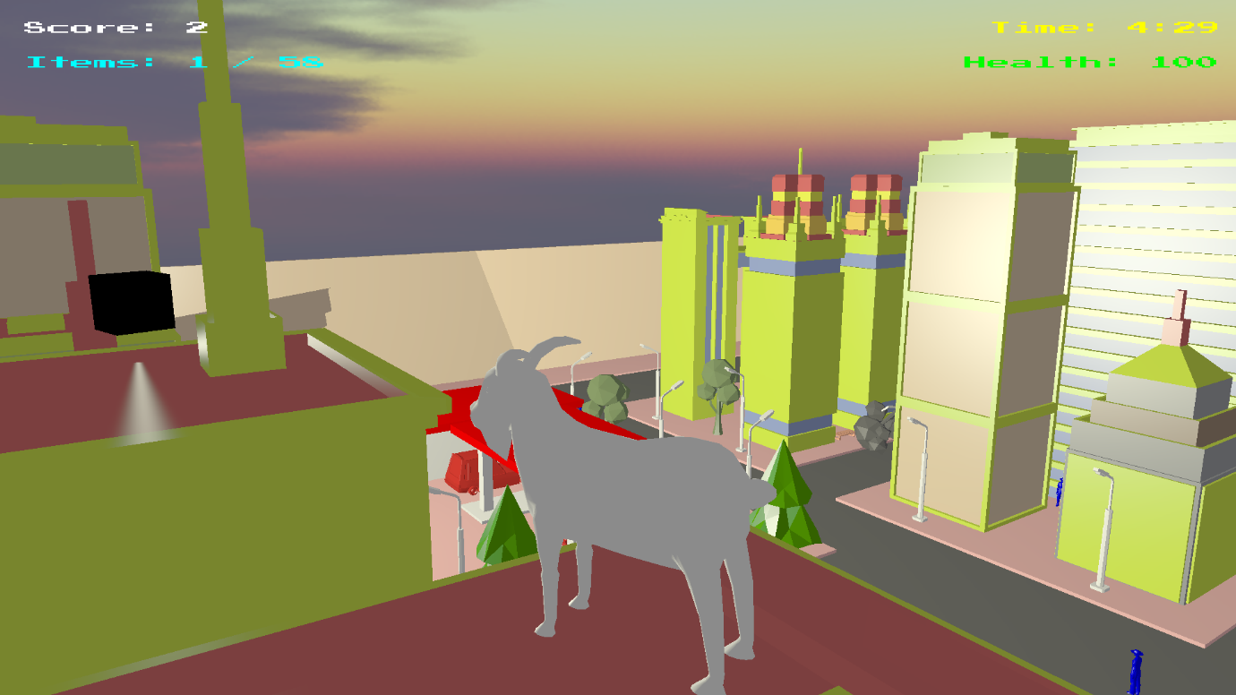

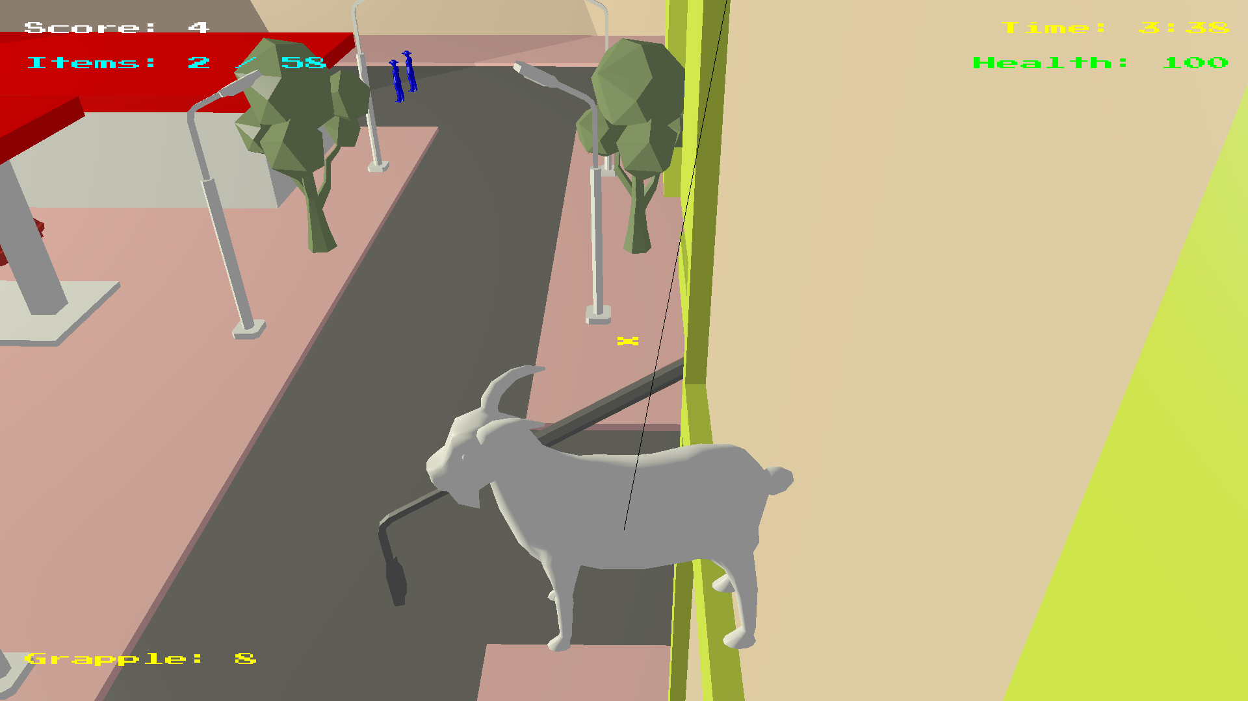

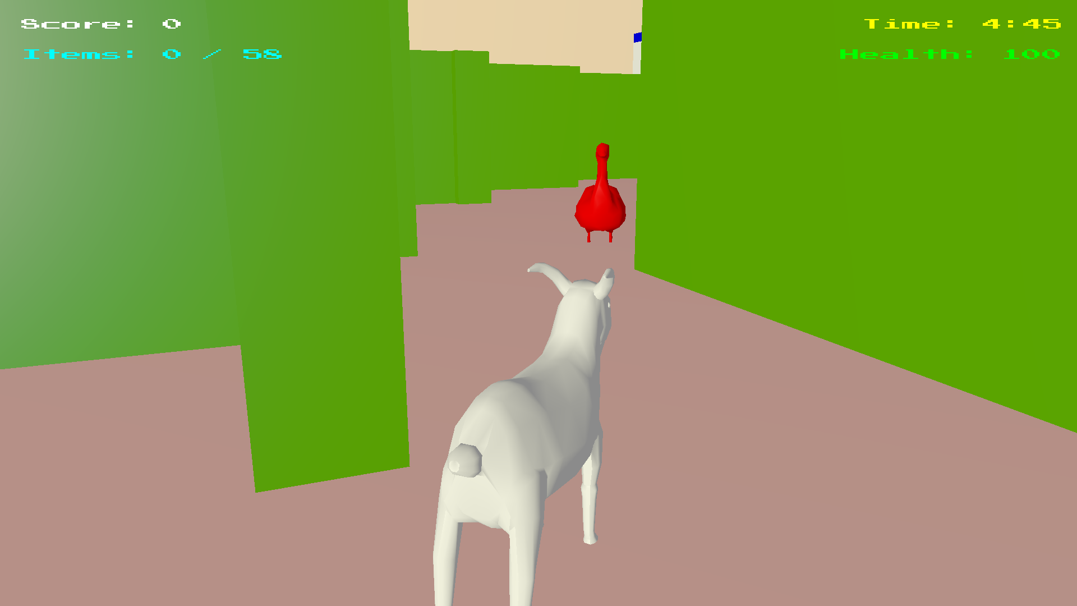

Thank you.