**JAINIKA_DAGA_DBMS_ASSIGNMENT**

**EXERCISE-1**

**1)Create a database schema and name it as website management.**

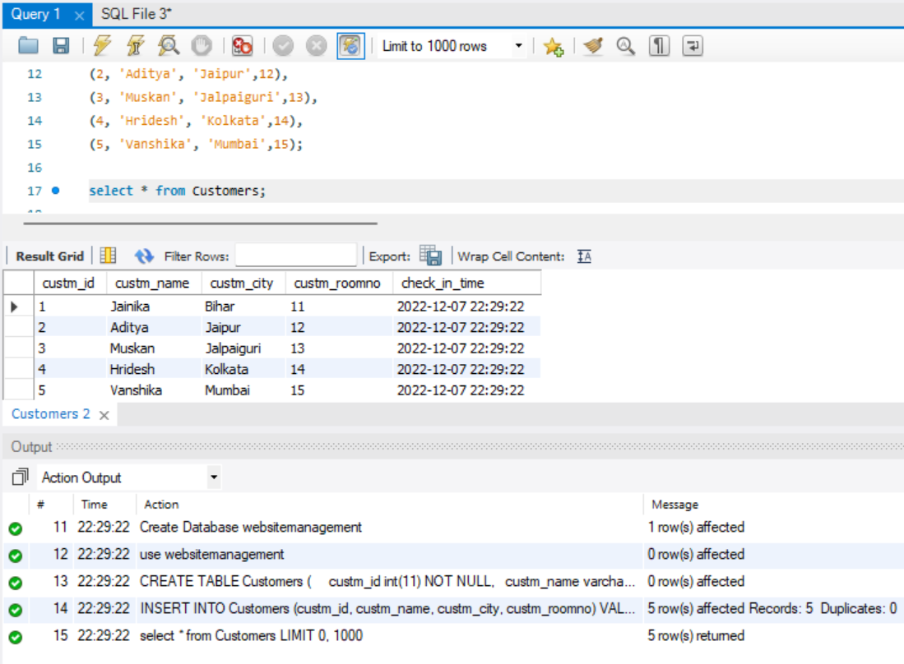

**Print Distinct City from Table Customers and Print Count Distinct City from Table Customers.**

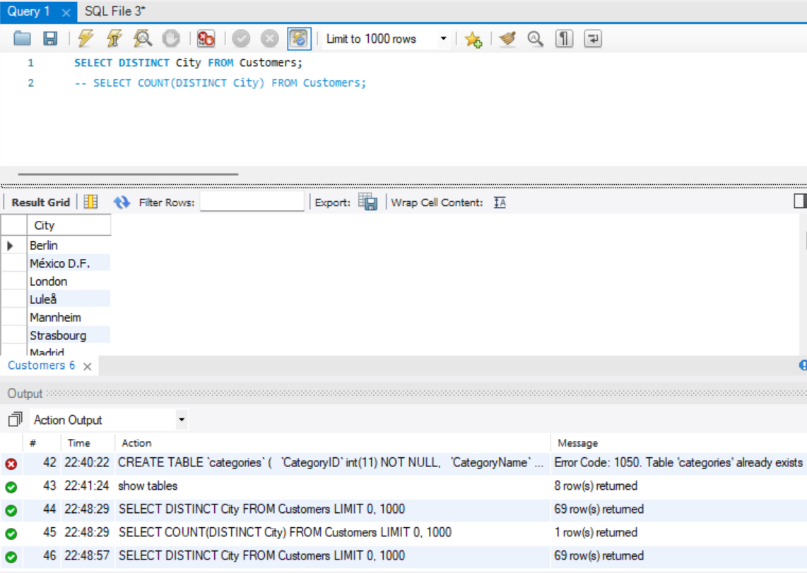

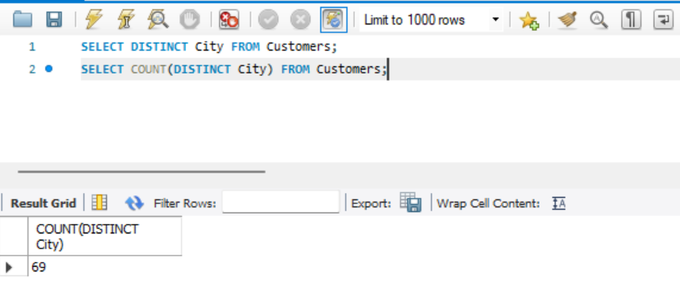

**Write a SQL query to get the least number of quantities and the highest number of quantities bought by the user consider the OrderDetails Table.**

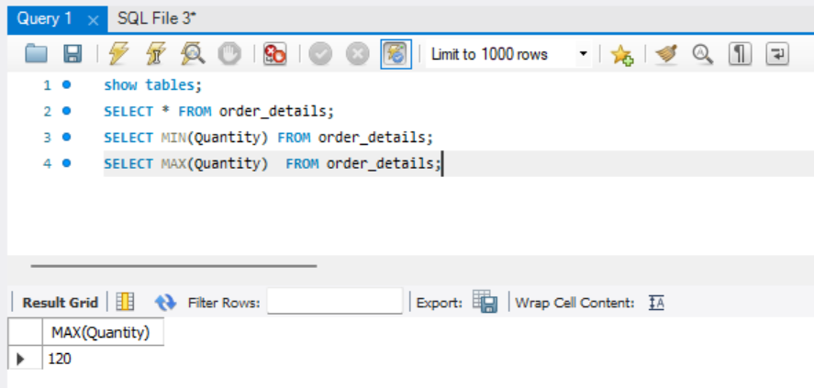

**Print the total and an average number of quantities ordered by users, consider the OrderDetails Table.**

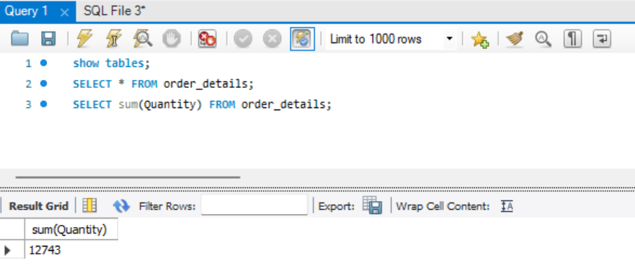

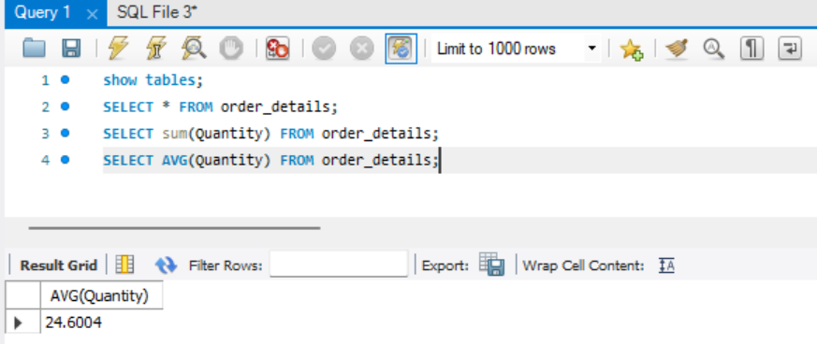

**Print name of the product which is present at the 5th position till the 15th position from Products table, use LIMIT keyword.**

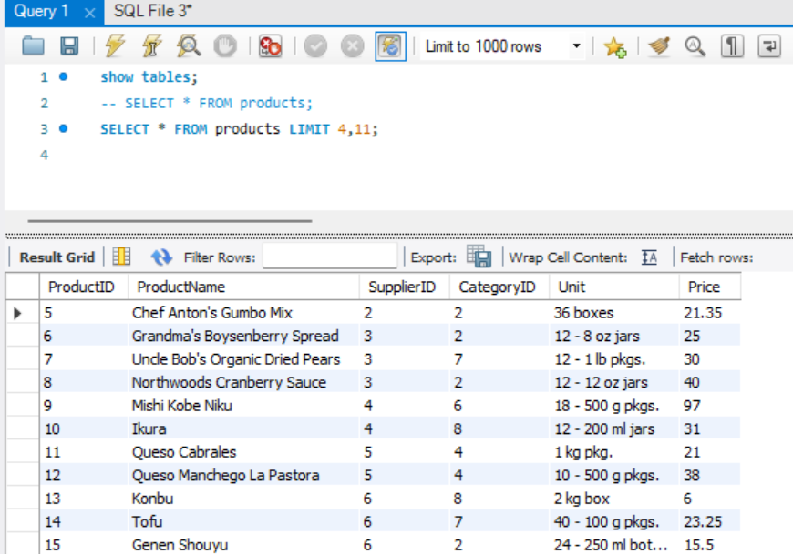

**Write a SQL query for all the details of the supplier whose name consists of “A” at the second position from the Suppliers table.**

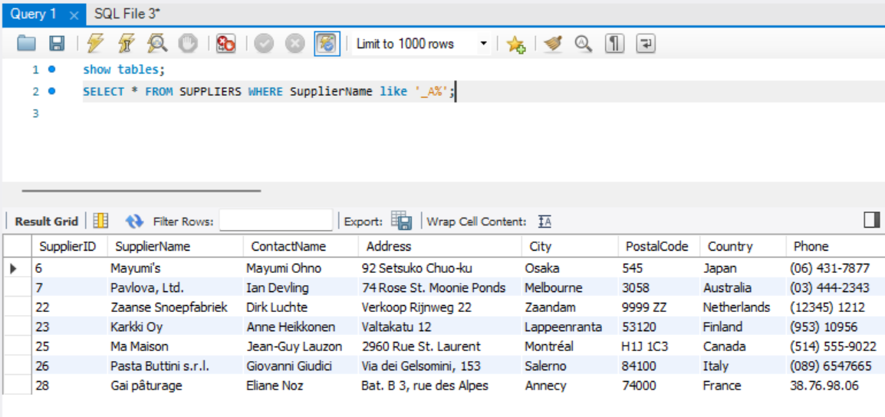

**Print the details of the customer who doesn’t stay in the USA and Canada from the Customers table.**

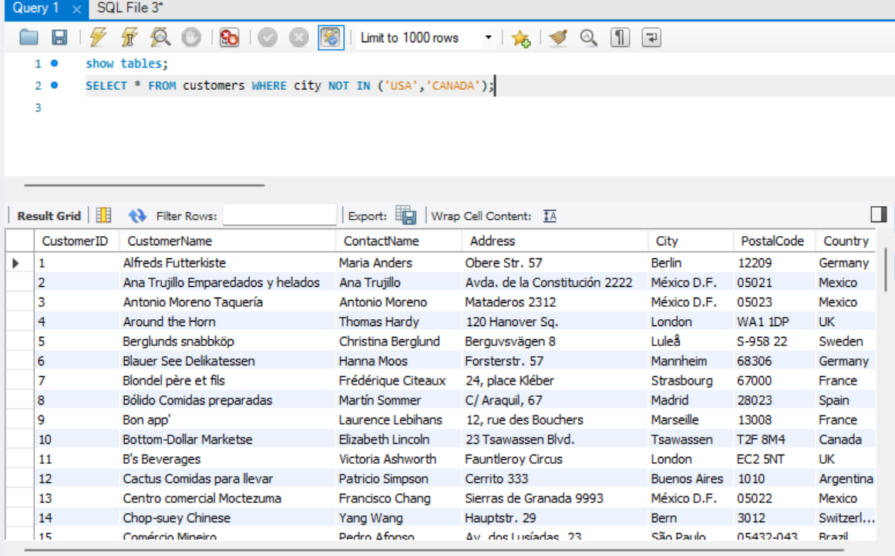

**Print the details of all the orders which were placed between the year 2020 to 2021 also print the same in descending order from the OrderDetails table.**

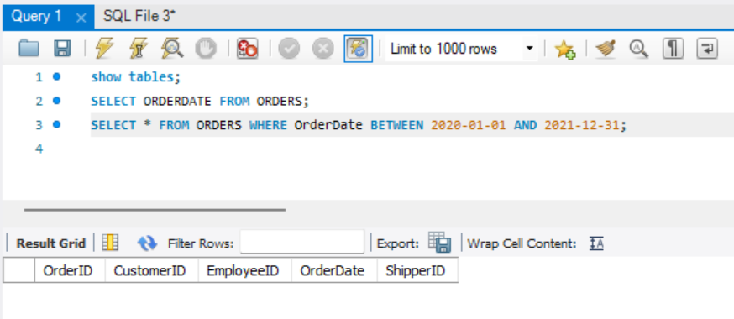

**Write a query to show the distinct city and their count from the Customers table.**

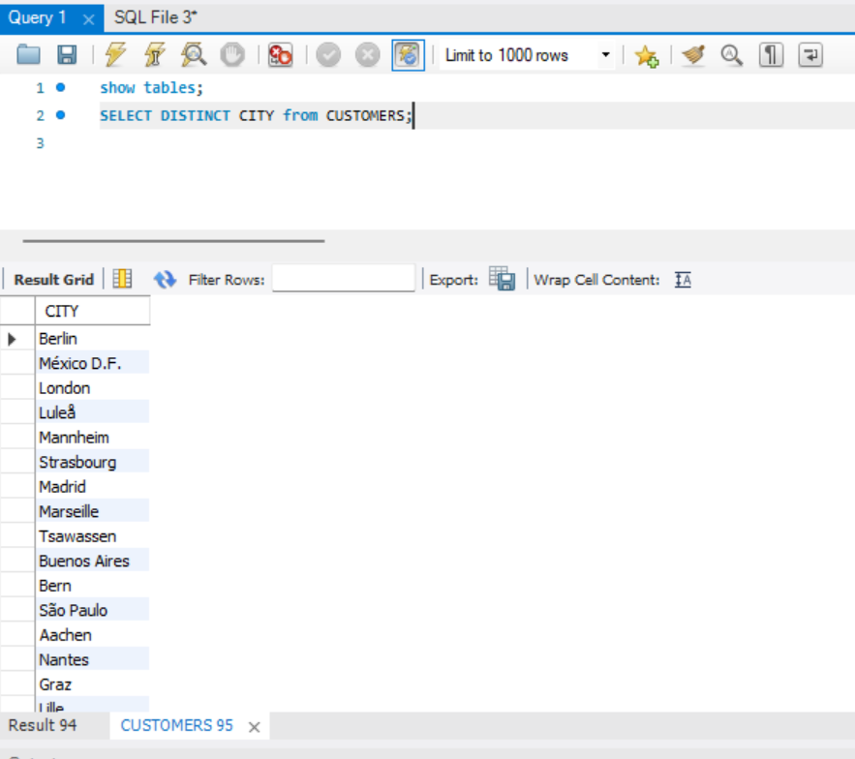

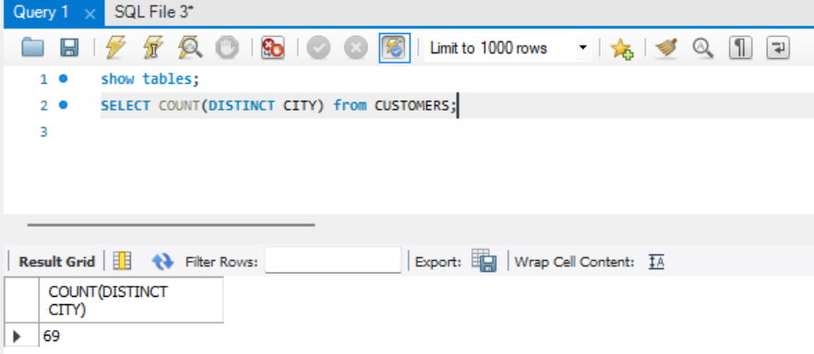

**Write a query to fetch details of all employees excluding the employees with first names, “Sanjay” and “Sonia” from the Employees table.**

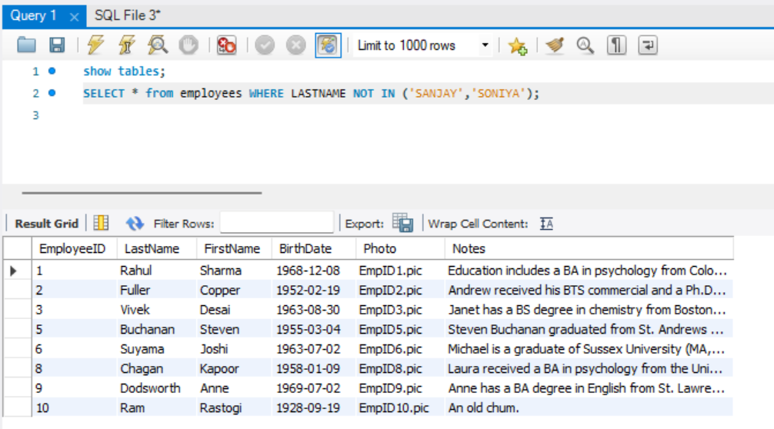

**Duplicate a table as similar to the Suppliers table and name it as SupplierDetail.**

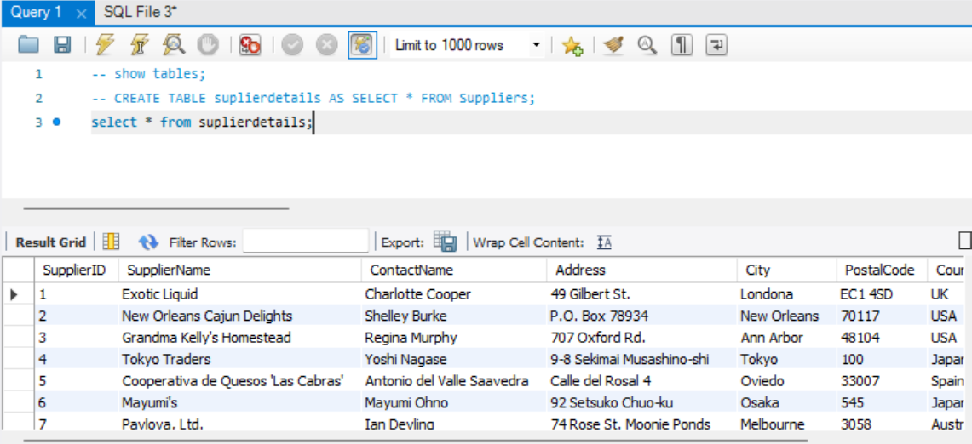

**Delete customer details whose country is Venezuela and print the rest of the Customer table .**

