* **Emerson Electric Co (GS co-advised):**
  + **Potential Commodity Link:** Emerson operates in automation and climate technologies. Their input costs (metals, plastics derived from petrochemicals) and their customers' energy costs are heavily influenced by commodity markets.
  + **How GS's Commodity Insight Could Have Added Value to M&A Advice:**
    - **Valuation Nuances:** When advising on restructuring or valuing divisions, GS could have provided deeper insights into how future commodity price scenarios would impact the long-term profitability and competitive positioning of different Emerson business units.
    - **Synergy Analysis:** In any M&A related to this restructuring, understanding the commodity cost exposure of potential targets or acquirers would be crucial for accurate synergy calculations.
    - **Strategic Rationale:** Advising Emerson on which businesses to keep or divest might have been influenced by GS's view on long-term energy and raw material cost trends, favoring businesses with more resilient supply chains or less commodity volatility.
* **Evoqua Water Technologies Inc (GS advised Evoqua, acquired by Xylem):**
  + **Potential Commodity Link:** Water treatment and technology involve significant infrastructure, chemicals for treatment, and energy for operations. The materials used in their equipment (specialty metals, plastics) are also commodity-linked.
  + **How GS's Commodity Insight Could Have Added Value to M&A Advice:**
    - **Long-Term Cost Projections:** Advising Evoqua on its sale to Xylem would involve projecting long-term operating costs. GS's commodity forecasts could provide a more robust basis for these projections, impacting valuation.
    - **Market Growth Drivers:** The drive for water efficiency (a key theme for Evoqua/Xylem) is partly driven by rising energy costs (making water pumping/treatment more expensive) and the need for resource efficiency in industries that are heavy water users (which are themselves affected by commodity prices). GS could frame the strategic rationale for the merger in this broader resource context.

**1. Leverage AI for Enhanced Client Engagement**

JPMorgan's substantial investment in AI—over $18 billion in 2025—has led to the development of approximately 100 AI tools aimed at improving productivity and reducing operational costs. [Business Insider](https://www.businessinsider.com/jpmorgan-how-artificial-intelligence-transforming-workflows-efficiencies-2025-5?utm_source=chatgpt.com)

**Actionable Steps:**

* **Expand AI Applications:** Utilize AI to personalize client interactions, predict market trends, and offer tailored financial solutions.
* **Integrate AI Across Departments:** Ensure AI tools are accessible and beneficial across all departments to streamline processes and enhance decision-making.

**2. Strategic Talent Acquisition in High-Growth Areas**

With a shift towards efficiency, JPMorgan emphasizes strategic hiring in roles that directly contribute to growth. [Business Insider](https://www.businessinsider.com/jpmorgan-investor-day-resist-hiring-headcount-ai-efficiencies-jamie-dimon-2025-5?utm_source=chatgpt.com)

**Actionable Steps:**

* **Targeted Hiring:** Focus on recruiting professionals with expertise in emerging sectors like fintech, AI, and sustainable finance.
* **Continuous Learning:** Invest in upskilling current employees to adapt to evolving market demands and technological advancements.[Scribd+3www.slideshare.net+3Business Insider+3](https://www.slideshare.net/slideshow/investor-day-may-2024-j-p-morgan-chase/271065230?utm_source=chatgpt.com)

**3. Expand Private Credit Offerings**

Recognizing the growth in private credit markets, JPMorgan is considering entering this space to offer clients alternative financing options. [Investopedia+2The Financial Brand+2Business Insider+2](https://thefinancialbrand.com/news/banking-trends-strategies/5-key-points-from-jpmorgan-chase-2024-investor-day-178422?utm_source=chatgpt.com)

**Actionable Steps:**

* **Develop Private Credit Products:** Design and offer private credit solutions to meet the needs of middle-market companies seeking non-traditional financing.
* **Risk Assessment Framework:** Implement robust risk assessment tools to evaluate and manage the unique risks associated with private credit lending.

**4. Enhance Digital Platforms for Client Services**

JPMorgan's commitment to digital transformation includes the development of platforms like Chase Travel and Chase Media Solutions, aiming to provide comprehensive services to clients. [Scribd](https://www.scribd.com/document/754585665/JPMorgan-INVESTOR-DAY-Full-presentation?utm_source=chatgpt.com)

**Actionable Steps:**

* **Integrate Services:** Create a unified digital platform that offers a range of services, from travel bookings to financial planning, enhancing client convenience.
* **Personalized Experiences:** Utilize data analytics to offer personalized recommendations and services, increasing client satisfaction and loyalty.

**5. Strengthen Presence in Sustainable Finance**

With a commitment to achieving net-zero emissions by 2050, JPMorgan is focusing on sustainable finance initiatives. [AInvest+2Reddit+2Reddit+2](https://www.reddit.com/r/StockInvest/comments/122ijih?utm_source=chatgpt.com)

**Actionable Steps:**

* **Green Investment Products:** Develop and promote investment products that support environmentally sustainable projects.
* **Client Education:** Provide resources and guidance to clients interested in sustainable investing, positioning JPMorgan as a leader in this space.

**5. Integrated Client Solutions Model**

**Objective:** Enhance client engagement by combining personalized advisory services with advanced digital tools for a seamless experience.

**Justification:**

* Clients increasingly expect real-time insights and tailored solutions.
* Integrating human expertise with technology enhances service delivery.

**Implementation:**

* Assign dedicated client strategists to key accounts.
* Develop digital platforms providing clients with real-time analytics and strategic roadmaps.

**Projected Outcome:**

* Improve client retention rates by 15% and increase cross-selling opportunities by 20%.

**2. Predictive Intelligence Platform**

**Objective:** Develop an AI-driven platform to identify emerging M&A opportunities and market trends ahead of competitors.

**Justification:**

* Goldman Sachs has invested heavily in technology to enhance deal origination.
* AI platforms can analyze vast datasets to uncover non-obvious opportunities.[eFinancialCareers+3bankingdive.com+3eFinancialCareers+3](https://www.bankingdive.com/news/goldman-solomon-26-raise-39-million-80-retention-bonus-waldron-private-credit/737713/?utm_source=chatgpt.com)

**Implementation:**

* Integrate alternative data sources such as patent filings, executive movements, and supply chain analytics.
* Collaborate with data scientists to build predictive models.

**Projected Outcome:**

* Identify and act on 15-20% more actionable opportunities annually.

**4. Global “Transition Arbitrage” & Special Situations Desk**

**🔍 Rationale:**

* **Over $3.5T in value transitions** expected across energy, industrials, and tech due to decarbonization, supply chain shifts, and AI/robotics adoption (McKinsey).
* Few players offer integrated cross-border, regulatory, and financing structuring.

**✅ Make it Even Better:**

* **“Transition Index” Model**: Build proprietary scoring models for transition-readiness across 40+ countries, sector-wise.
* **Sovereign & DFIs Connect**: Partner with governments, SWFs, and development banks to become trusted transition deal orchestrators.

**📈 Projected Outcome:**

* **$1B+ in complex, high-margin mandates** over 5 years.
* Dominance in emerging special-situation advisory (ESG carve-outs, stranded asset repositioning, etc.).

**📊 Comparative Compensation Analysis: First-Year Analysts (2024–2025)**

| **Firm** | **Base Salary** | **Bonus** | **Total Compensation** | **Notes** |
| --- | --- | --- | --- | --- |
| **Centerview Partners** | $130,000 | $90,000 | $220,000 | Includes a $50K signing bonus for a 3-year commitment |
| **Evercore** | $120,000 | $90,000 | $210,000 | Offers early promotion to Associate with $70K bonus |
| **Lazard** | $120,000 | $85,000 | $205,000 | Known for global financial advisory services |
| **Goldman Sachs** | $110,000 | $68,000 | $178,000 | Prestigious brand with strong deal flow |
| **JPMorgan Chase** | $110,000 | $65,000 | $175,000 | Large-scale deals and diverse financial services |

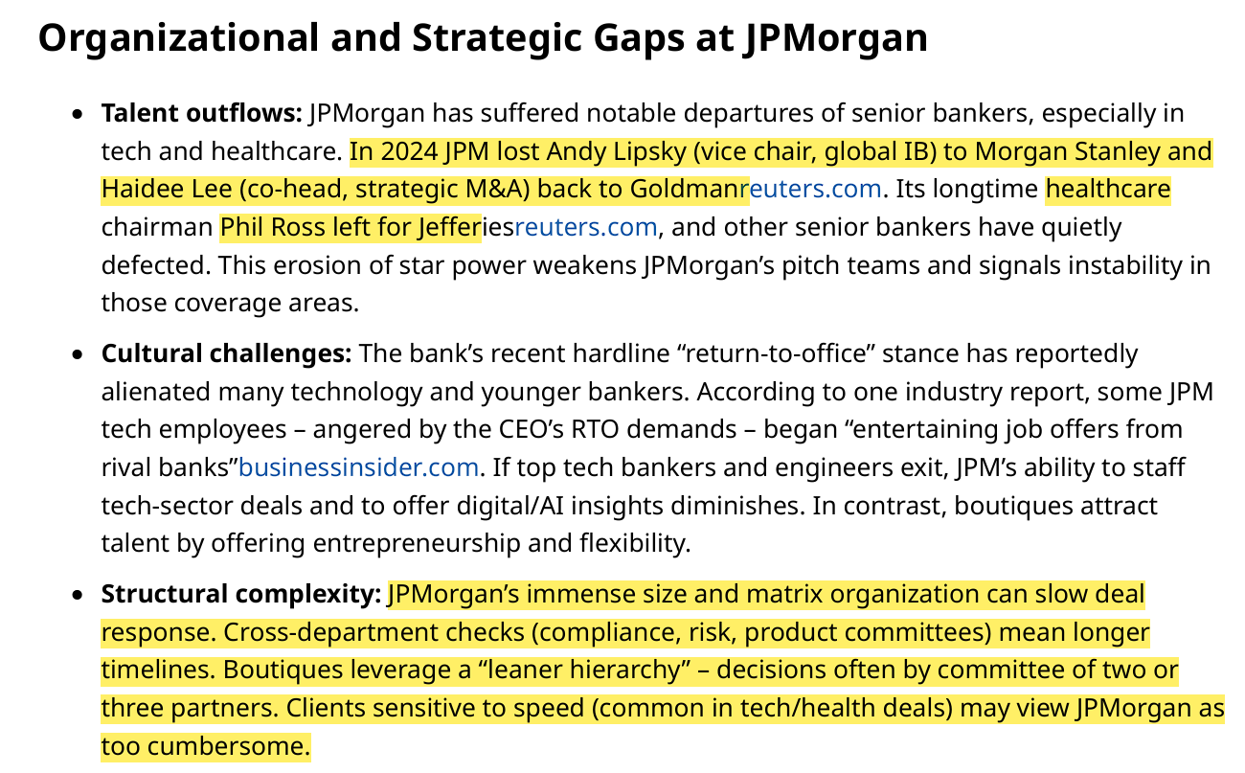

JPMorgan’s strength is its full-service platform, but the trends imply it must calibrate between “one stop-shop” and pure advisory image. Clients choosing boutiques signal they want only advice – not ancillary services.