CAS Activities Finder: Criteria C and D

Criterion C: System overview
CAS Activities Finder · success criteria SC1–SC10 as defined in Criterion A

C1. System model
The product is a three-tier JavaScript web application (Figure C1). The browser shows a single page whose screens are drawn by app.js. The Express server authenticates each request, applies the rules, and is the only tier that touches the SQLite database (Figure C2). Rules are kept in pure-function modules (Figure C3) so that each one can be tested on its own.
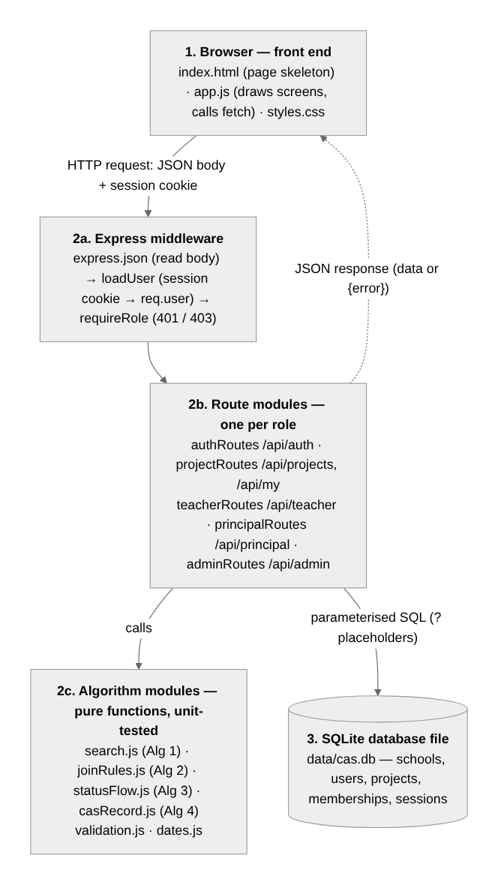 Figure C1: Architecture, modules and API route groups.
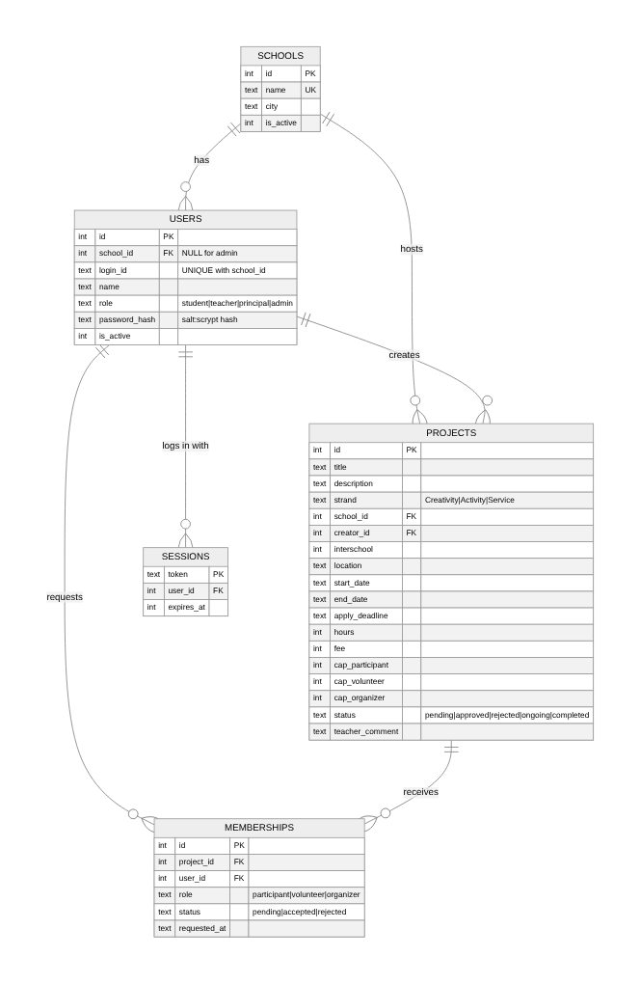 Figure C2: Database model. MEMBERSHIPS links students and projects (many-to-many); UNIQUE(project_id, user_id) blocks duplicate requests.
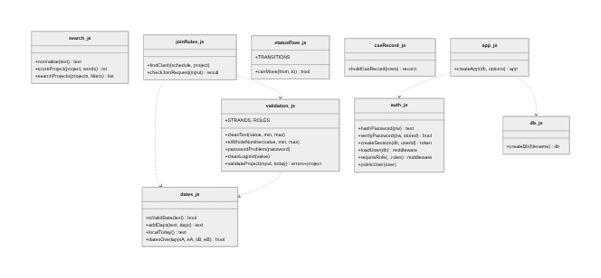 Figure C3: Module interfaces.

C2. Algorithms
// Algorithm 1 — search and rank (SC2). Input: projects the user may see (filtered by SQL first).
FUNCTION normalise(text)
RETURN lower case of text, accents removed, non-letters/digits → space, repeated spaces → one, trimmed
FUNCTION searchProjects(projects, query, strand, scope, openOnly, mySchool, today)
words ← split(normalise(query), " ") without empty strings
results ← empty list
LOOP FOR EACH p IN projects
IF strand ≠ "" AND p.strand ≠ strand THEN CONTINUE
IF scope = "mine" AND p.school ≠ mySchool THEN CONTINUE
IF scope = "other" AND p.school = mySchool THEN CONTINUE
IF openOnly AND p.applyDeadline < today THEN CONTINUE
IF words is empty THEN score ← 1
ELSE
score ← 0
LOOP FOR EACH w IN words
IF w is inside normalise(p.title) THEN score ← score + 3
ELSE IF w is inside normalise(p.otherText) THEN score ← score + 1
ELSE score ← 0; EXIT LOOP // every word must appear
IF score > 0 THEN append (p, score) to results
SORT results BY score DESC, THEN startDate ASC
RETURN results
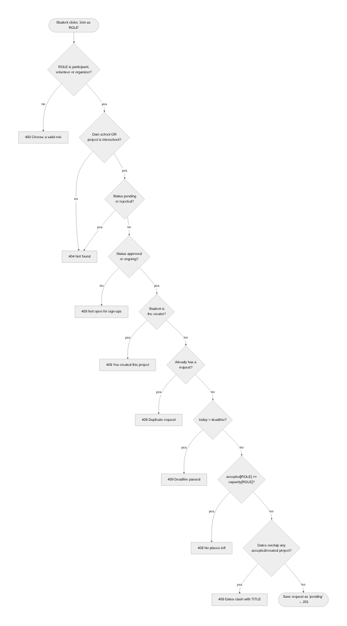 Figure C4: Algorithm 2, join-request rules (SC4). Ranges clash when startA ≤ endB AND startB ≤ endA. Accepting a request (SC5) re-runs the capacity and clash checks.
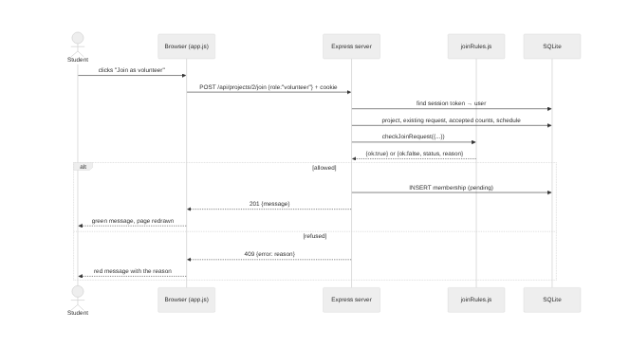 Figure C5: A join request passing through the three tiers.
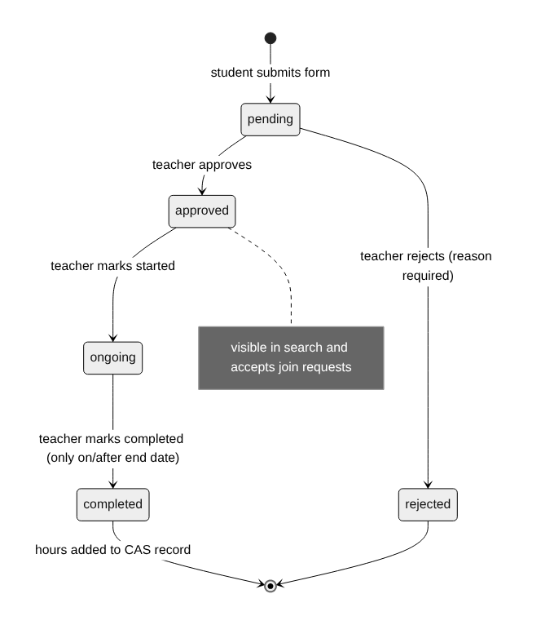 Figure C6: Algorithm 3, project life-cycle (SC6), stored as a table of allowed next states.
// Algorithm 4 — CAS record (SC8). rows = projects the student created or was accepted into.
FUNCTION buildCasRecord(rows)
totals ← {Creativity: 0, Activity: 0, Service: 0, all: 0}; completed ← 0
entries ← copy of rows SORTED BY startDate ASC
LOOP FOR EACH r IN entries
IF r.status = "completed" THEN
totals[r.strand] ← totals[r.strand] + r.hours; totals.all ← totals.all + r.hours; completed ← completed + 1
RETURN entries, totals, completed
// Algorithm 5 — authentication and authorisation (SC1, SC9)
ACTIVATE(id, password): IF id on roster AND not activated AND password strong
THEN store salt + ":" + scrypt(password, salt) // salt = 16 random bytes
LOGIN(id, password): IF scrypt(password, storedSalt) equals storedHash (constant-time)
THEN token ← 32 random bytes; save (token, user, now + 8 h); set HttpOnly cookie
EVERY REQUEST: user ← session WHERE token = cookie AND not expired AND user and school active
IF route needs a role: no user → 401; role not allowed → 403

C3. User interface design
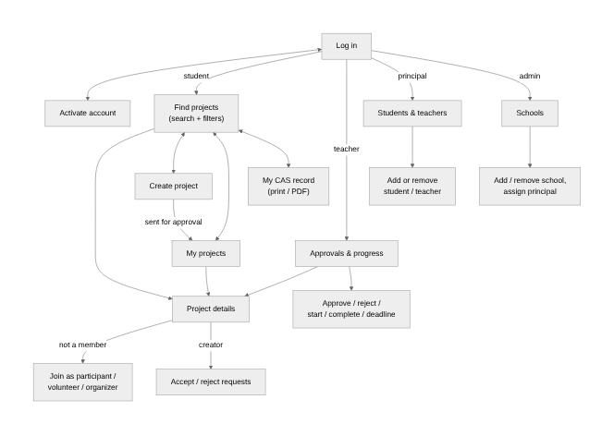 Figure C7: Screens per role.
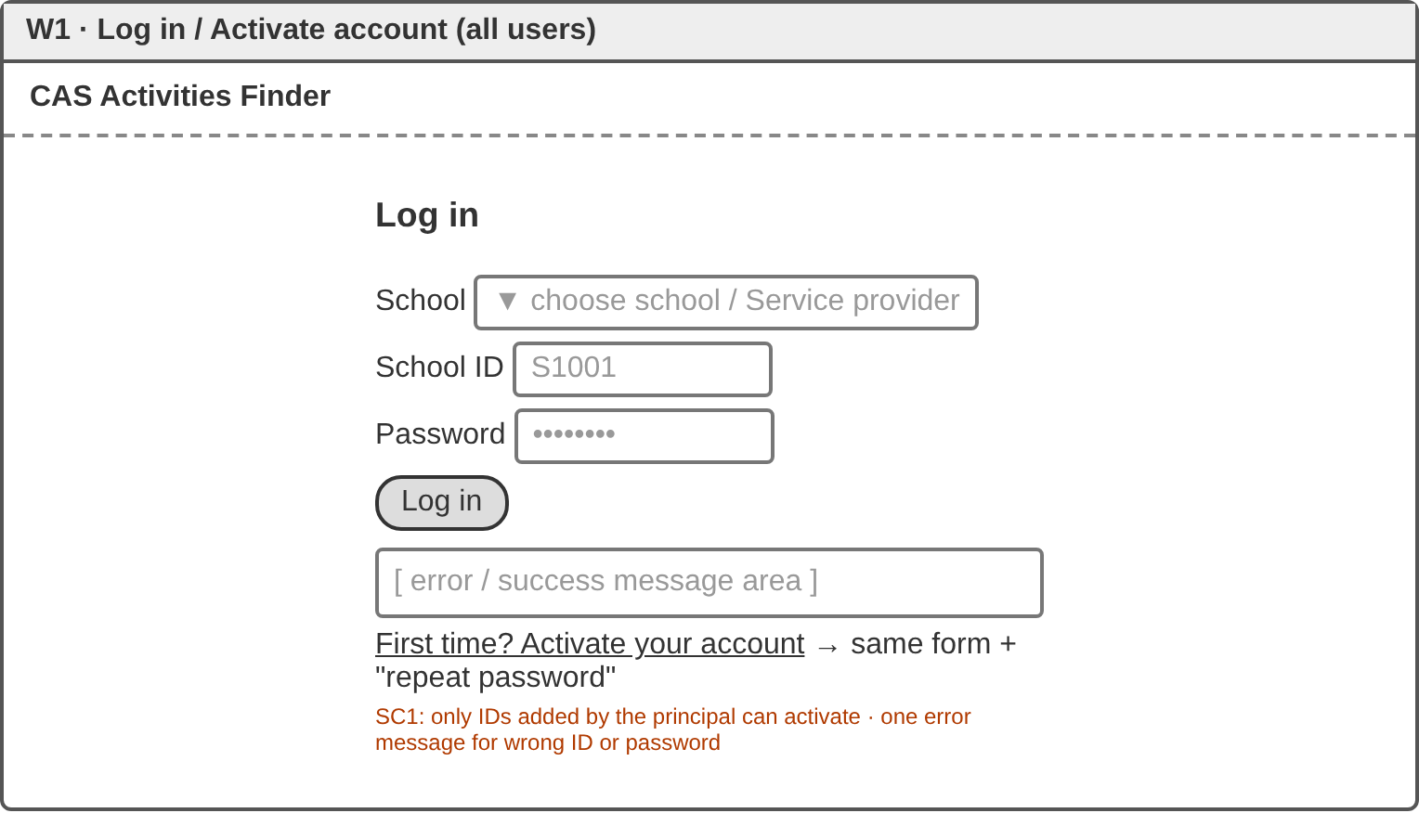 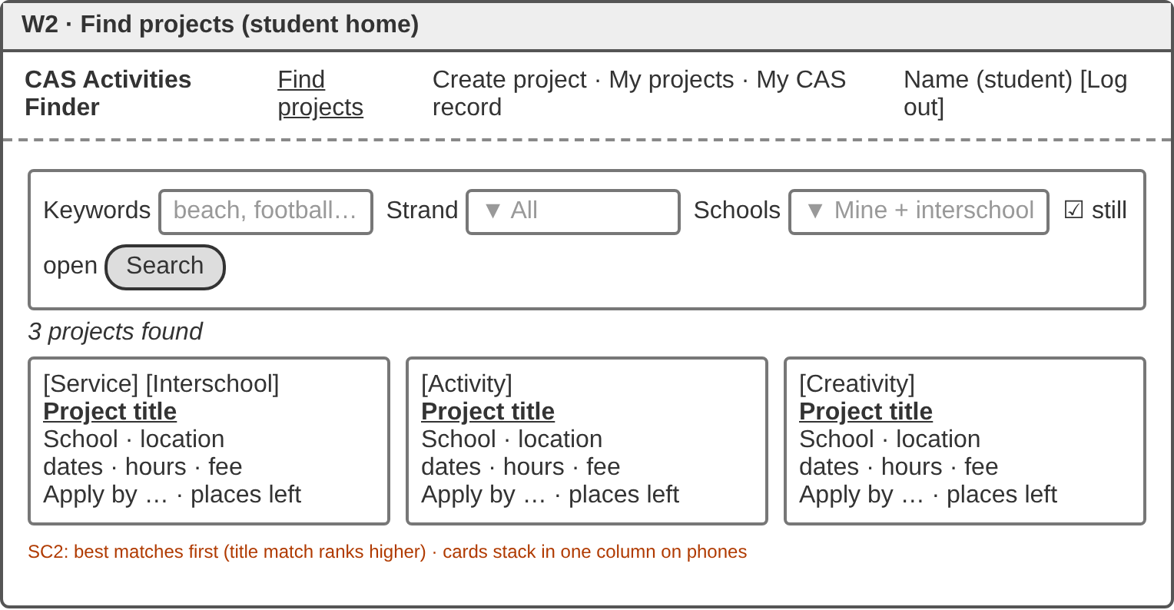 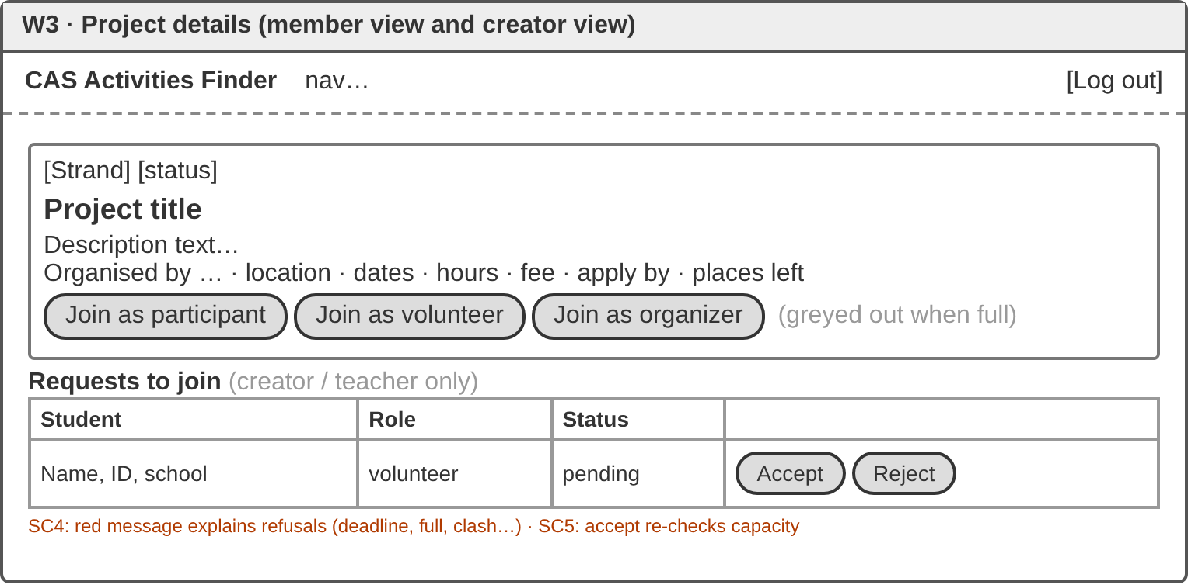 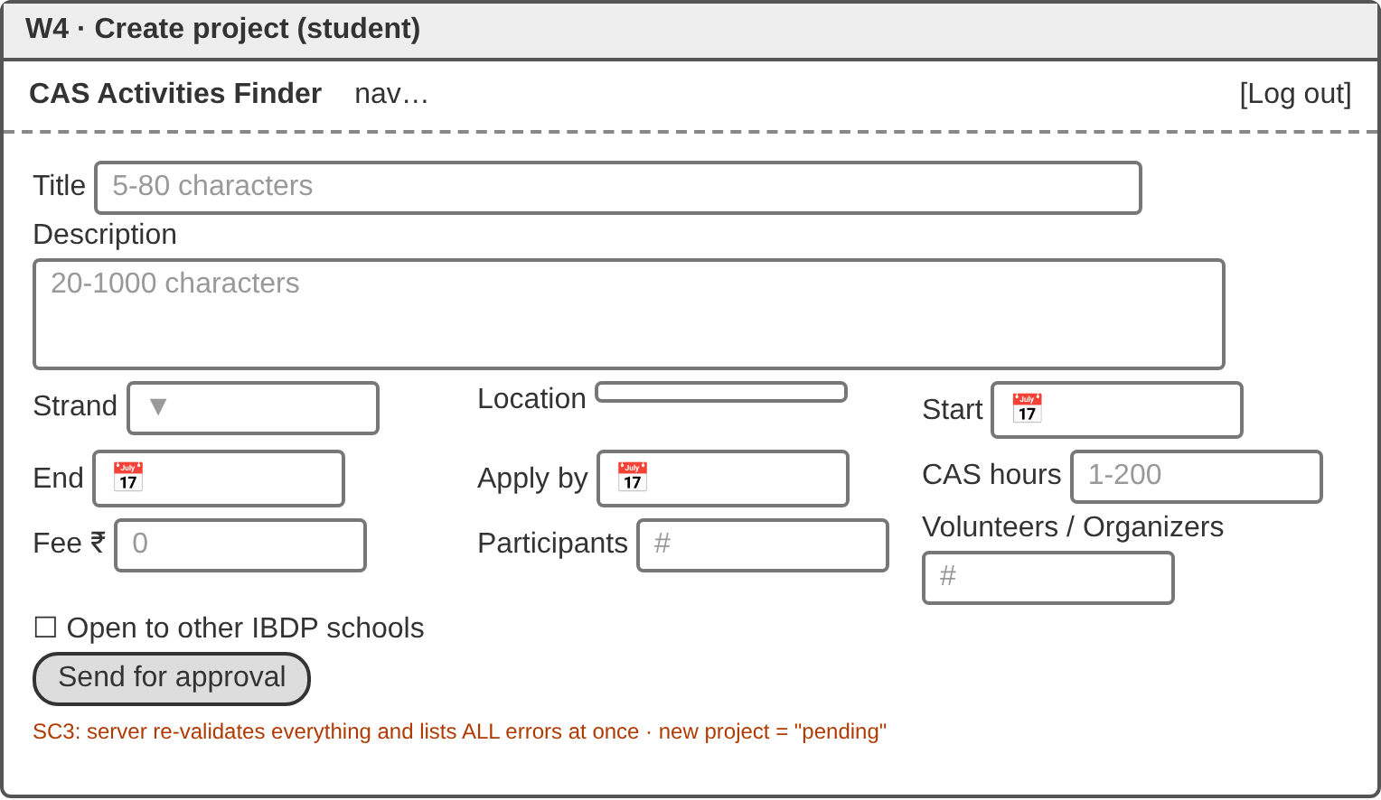 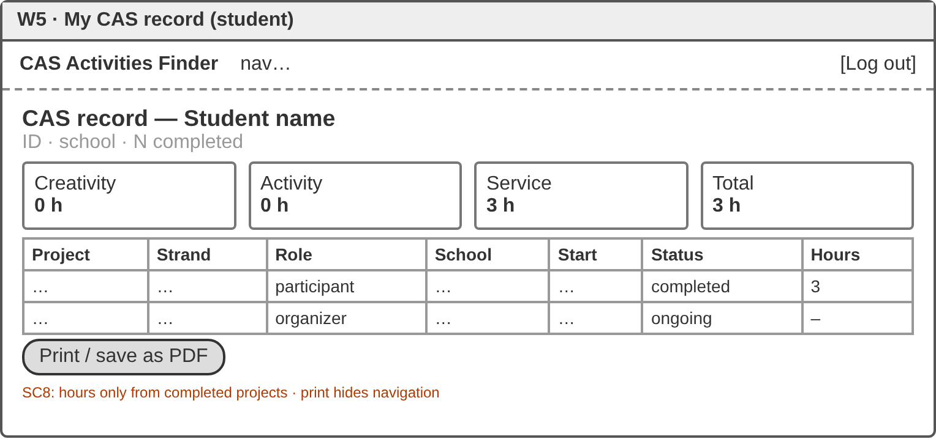 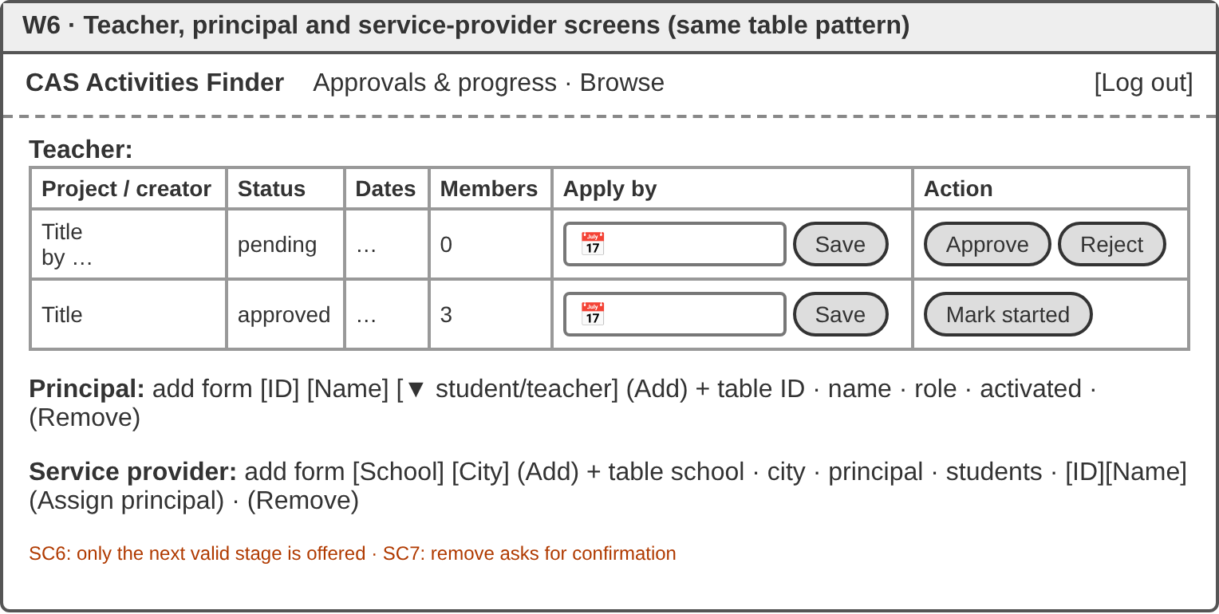 Figures W1–W6: Wireframes, annotated with the success criterion each serves.

C4. Testing strategy
There are three levels of testing: unit tests on the algorithm functions, HTTP integration tests on a fresh seeded database with the date fixed at 2026-10-01, and UI tests in Chromium. Every SC has normal (N), boundary (B) and invalid (I) cases.
Test | SC | Type | Input | Expected
T01 | 3 | N/B/I | 2028-02-29; 2026-02-30; 14/10/2026 | valid; invalid; invalid
T02 | 4 | B | ranges touching on one day; next day | clash; none
T03–06 | 3 | B/I | title 4/5/80/81 chars; deadline yesterday/today/after start; hours 0/4.5/200; empty form | limits accepted; others refused; all errors listed
T07, T15 | 1 | B/I | 8-char password; Pass1; unknown ID; second activation | accepted; refused
T16 | 1 | I | wrong password vs unknown ID | identical 401; only salt:hash stored
T08–10, T18 | 2 | N/I | CLEAN, cafe, clean-up!!, skydiving, blank | title match first; matched; none; all
T28–29 | 2 | extreme | 2,000 projects (HTTP); 20,000 (function) | < 1 s; < 0.5 s
T19–20 | 3 | N/I | valid project; 2 bad fields; 60 KB body | pending and hidden; 2 errors; 413
T11–12, T22 | 4 | B/I | on/after deadline; last place/full; duplicate; own; clash; hidden | only valid cases accepted, with reasons
T23 | 5 | B/I | 2 requests, 1 place; non-creator decides | second refused; 404
T13, T21 | 6 | I | skip a stage; reject without reason; complete early | refused
T25–26 | 7 | N/I | add duplicate ID; remove student; replace principal | 409; old cookie 401; old principal refused
T14, T24 | 8 | N/B | completed + ongoing; new student | completed hours only; empty
T17, UI | 9 | I | cross-role calls; title <img onerror=…> | 401/403; shown as text
T27 | 10 | N | restart server on the same file | data and login kept

Criterion D: Development
CAS Activities Finder · full source code in the Appendix · test IDs refer to Criterion C4

D1. Functionality
All ten success criteria work and are shown in the video. The 29 automated tests all pass (Figure D1).
SC | Evidence | Tests
1 | login | T07, T15–16
2 | browse, search | T08–10, T18, T28–29
3 | refused form, pending | T01, T03–06, T19–20
4 | joined, clash | T02, T11–12, T22
5 | requests | T23
6 | teacher | T13, T21
7 | principal, admin | T25–26
8 | CAS record | T14, T24
9 | phone layout | T17, UI
10 | restart in video | T27

D2. Techniques

1. Relational database with constraints and parameterised SQL
role TEXT NOT NULL CHECK (role IN ('participant', 'volunteer', 'organizer')),
UNIQUE (project_id, user_id) // db.js — MEMBERSHIPS
db.prepare('SELECT status FROM memberships WHERE project_id = ? AND user_id = ?').get(project.id, req.user.id)
Students and projects have a many-to-many relationship, so a linking table was needed (Figure C2). The CHECK and UNIQUE constraints repeat the JavaScript rules inside the database, so a missed check in a route still can’t store a duplicate or an invalid value. The ? placeholders make all input data rather than SQL, which prevents injection.

2. Normalised partial matching with weighted ranking (Algorithm 1)
if (title.includes(word)) score += 3;
else if (rest.includes(word)) score += 1;
else return 0;
results.sort((a, b) => b.score - a.score || a.start_date.localeCompare(b.start_date));
normalise() lower-cases text, strips accents using Unicode NFD, and replaces punctuation, so CLEAN, cafe and clean-up!! all match (T08). When two scores tie, b.score - a.score is 0, so || falls through to the start date. SQL removes what the user may not see; JavaScript ranks, which LIKE can’t do.

3. Ordered rules and conflict detection (Algorithm 2)
const capacity = project[`cap_${role}`];
if ((counts[role] || 0) >= capacity) return { ok: false, status: 409, reason: `There are no ${role} places left.` };
const clash = findClash(schedule, project); // startA <= endB && startB <= endA
checkJoinRequest is pure: it takes data in and returns {ok, status, reason}, so all eight rules are unit-tested without a server (T11–12). The computed property cap_${role} replaces three near-identical branches. findClash is reused when a creator accepts a request, because the student may have committed elsewhere in the meantime.

4. State machine as a lookup table (Algorithm 3)
const TRANSITIONS = { pending: ['approved', 'rejected'], approved: ['ongoing'], ongoing: ['completed'], rejected: [], completed: [] };
const canMove = (from, to) => (TRANSITIONS[from] || []).includes(to);
The table mirrors Figure C6 directly, and adding a state takes one line.

5. Hashed passwords, sessions and higher-order middleware
const hash = crypto.scryptSync(password, salt, 64).toString('hex');
return crypto.timingSafeEqual(actual, expected);
function requireRole(...roles) { return (req, res, next) => { /* 401 / 403 / next() */ }; }
requireRole returns a function, so router.use(requireRole('teacher')) protects a whole route file. Cookies are httpOnly and sameSite: 'strict'. The same login error for an unknown ID and a wrong password hides which IDs exist (T16).

6. Validation that reports every error
return !Number.isNaN(date.getTime()) && date.toISOString().slice(0, 10) === text; // rejects 2026-02-30
JavaScript silently rolls 30 February over to 2 March, so converting the date back to text exposes impossible dates. validateProject collects all errors, so a student fixes the form in one attempt. The server re-checks everything: with the browser’s checks disabled, the bad form was still refused.

7. Asynchronous requests and output escaping
const response = await fetch(url, options);
if (!response.ok) throw new Error(data.error || `Request failed (${response.status})`);
const esc = (value) => String(value ?? '').replace(/[&<>"']/g, (ch) => map[ch]);
All screens use one api() helper, so the server’s reason always reaches the user. Text written by users passes through esc(), so a project titled <img src=x onerror=alert(1)> displays as plain text (screenshot).

8. Dependency injection
createApp(db, { today }) receives its database and clock. Tests pass an in-memory database and a fixed date, so the date rules give the same result on every run.

D3. Evaluation of decisions
Decision | Strength | Limitation
JavaScript on both tiers (originally planned: Java) | one language, native JSON, shared helpers | no compile-time types, so the tests had to catch type errors
SQLite built into Node | no server to install; constraints, joins | one writer at a time; PostgreSQL needed for city-wide use
Synchronous queries | a capacity check and the following insert can’t interleave, which prevents overbooking (T23) | a slow query would block others; measured ≤ 60 ms
Soft delete | CAS history kept; reversible | an ID can’t be reused
Sessions in the database | survive restarts (T27); removal logs out instantly | one query per request
No front-end framework | no build step; every line is explainable | whole screens re-render; some repeated wiring

D4. Testing
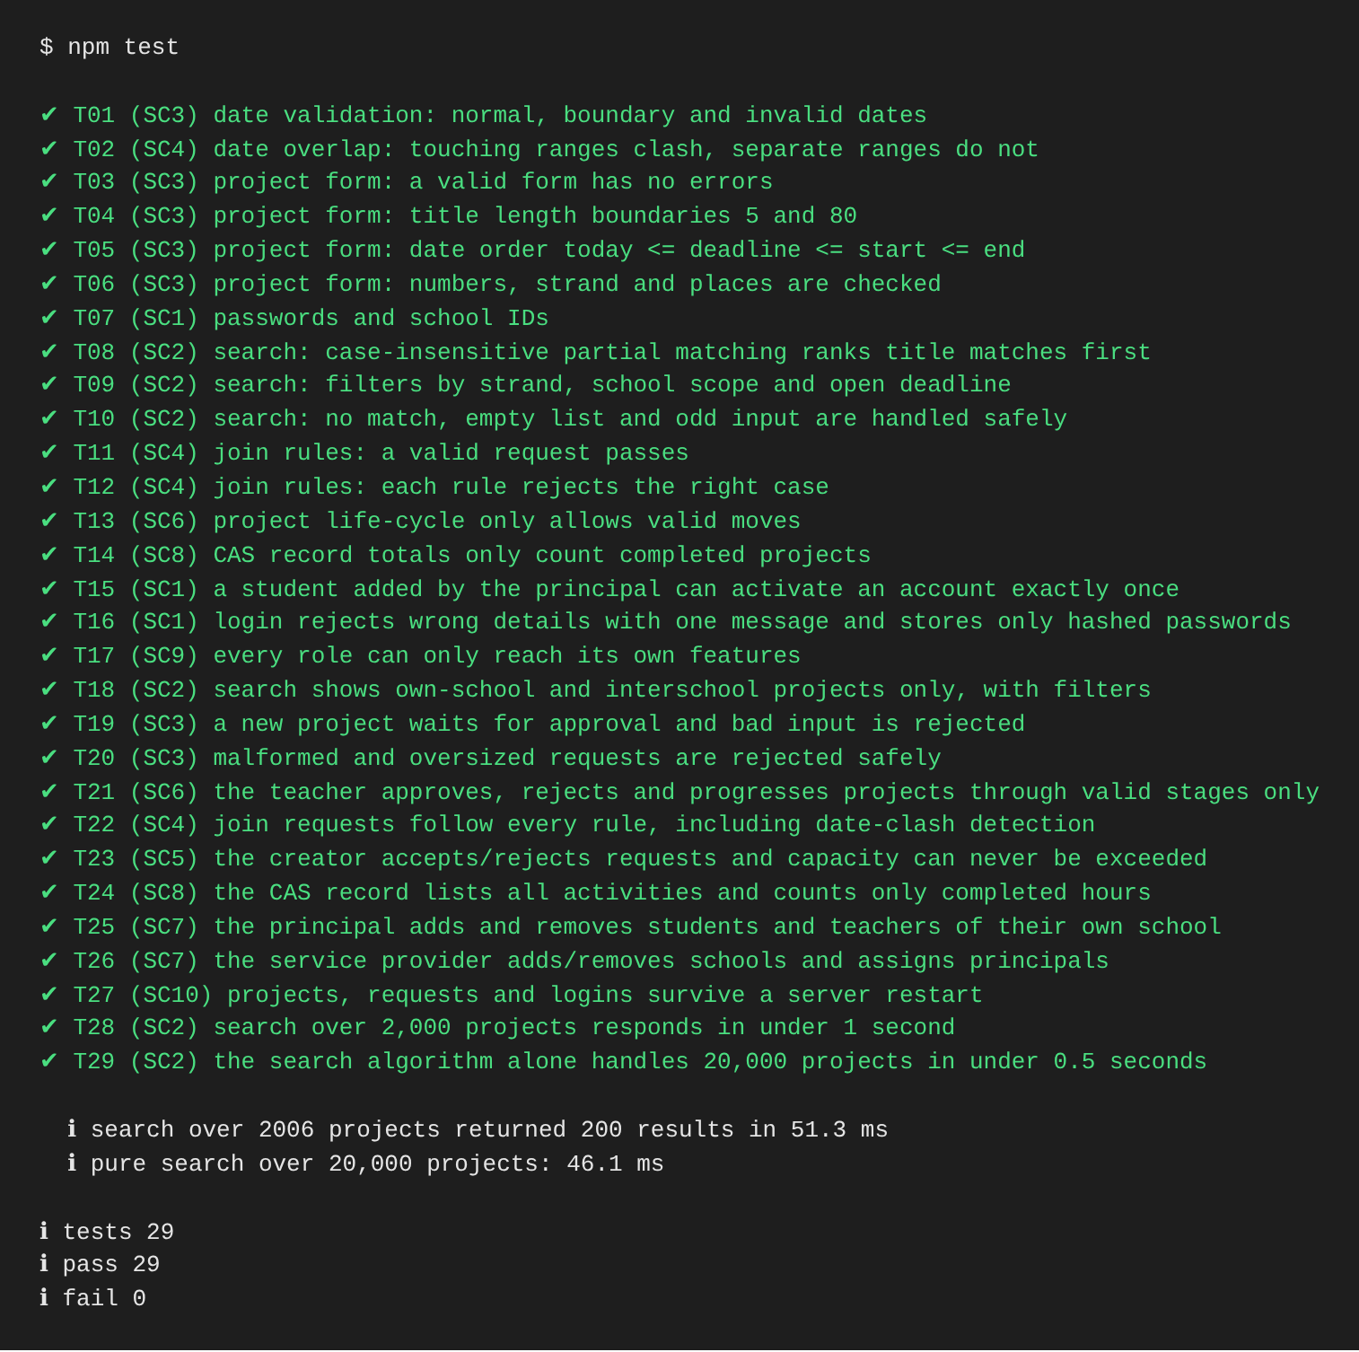 Figure D1: npm test output.
Correctness. Each algorithm was unit-tested with normal, boundary and invalid data, then every route was tested end-to-end over HTTP.
Reliability. Each test gets its own server and database, so test order can’t matter. The suite also covers malformed JSON, oversized bodies, empty records, stale cookies and restarts.
Efficiency. Searching 2,006 projects took 51 ms over HTTP. The algorithm alone took 46 ms for 20,000 projects: an O(n) scan plus an O(k log k) sort of the k matches.
Defect found. T22 failed at first because joining a pending project returned 409 “not open”, which revealed that the hidden project existed. Pending and rejected projects now return 404, and T12 covers both cases.
Justification. Every success criterion has automated tests, and every exit in Figure C4 has an assertion. One gap remains: there was no long-term trial with real students, which Criterion E addresses.

