BDA-LAB01

-Jainil Trivedi (CE166)

**Tasks**

1. **Given the spreadsheet file convert it into a csv**

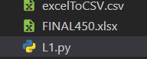

Code:

import pandas as pd

excel = pd.read_excel('FINAL450.xlsx')

df = pd.DataFrame(excel)

df.to_csv("excelToCSV.csv",index=False)

1. **Import a csv into MySQL database table**

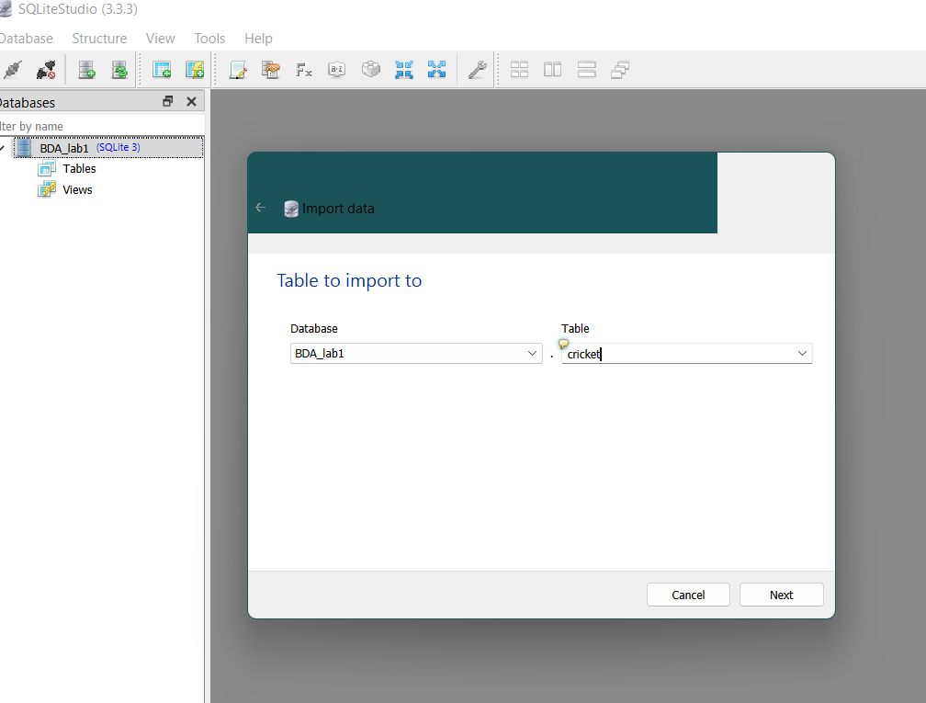

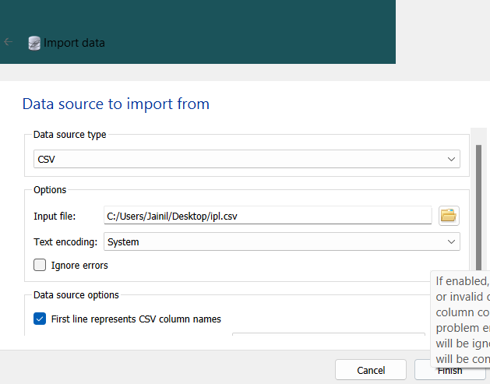

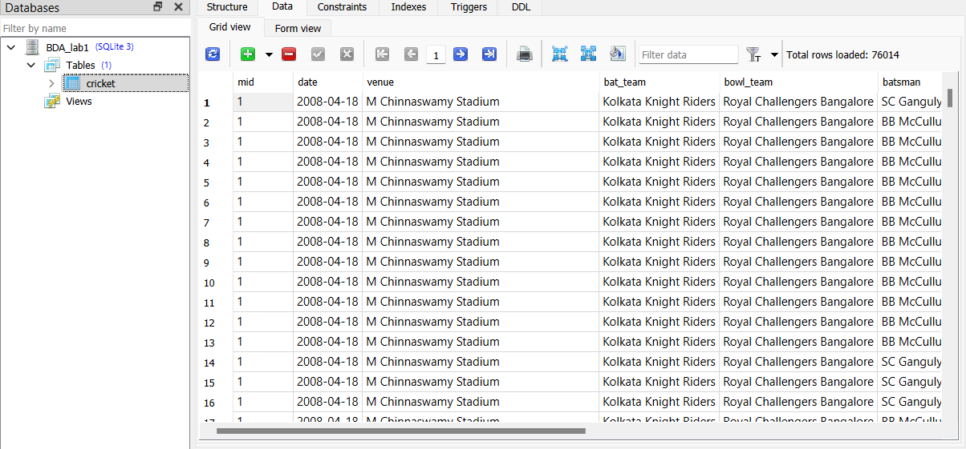

1. **Write a computer program to read records from database and generate data file.**

**=> XML**

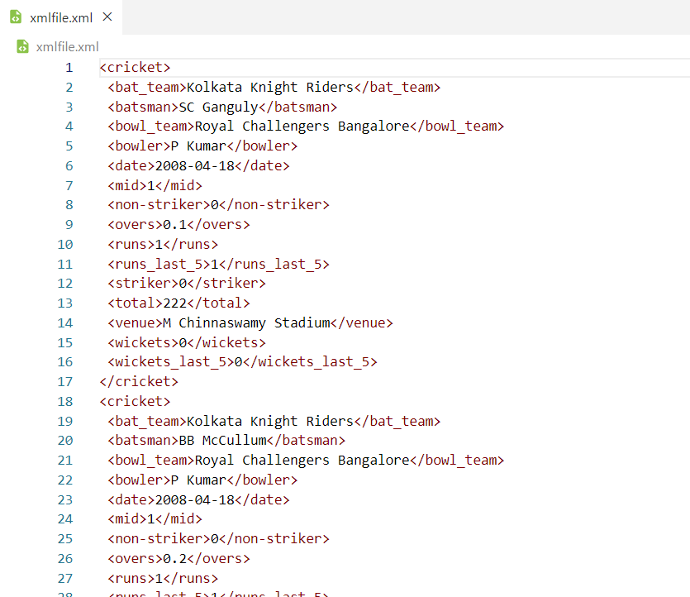

* **JSON**

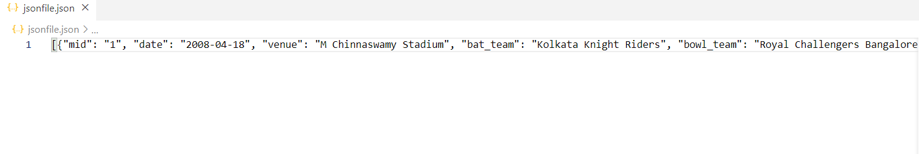

import sqlite3

import json

from textwrap import wrap

from dict2xml import dict2xml as xmlify

conn = sqlite3.connect("C:\\Users\\Jainil\\Downloads\\SQLiteStudio\\BDA_lab1")

cur = conn.cursor()

cur.execute('SELECT * FROM cricket')

columns = list(map(lambda x:x[0],cur.description))

records = cur.fetchall()

record_list = []

for record in range(0,len(records)):

    record_dict = {}

    for column in range(0,len(columns)):

        record_dict[columns[column]] = records[record][column]

    record_list.append(record_dict)

json_obj = json.dumps(record_list)

xml_boj = xmlify(record_list,wrap='cricket',indent=" ")

json_file = open("jsonfile.json","w")

json_file.write(json_obj)

xml_file = open("xmlfile.xml","w")

xml_file.write(xml_boj)

conn.close()

1. **Import XML/JSON file into another database/table. i.e, MS Access. Oracle, etc.**

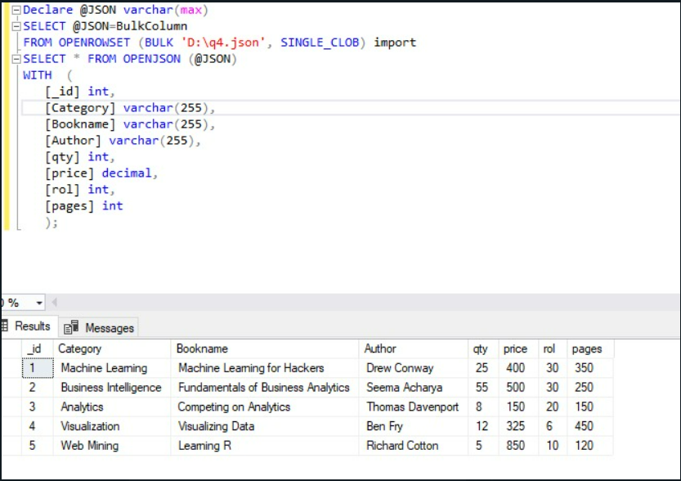

1. **Export database dump for data migration/archival**

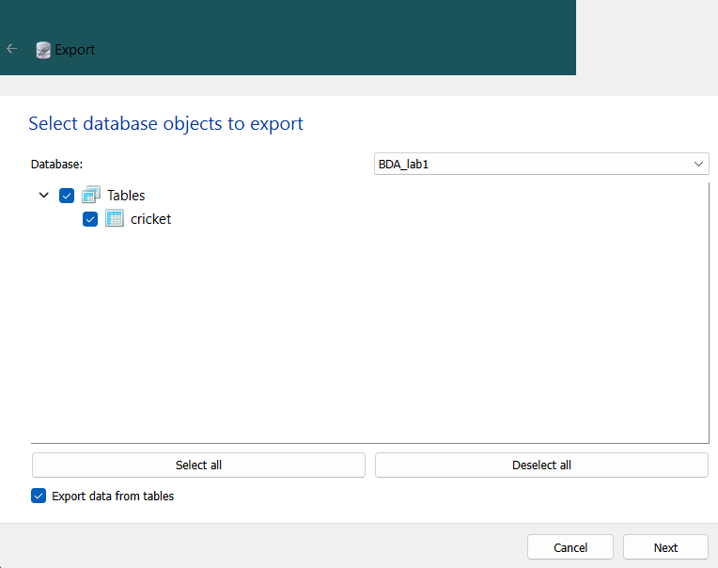

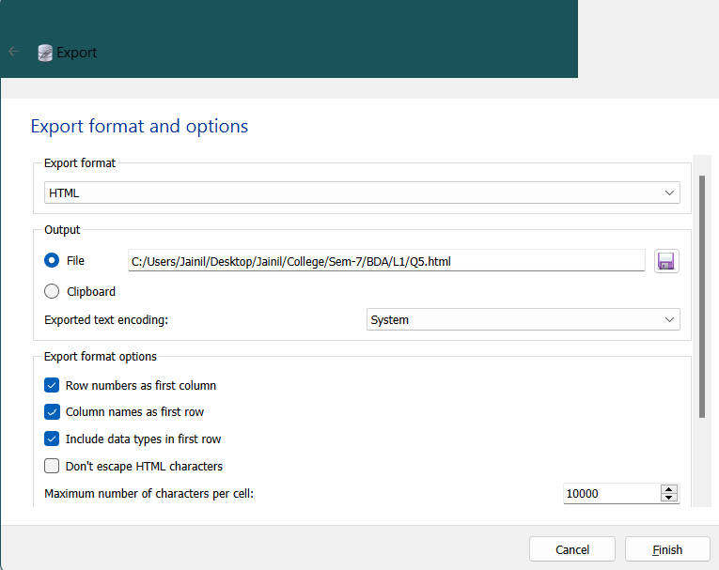

1. **Validate/Map data types across different database systems when migrating from one to another**

In SqliteStudio

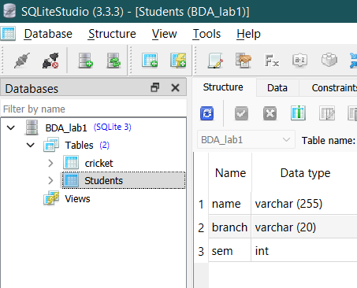

In mysql

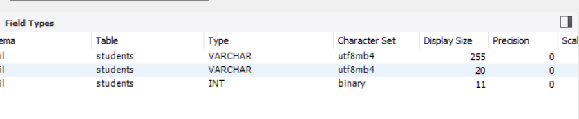

1. **Represent Data Cube and perform operations. OLAP - Data Warehouse**
2. **Cube**

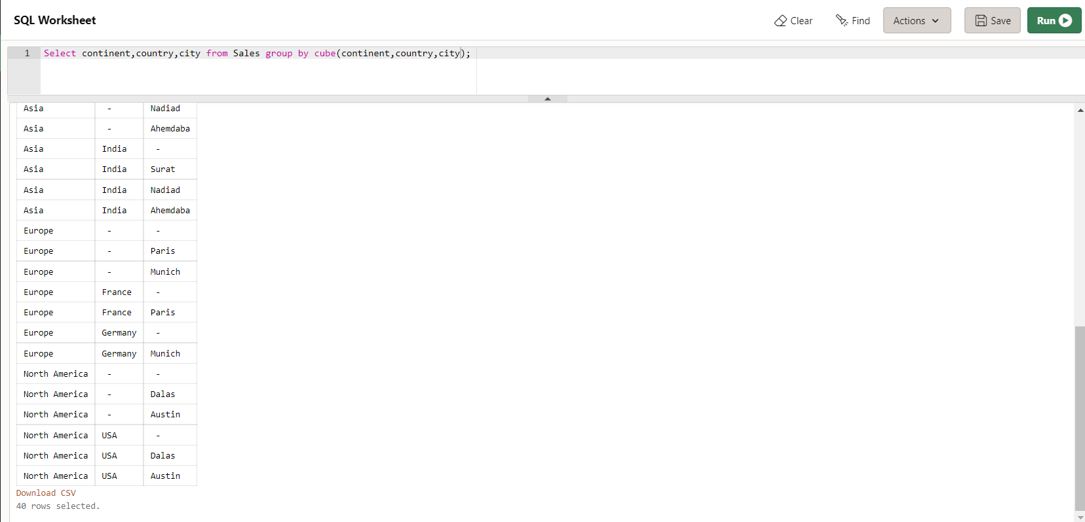

1. **Roll up**

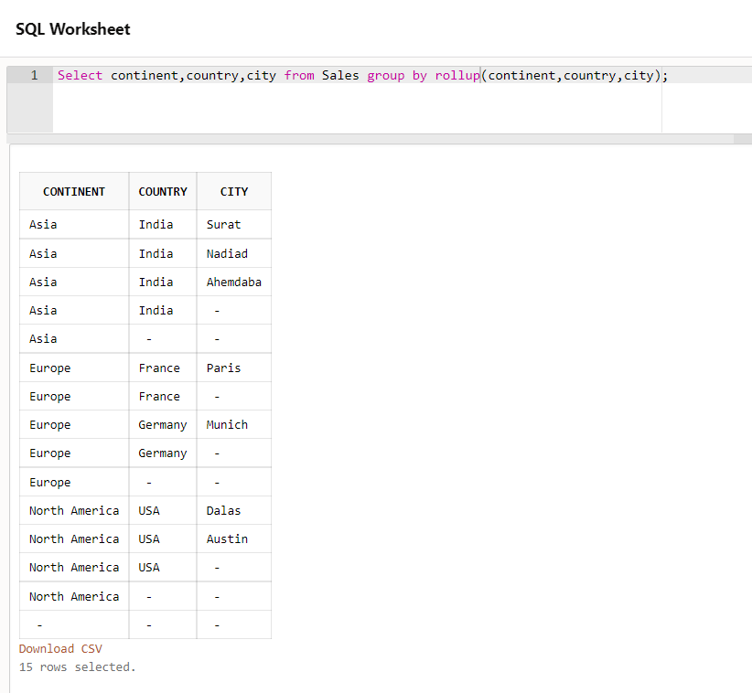

1. **Slice**

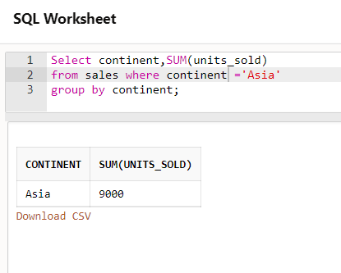

1. **Dice**

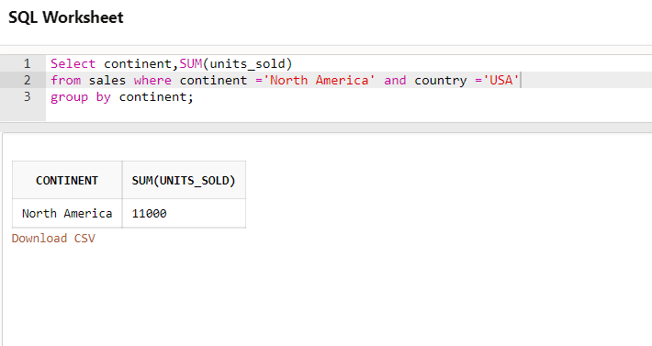

1. **Generate pdf report/ Use any visualization tool. i.e., pie chart, maps.**

import pandas as pd

import matplotlib.pyplot as plt

ds = pd.read_csv("Q8.csv")

topic = ds['Topic']

questions = ds['Questions']

x=list(topic)

y=list(questions)

plt.legend('topic','solved')

plt.pie(y,labels=x,autopct='%.2f%%')

plt.savefig("piechart_Q8.pdf",format="pdf")

