BDA-LAB02

-Jainil Trivedi (CE166)

**Aim**: Configuring and experiencing Hadoop Single node cluster. Start/stop script and monitoring.

Tasks

1. Locate the log directory and refer for troubleshooting.

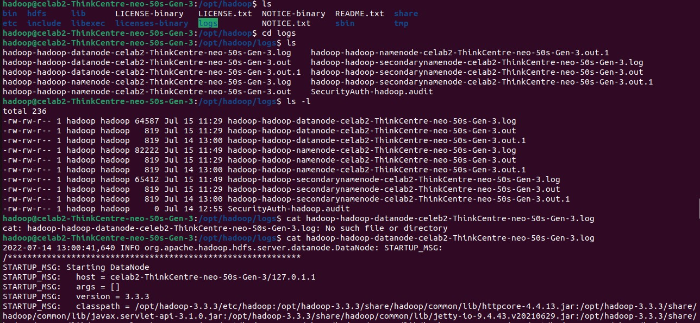

1. Change the URL of HDFS Web UI to localhost:51234 instead of localhost:50070 and the access the web UI using new URL.

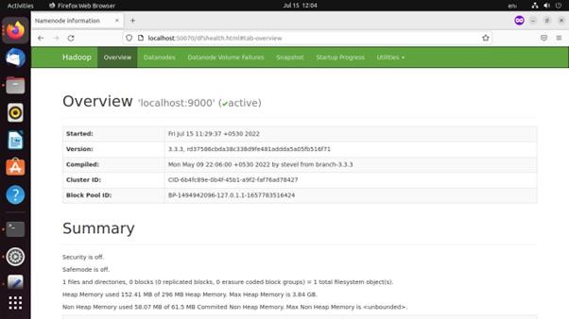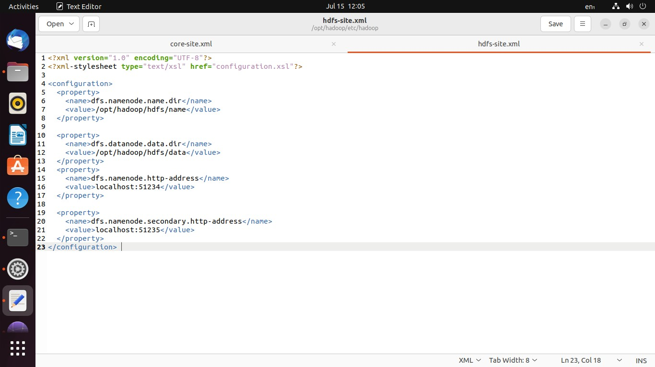

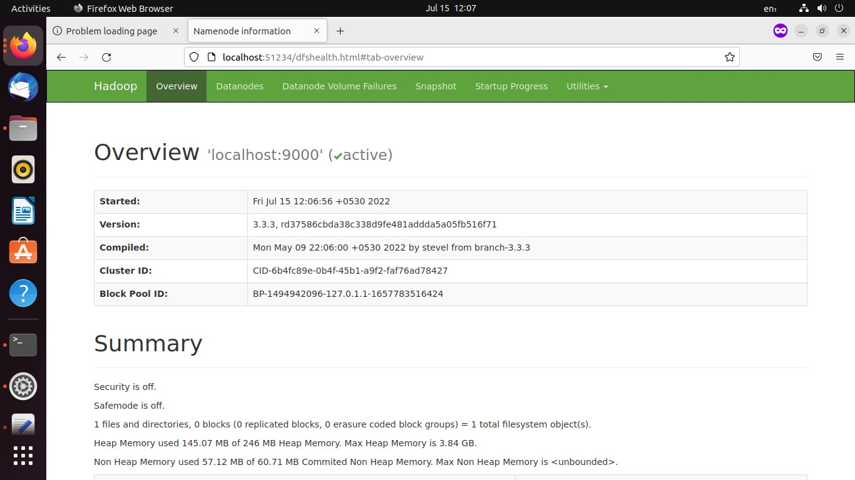

1. Undo changes done in task2.

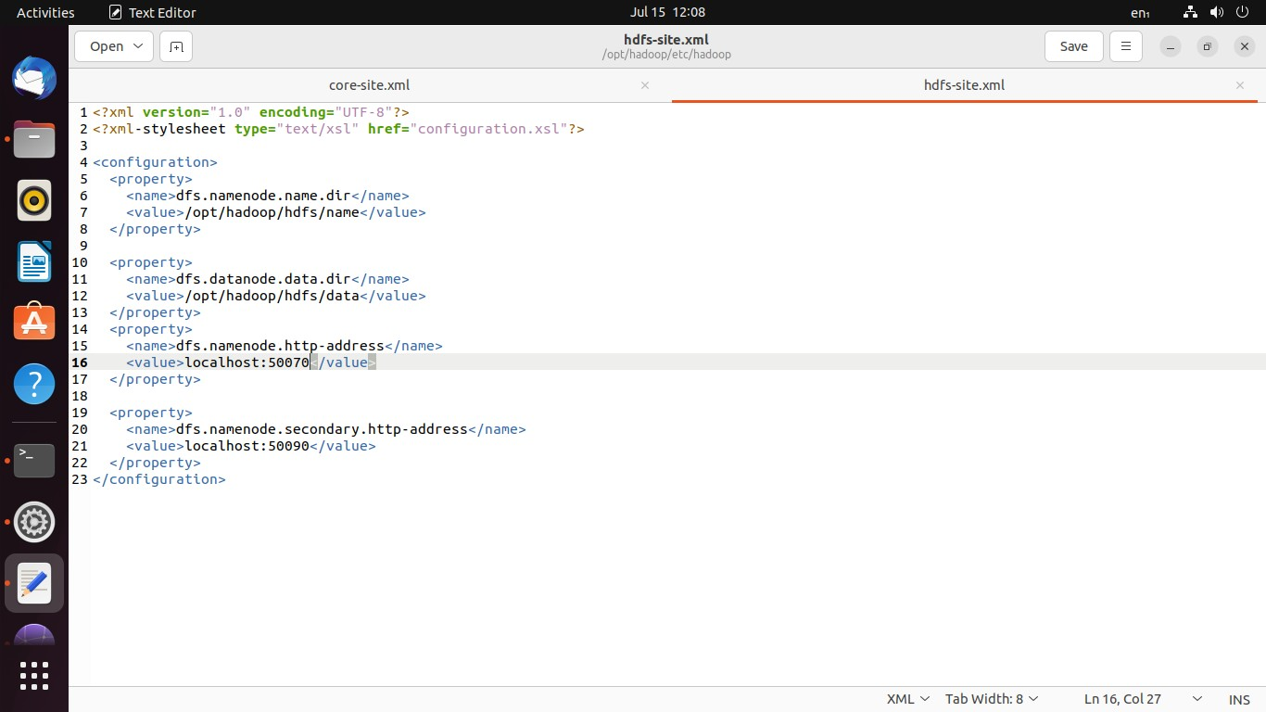

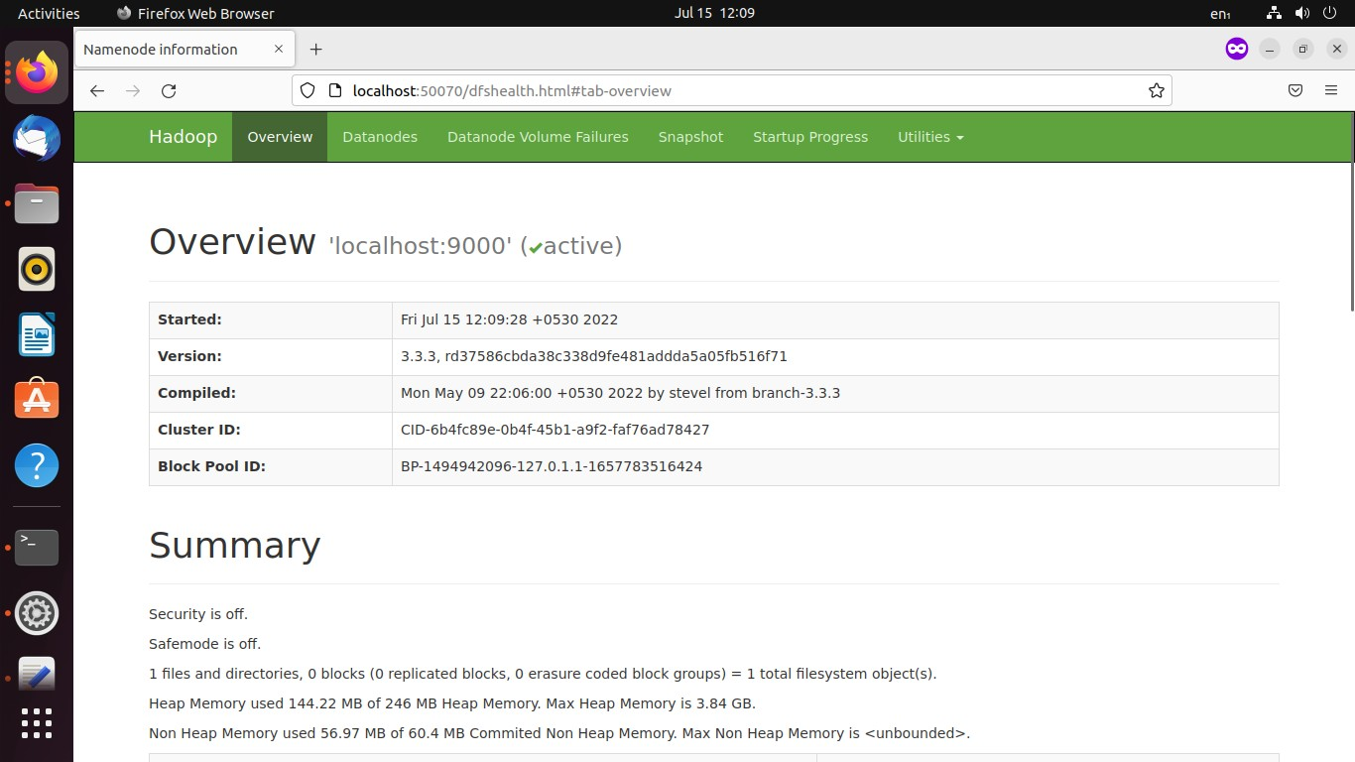

1. Find out what is current location of namenode and datanode storage directories. Normally whenever cleanup is required, tmp folder is one to be emptied up (not to confuse with formatting file system). Hence, it is advised data and metadata better be outside tmp. Do the needful to have namenode and datenode directories in /opt/hadoop, if present within tmp.

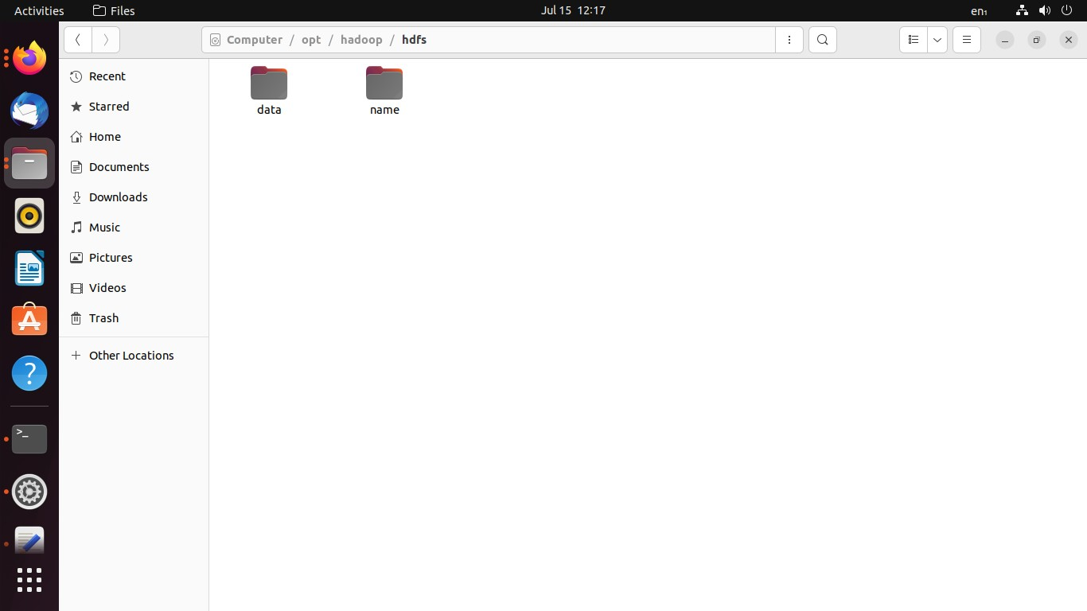

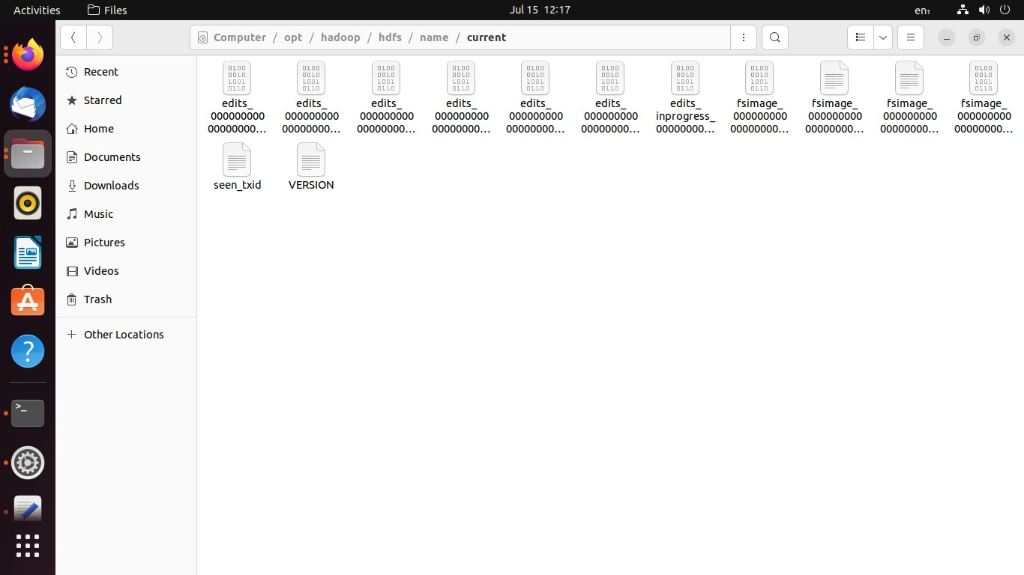

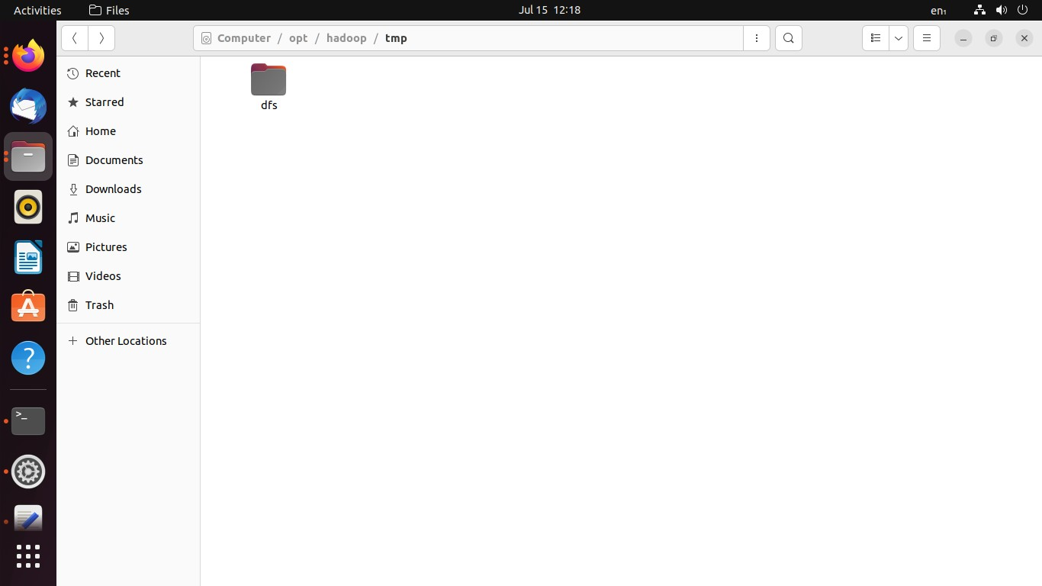

1. Analyze the output of following command: [hadoop@hadoop-clone hadoop]$ ps -ef |grep NameNode [hadoop@hadoop-clone hadoop]$ ps -ef |grep DataNode

