BDA-LAB 03

* Jainil Trivedi (CE166)
* **Aim:** "Interfacing to Distributed File System – HDFS commands and Web GUI file system browser usage"

1. Create a directory named 'Test' from HDFS web UI in '/user/hadoop'. It should give error message. Read this message and solve the error.

stop-dfs.sh

Add in core-site.xml   
<property>

<name>hadoop.http.staticuser.user</name>

<value>hadoop</value>

</property>  
  
 now start-dfs.sh  
 checking again, the error is gone

1. Create a text file in local file system and put the same file in HDFS using appropriate command.  
   touch /home/hadoop/Desktop/Q2.txt  
   hdfs dfs -put /home/hadoop/Desktop/Q2.txt /user/hadoop/test  
     
   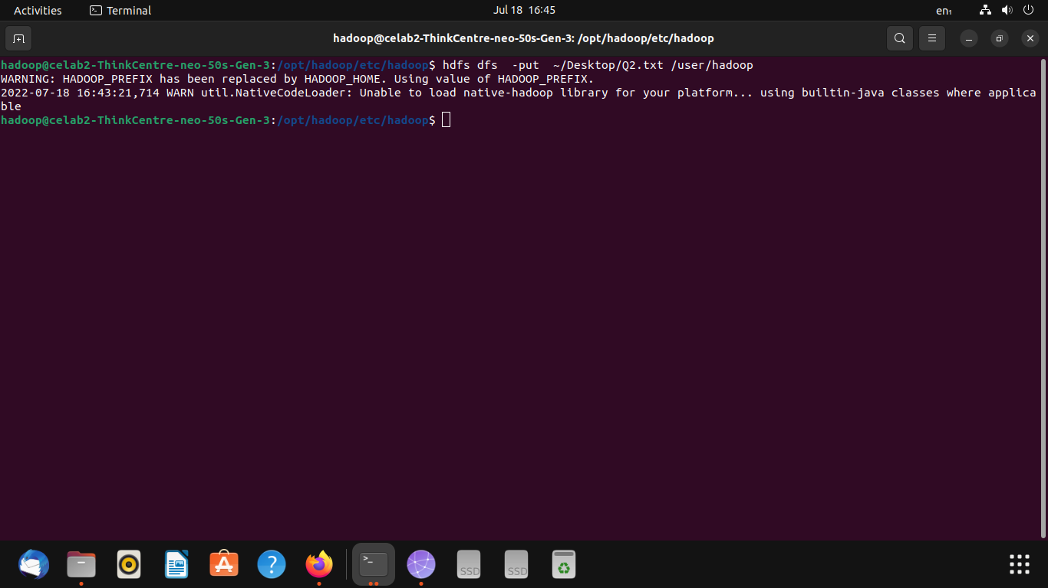
2. Display the contents of this file of HDFS on terminal.  
    hdfs dfs -cat /user/hadoop/test/Q2.txt  
     
     
     
   Same file on the GUI

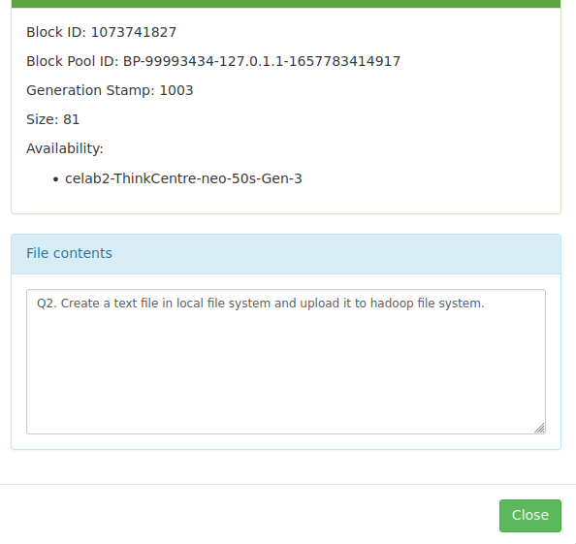

1. Download this file of HDFS on local machine and change its contents. Upload this modified file again on HDFS and verify its contents. Also make sure that this file should be deleted from local machine automatically. Also check the same on the gui

hdfs dfs -moveFromLocal /home/hadoop/Downloads/Q2.txt /user/hadoop  
hdfs dfs -cat /user/hadoop/Q2.txt

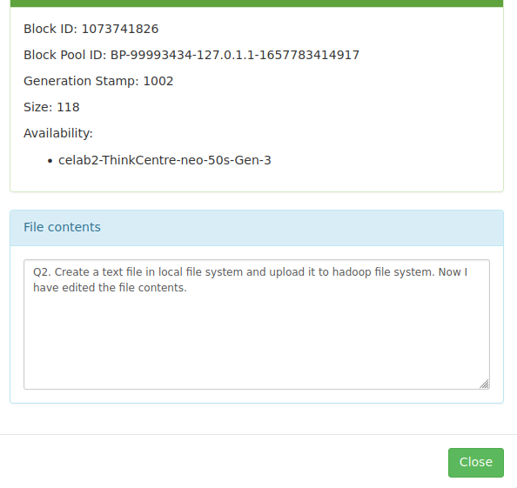

1. Find out a way to display all file system commands supported by hdfs. Record the list.

