BDA LAB 04

* Jainil Trivedi (CE166)
* **Aim:** "Write a map-reduce program to count the frequencies of words from distributed storage source and understand the phases involved in map-reduce programming."

1. To practice MapReduce programming in Hadoop using Java Coding.

We create a file which contains details about the number of pages in each book.  
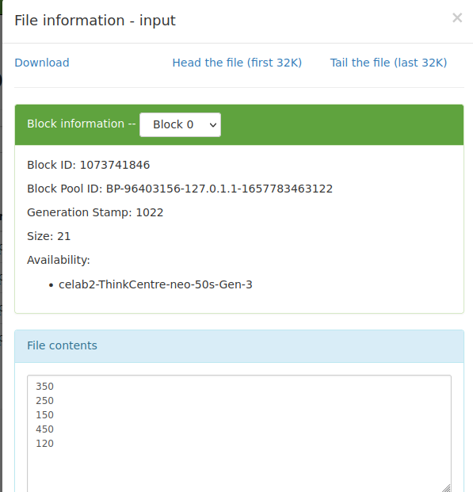

Now, apply map reduce to find number of big books ( >300 pages) and small books ( <300 pages )

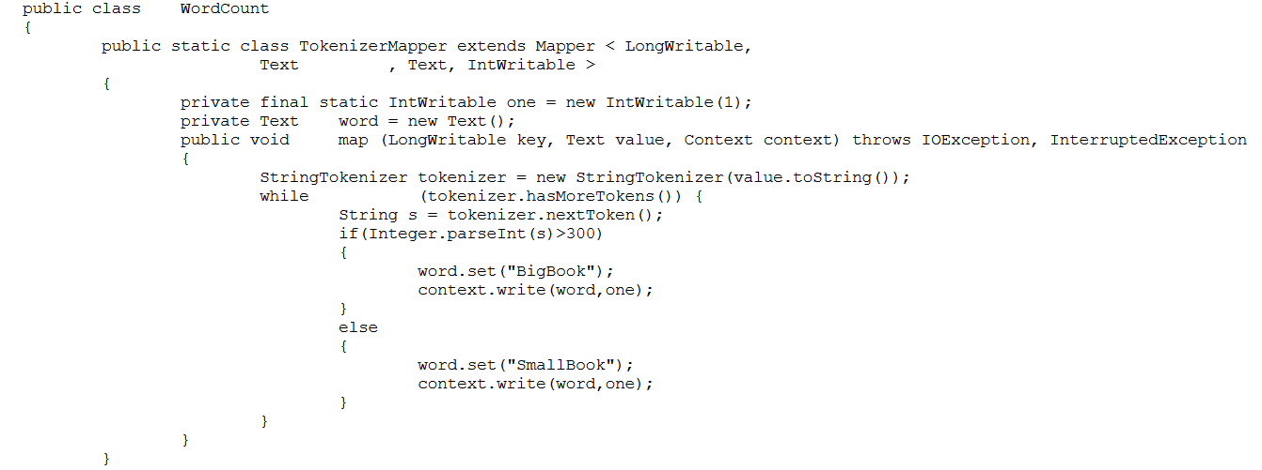

Now execute the program

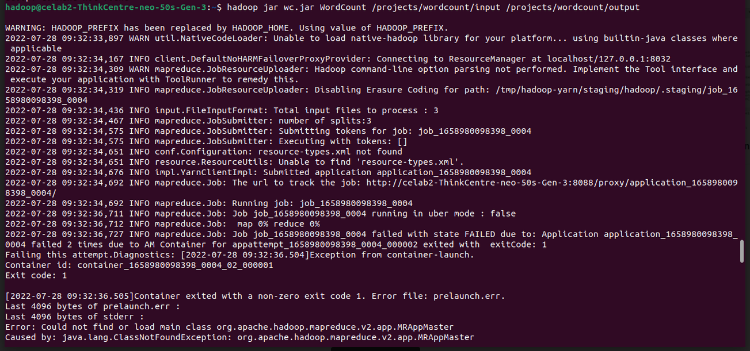  
  
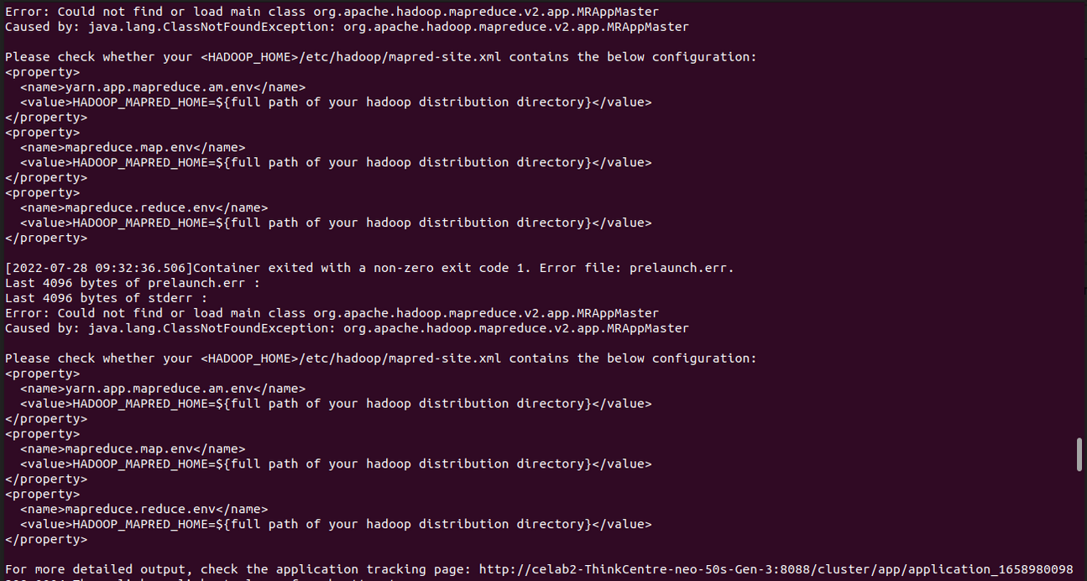

Now, check for the output   
  
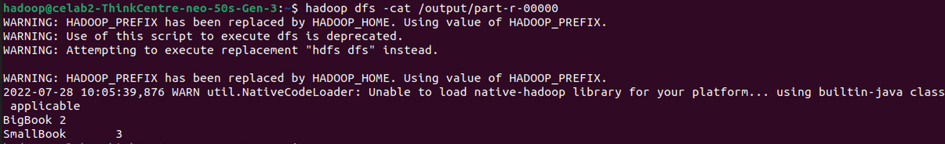

**JOB HISTORY**

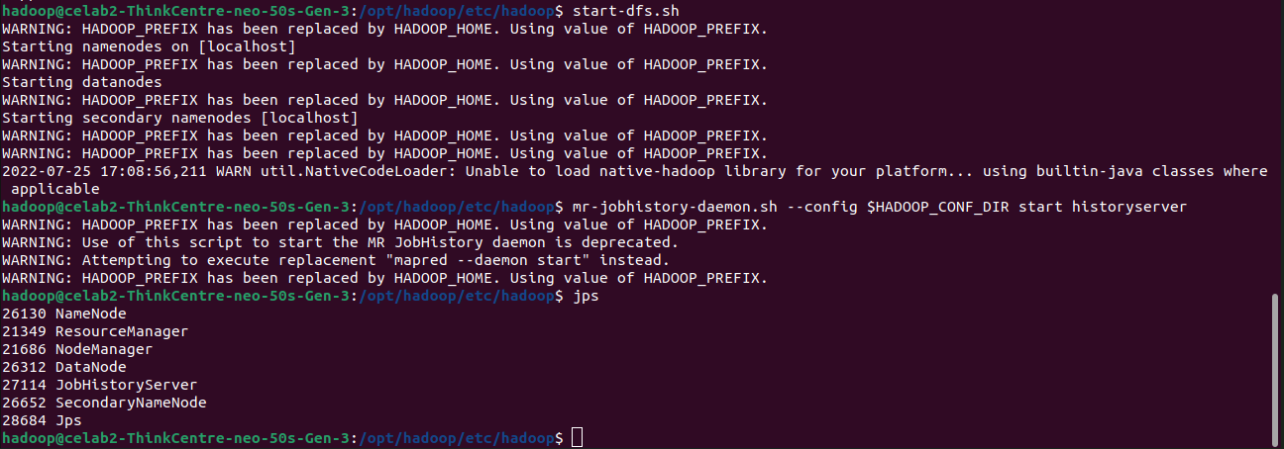

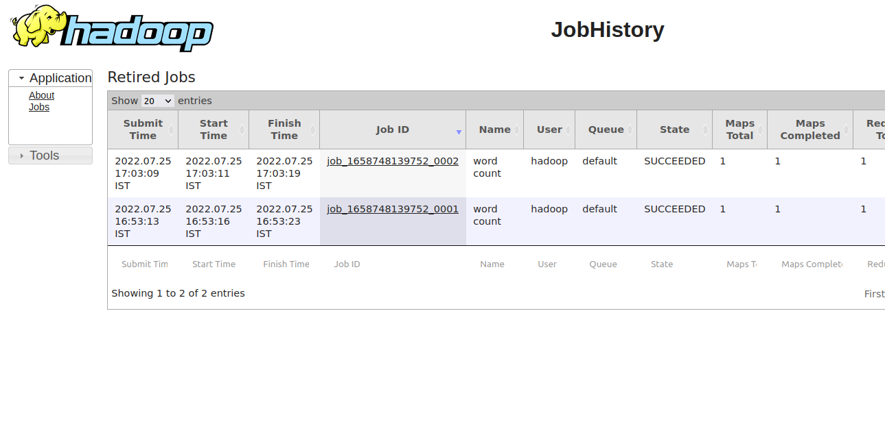

**Command History:** history 81 > commands.txt

728 cd ~/Desktop

729 touch books.txt

730 gedit books.txt

731 vi books.txt

732 gedit books.txt

733 hdfs dfs -moveFromLocal ~/Desktop/books.txt /user/hadoop

734 hdfs dfs -moveFromLocal ~/Desktop/books.txt /user/hadoop/imput

735 hdfs dfs -ls /user/hadoop

736 hdfs dfs -mkdir -p /user/hadoop

737 hdfs dfs -ls /user/hadoop

738 hdfs dfs -moveFromLocal ~/Desktop/books.txt /user/hadoop/input

739 hdfs dfs -put ~/Desktop/books.txt /user/hadoop/input

740 clear

741 gedit touch.txt

742 hdfs dfs -put ~/Desktop/books.txt /user/hadoop/input

743 gedit books.txt

744 ls

745 rm touch.txt

746 ls

747 hdfs dfs -put ~/Desktop/books.txt /user/hadoop/input

748 clear

749 touch wc.java

750 gedit wc.java

751 clear

752 hdfs dfs -put ~/Desktop/wc.java /user/hadoop/

753 cd ~/.bash

754 cd $HADOOP_HOME

755 LS

756 ls

757 cd etc

758 ls

759 cd hadoop/

760 ls

761 gedit core-site.xml

762 clear

763 gedit core-site.xml

764 clear

765 java --verison

766 java -verison

767 java

768 java -version

769 hadoop version

770 echo $HADOOP_HOME

771 WHOAMI

772 whoami

773 stop-historysever.sh

774 cat wordcount.java

775 clear

776 cd ..

777 clear

778 cd etc

779 cd hadoop/

780 gedit core-site.xml

781 cat core-site.xml

782 cd ..

783 ls

784 export HADOOP_CLASSPATH=$(hadoop classpath)

785 hadoop classpath

786 javac -cp `hadoop classpath` WordCount.java

787 javac -cp `hadoop classpath` /user/hadoop/ wc.java

788 javac -cp `hadoop classpath` /user/hadoop/wc.java

789 clear

790 export HADOOP_CLASSPATH=$(find /user/hadoop -name '*.jar')

791 export HADOOP_CLASSPATH=$(find $HADOOP_HOME -name '*.jar')

792 javac -cp $HADOOP_CLASSPATH /user/hadoop/wc.java

793 javac -cp $HADOOP_CLASSPATH /user/hadoop/wc.java /user/hadoop/input

794 ls

795 javac -cp $HADOOP_CLASSPATH /user/hadoop/wc.java /user/hadoop/input /user/hadoop/output

796 hadoop jar wc.jar WordCount /user/hadoop/input /user/hadoop/output

797 cd ~/Desktop

798 javac -cp $HADOOP_CLASSPATH WordCount.java

799 clear

800 javac -cp $HADOOP_CLASSPATH WordCount.java

801 clear

802 javac -cp `hadoop classpath` WordCount.java

803* jar cf wc.jar WordCount*.clas

804 clear

805 hadoop jar wc.jar WordCount /user/hadoop/input /user/hadoop/output

806 hadoop jar wc.jar WordCount /user/hadoop/input /user/hadoop/uotput2

807 history

808 history 100

809 history 82 >commands.txt