LAB 06

-Jainil Trivedi (CE166)

**1. Write queries to write crud operations in MongoDB**

INSERT

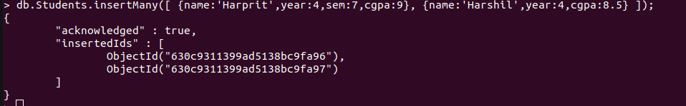

FIND/READ

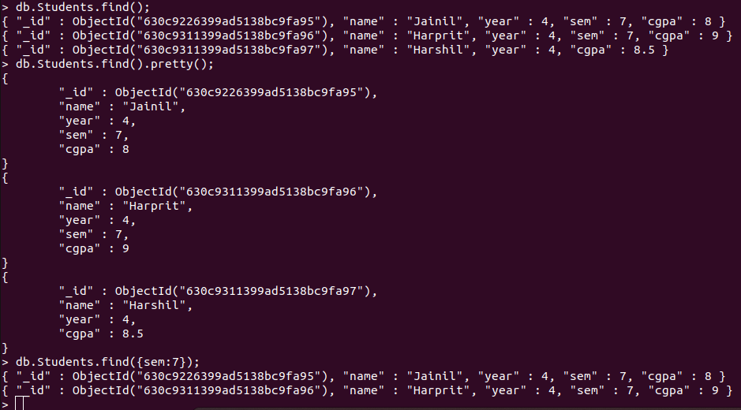

UPDATE

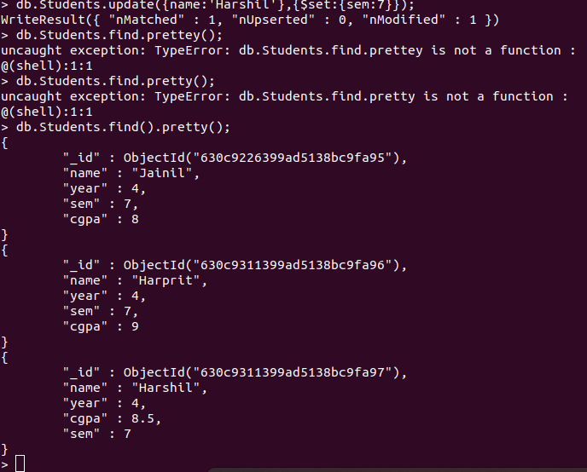

DELETE

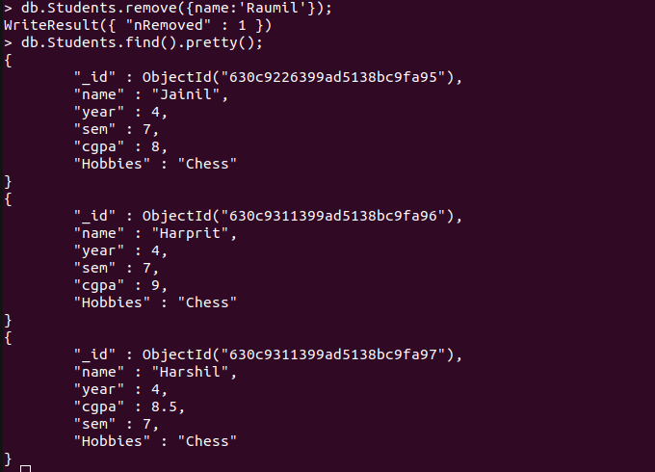

**2. To practice MapReduce programming in MongoDB.**

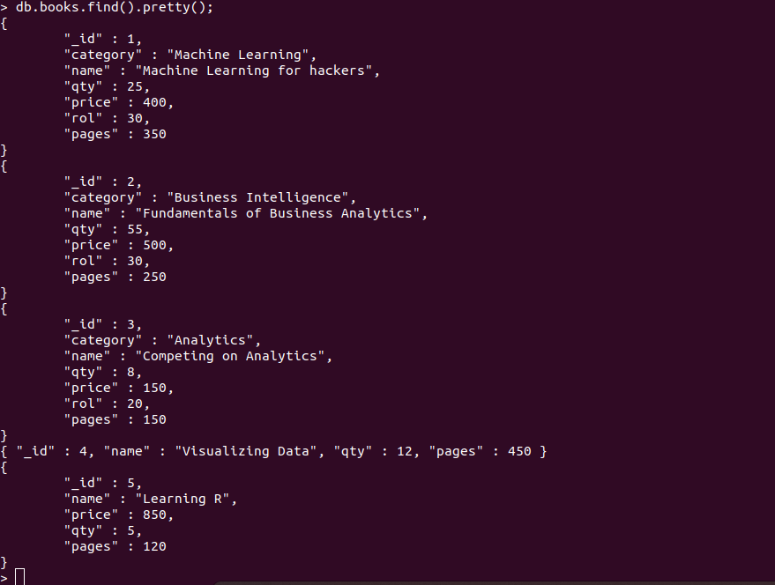

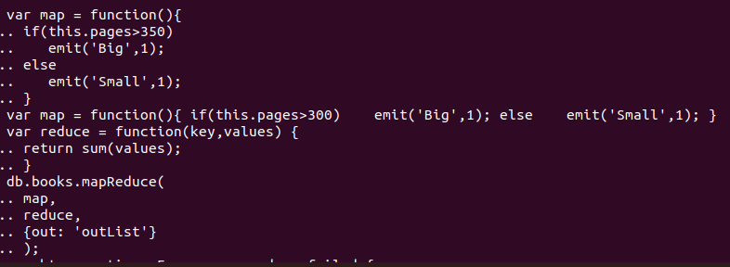

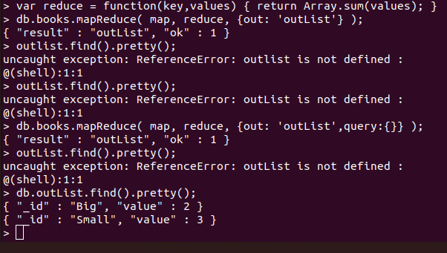

**3. To practice import, export and aggregation in MongoDB.**

