BDA Lab 08

* Jainil Trivedi (CE166)
* **Aim:** "Leveraging machine learning to classify image."

In this lab, I have tried to classify Images of husky and golden retriever using CNN. It is a deep learning technique, specially used in detecting images.

*Structure and Working of CNN:*

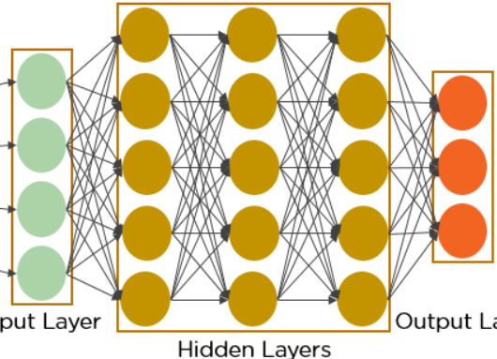

The input layer(green) is where we give dataset to the model. In the hidden layer, we perform convolution, max pooling and flattening. Finally, this output is sent to the output layer(orange).

