BDA Lab 09

* Jainil Trivedi (CE166)

# AIM: SQL Crud Operations (Hive)/ Distributed Databases (HBase)

Installation Steps:



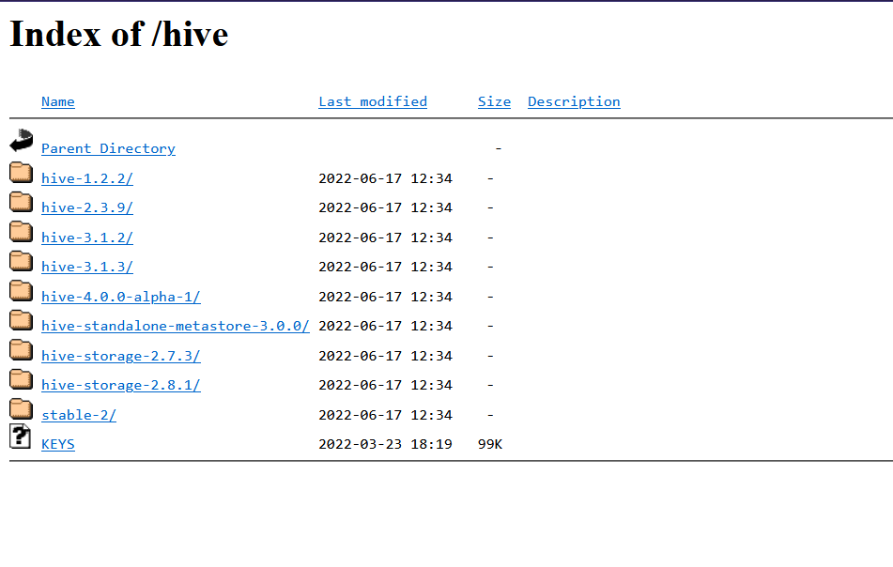

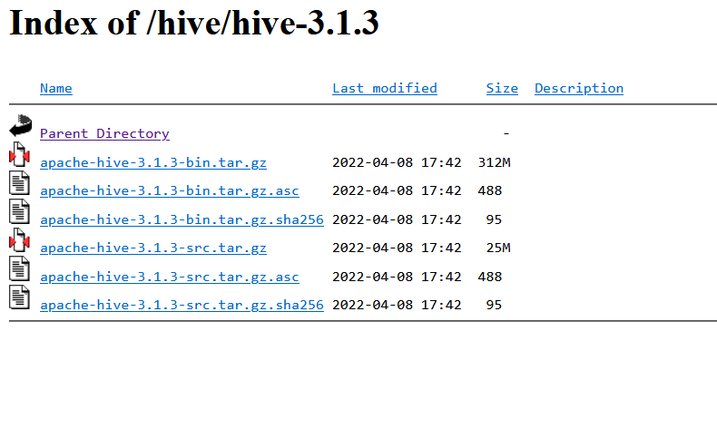

Use: start-dfs.sh; start-yarn.sh; start-history-server.sh

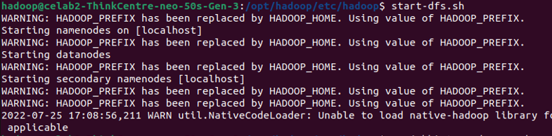

Now use command: jps to verify if above commands were successful or not.

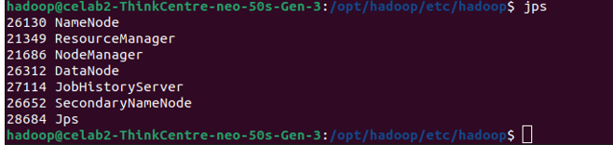

Download and extract hive to /opt/hive.

adding hive path in bashrc

HIVE_HOME=<dirWhereYouInstalledHive> into bash profile ~/.bashrc file



Make The following directories in hadoop.

hadoop fs -mkdir -p /tmp

hadoop fs -mkdir -p /user/hive/warehouse

hadoop fs -chmod g+w /tmp

hadoop fs -chmod g+w /user/hive/warehouse

To use the Hive CLI from the shell use command:

$HIVE_HOME/bin/hive

HIVE Online Platform: <https://demo.gethue.com/hue/editor/?type=6>

Creating the table

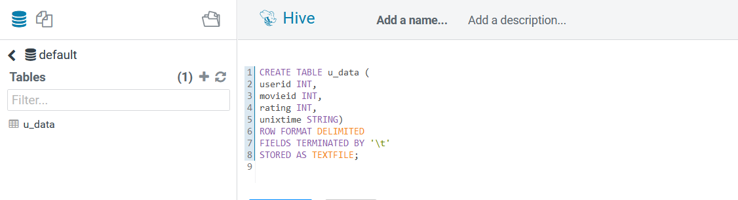

Inserting into the table

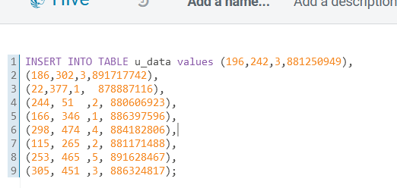

Showing all data inserted.

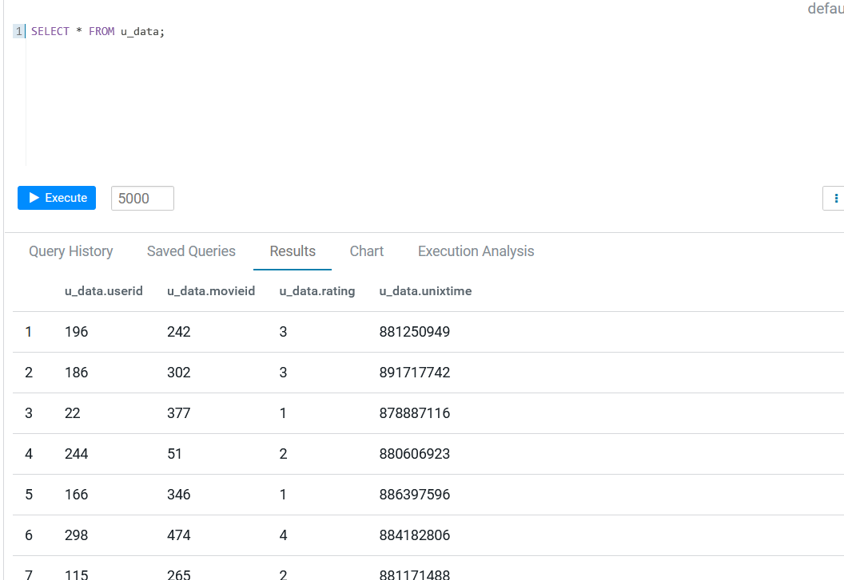

Finding total number of records in u_data.

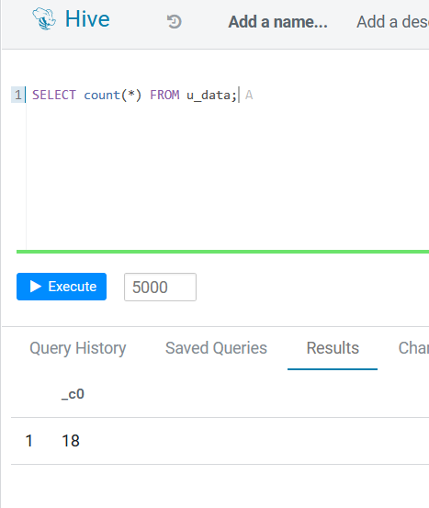

Drop Table

