Weekly Status Report
E-Pharma Management System — Phase 5
Employee | Jainish Nikul Shah | Designation | Software Engineer
Project | Techmentee — E-Pharma Management System | Coordinator | Vaishali Pujari
Reporting Period | Phase 5 — 10 August 2026 – 14 August 2026 | Report Date | 14 August 2026
Phase | Phase 5 — Performance & Security | Overall Status | Completed (ahead of schedule)
1. Summary
All Phase 5 objectives — PostgreSQL migration, encryption at rest, audit logging, load testing and an accessibility pass — were completed and verified. The database work was implemented as a single dual-backend data layer rather than a one-way migration: the application runs on SQLite with zero configuration for demonstrations and on PostgreSQL for production simply by setting a connection string, with the same automated test suite proving both. Running the suite against a live PostgreSQL server surfaced three real portability defects (foreign-key declaration order, character-encoding of currency and dash characters, and decimal versus floating-point number formatting) that a code review alone would not have caught; all three were fixed and re-verified.
2. Tasks Completed This Phase
Task (Phase 5 scope) | Status | Remarks
PostgreSQL migration | Completed | Dual-backend data layer: SQLite by default, PostgreSQL when DATABASE_URL is set. Placeholders, RETURNING id, schema types and transactions are translated in one place. The complete test suite was executed against a live PostgreSQL server and passes on both backends
Encryption at rest for medical records | Completed | Prescriptions, consultation messages and verification documents are encrypted (Fernet: AES-CBC with HMAC authentication) before storage and decrypted on read, so a stolen database file contains only ciphertext
Audit logging | Completed | New audit_log table records logins including failed attempts, registrations, approvals, orders, prescriptions and content edits; reviewable by administrators through a dedicated, admin-only endpoint
Load testing | Completed | Repeatable benchmark script added (loadtest.sh). Measured locally: approximately 2,100–2,900 requests/second across the hot endpoints, 95th-percentile latency at or below 19 ms, with zero failed requests
Accessibility pass | Completed | Skip-to-content link, visible keyboard focus indicators, ARIA labelling, tab semantics with selection state, live regions for status messages, dialog semantics with focus management and Escape-to-close, alternative text on all images, and reduced-motion support
Testing & documentation | Completed | Test suite grown to 49 assertions — including one that reads the raw database column to prove the stored medical record is ciphertext — and verified on both SQLite and PostgreSQL; README and analysis document updated
3. Deliverables
- Dual-backend data layer supporting SQLite and PostgreSQL from one code path
- Encryption module protecting prescriptions, consultation messages and verification documents at rest
- Audit trail with an administrator review endpoint
- Repeatable load-test script with recorded baseline measurements
- Accessibility improvements across the entire interface
- Test suite expanded to 49 assertions, passing on both database backends; documentation updated
4. Measured Results
- Throughput: approximately 2,100–2,900 requests/second on the read endpoints; 95th-percentile latency at or below 19 ms; zero failed requests
- Correctness: 49 of 49 automated assertions pass on SQLite and on PostgreSQL
- Security: the raw database column for a stored prescription was confirmed to contain ciphertext, while the API returns the correct plaintext to the authorised user
5. Plan for Next Phase (Phase 6 — Deployment & Handover)
- Production deployment on the agreed hosting environment, served by a production application server behind TLS
- Provision the managed PostgreSQL instance and load the encryption key from a secrets manager
- Final documentation, demonstration and handover
6. Issues / Blockers
None blocking. Before deployment, three confirmations are requested from the coordinator: the target hosting environment and managed PostgreSQL instance; the payment provider to license for go-live (Stripe or Razorpay, both integrated); and the SMS/email provider for live notification delivery. A data-retention policy and consent capture remain outstanding for full HIPAA/GDPR alignment and are proposed for Phase 6.

Prepared by: Jainish Nikul Shah, Software Engineer
Submitted to: Vaishali Pujari, Project Coordinator
Few Screenshot as the reference
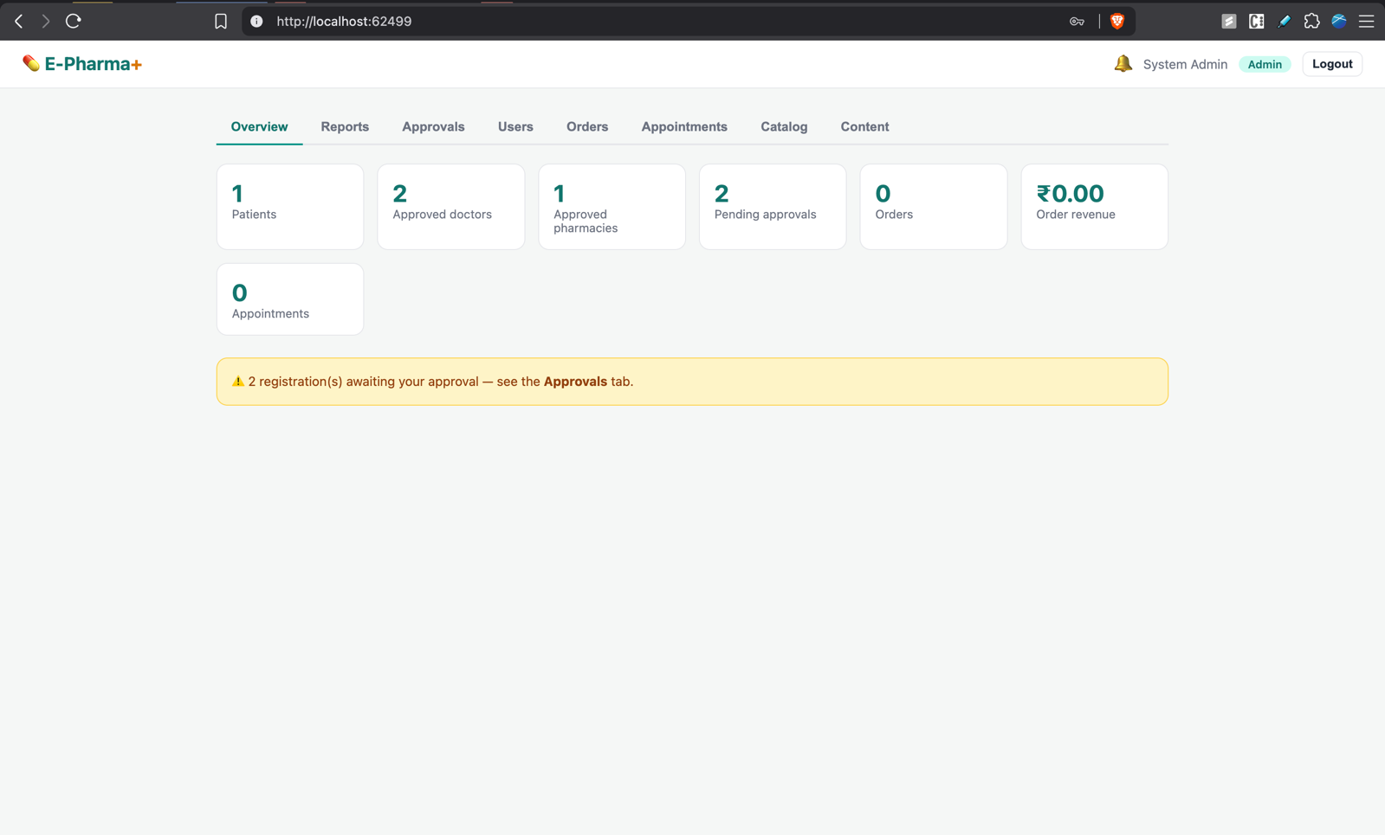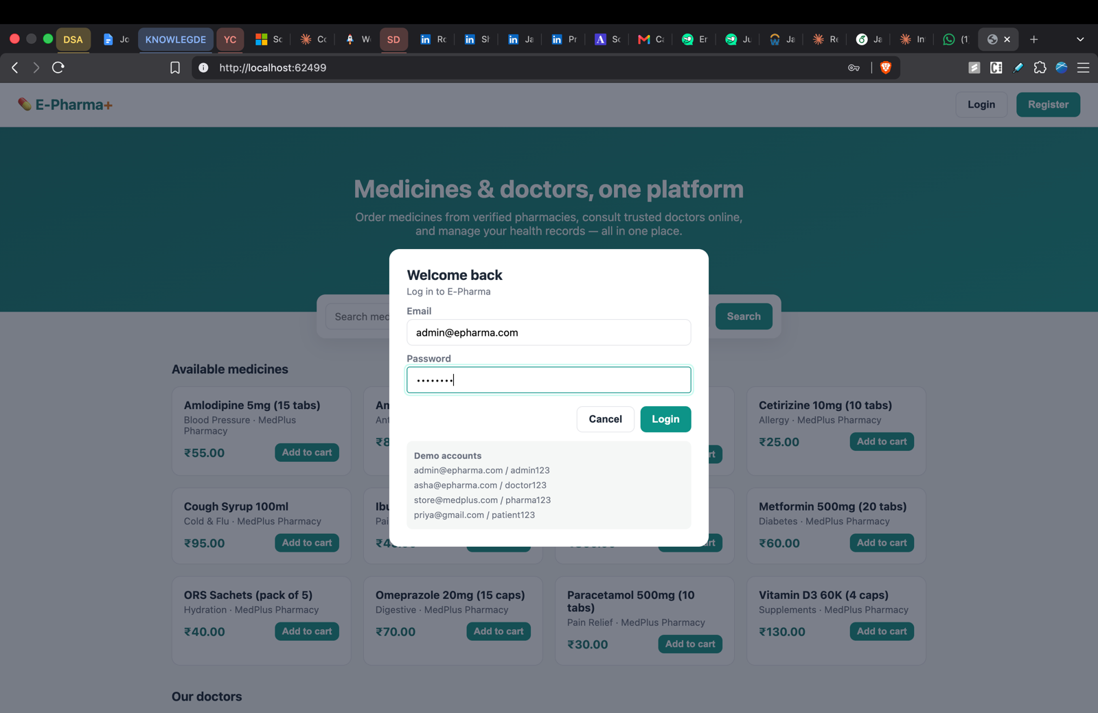
Admin DashBoard 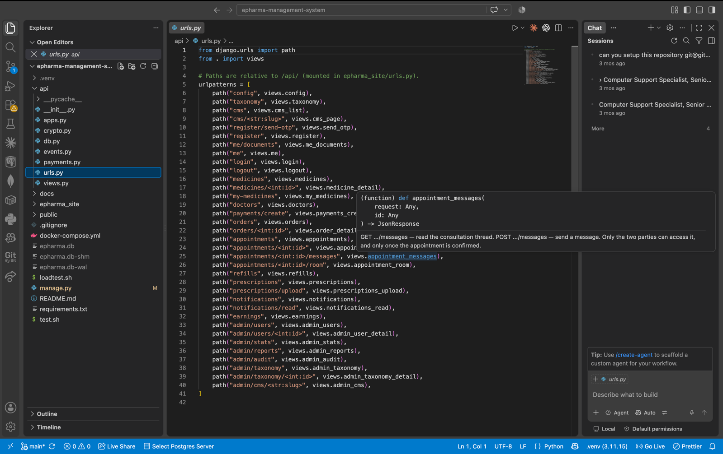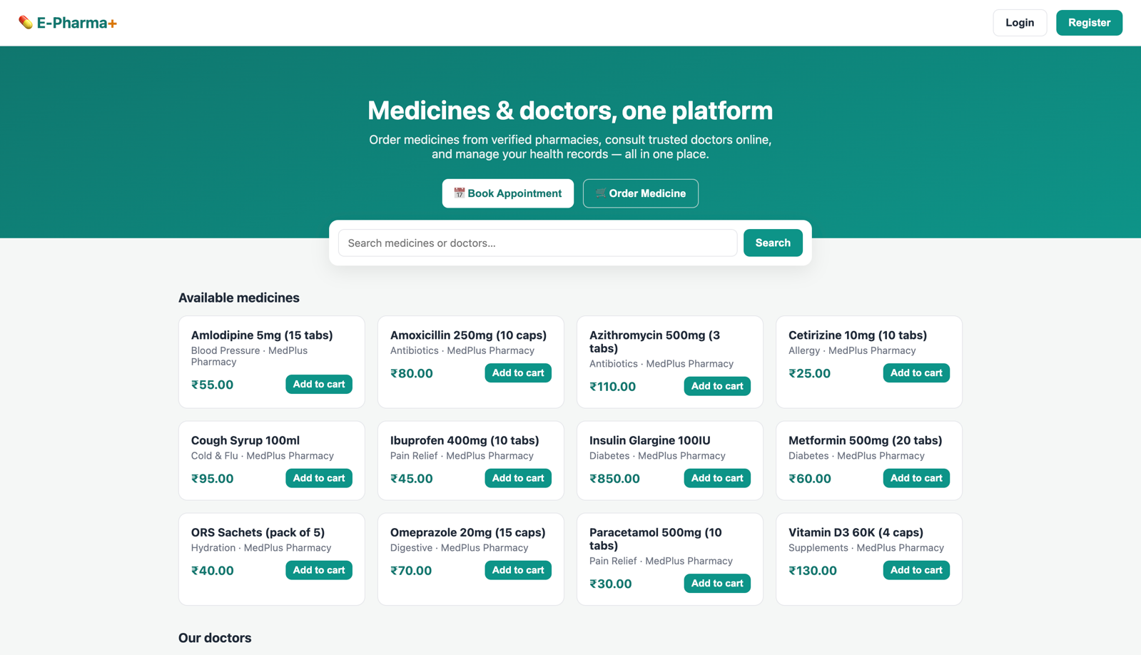
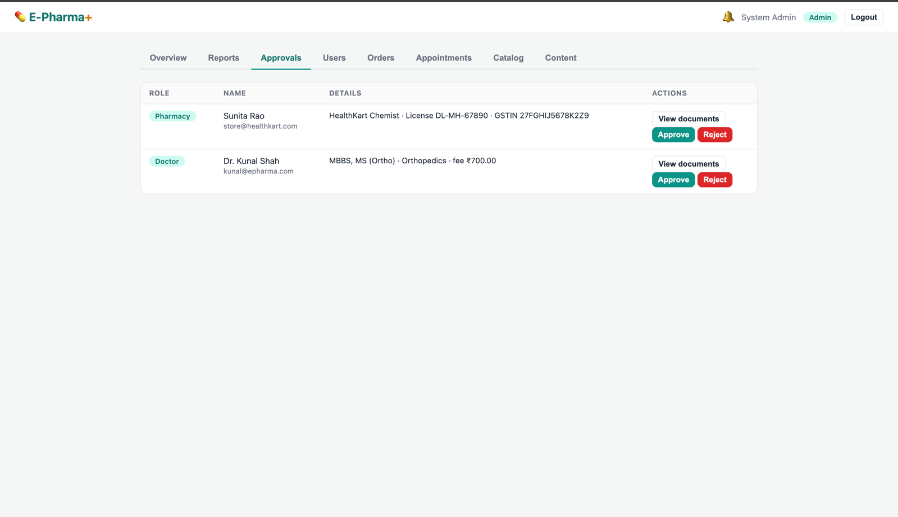

Below code shows the implementation for the Admin Dashboard Backend APIs
# ==================== admin ====================
@api
def admin_users(request):
"""GET /api/admin/users?status=&role= — admin. All non-admin users, optionally filtered."""
user, err = require_auth(request, "admin")
if err:
return err
sql, params = "SELECT * FROM users WHERE role != 'admin'", []
if request.GET.get("status"):
sql += " AND status = ?"
params.append(request.GET["status"])
if request.GET.get("role"):
sql += " AND role = ?"
params.append(request.GET["role"])
return J([db.public_user(u) for u in db.query(sql + " ORDER BY id DESC", params)])

@api
def admin_user_detail(request, id):
"""PATCH /api/admin/users/<id> — admin approves or rejects a pending doctor/pharmacy."""
user, err = require_auth(request, "admin")
if err:
return err
target = db.get("SELECT * FROM users WHERE id = ?", (id,))
if not target:
return J({"error": "User not found"}, 404)
status = request.data.get("status")
if status not in ("approved", "rejected"):
return J({"error": "Invalid status"}, 400)
db.run("UPDATE users SET status = ? WHERE id = ?", (status, target["id"]))
db.audit(user, f"user.{status}", f"{target['role']} #{target['id']} ({target['email']})")
notify(target["id"], f"Your {target['role']} account was {status} by the admin")
return J(db.public_user(db.get("SELECT * FROM users WHERE id = ?", (target["id"],))))

@api
def admin_stats(request):
"""GET /api/admin/stats — admin. Headline KPI counts for the dashboard overview."""
user, err = require_auth(request, "admin")
if err:
return err

def c(sql):
return db.get(sql)["c"]

return J({
"patients": c("SELECT COUNT(*) AS c FROM users WHERE role = 'patient'"),
"doctors": c("SELECT COUNT(*) AS c FROM users WHERE role = 'doctor' AND status = 'approved'"),
"pharmacies": c("SELECT COUNT(*) AS c FROM users WHERE role = 'pharmacy' AND status = 'approved'"),
"pending_approvals": c("SELECT COUNT(*) AS c FROM users WHERE status = 'pending'"),
"orders": c("SELECT COUNT(*) AS c FROM orders"),
"revenue": db.get("SELECT COALESCE(SUM(total), 0) AS s FROM orders")["s"],
"appointments": c("SELECT COUNT(*) AS c FROM appointments"),
})

@api
def admin_reports(request):
"""GET /api/admin/reports — admin. Aggregation queries powering the Reports charts."""
user, err = require_auth(request, "admin")
if err:
return err
# NOTE: CAST(...AS TEXT) and CAST(...AS NUMERIC) keep these portable across SQLite and Postgres
# (Postgres can't substr a timestamp, and its ROUND needs numeric input).
return J({
"revenue_by_day": db.query("SELECT substr(CAST(created_at AS TEXT),1,10) AS day, ROUND(CAST(SUM(total) AS NUMERIC),2) AS revenue, COUNT(*) AS orders FROM orders GROUP BY substr(CAST(created_at AS TEXT),1,10) ORDER BY day"),
"orders_by_status": db.query("SELECT status, COUNT(*) AS count FROM orders GROUP BY status"),
"top_medicines": db.query("SELECT name, SUM(qty) AS units, ROUND(CAST(SUM(price*qty) AS NUMERIC),2) AS revenue FROM order_items GROUP BY name ORDER BY units DESC LIMIT 5"),
"revenue_by_pharmacy": db.query("SELECT u.store_name AS pharmacy, ROUND(CAST(SUM(o.total) AS NUMERIC),2) AS revenue, COUNT(*) AS orders FROM orders o JOIN users u ON u.id=o.pharmacy_id GROUP BY u.store_name ORDER BY revenue DESC"),
"appointments_by_status": db.query("SELECT status, COUNT(*) AS count FROM appointments GROUP BY status"),
"consultations": db.get("SELECT COUNT(*) AS total, COALESCE(SUM(d.fee),0) AS revenue FROM appointments a JOIN users d ON d.id=a.doctor_id WHERE a.status='completed'"),
})

@api
def admin_taxonomy(request):
"""POST /api/admin/taxonomy — admin adds a category or specialty (ignored if it already exists)."""
user, err = require_auth(request, "admin")
if err:
return err
b = request.data
if b.get("type") not in ("category", "specialty") or not non_empty(b.get("name")):
return J({"error": "A type (category/specialty) and name are required"}, 400)
db.run("INSERT INTO taxonomy (type, name) VALUES (?, ?) ON CONFLICT DO NOTHING", (b["type"], b["name"].strip()))
return J(db.get("SELECT * FROM taxonomy WHERE type = ? AND name = ?", (b["type"], b["name"].strip())))

@api
def admin_taxonomy_detail(request, id):
"""DELETE /api/admin/taxonomy/<id> — admin removes a category or specialty."""
user, err = require_auth(request, "admin")
if err:
return err
db.run("DELETE FROM taxonomy WHERE id = ?", (id,))
return J({"ok": True})

@api
def admin_cms(request, slug):
"""PUT /api/admin/cms/<slug> — admin creates or updates a CMS page (upsert on slug)."""
user, err = require_auth(request, "admin")
if err:
return err
b = request.data
if not non_empty(b.get("title")) or not non_empty(b.get("body")):
return J({"error": "Title and body are required"}, 400)
db.run("INSERT INTO cms_pages (slug, title, body, updated_at) VALUES (?, ?, ?, CURRENT_TIMESTAMP) "
"ON CONFLICT(slug) DO UPDATE SET title = excluded.title, body = excluded.body, updated_at = excluded.updated_at",
(slug, b["title"].strip(), b["body"]))
db.audit(user, "cms.update", slug)
return J(db.get("SELECT * FROM cms_pages WHERE slug = ?", (slug,)))

@api
def admin_audit(request):
"""GET /api/admin/audit — admin. The most recent 100 audit-trail entries (security review)."""
user, err = require_auth(request, "admin")
if err:
return err
return J(db.query("SELECT * FROM audit_log ORDER BY id DESC LIMIT 100"))

