Weekly Status Report
E-Pharma Management System — Phase 7
Employee | Jainish Nikul Shah | Designation | Software Engineer
Project | Techmentee — E-Pharma Management System | Coordinator | Vaishali Pujari
Reporting Period | Phase 7 — 24 August 2026 – 30 August 2026 | Report Date | 28 August 2026
Phase | Phase 7 — Compliance & Data Governance | Overall Status | Completed
1. Summary
Phase 7 addresses the data-protection work that was listed as outstanding at handover, and which a platform holding prescriptions and medical records needs before it serves real patients. Four things were delivered: consent is now captured and provable at registration; every person can download all data held about them and can erase their account; each type of record has a defined retention period that is enforced automatically; and the key protecting medical records can be rotated without downtime. The judgement call in this phase was what "delete my account" should do, since pharmacies are normally required to keep prescription and payment records. The approach taken is to erase the person rather than the records, which is explained in section 4 and written into the code itself. Screenshots of the new features and of that decision are in the appendices.
2. Tasks Completed This Phase
Task | Status | Remarks
Consent capture at registration | Completed | Consent is now required to create an account. The box is unticked by default and the Register button stays disabled until it is accepted, so consent cannot be given by omission. The policy version and the time of acceptance are stored on the account and written to the audit trail, making consent provable
Right of access and data portability | Completed | Any signed-in person can download everything held about them — account, orders, appointments, prescriptions and consultation messages — as a readable file. Encrypted records are decrypted for their owner; the password hash is never included
Right to erasure | Completed | A person can erase their own account. Identifying details are overwritten, the sign-in is disabled and all sessions end. Orders, payments and prescriptions are kept in a form that no longer identifies anyone, because pharmacies are required to retain them. Protected by password confirmation and a typed confirmation
Data-retention policy | Completed | Each type of record now has a retention period (verification codes, idle sessions, read notifications, audit trail). Expired records are removed by a purge that is safe to run repeatedly and is intended for a nightly job; administrators can also see the policy and run it on demand
Encryption-key rotation | Completed | A retired key can still decrypt existing records while a new key encrypts new ones, and a command re-encrypts the remaining rows. This means the encryption key protecting medical records can be changed without downtime or data loss
Testing & documentation | Completed | Test suite grown from 49 to 65 checks, passing against both databases. Key rotation was additionally verified end to end. Documentation updated with the new endpoints, settings and retention windows
3. Deliverables
- Consent capture at registration, recorded against a policy version and audited
- Self-service data download and account erasure, in a new Privacy area available to every role
- Data-retention policy with an automatic purge, visible and runnable by administrators
- Encryption-key rotation, with a command to re-encrypt existing records
- Test suite expanded to 65 checks, passing on both databases; documentation updated
4. Design Decision: What Deleting an Account Means
A request to delete an account conflicts with the duty to retain medical and financial records. Deleting everything would breach that duty; keeping everything would defeat the right to erasure. The system therefore erases the person, not the record: name, contact details and uploaded documents are overwritten, the sign-in is disabled and all sessions are ended, while orders, payments and prescriptions remain for their required retention period in a form that no longer identifies anyone. This is the standard way the two obligations are reconciled. It is implemented as a single function with the reasoning written above it, so that if the law of the deployment requires outright deletion instead, there is exactly one place to change.
5. Verification
- 65 automated checks pass on both SQLite and PostgreSQL (49 before this phase)
- Erasure was tested end to end: the account can no longer sign in, existing sessions stop working, and the order records survive without identifying anyone
- The data export was checked to contain readable prescriptions and to never include the password hash
- Key rotation was verified by writing a record under one key, confirming the new key alone could not read it, rotating, and confirming it could
6. Issues / Blockers
None. The decisions still outstanding from the previous phase are unchanged and remain business choices rather than development work: the hosting environment and managed database, the payment provider to license, and the SMS/email provider. The demonstration accounts must still be removed before the platform serves real users.

Prepared by: Jainish Nikul Shah, Software Engineer
Submitted to: Vaishali Pujari, Project Coordinator

Appendix A — The New Features
Screenshots taken from the running application.
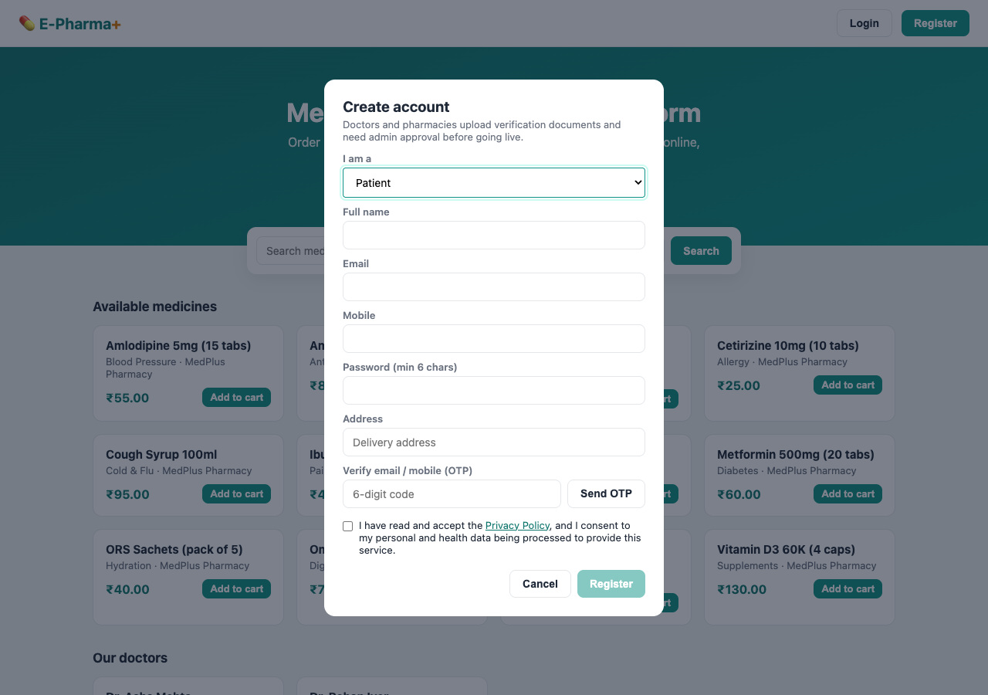
Figure A1 — Consent at registration: unticked by default, with the Register button disabled until it is accepted
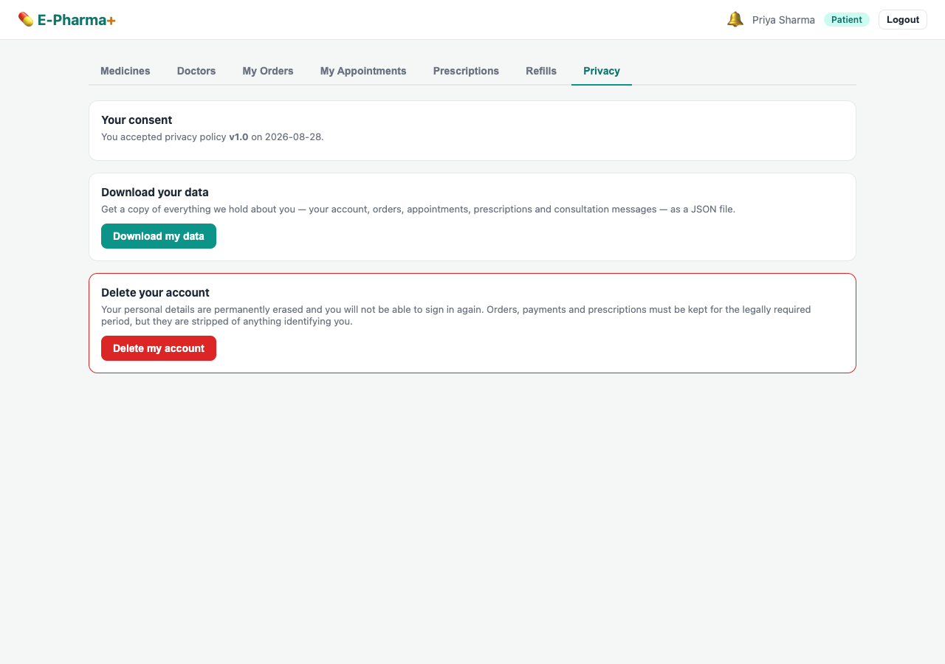
Figure A2 — Privacy area: the consent on record, a download of all personal data, and account deletion
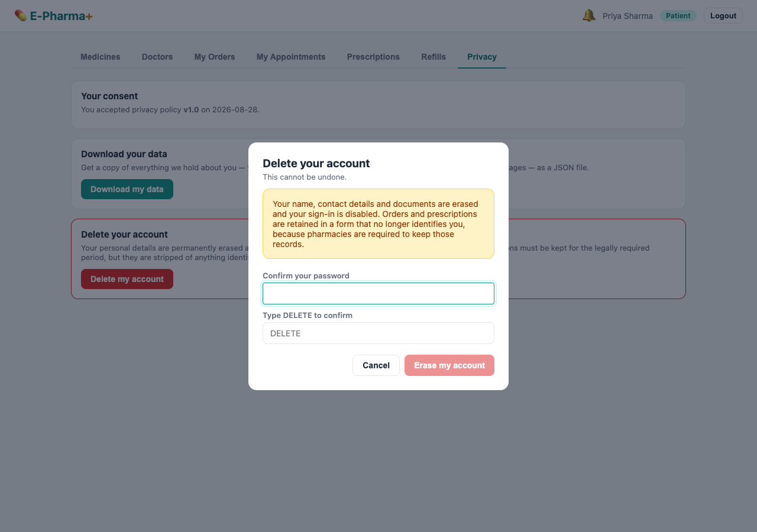
Figure A3 — Erasure confirmation: states plainly what is deleted and what must be retained, and requires the password plus a typed confirmation
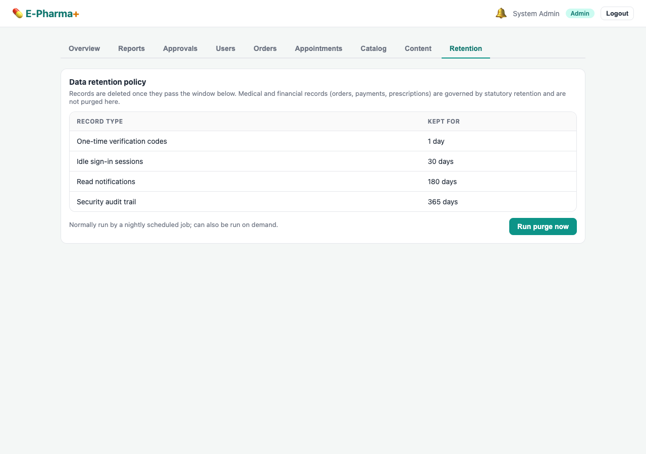
Figure A4 — Administrator view of the data-retention policy, with the purge that enforces it

Appendix B — Representative Code
Extracts from the project source showing how the decisions above are implemented.
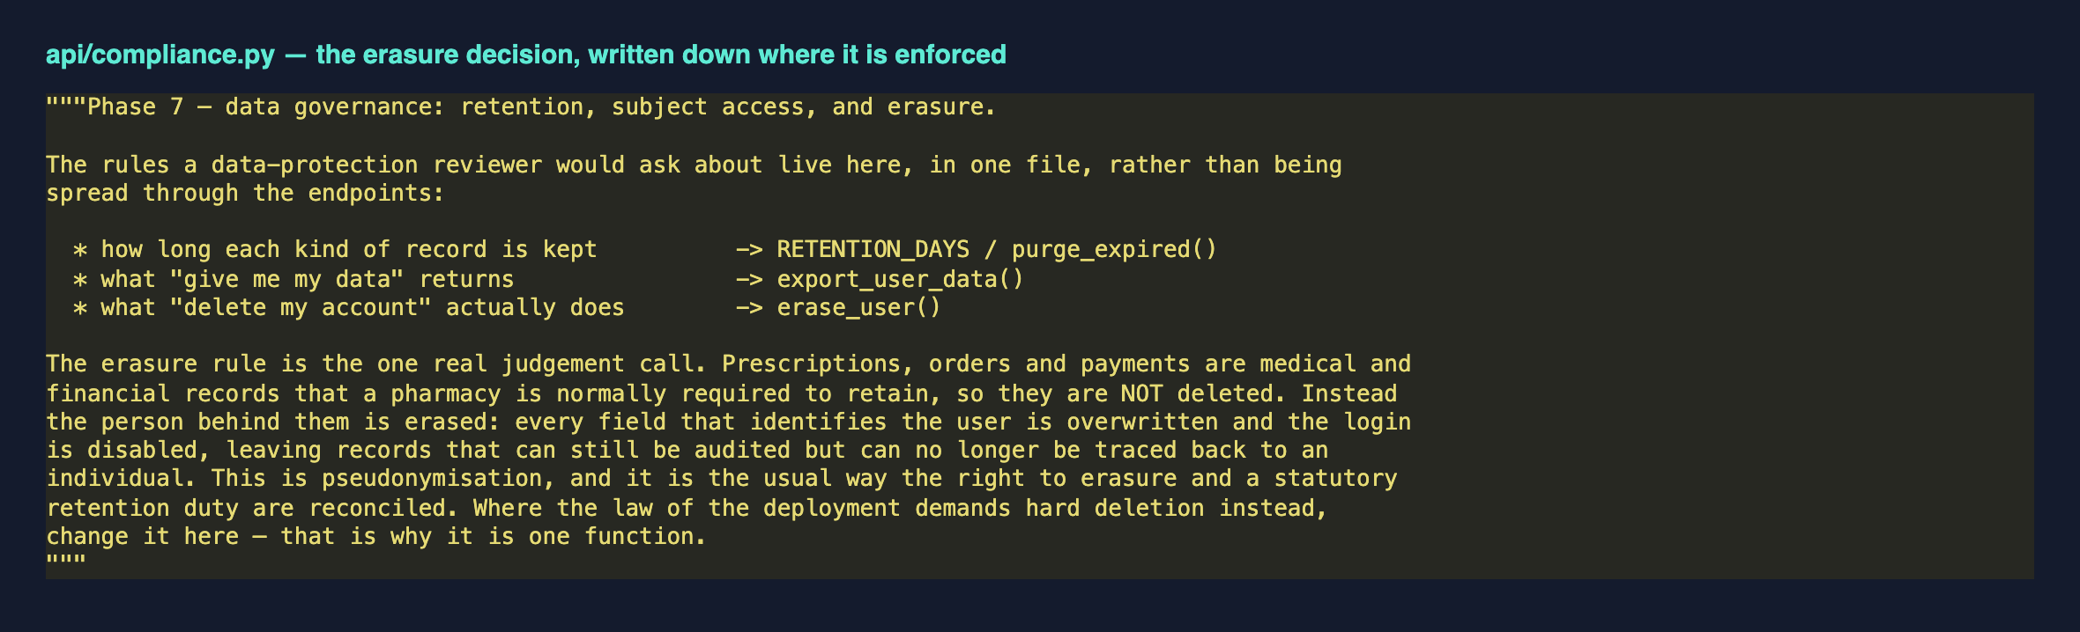
Figure B1 — The erasure decision is documented in the same file that enforces it, so the reasoning cannot drift from the behaviour
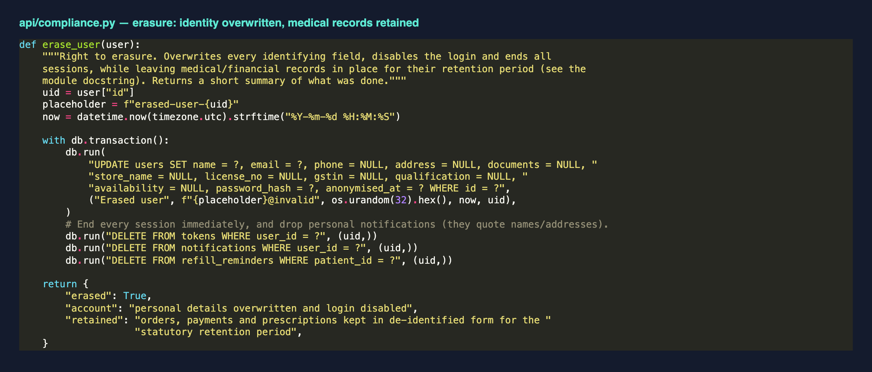
Figure B2 — Erasure in practice: identifying fields overwritten and sessions ended, inside a transaction
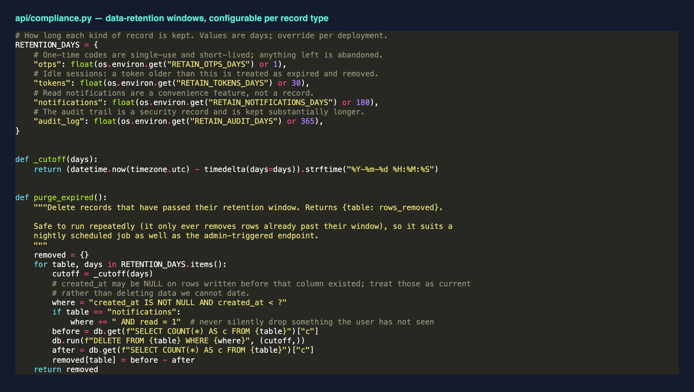
Figure B3 — Retention windows are configurable per record type, and the purge only ever removes records already past their window

