Weekly Status Report
E-Pharma Management System — Phase 9: Deployment & Documentation
Field | Detail
Prepared by | Jainish Nikul Shah, Software Engineer
Project | Techmentee — E-Pharma Management System
Project Coordinator | Vaishali Pujari
Reporting period | 7 September 2026 – 13 September 2026
Report date | 11 September 2026
Phase | Phase 9 — Deployment & Documentation
Status | Completed

1. Summary
The production deployment package — the container image and the compose stack that runs the application alongside PostgreSQL — was written in Phase 6 but had never actually been run. This phase ran it end to end, and that immediately found three defects that no amount of testing on a developer machine could have exposed.
The most serious: a routine database restart left the application broken until someone noticed and restarted it by hand, while the container platform continued to report it as healthy. All three defects are fixed and verified on the real stack, and a new deployment verification script now fails if any of them returns.
The documentation set — operations runbook, deployment runbook, handover, README and configuration template — was brought in line with the deployed system.

2. Work completed

2.1 The production stack, run for the first time
The image was built and the stack started exactly as shipped, with generated secrets and PostgreSQL. It started, served the application and passed the smoke test — which is precisely why the defects below had gone unnoticed: none of them shows up in a stack that is simply started and looked at.

2.2 Three deployment defects, each reproduced before it was fixed
Defect | Effect | Fix
The worker count could not be tuned | The documented setting (WEB_CONCURRENCY) was overridden by a value hard-coded in the image. Asking for six workers produced three. | The image now sets only the variable, so it takes effect.
Settings never reached the application | The compose file forwards only the settings it names, and every setting added since Phase 6 was missing — rate limits, proxy trust, retention and key rotation. Behind a proxy, all users shared one rate-limit allowance: 13 of 40 different users were refused. | Every setting is now passed through. Proxy trust still defaults to off, the safe choice, and the go-live checklist says when to turn it on.
A database restart was a permanent outage | After PostgreSQL restarted, every request failed indefinitely — and the platform still reported the container healthy, so it was never restarted automatically. | The connection is opened when first needed and reopened when the database drops it. Recovery now takes about five seconds, with no restart.

2.3 Deployment verification
A new script builds the production stack and checks thirteen properties that the existing read-only smoke test cannot see: the worker count follows its setting, every configuration setting reaches the application, rate limiting treats different users behind a proxy separately while still limiting an abusive one, the application recovers from a database restart, and it starts on an empty database with no database running at all, then sets itself up once one appears. It uses its own throwaway secrets and removes everything it created.

2.4 PostgreSQL test runs
The automated suite now runs cleanly against PostgreSQL, twice in succession on the same database — the first real confirmation of the automatic database reset added in the previous phase. The first attempt found a fault in the test suite itself: two helper servers were writing into the main test database, so the suite counted nine orders instead of one. The helpers now use their own storage. All 106 checks pass on both SQLite and PostgreSQL.

2.5 Documentation
- The operations runbook describes the fixed behaviour, with new troubleshooting entries for the three defects and an extended go-live checklist.
- The deployment runbook documents the worker setting, and the rule that the compose file passes only the settings it lists.
- The configuration template now lists every setting the application reads, which the verification script checks against the compose file.
- The handover, README and development plan reflect the deployment and verification tooling.

3. The defect that mattered most
Databases restart: for maintenance, for a provider’s security patch, or during a failover. It is routine, and an application is expected to ride through it.
This one did not. It opened its database connection once, when it started, and never checked it again. After a restart that connection was dead, and every request failed from then on. The health check correctly reported the problem — but the container platform’s own status still read healthy, and the platform only restarts containers that stop, not ones that report themselves unwell. The result was an outage with no automatic recovery, lasting until someone noticed and intervened by hand.
The same design meant the application could not start at all if the database was briefly unavailable, so it could not even report that it was waiting.
The fix is small and contained to the data layer. The connection is opened when first needed; if the database has dropped it, the next request opens a fresh one. A worker now starts without a database, answers health checks with the reason it is unavailable, and completes its set-up the moment the database appears. Recovery from a restart was measured at about five seconds.

4. Proving the verification works
A check that has only ever passed proves nothing — it may simply be unable to fail. So the verification script was also run against a copy of the project with two of the fixes deliberately undone. It failed exactly the three checks those fixes cover, still passed the ten that were unaffected, and reported failure. It detects a regression and does not raise false alarms.

5. Results
Check | Before | After
Worker count follows its setting | Asked for 6, ran 3 | Asked for 4, runs 4
40 different users behind a proxy | 13 refused | None refused
One abusive client behind a proxy | Limited | Still limited
Database restart | Permanent failure; reported healthy | Recovers in ~5 s, no restart
Start with no database | Worker failed to start | Starts, reports 503, sets itself up
Deployment verification | Did not exist | 13 of 13 pass
Automated suite | 106 on SQLite; PostgreSQL unverified | 106 on SQLite and PostgreSQL

6. What remains
Phase 10 (14–17 September) is the final demonstration and handover.
Three items from the project workflow document have not been built: role and permission management for the administrator, consent-gated access for a doctor to a patient’s history, and choosing a pharmacy by location or price. With four days left they need a decision on whether they are in scope for handover or recorded as recommended next work.
Decisions still needed from the business rather than from engineering: the hosting environment and managed PostgreSQL instance, which payment provider to license, and which SMS or email provider to use. Each is a configuration change; the application is ready for all of them.

Appendix A — Evidence
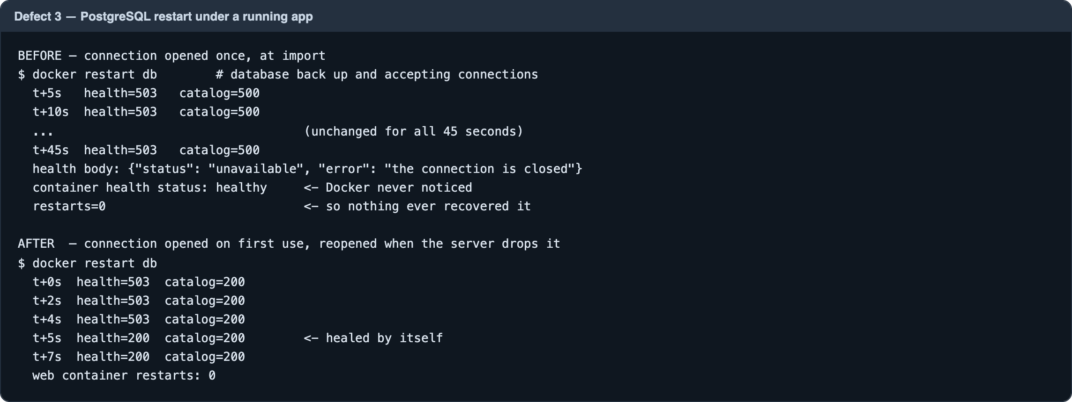
Figure A1 — A database restart: permanent failure before the fix, self-recovery in about five seconds after
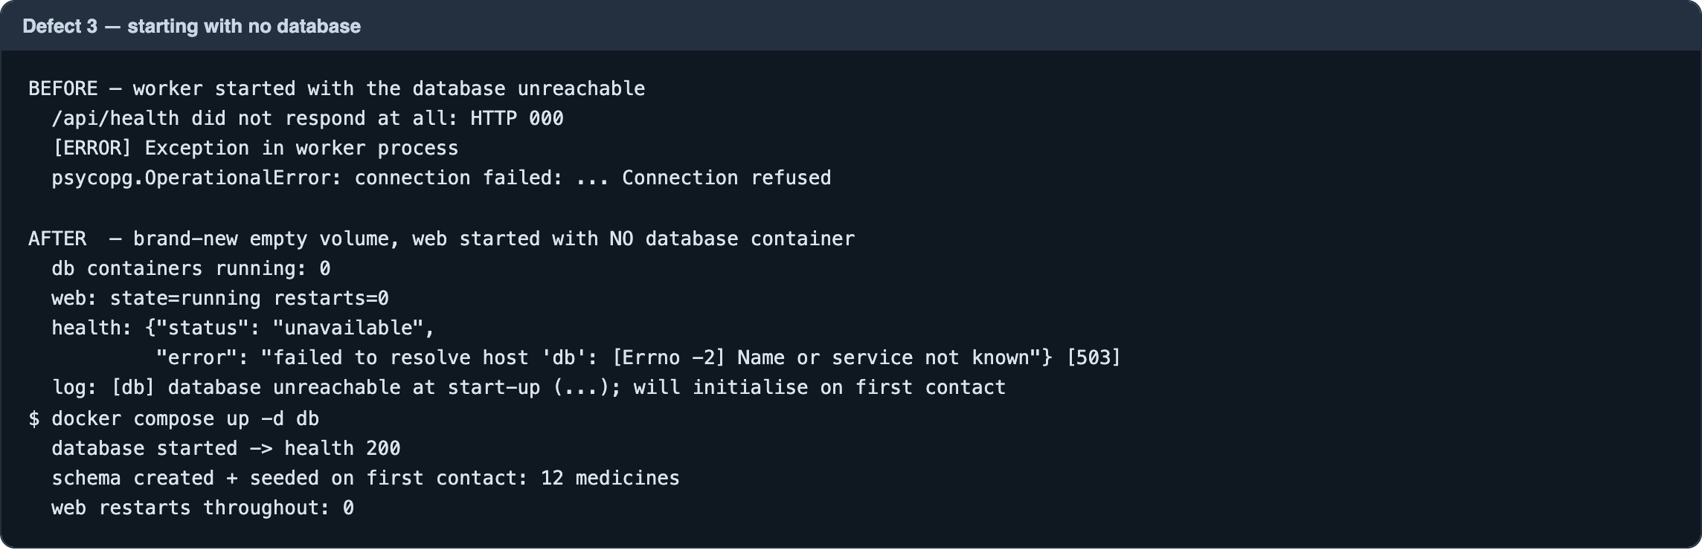
Figure A2 — Starting with no database: the worker used to die; it now reports 503 and sets itself up when the database appears
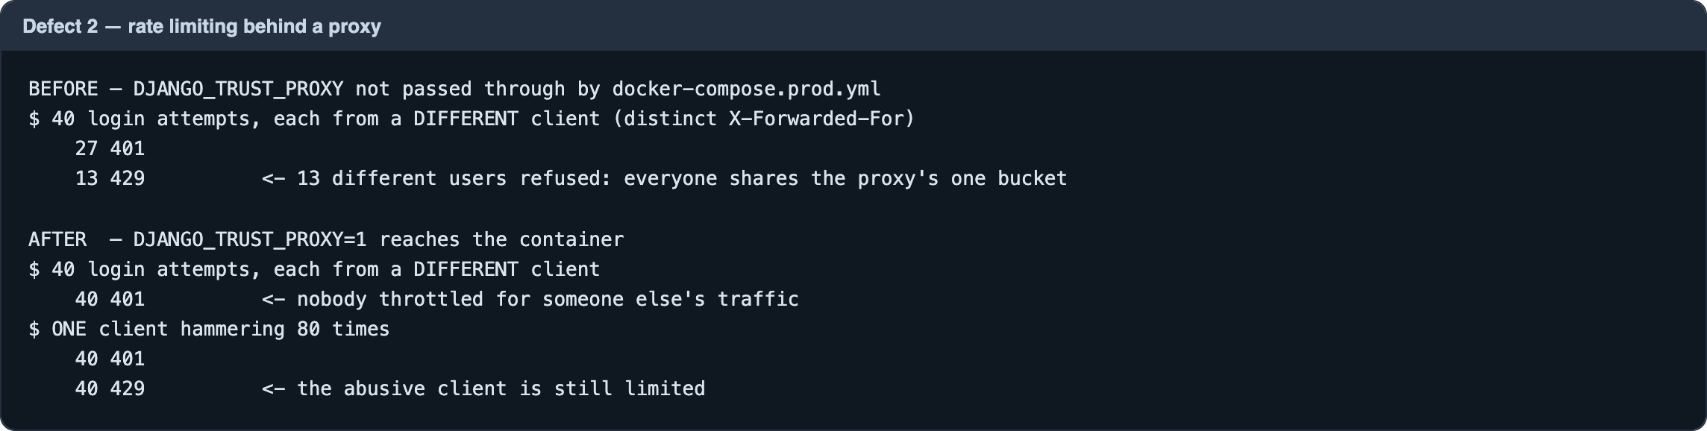
Figure A3 — Rate limiting behind a proxy: shared by everyone before, per client after
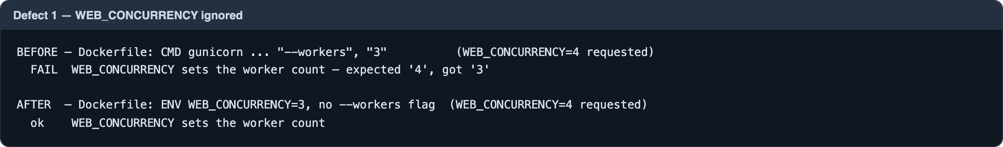
Figure A4 — The worker-count setting, ignored before and honoured after
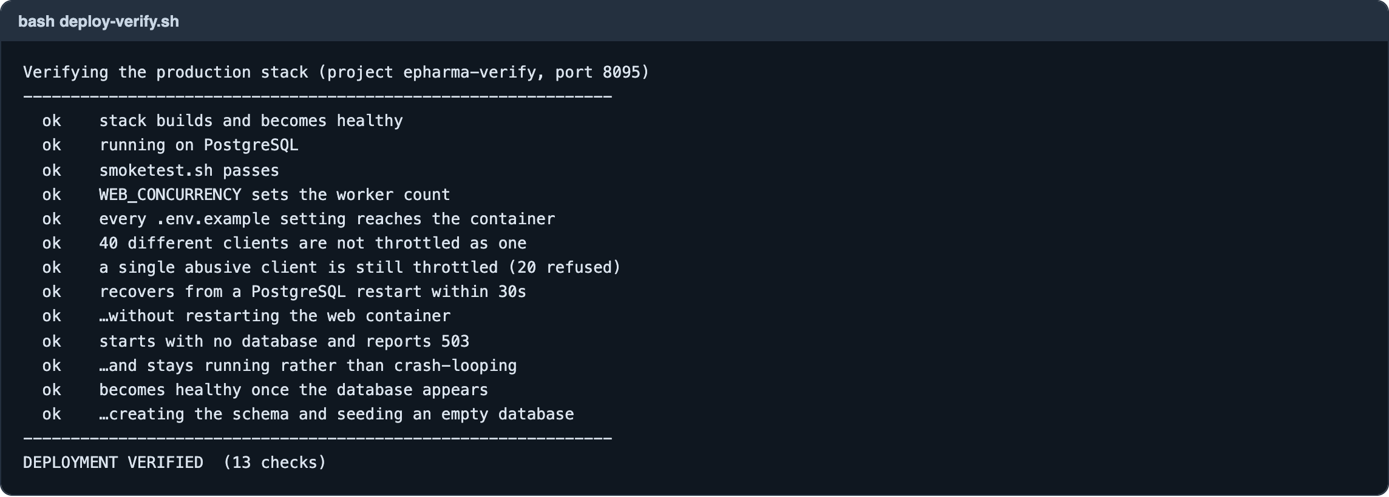
Figure A5 — The deployment verification script: 13 of 13 checks pass
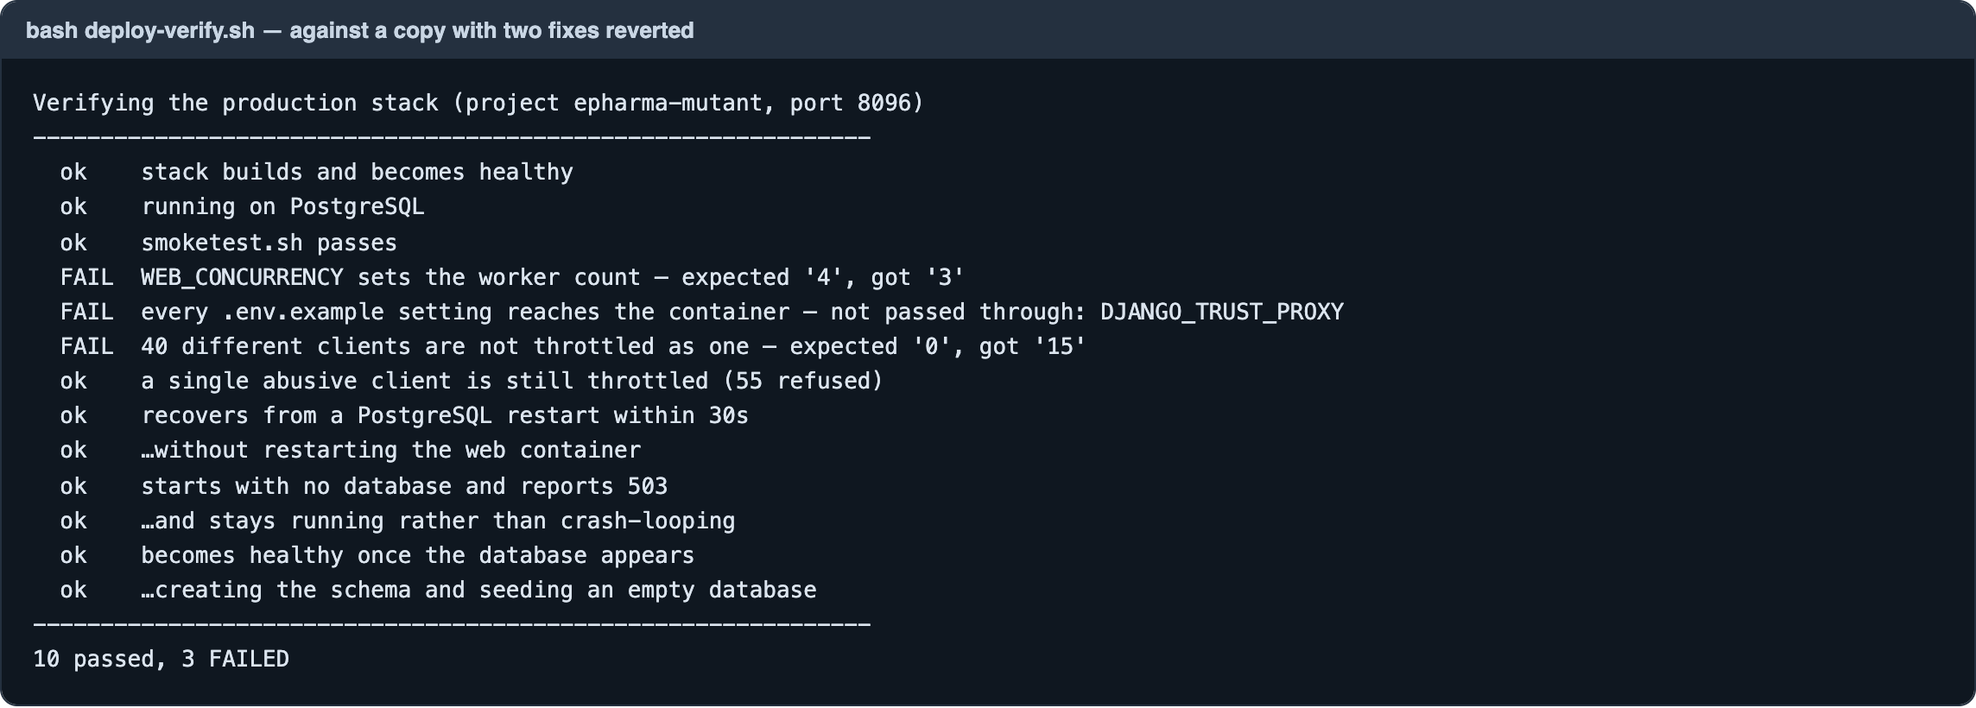
Figure A6 — The same script against a copy with two fixes undone: exactly the three affected checks fail
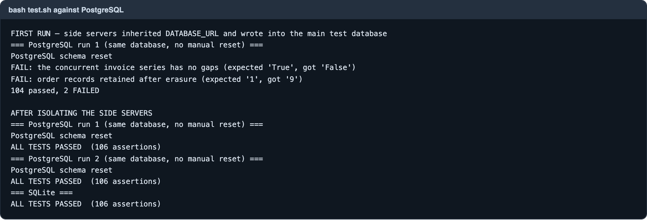
Figure A7 — The automated suite on PostgreSQL: the test-isolation fault, then two clean consecutive runs

Appendix B — The code
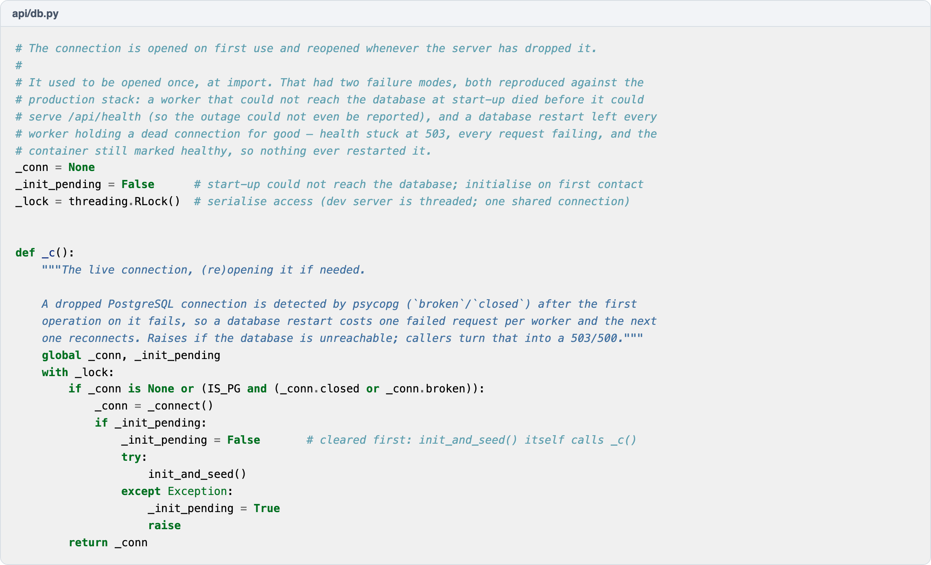
Figure B1 — The database connection, opened on first use and reopened when dropped
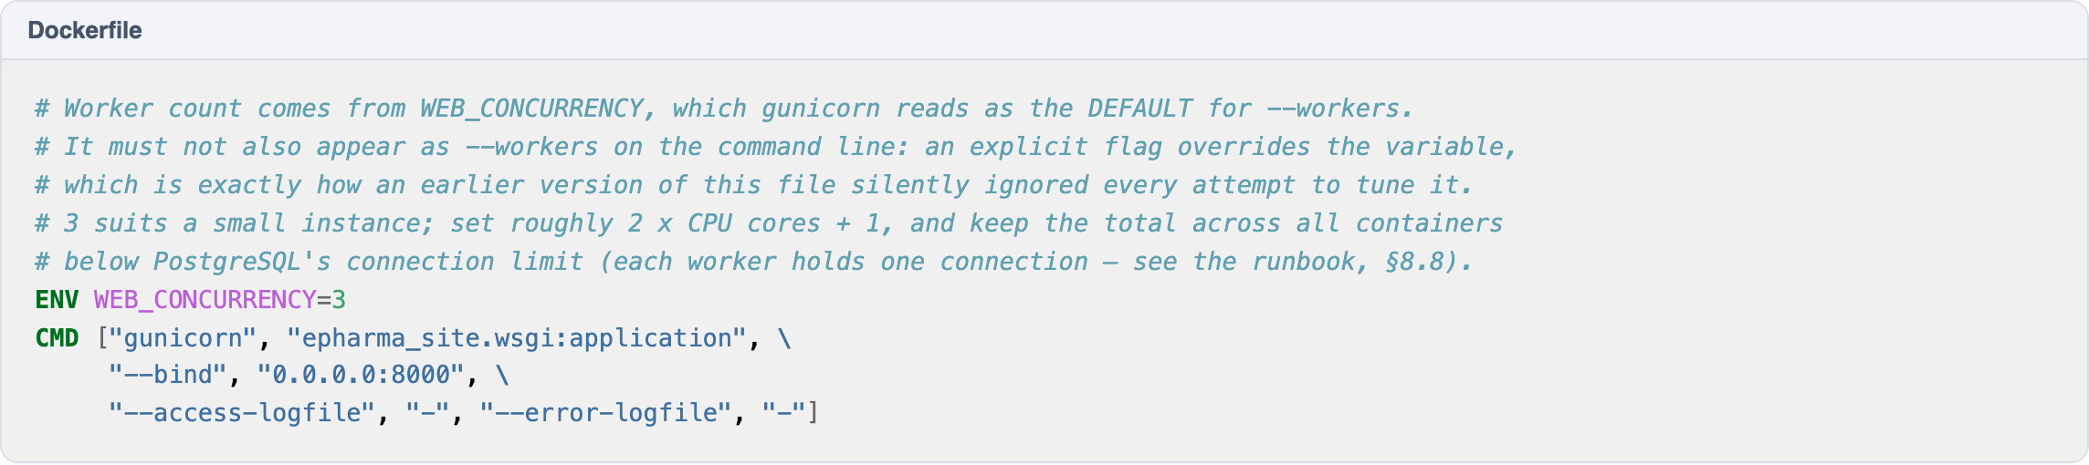
Figure B2 — The worker count taken from its setting, and why no command-line flag may override it
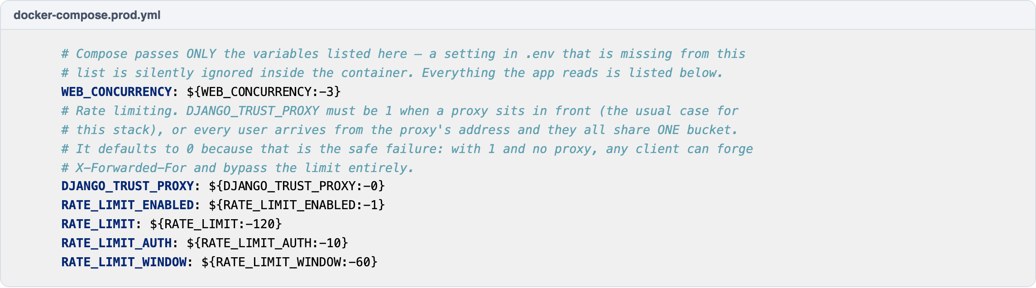
Figure B3 — Every setting passed through to the application, with the proxy-trust default explained

