Weekly Status Report
E-Pharma Management System — Phase 8: Testing & Reliability
Field | Detail
Prepared by | Jainish Nikul Shah, Software Engineer
Project | Techmentee — E-Pharma Management System
Project Coordinator | Vaishali Pujari
Reporting period | 31 August 2026 – 6 September 2026
Report date | 6 September 2026
Phase | Phase 8 — Testing & Reliability
Status | Completed

1. Summary
This was the testing phase. The application had been built and verified feature by feature, but it had never been put under concurrent load, and it had no protection against a client sending more requests than it should. Both gaps are now closed, and the whole system is documented in a single operations runbook.
Load testing paid for itself immediately. It exposed a defect on the payment path that no feature test could have found: under concurrent checkout across worker processes, 26 of 60 orders failed with an internal server error — after the customer had already paid. That is fixed, and a test now fails if it returns.
The automated suite grew from 65 to 106 assertions and was reworked so a run reports every failure instead of stopping at the first one. The fulfilment and billing features delivered earlier in the same week are summarised in section 5.

2. Testing and load work

2.1 Load and concurrency testing
- A Locust suite with four user profiles: anonymous browsing, a signed-in patient including the full paid-checkout path, a pharmacy working its order queue, and a no-think-time client used to find the ceiling.
- Three scenarios — realistic traffic with human pauses, saturation to find the throughput ceiling, and an abusive client to prove excess load is refused rather than allowed to degrade the service for everyone else.
- A separate database contention test that measures how throughput scales with worker processes, exercises concurrent checkout, and shows what happens when the database refuses a connection.

2.2 Test suite hardening
- The suite aborted at the first failed assertion, so each run reported one problem at a time — fix, wait, find the next. It now records every outcome and lists all failures together at the end, exiting non-zero if any failed.
- Six endpoints had no coverage at all. The important one was logout: nothing was checking that signing out actually ends the session, which is a security path — a token that outlives its logout is a defect no other test would have caught.
- Two assertions addressed seeded records by hard-coded database id. A change to the seed order would have pointed them at different records and they would still have passed. Both now look the record up by name or role.
- A PostgreSQL run left data behind, so a second run failed and the documentation told the reader to drop the database by hand. The suite now resets the schema itself.
- Invoice numbering under simultaneous checkout was proved by hand when it was written and then left unguarded; it is now a standing assertion.

2.3 Request rate limiting
- Every API route is rate limited per client, in two tiers: login, registration and account deletion get a tight allowance, because those are the endpoints an attacker brute-forces; everything else gets a general allowance.
- A refused request returns 429 with a JSON body, a Retry-After header and the standard rate-limit headers, so a well-behaved client can slow down before it is refused rather than after.
- Health checks are never rate limited. A throttled health check makes a load balancer pull a healthy server out of rotation, turning a traffic spike into an outage.
- The client address is taken from the connection unless the application is explicitly told it sits behind a trusted proxy. Trusting the forwarded header by default would let anyone forge a new identity on every request and bypass the limit entirely.

2.4 Operations runbook
A single end-to-end document covering the system, how to start it, how to prove it works, the complete business flow across all four roles, administration, deployment, day-to-day operation, troubleshooting, recovery and decommissioning. Every command in it was run before it was written down.
Writing it surfaced that the three existing documents contradicted each other — the test suite was described as 45, 49 and 65 assertions in three different places, and the demo script opened with a command that had not existed since the backend moved to Python. Those are corrected.

3. The defect the load test found
Placing an order is the application’s most careful path: it verifies the payment, decrements stock, recomputes the total to reject a tampered cart, and reserves a tax-invoice serial — all inside one database transaction.
That transaction was opened in deferred mode. A deferred transaction takes a read lock and upgrades to a write lock on its first write. SQLite deliberately does not apply its busy timeout to that upgrade, because waiting there can deadlock — so when two workers checked out at the same moment, the second failed instantly with "database is locked" rather than waiting its turn. The customer saw an internal server error on a payment that had already been taken.
The fix is to take the write lock up front, where the busy timeout does apply. All three write paths — order placement, stock movements and account erasure — now do so. Sixty concurrent checkouts across four worker processes now all succeed.
This could only be found with real concurrency across processes. The development server funnels every request through one database connection behind one lock, so the contention never arises there, and the concurrency assertion already in the test suite ran against that server and could never have caught it. The regression guard therefore lives in the contention test, which runs a real multi-process server.

4. Trusting the measurements
Two defects in the test harness itself reported failures the application had not caused. Both are worth recording, because a load test that cries wolf is worse than no load test at all.
The first was worker readiness. Waiting for the health endpoint proves only that one worker has started — the server hands each connection to whichever worker accepts it first, so a warm-up can be answered entirely by workers already running while a sibling is still starting. Measuring through that window reported thousands of application failures that were really start-up. The check now sends a burst wider than the worker count in parallel and requires two clean bursts in a row.
The second was subtler. The load generator itself ran out of local network ports, because the default server configuration closes every connection and each request therefore consumed a new one. That surfaced as up to 9,747 errors that look exactly like server failures and are not. The harness now uses connection reuse, which removes the artefact and does not change what is being measured.
The scaling table now also reports what failed, not merely how many, so a connection the server never accepted can no longer be mistaken for the application returning an error.

5. Features delivered earlier in the same week
Before the testing work, the three remaining items in the pharmacy side of the project workflow document were completed. They are summarised here for completeness; the testing above covers them.
Feature | What it does
GST tax invoices | Every paid order raises a tax invoice on a serial that is consecutive per pharmacy and reset each financial year. Medicine is sold at MRP, which already contains the tax, so the invoice extracts the CGST and SGST rather than adding them — the total is exactly what the customer paid. Printable to PDF from the browser.
Immutable invoice lines | The tax rate is stored on the order line alongside the price, so moving a product to another GST slab cannot rewrite an invoice that has already been issued.
Delivery assignment | A pharmacy assigns each delivery order to its own rider or to a partner courier. An order cannot be marked shipped until it has a carrier, and the patient is told who is holding it.
Stock in / out ledger | Every movement of stock is recorded with its reason, the resulting balance and who caused it. Restocking books a quantity and a reason instead of overwriting the level; a direct edit is still allowed but logged as an adjustment.

6. Measured results
Measurement | Result
Realistic load (60 users, think time) | 72 requests/second, 10 ms at the 95th percentile, zero failures
Throughput ceiling (saturation) | ~3,480 requests/second, 18 ms at the 95th percentile
Under rate limiting (abusive client) | Excess shed at ~3,365 requests/second, 7 ms — refusing load is cheaper than serving it
Worker scaling (1 / 2 / 4 / 8) | 1,580 / 2,810 / 3,470 / 3,515 requests/second, zero failures
Concurrent checkout | 60 of 60 succeed (was 34 of 60)
Automated assertions | 106, passing on both SQLite and PostgreSQL
Throughput nearly doubles from one worker to two and is flat by eight — beyond that point the machine’s processor cores, not the application, are the limit. Under realistic load the same setup is idling.

7. Known limitation, recorded not hidden
The database connection is opened when the application starts. A worker that cannot reach the database — which is exactly what running out of database connections looks like from the application’s side — therefore dies during start-up. It never reaches the health endpoint that exists to report this condition, so the health check does not answer at all rather than reporting the server as unhealthy, and the workers restart in a loop.
The consequence is that exhausting the database connection budget is a full outage rather than a graceful degradation. Until the connection is opened lazily and retried, the number of worker processes across all servers must be kept comfortably below the database’s connection limit. This is documented in the runbook together with the fix; it was left as a recorded decision rather than changed quietly, because it rewrites the layer every other part of the application depends on.

8. Plan for the coming week
Phase 9 (7–13 September) takes the remaining items from the project workflow document — role and permission management for the administrator, consent-gated access for a doctor to a patient’s history, and pharmacy selection by location or price — followed by final documentation, the demo and handover in the closing week.
Two decisions are still needed from the business rather than from engineering: which payment provider to license, and which SMS or email provider to use. Both are configuration switches; the code paths exist and are tested against mock providers.

Appendix A — Testing evidence
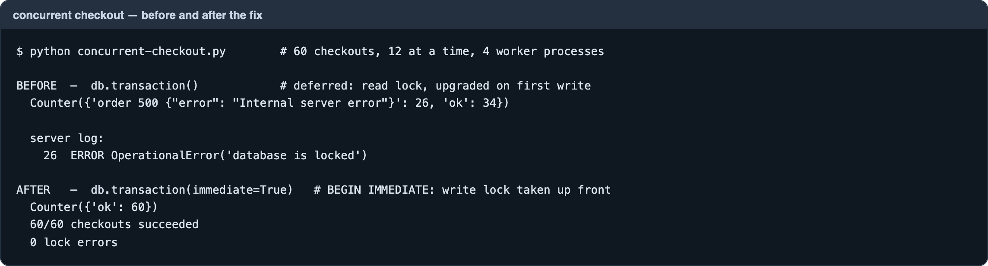
Figure A1 — The payment-path defect, before and after the fix
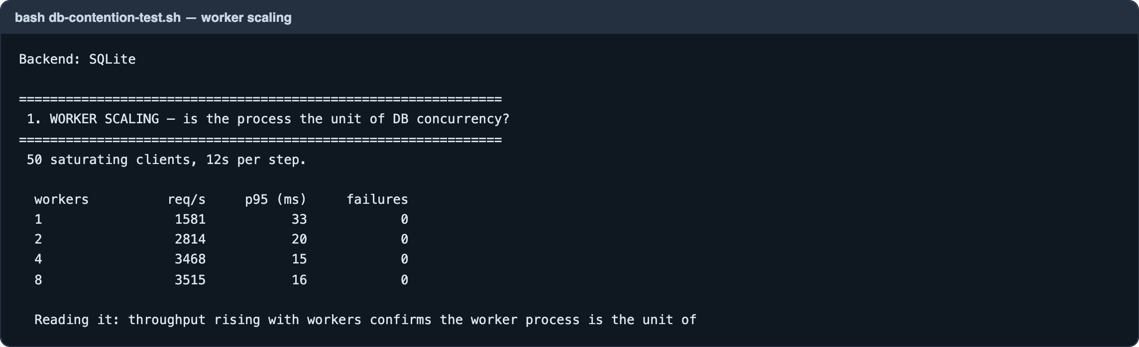
Figure A2 — Throughput against worker processes, zero failures at every step
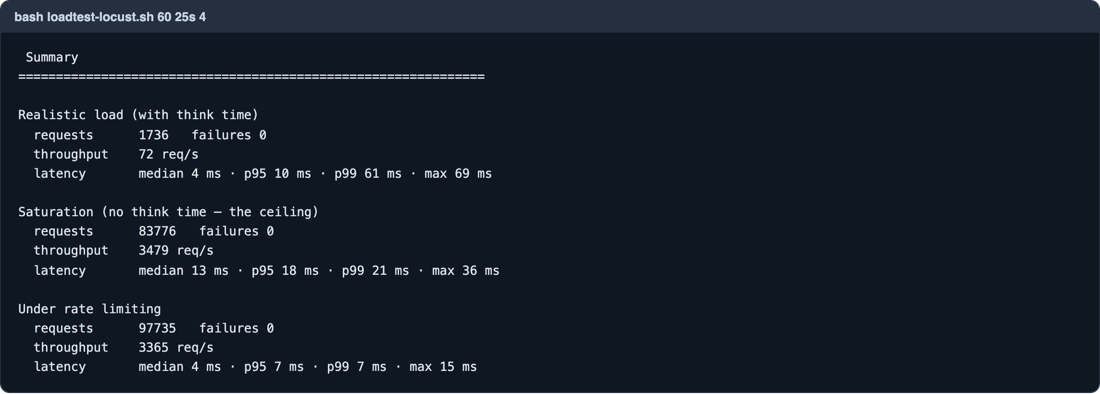
Figure A3 — Locust: realistic load, the saturation ceiling, and load shed under rate limiting
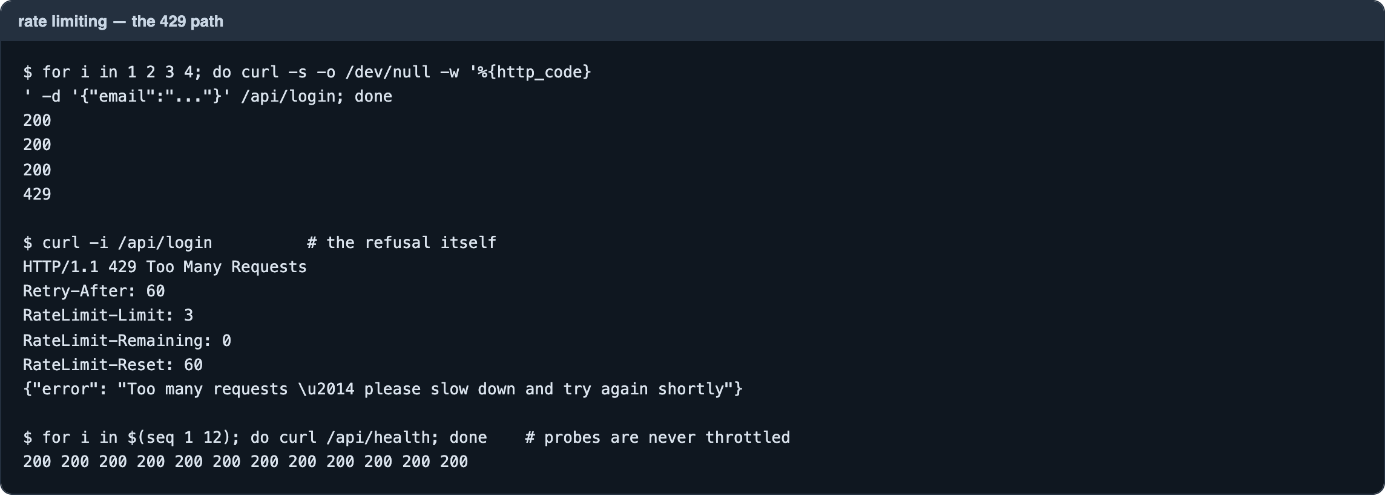
Figure A4 — The 429 path: three requests allowed, the fourth refused with Retry-After; health checks unaffected
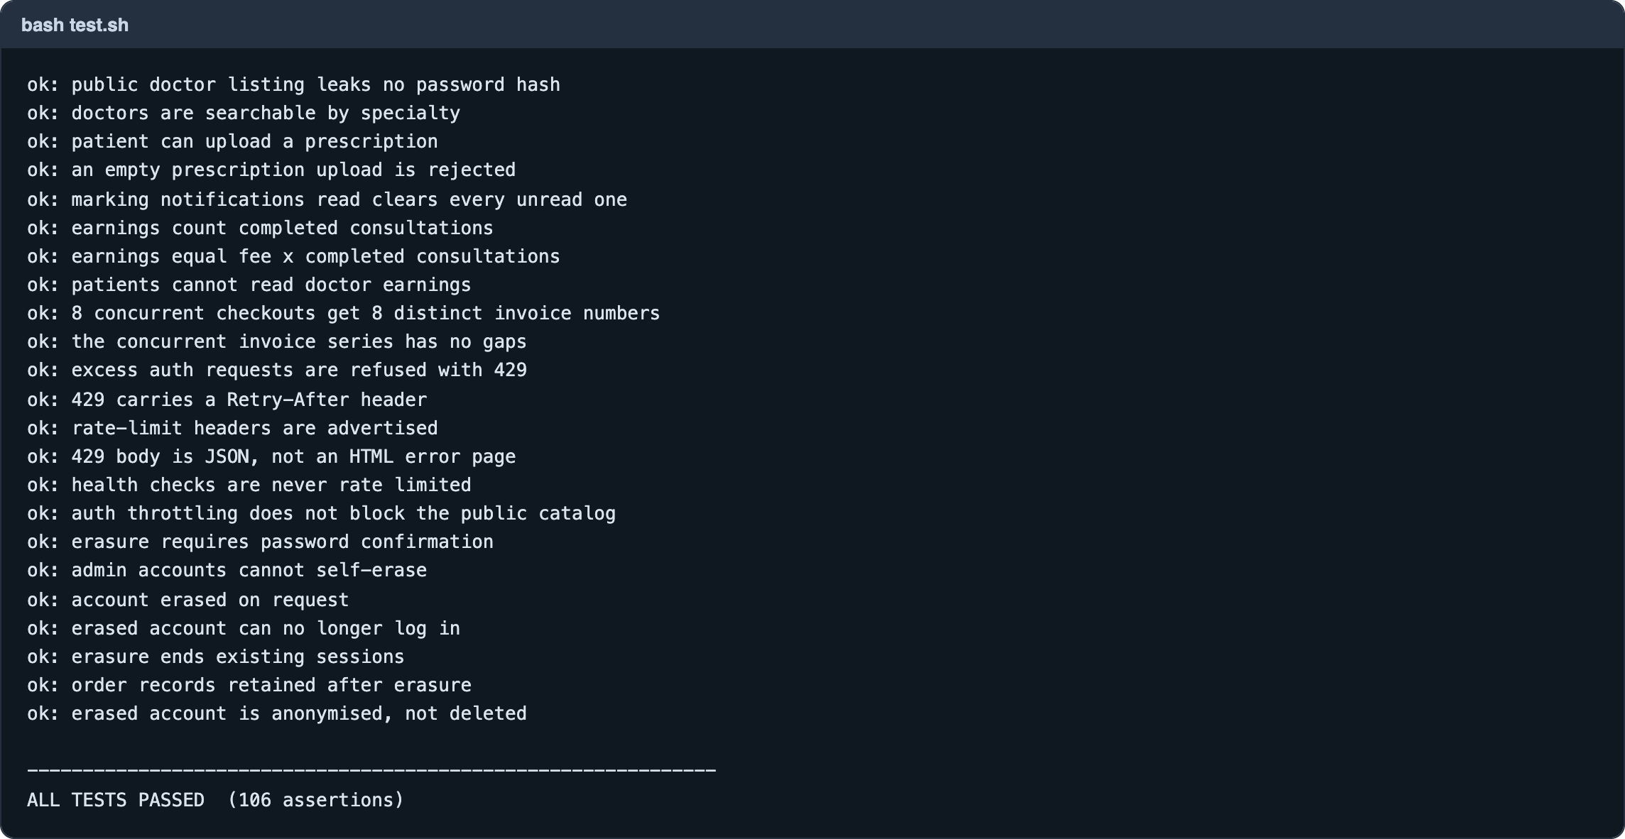
Figure A5 — The automated suite: 106 assertions
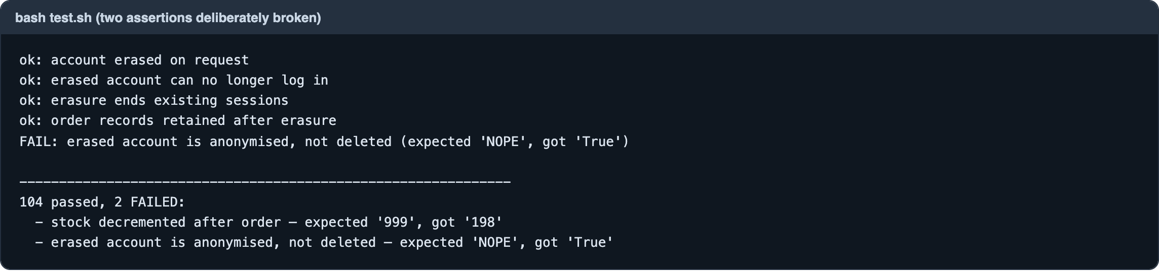
Figure A6 — With two assertions deliberately broken: both reported together, the run completes, exit status non-zero

Appendix B — Features delivered this week
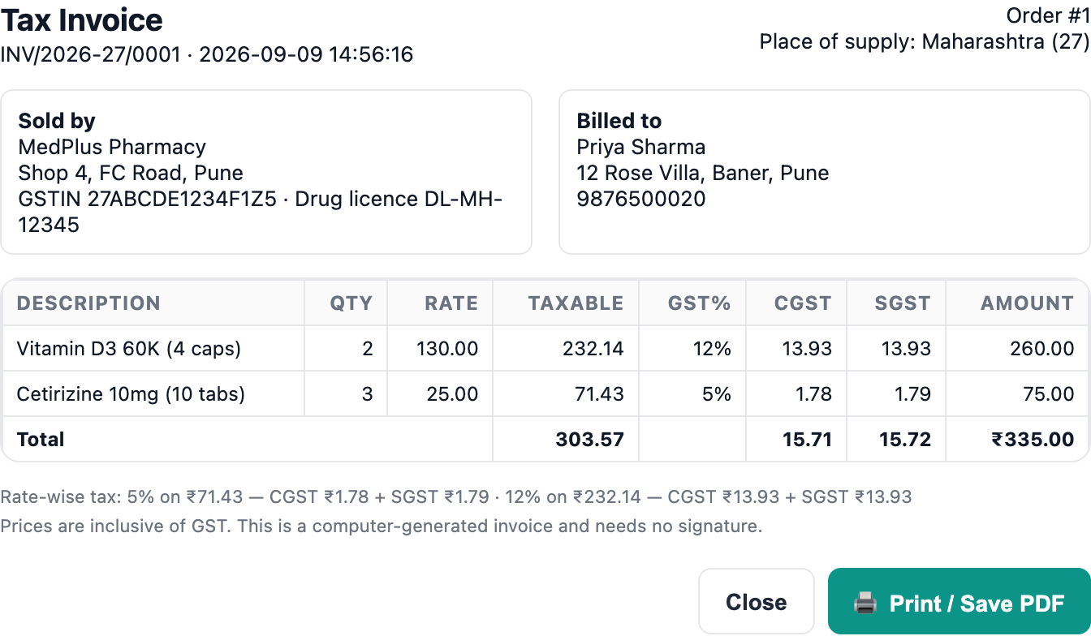
Figure B1 — The GST tax invoice: taxable value, CGST and SGST extracted from a GST-inclusive price
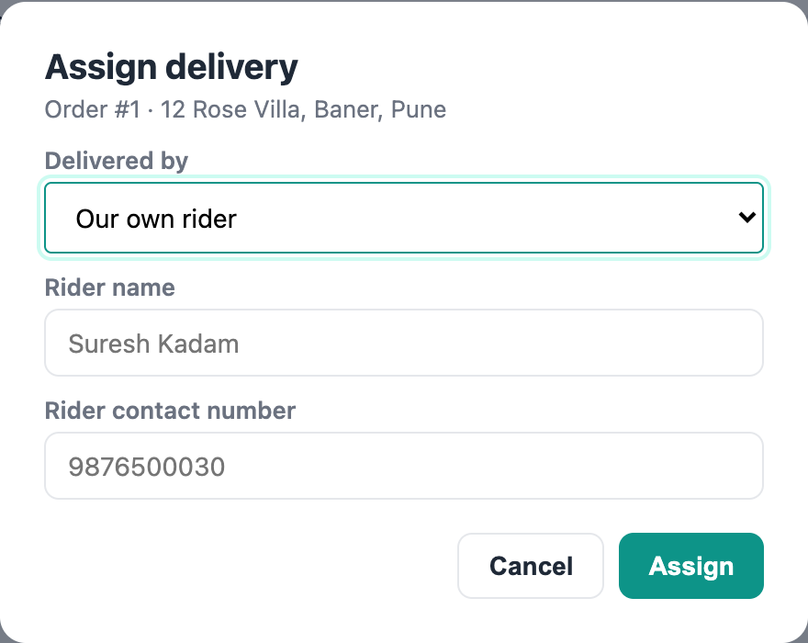
Figure B2 — Assigning an order to an own rider or a partner courier
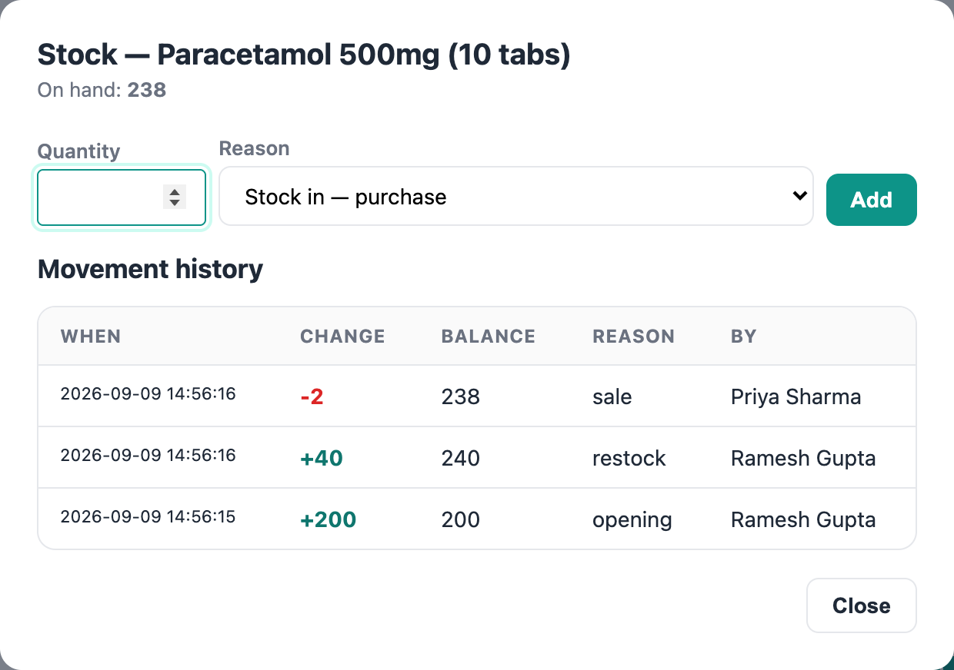
Figure B3 — Stock movement history: every change with its reason, balance and author

Appendix C — The code
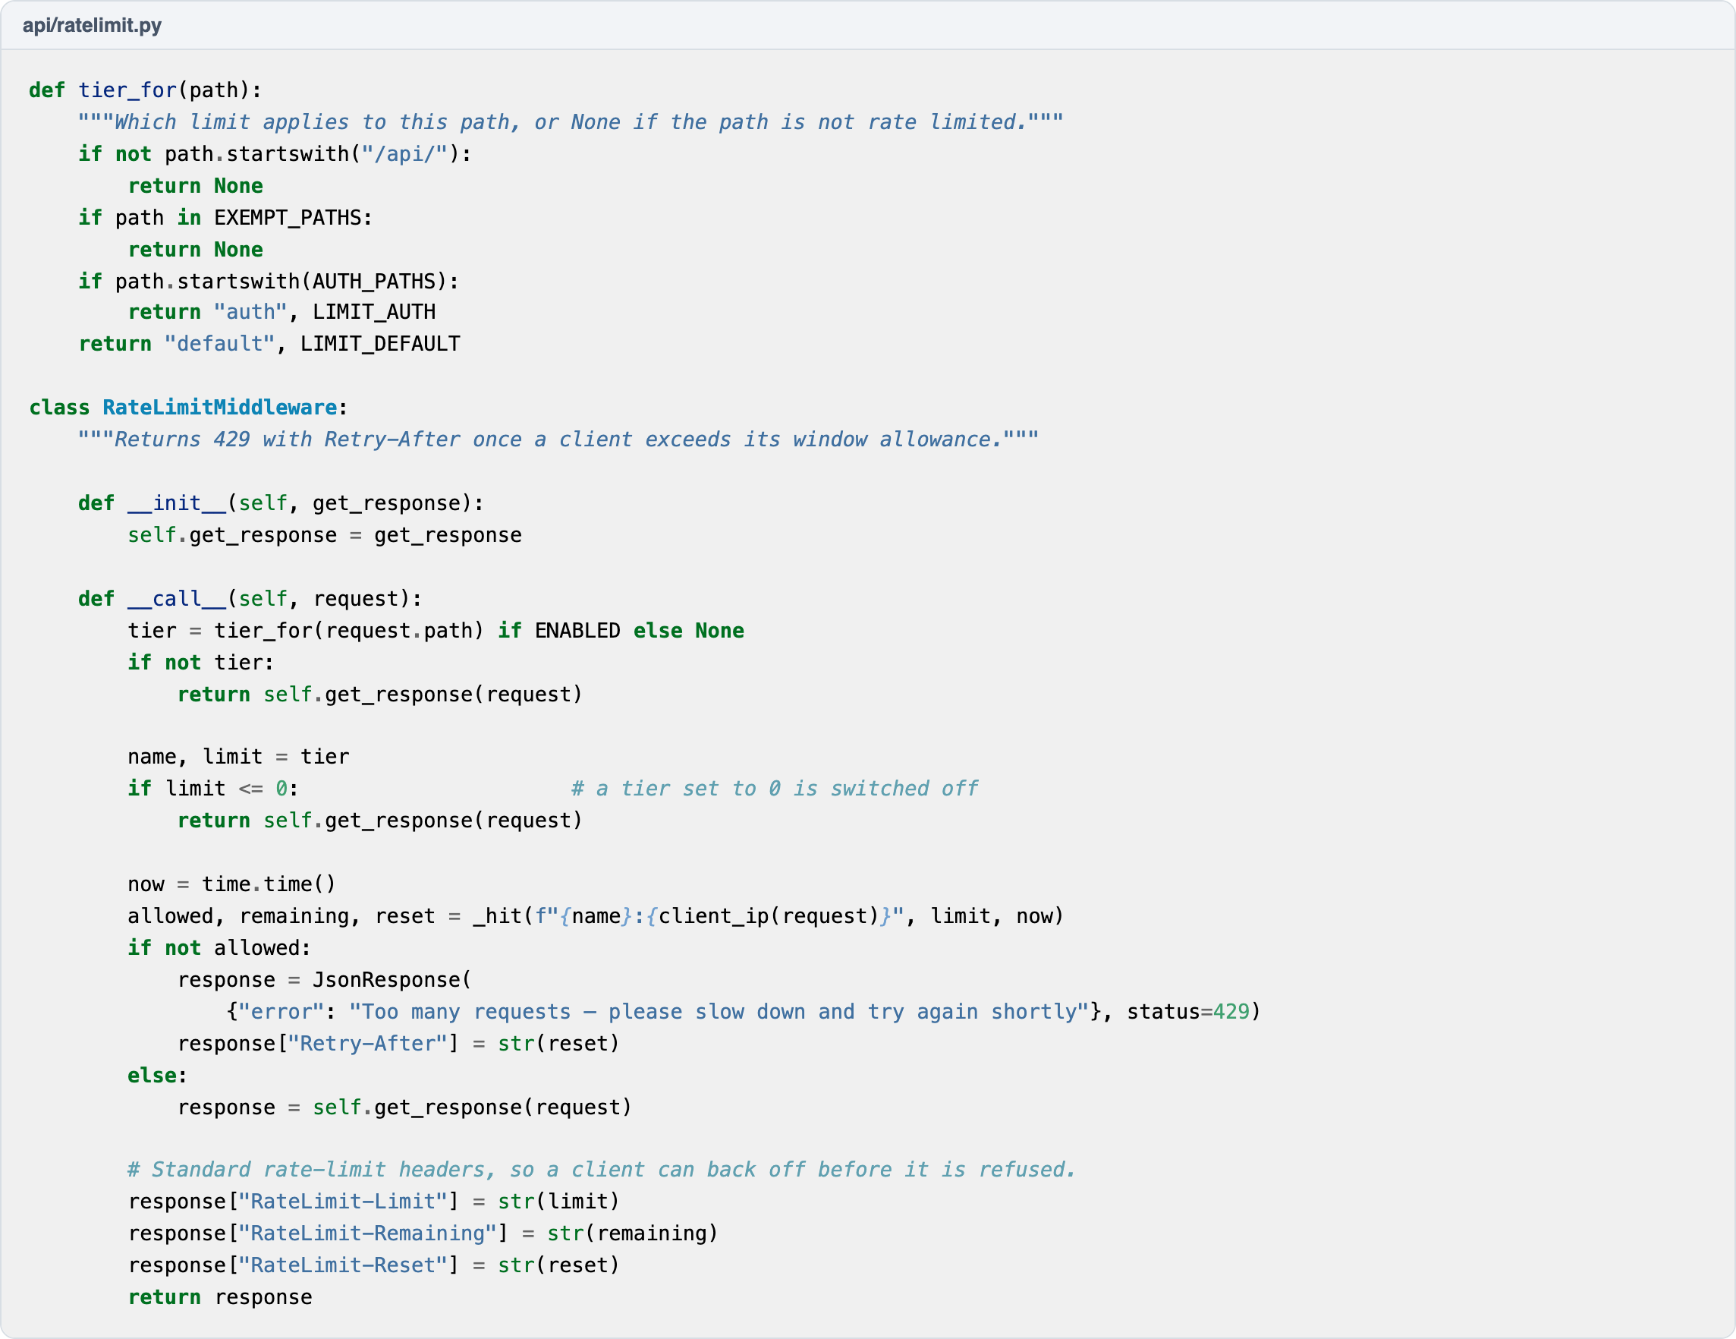
Figure C1 — Rate-limit tiers and the middleware that returns 429
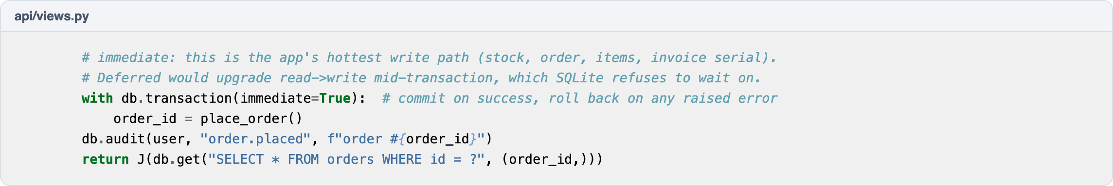
Figure C2 — Taking the write lock up front, and why
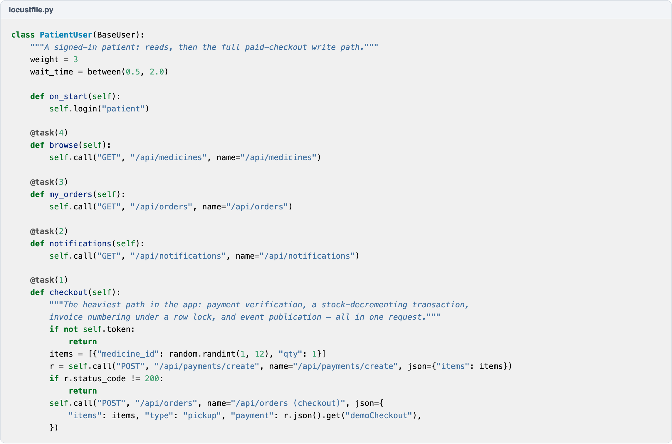
Figure C3 — The Locust patient profile, including the paid-checkout path
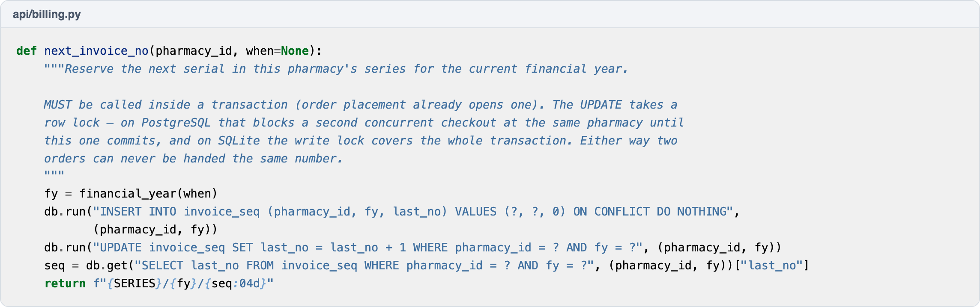
Figure C4 — The locked per-pharmacy invoice counter

