**E-R DIAGRAM**

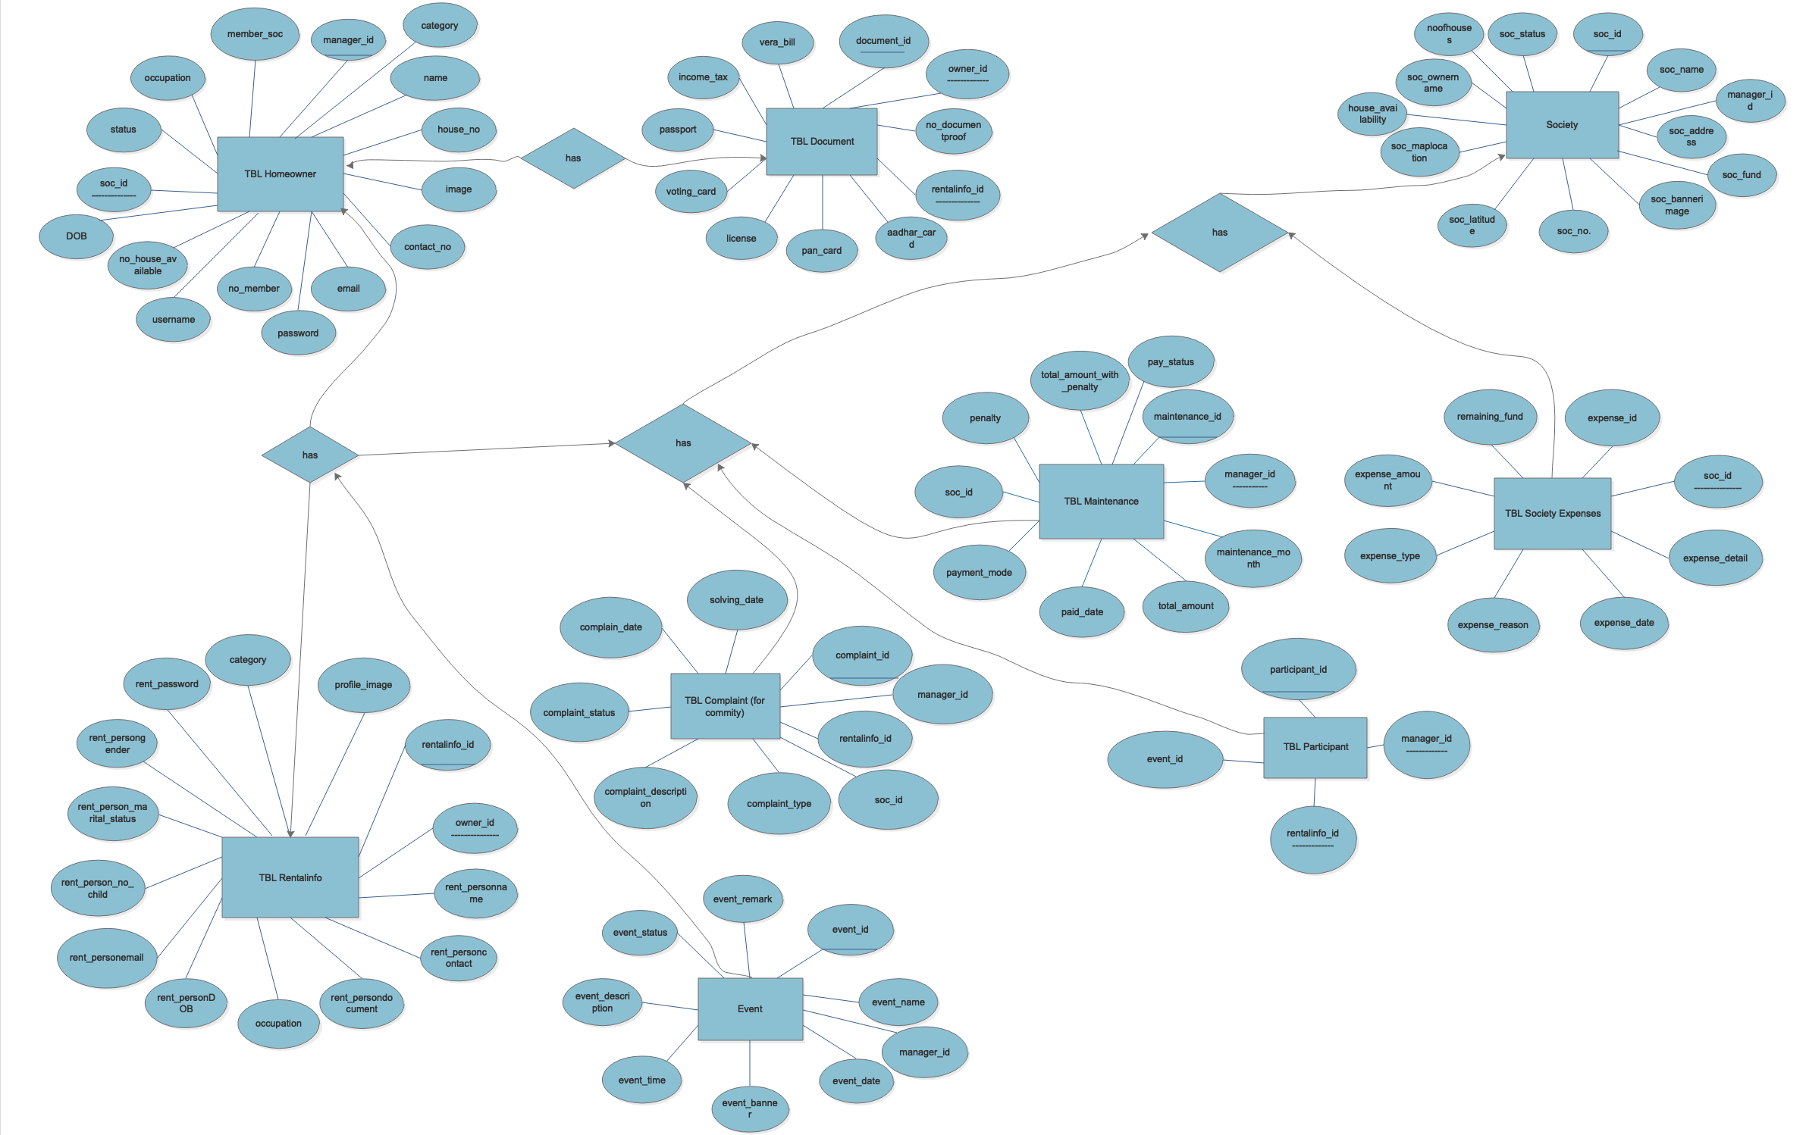

**FIGURE 1 [E-R DIAGRAM]**