1.find s algorithm:

Output:

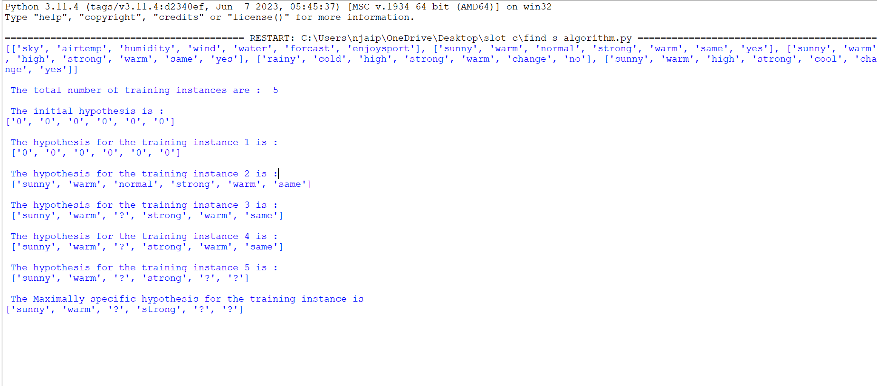

2.candidate elimination algorithm:

Output:

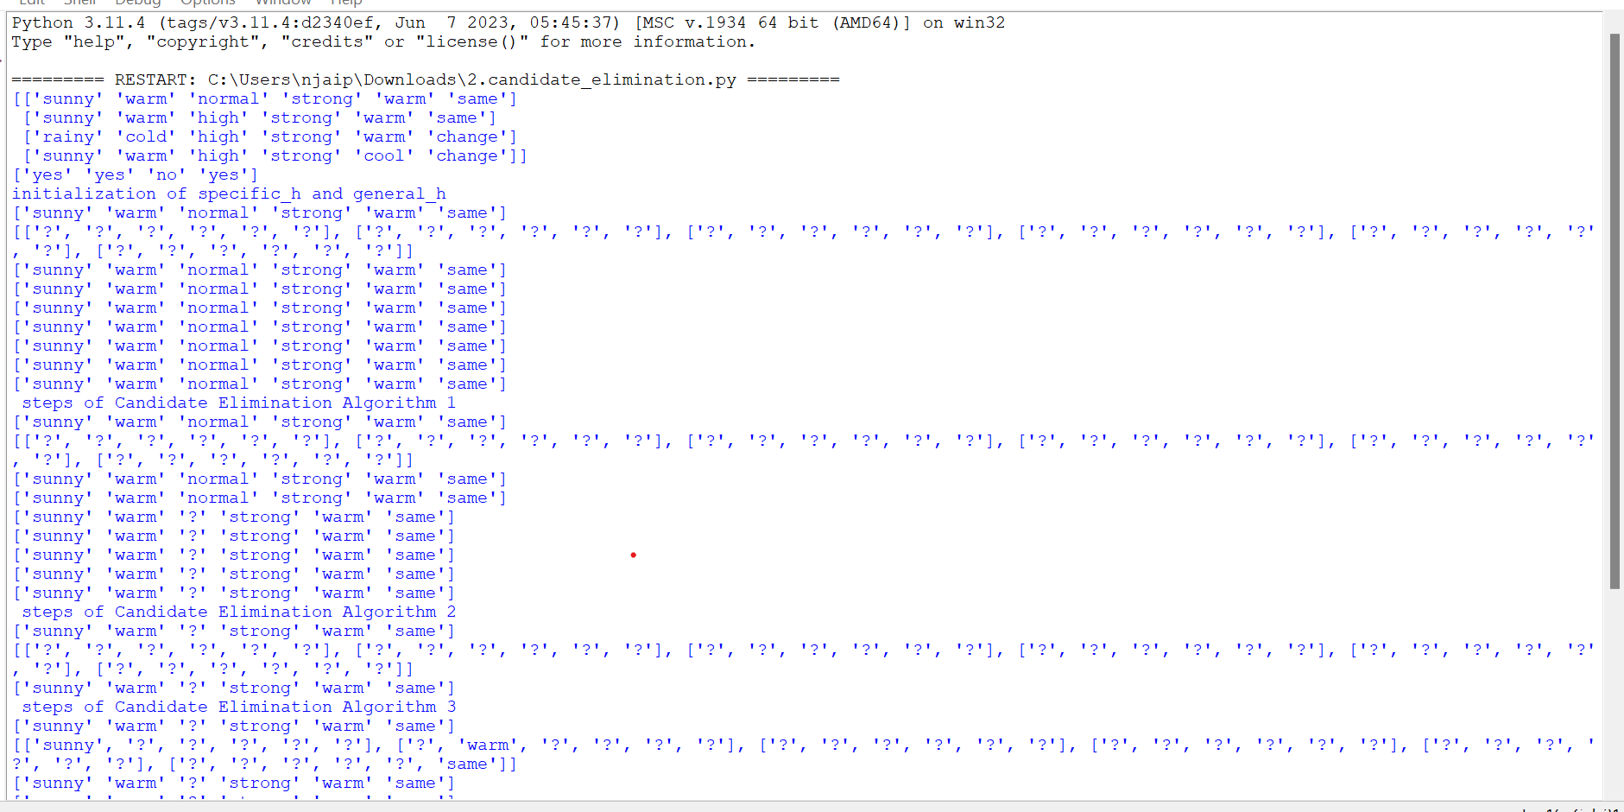

3. ID3 algorithm:

Output:

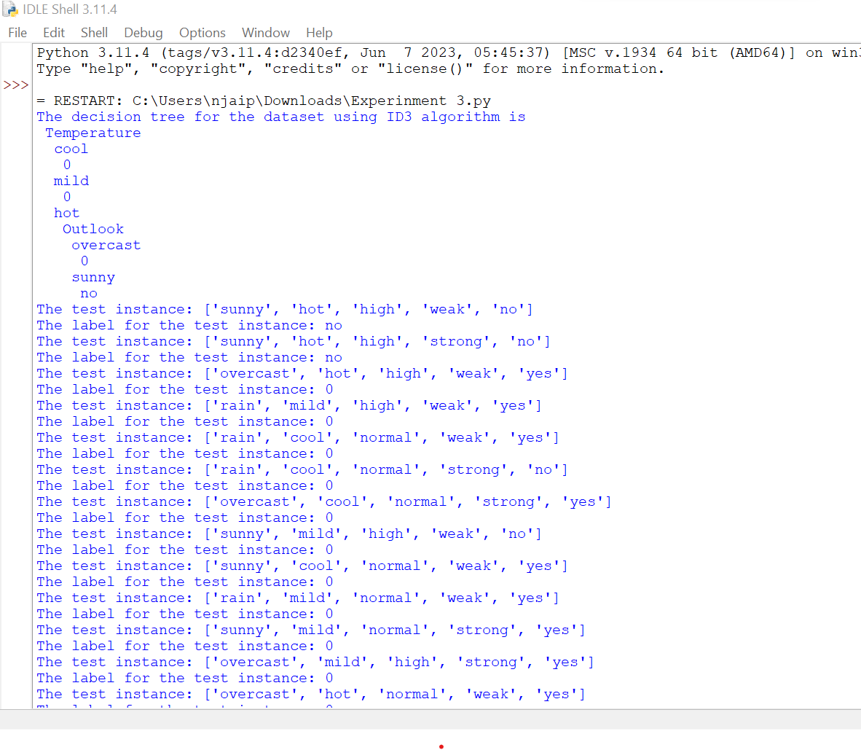

4.Back propagation algorithm:

Output:

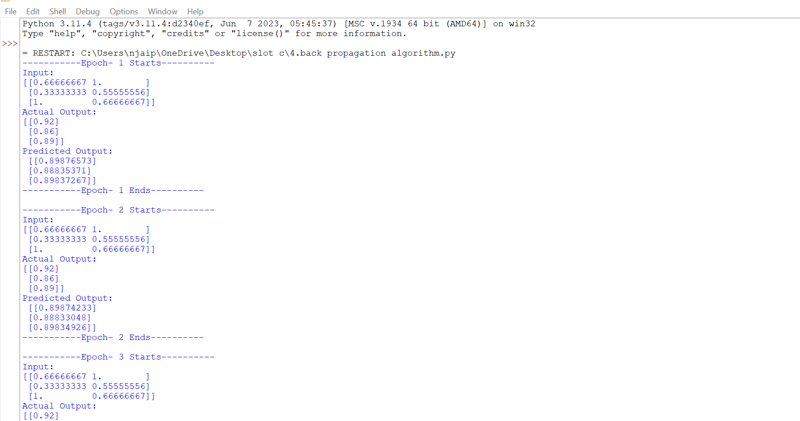

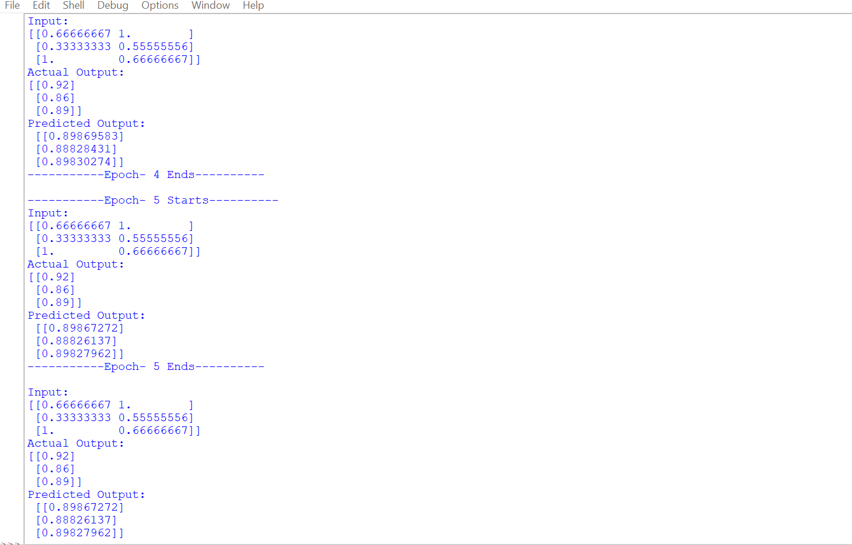

5.KNN algorithm

Output:  
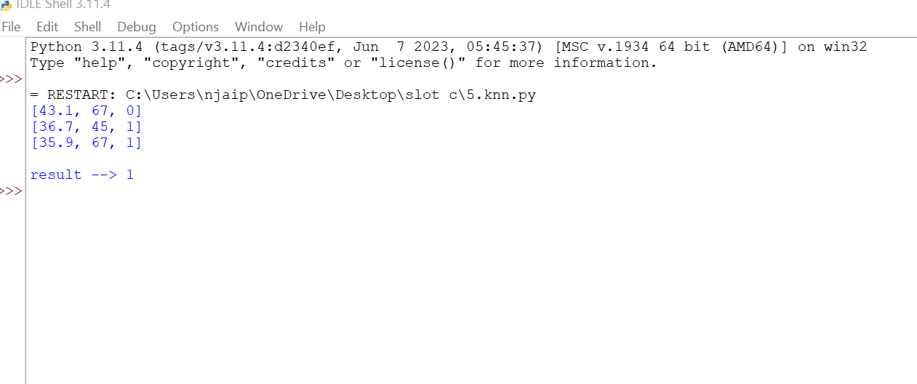

6.Navies bayes algorithm:

Output:

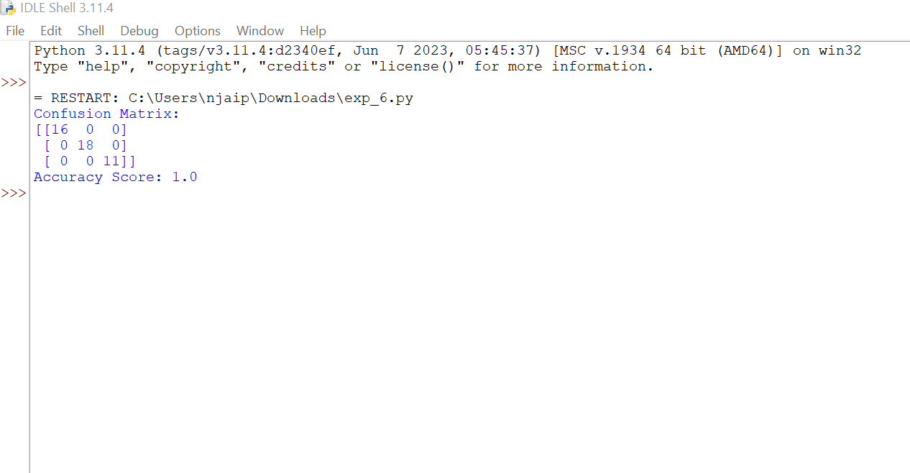

7. Logistic regression:

Output:

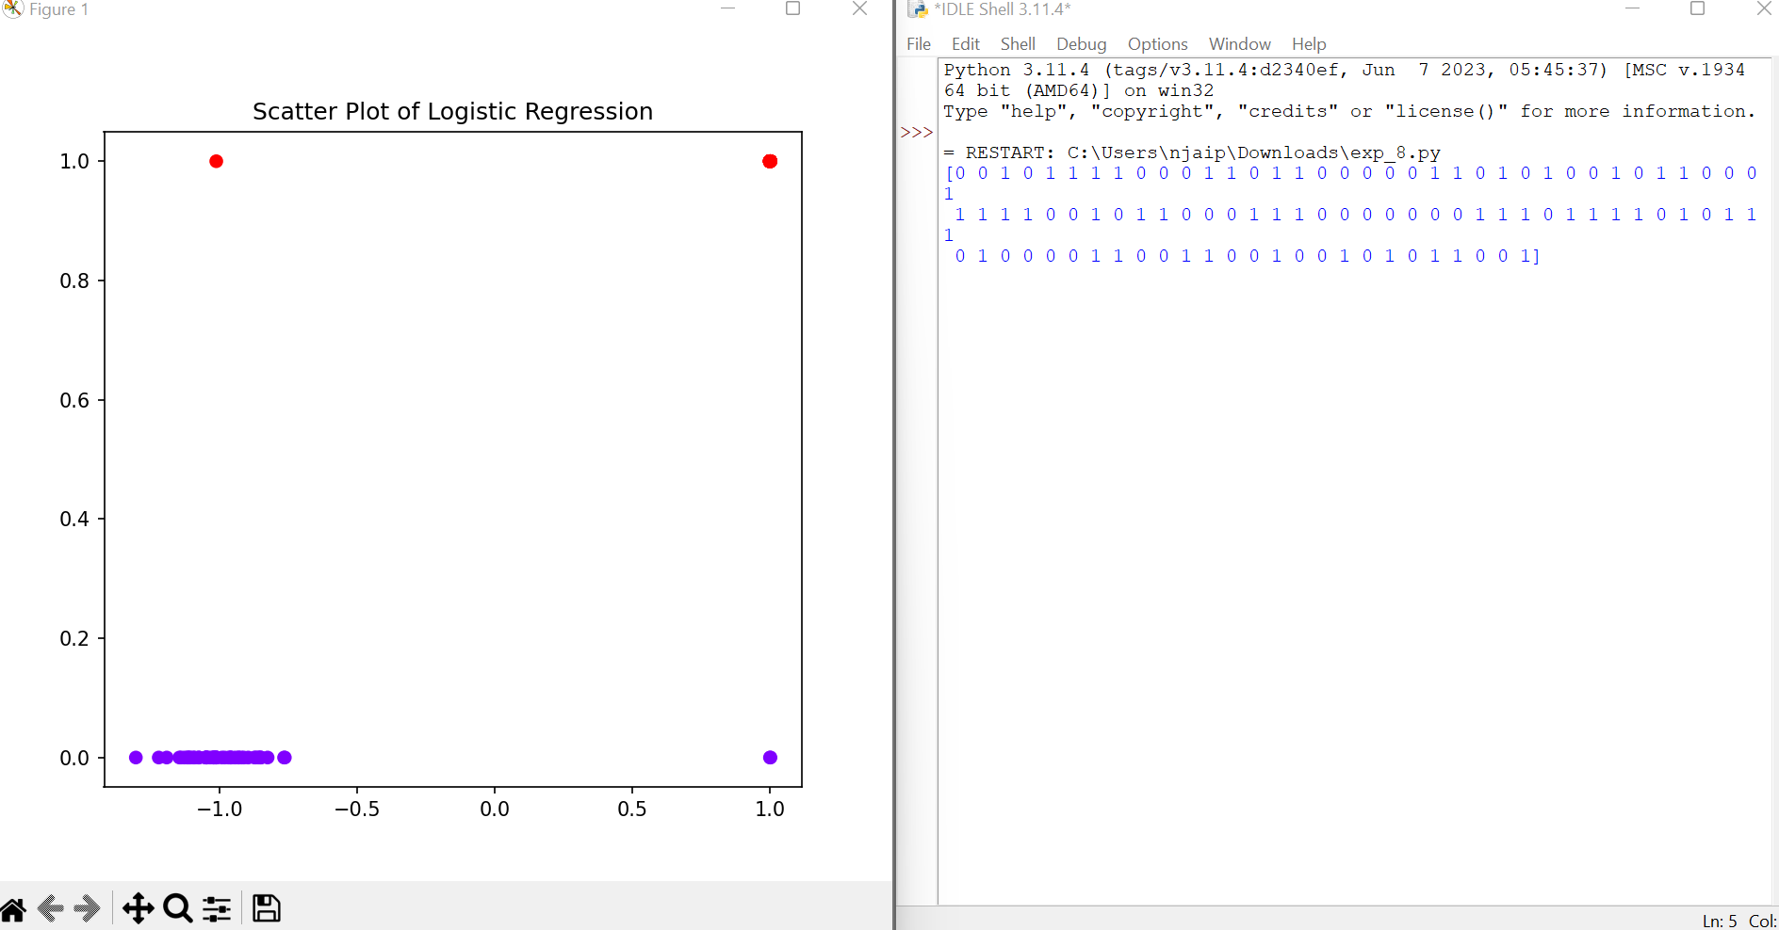

8.linear regression:

Output:

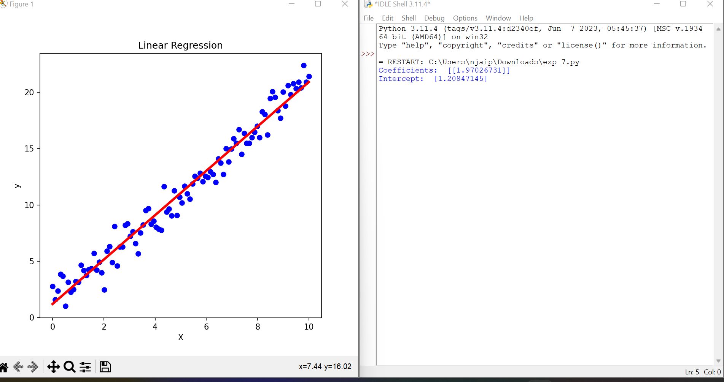

9. polynomial regression

Output:

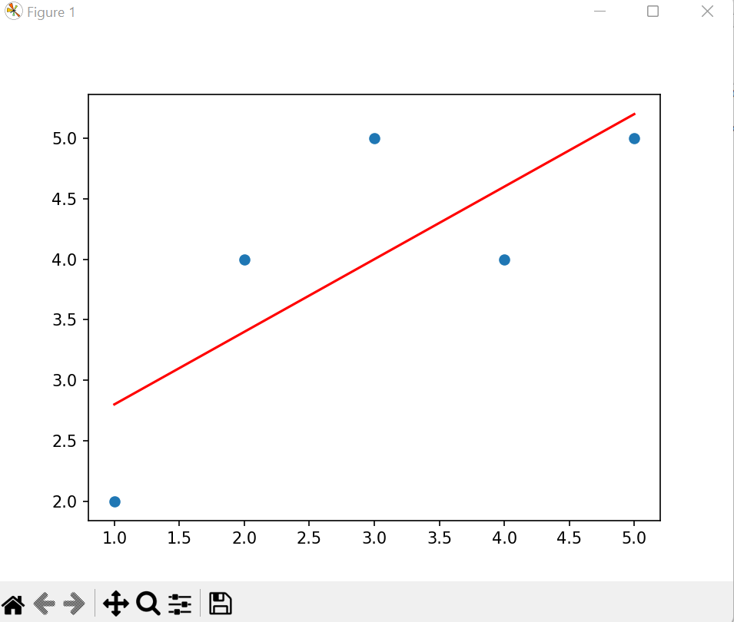

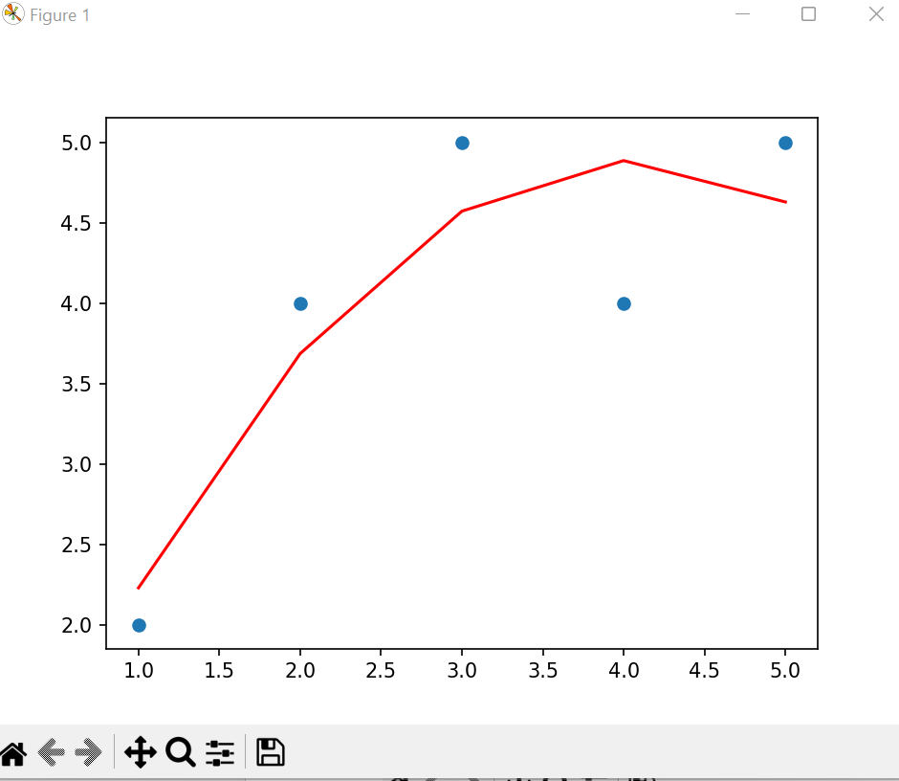

10. Expectation and maximation:

Output:

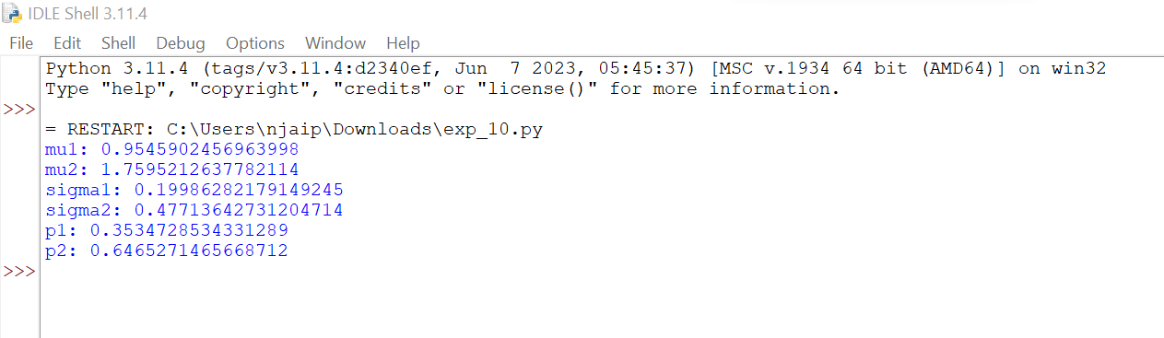

11.Credit score classification:

Output:  
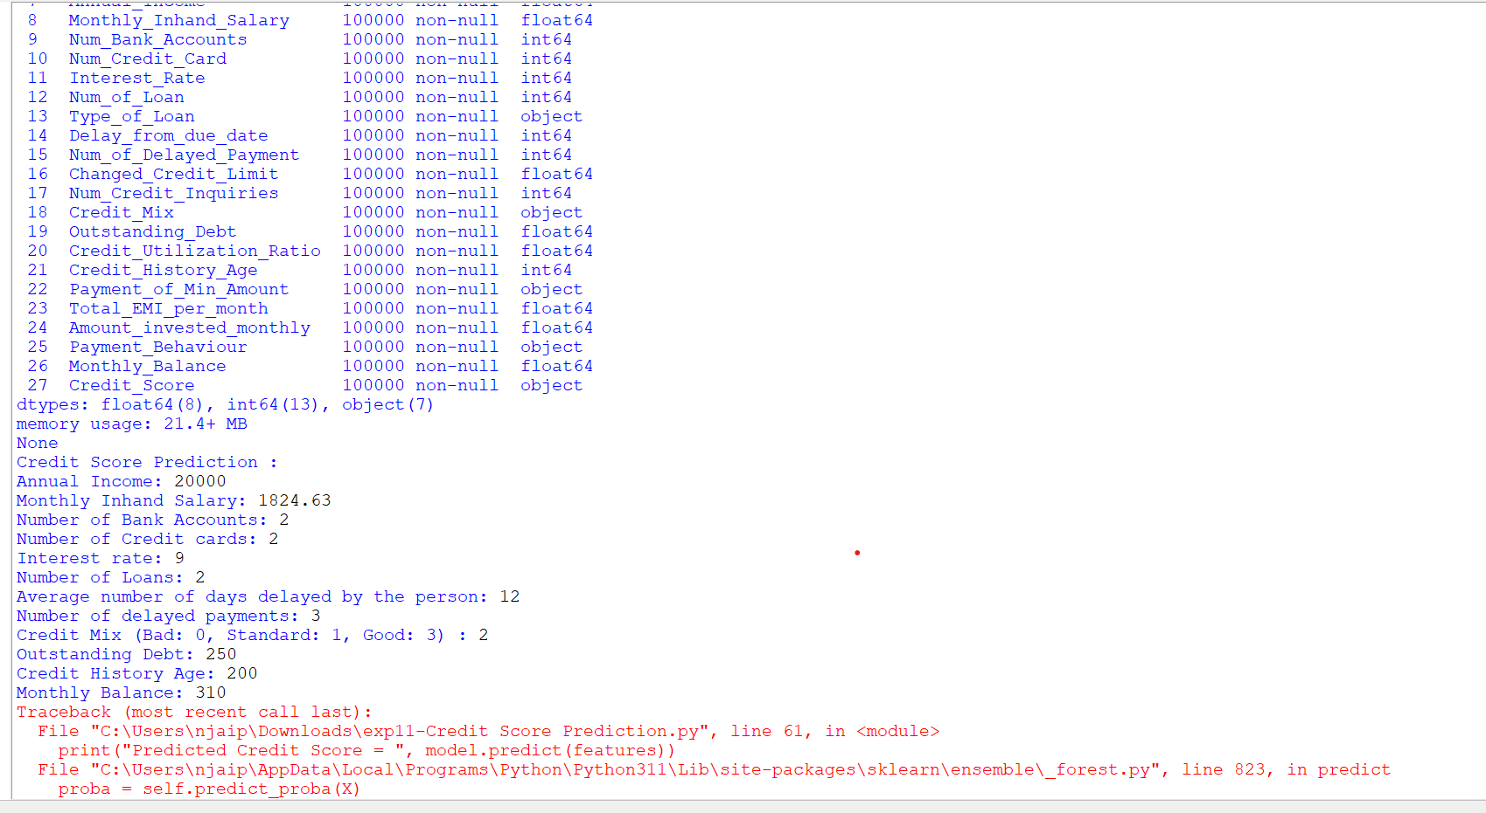

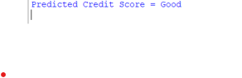

12. iris flower classification using KNN:

Output:

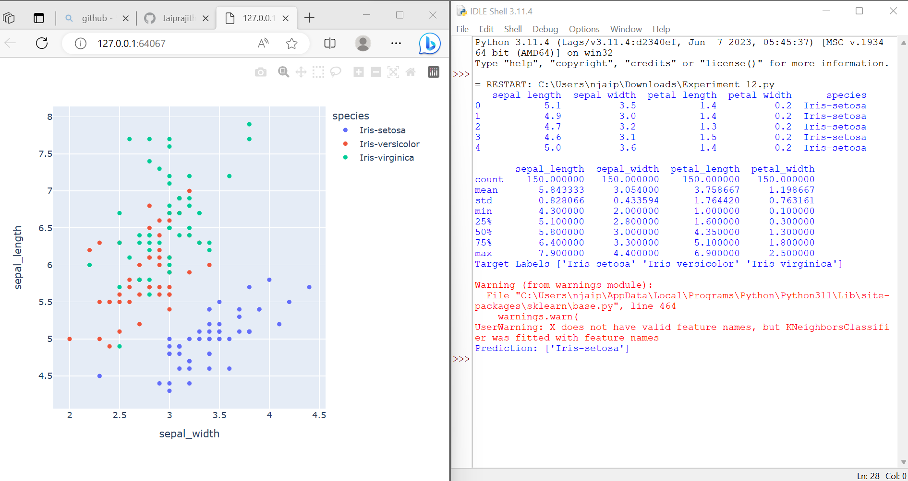

13. car price prediction:

Output:

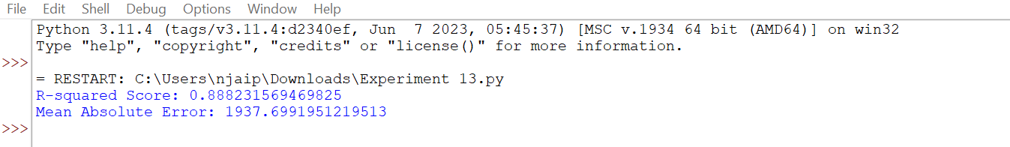

14. house price prediction:

Output:

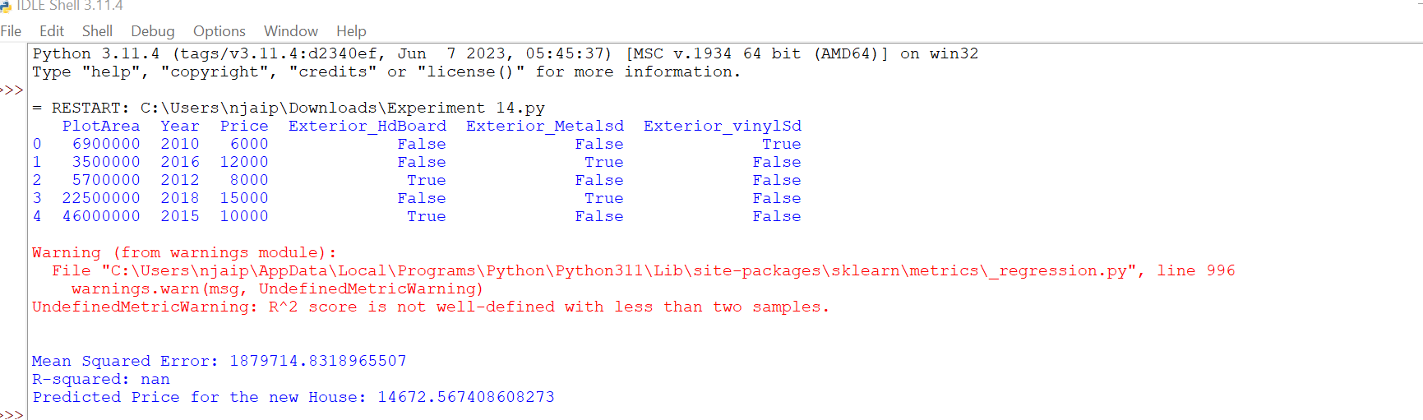

15. Naive iris classification:  
output:

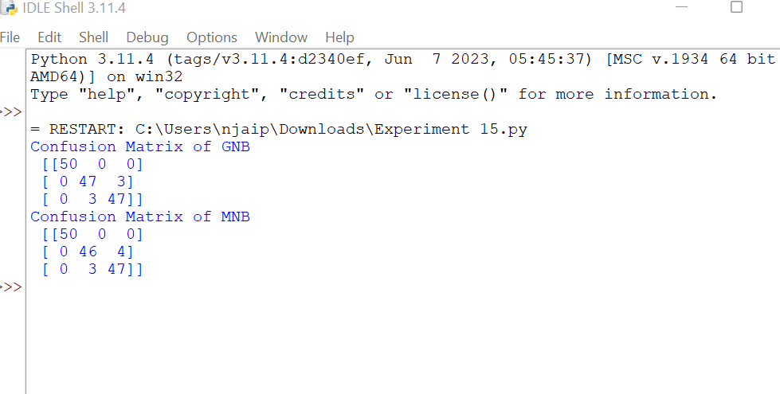

16. Comparision of classification:  
output:

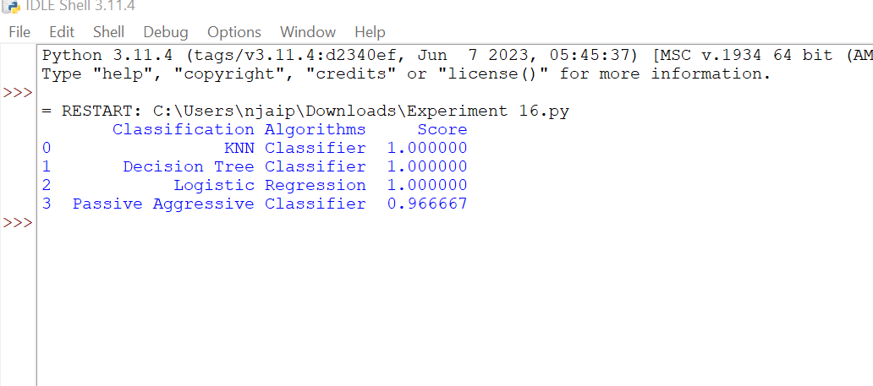

17. mobile price classification:

Output:

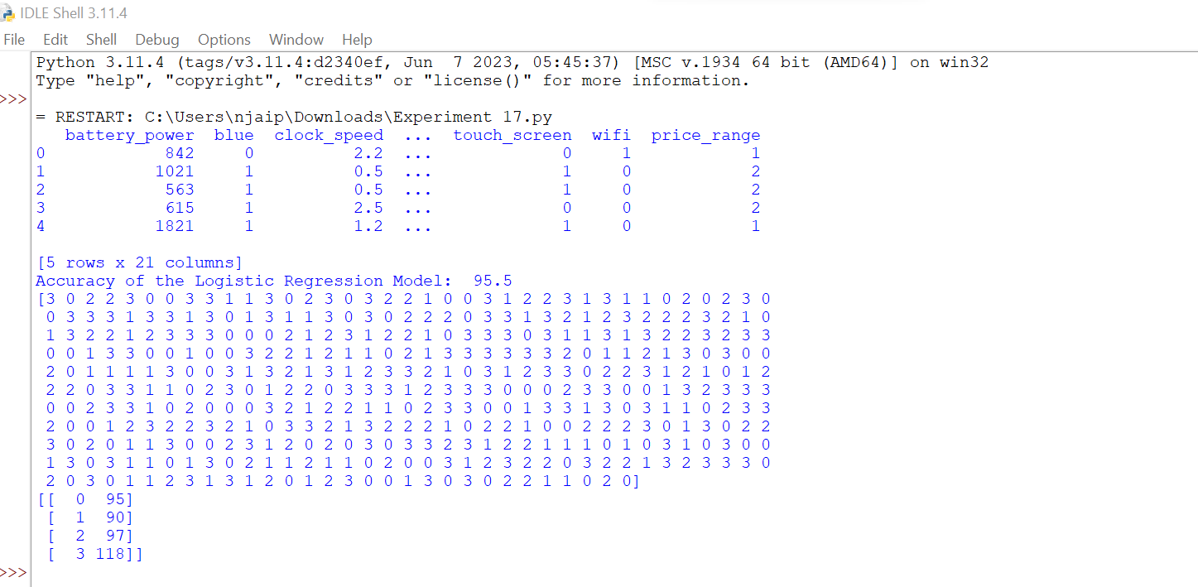

18. preception iris classification:

Output:

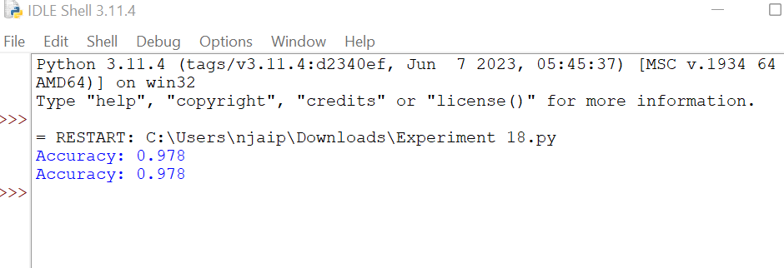

19. implementation of naïve bayes algorithm:

Output:

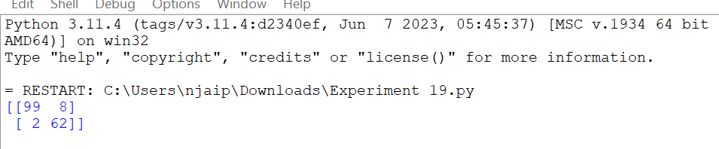

20. Future sales prediction using python:

Output:

