软件学院 ２００8 级软件工程专业(2008-2)
《线性代数》期中试题试卷

(考试形式： 闭 卷 考试时间: 120分钟)
警 示

《中山大学授予学士学位工作细则》第六条

考试作弊不授予学士学位

方向：___________ 姓名： ______ 学号： 成绩：____________

1. Fill the blank (4 titles * 5 points/title = 20 points)

- Given a linear system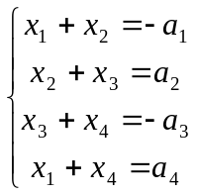, and if the system is consistent, the constants 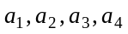 must satisfy .

- The reduced echelon form of 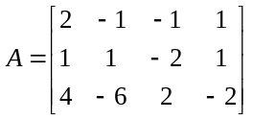 is .

- Suppose T：R²→R² is a transformation, which reflection through the x₁-axis first, and then reflection through the line x₂=x₁. So the standard matrix of T is .
- Given matrix 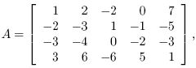the basis of Col A is ____________；Nul A is a _______ dimensional subspace of Rk, and k is _______, the rank of A is _______.

2. Mark each statement True or False, and descript your reasons (3titles * 5 points/title = 15 points)

(1) Suppose vectors v₁ and v₂ span a plane in R³, and v₃ is not in this plane. Then {v₁，v₂，v₃} is linear independent.

(2) If 3*3 matrices A and B each have three pivot positions, then A can be transformed into B by elementary row operations.

(3) If A is 3*3 matrix, there exist element matrices 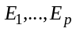 such that 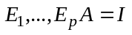

3. Problem issues (12 + 8 + 10 + 8 = 38 points)
- Determine the vectors below linear dependent or not. Describe your reasons. (2 titles * 6 points/title = 12 points)
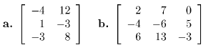

- Calculate LU factorization of 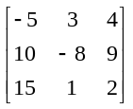 matrix. (8 points).

- Let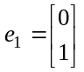,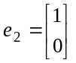,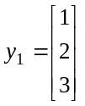,and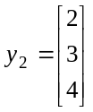,Suppose 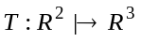 is a linear transformation which mapping into 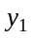, and mapping 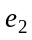 into 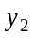. Find the image of 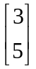. (10 points).

- Suppose matrix 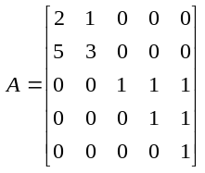, find A⁻¹.(8 points).

4. Prove issues (10 + 7 = 17 points)
- Suppose the vectors α₁,…,α_{t} are solutions of homogeneous linear system Ax=0 and the vectors is linear independent. β is not the solution of Ax=0. Please prove that β+α₁,…,β+α_{t} are linear independent. (10 points).

- Suppose A is 6*4 matrix, B is 4*6 matrix, prove 6*6 matrix AB is not invertible. (7 points).

5. Synthesis (10 points)
Suppose A is an nxn matrix, and satisfy A²-A+I_{n}=0, show A is invertible, and find A⁻¹. (10 points).

