软件学院2009 级软件工程专业(2009-1)
《线性代数》期中试题试卷(A)
(考试形式：闭卷 考试时间: 100分钟)
警 示
《中山大学授予学士学位工作细则》第六条
考试作弊不授予学士学位

方向：___________ 姓名： ______ 学号： 成绩：____________

注意：答案一定要写在答卷中，写在本试题卷中不给分。答题时注明各题题号，并在答题
纸上写上姓名和学号。本试卷要和答卷一起交回。

一、填空题（每小题4分，共16分）
1. Let 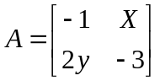 and 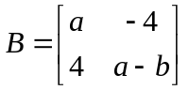 if A = B, then a = , b = , x = , y = 。
2. Find the inverses of matrices 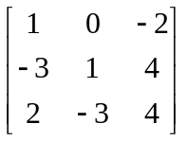.
3. Find, if possible, an LU factorization of each of the following matrices:
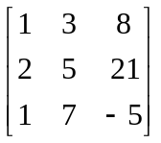
4．Let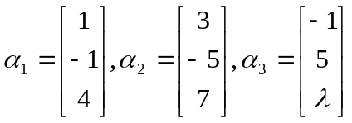，whenλ= ,{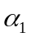, 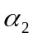,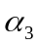} is linearly dependent set。

二、判断题（每小题3分，共24分）
1. The matrix 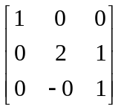 is elementary.
2. If A and B are invertible matrices, so is A + B.
3. The function T: R3R4 defined by 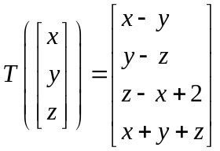is a linear transformation
4. if 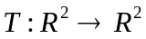is a linear transformation such that 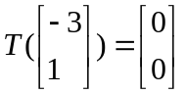 , then T is not one to one
5. If a matrix A has row echelon from u, the pivot columns of A are the pivot columns of u
6. If a 4*4 matrix A has row echelon form 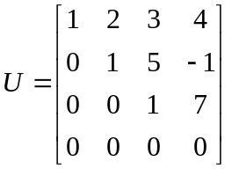 , the system Ax = 0 has only the trivial solution.
7. If A and B are invertible matrices and XA= B, the X= A⁻¹B.
8. If x₀ is a solution to the system Ax = b with 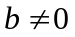, then 2x₀ is also a solution.

三、计算题（40分）
- Let 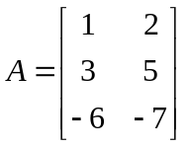 and 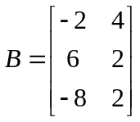 solve the equation 2A + 4X=3B.

- Let 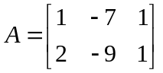 and 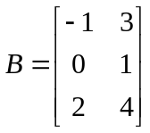
(a). Compute AB and BA
(b). Is A invertible? Explain.

3. .Let 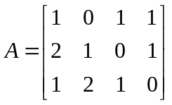, 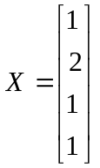
(a). Find Ax
(b). Find x^{T}A^{T} by two different methods

4. Let 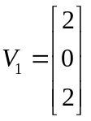, 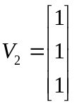, 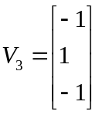, and 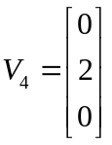
Determine whether every vector in R3 is a Linear combination of the given vectors.write the solution x₀ the following Linear systems in the form x=xp+xh where xp is a particular solution and xh is a solution of the corresponding homogeneous system
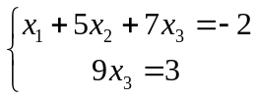

四、证明题（每题10分，20分）
- Suppose A and B are m*n matrices such that Ae_{i}=Be_{i} for each 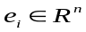, prove that A = B
- Show that if A is an invertible matrix, then so is A^{T}, and (A^{T})⁻¹=(A⁻¹)^{T}

