软件学院 ２０1 0 级软件工程专业(2010-11)
《线性代数》期中试题试卷

(考试形式： 闭 卷 考试时间: 120分钟)
警 示

《中山大学授予学士学位工作细则》第六条

考试作弊不授予学士学位

方向：___________ 姓名： ______ 学号： 成绩：____________

1. Fill the blank (4 titles * 5 points/title = 20 points)
- Given a linear system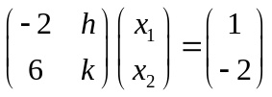, and if the system is consistent, the constants h and k must satisfy .
- The reduced echelon form of 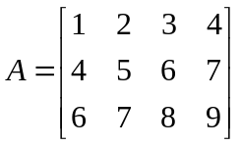 is .
- Suppose T: R² → R² is a transformation, which performs a horizontal shear that transforms 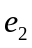 into 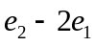 first (leave unchanged), and then reflects points through the line 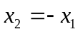. So the standard matrix of T is .
- The determinant of 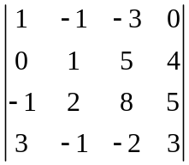 is _______.

2. Mark each statement True or False, and descript your reasons (3titles * 5 points/title = 15 points)
(1) If is a linear combination of and  in R^{m}, then must be a linear combination of and .
(2) If A is a 6×5 matrix, the linear transformation 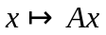 can’t map R⁵ onto R⁶.
(3) If A is 3×3 matrix, there exist element matrices 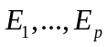 such that 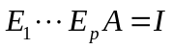.

3. Problem issues (12 + 8 + 10 + 8 = 38 points)
- Determine the vectors below linear dependent or not. Describe your reasons. (2 titles * 6 points/title = 12 points)
a. 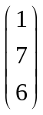, 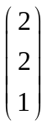, 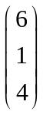, 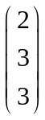 b. 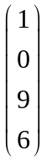, 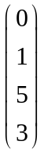, 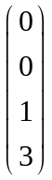, 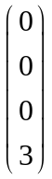
- Calculate LU factorization of 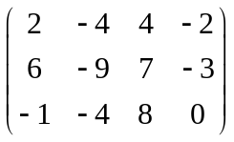 matrix (8 points).
- Given the 4 × 4 matrix that translation by the vector 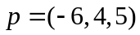, using homogeneous coordinates (10 points).
- Suppose matrix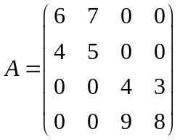, find A⁻¹ (8 points).

4. Prove issues (10 + 9 = 19 points)
- Let T : R^{n} → R^{n} be the transformation. Show that if T maps two linear independent vectors onto a linear dependent set, then the equation 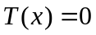 has a nontrivial solution (10 points).
- Show that if A is invertible, then 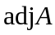 is also invertible.(9 points)

5. Synthesis (8 points)
Suppose A is an n×n invertible matrix, , 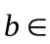 R^{n} and 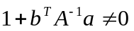, prove 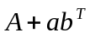 is invertible, and 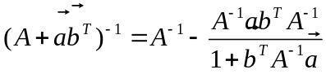 (10 points).

