Section 1:

Section 2:

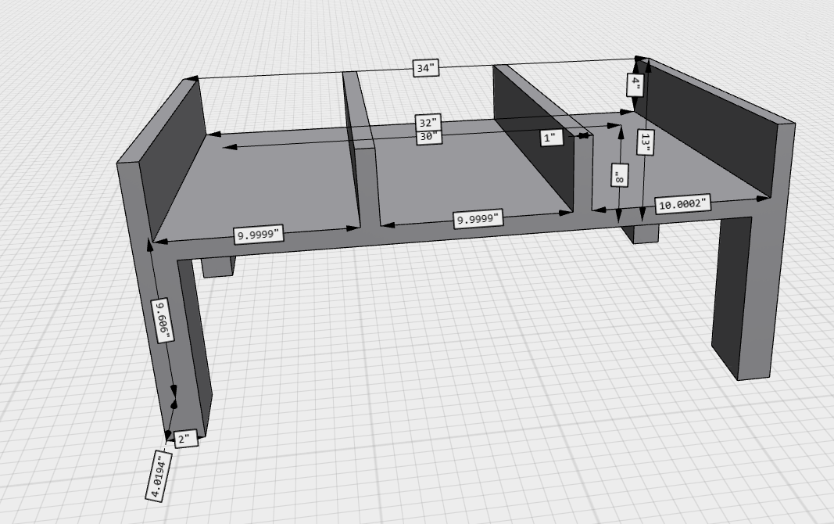

Section 3:

Tennis Ball Catch:

