1 | 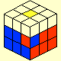 | (R U' U'R' U)2 y'(R' U' R)
2 | 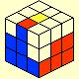 | (U R U' R' U') y'(R' U R)
3 | 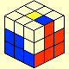 | y U'(L' U L U)y' (R U' R')
4 | 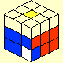 | (R U R' U')(R U'U' R' U')(R U R')
5 | 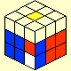 | (R U' R U)y(R U' R' F2)
6 | 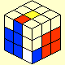 | y'(R' U' R U)(R' U' R)
7 | 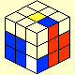 | (R U' R' U)(R U' R')
8 | 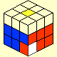 | (R U'U')(R U R' U)(R U'U')R2
9 | 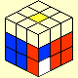 | R2 y(R U R' U')y'(R' U R')
10 | 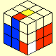 | y' (R' U)(R U')(R' U R)
11 | 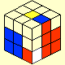 | (R U R' U' )(R U R')
12 | 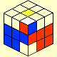 | (R U R' U')2 (R U R')
13 | 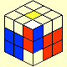 | (R U' R') y' (R' U2 R)
14 | 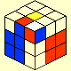 | y'(R' U2)(R U R' U')R
15 | 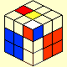 | d' z U'(R2 U)(R' U' R U)
16 | 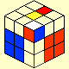 | F' L' U2 r U x'
17 | 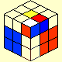 | y' (U2 R2' U2)(R U R' U R2)
18 | 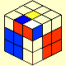 | R U' R U2(R U R' U')R U R'
19 | 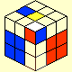 | R y (R U2 R' F')
20 | 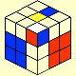 | U(R U'U')(R' U R U' )R'
21 | 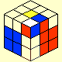 | (R U'U')(R' U' R U)R'
22 | 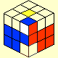 | U'(R U')(R' U2)(R U' R')
23 | 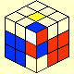 | U' (R U R') d (R' U' R)
24 | 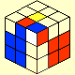 | d (R' U R U')(R' U' R)
25 | 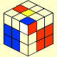 | y' (R' U' R)
26 | 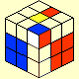 | U' R U' R' d R' U' R
27 | 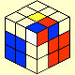 | U' R U2 R' d R' U' R
28 | 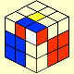 | y' (R' U)(R d' U')(R U R')
29 | 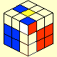 | U' (R U'U')(R' U2)(R U' R')
30 | 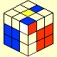 | U' (R U)(R' U2)(R U' R')
31 | 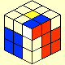 | U R U' R'
32 | 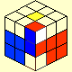 | U' (R U'U' R' U)(R U R')
33 | 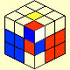 | d (R' U' R) d' (R U R')
34 | 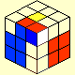 | x(U R' U' l)
35 | 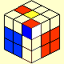 | R2 y (R U R' U')y' R2
36 | 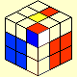 | d (R' U2)(R U'U')(R' U R)
37 | 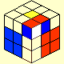 | (R U' R' U)(d R' U' R)
38 | 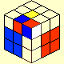 | d R U2 R' d' (R' U R)
39 | 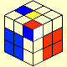 | U' R U R'U (R' U R)
40 | 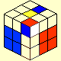 | (R U R')
41 | 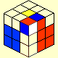 | U' (R U' R' U)(R U R')
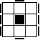 | (R U'U') (R2' F R F') U2 (R' F R F')
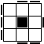 | (F R U R' U' F') (f R U R' U' f')
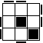 | f(R U R' U')f' U' F(R U R' U')F'
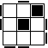 | f(R U R' U')y x(R’ F)(R U R' U')F'
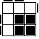 | (r' U2) (R U R'U) r
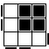 | (r U'U') (R' U' R U' r')
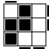 | r U R' U R U'U' r'
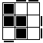 | r' U' R U' R' U2 r
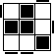 | (R' U' R) y' x' (R U')(R'F) (R U R')
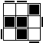 | (R U R'U)(R'F R F') (RU'U'R')
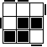 | r'(R2 U R' U)(R U'U' R' U) (r R')
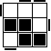 | L2 l U' z (U R'U') (R2 U R') z' r R'
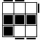 | (r U' r' U')(r U r') (F' U F)
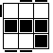 | R' F R U R' F'R (F U' F')
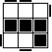 | (r' U' r) (R'U'R U) (r' U r)
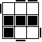 | R B R' L U L' U' R B' R'
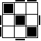 | (R U R' U) (R' F R F'U2) R' F R F'
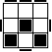 | (R U R' U) (R' F R F') U2 r (R'U) R U'r'
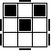 | r'(R U) (R U R'U')(r R'2 F R F')
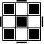 | r'(R U) (R U R'U' r2)(R2'U) (R U') r'
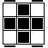 | (R U'U') (R' U' R U R' U') (R U' R')
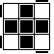 | R U'U' (R'2 U') (R2 U') R'2 U' U'R
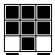 | (R2 D) (R' U2) (R D') (R' U2 R')
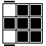 | (r U R' U') (r' F R F')
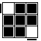 | F'(r U R' U') (r' F R)
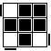 | R U'U' R' U' R U' R'
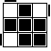 | R' U2 R U R' U R
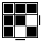 | (r U R' U') (r' R U) (R U' R')
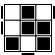 | (R2 U' R) F (R' U) (R2 U') (R' F' R)
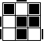 | (R2 U R' B')(RU') (R2' U) (l U l')
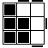 | (r' F' U F) (L F' L' U' r)
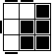 | (R U)(B' U')(R' U R B R')
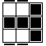 | (R U R' U') (R' F R F')
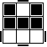 | (R'U'R U)y(r U R' U')r' R
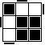 | R U'U'R2' F R F'(R U'U'R')
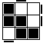 | R'U'R U' R'U R U l U'R'U
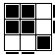 | F (R U' R'U'R U) (R' F')
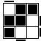 | (R U R'U) (RU'R'U') (R'F R F')
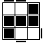 | (L F'L' U'L U) (F U' L')
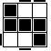 | (R' F R U R'U') (F' U R)
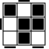 | R U' R' U2 R U y R U' R' U' F'
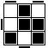 | (R'U RU'U' R' U')(F' U)(F U R)
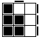 | (B' U') (R' U R B)
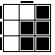 | f (R U R' U')f'
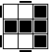 | F (R U R' U') F'
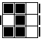 | (R' U') R' F R F' (U R)
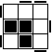 | B'(R' U' R U)2 B
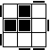 | F (R U R' U')2 F'
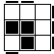 | R B'(R2 F)(R2 B) R2 F' R
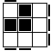 | R' F R2 B'R2 F' R2 B R'
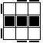 | f (R U R' U')2 f'
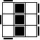 | R'U' R U' R' d R' U l U
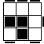 | (r' U2) (R U R'U') (R U R'U) r
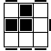 | (r U'U') (R' U' R U R' U') (R U' r')
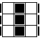 | (R U'U') (R'2 U') R U' R'U2 (F R F')
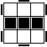 | F (R U R'U')(R F')(r U R'U')r'
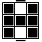 | (R U R' U' r)(R' U) (R U' r')

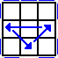 | (R U' R)(U R U R)(U' R' U' R2)
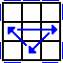 | (R2' U)(R U R' U')(R' U')(R' U R')
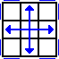 | L2(l'2 U)L2(l'2 U2)L2(l'2 U)L2 l2
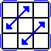 | (U R'U')(R U'R)(U R U')(R'U R U)(R2 U')(R'U)
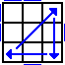 | x' R2 D2(R' U' R)D2(R' U R')
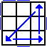 | (l U' R)D2(R' U R)D2 R2
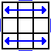 | F'(r U R' U') (r' F R2) x’z RU’R’D’ (RUR’)
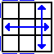 | (R U R' U')(R' F)(R2 U' R' U')(R U R' F')
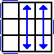 | U'(R'U R U' R'2 b')x(R'U R)y'(R U R' U' R2)
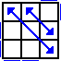 | (R' U R' U') yx2 (R' U R' U'R2) xz'(R'U'R U R)
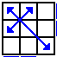 | F(R U'R' U')(R U R' F')(R U R' U')(R' F R F')
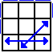 | z(U' R D')(R2 U R' U' R2 U)z'(R U')
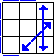 | (R U R'F')(R U R'U')(R'F R2 U'R'U')
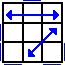 | (R' U2)(R U'U')(R' F R U R' U')(R'F' R2 U')
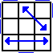 | (R U'U')(R' U2)(R B' R' U')(R U R B R2' U)
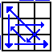 | (R2' u' R U' R)(U R' u)(R2 f R' f')
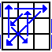 | (R U R')y'(R2' u' R U')(R' U R' u R2)
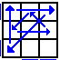 | (R2 u)(R' U R' U')(R u') (R2' F' U F)
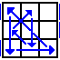 | (R' d' F)(R2 u)(R' U)(R U' R u' R2)
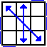 | z(R' U R')z'(R U2 L' U R') z(U R')z'(R U2 L' U R')
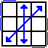 | z(U'R D')(R2 U R'U')z'(R U R') z(R2 U R')z'(R U')
 |  | 顺时针 ９０度 | 逆时针 ９０度 | 顺时针 １８０度 | 逆时针１８０度
前面  F：Front |  | 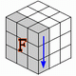 | 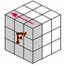 | 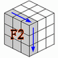 | 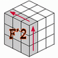
 |  | 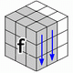 | 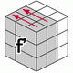 | 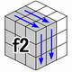 | 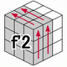
后面  B：Back |  | 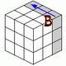 | 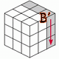 | 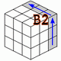 | 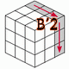
 |  | 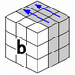 | 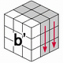 | 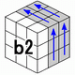 | 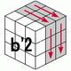
上面  U: Up |  | 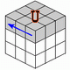 | 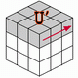 | 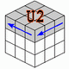 | 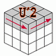
 |  | 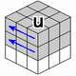 | 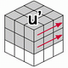 | 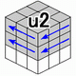 | 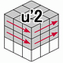
下面  D: Down |  | 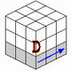 | 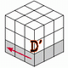 | 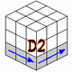 | 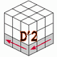
 |  | 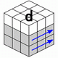 | 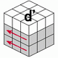 | 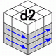 | 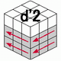
左面  L: left |  | 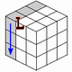 | 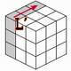 | 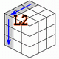 | 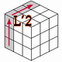
 |  | 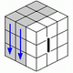 | 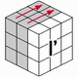 | 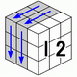 | 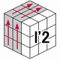
右面  R: Right |  | 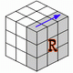 | 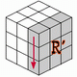 | 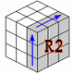 | 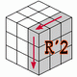
 |  | 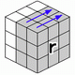 | 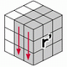 | 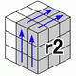 | 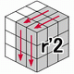

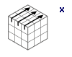整个魔方以R的方向转动 | 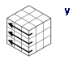整个魔方以U的方向转动 | 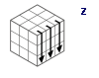整个魔方以F的方向转动
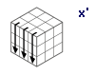整个魔方以R'的方向转动 | 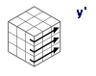整个魔方以U'的方向转动 | 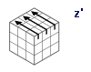整个魔方以F'的方向转

