* ER_1000_10_0

Naive: 0.858

Got: 0.918

* ER_1000_20_0

Naive: 0.8099

Got: 0.948

* ER_2000_10_0

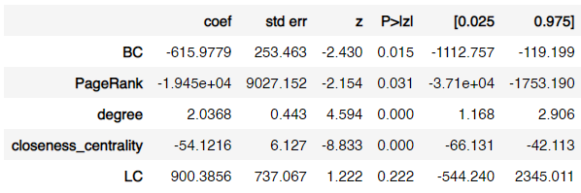

Naive: 0.8495

Got: 0.9505

* ER_2000_20_0

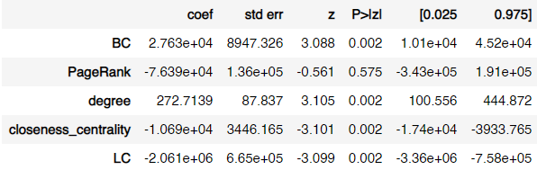

Naive: 0.7865

Got: 0.8855

* ER_5000_20_0

Naive: 0.7818

Got: 0.9742

Análisis:

|  |  |
| --- | --- |
| Medida | Significativo |
| BC | 4/5 |
| PageRank | 2/5 |
| Degree | 4/5 |
| CC | 5/5 |
| LC | 3/5 |