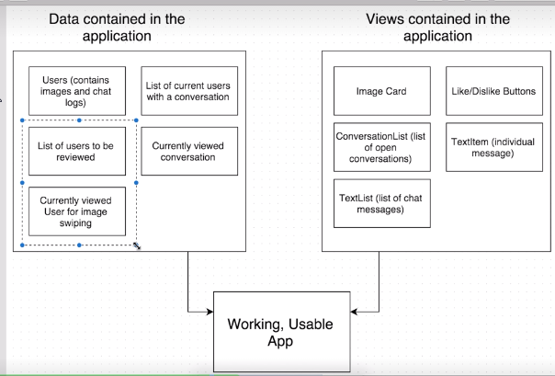

BOOK APP
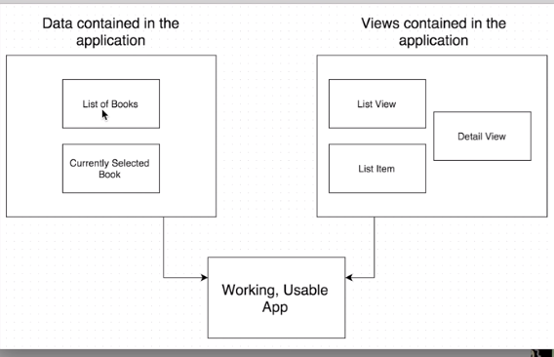

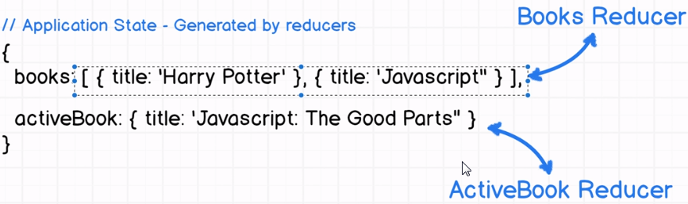

CONTAINERS CONTINUED

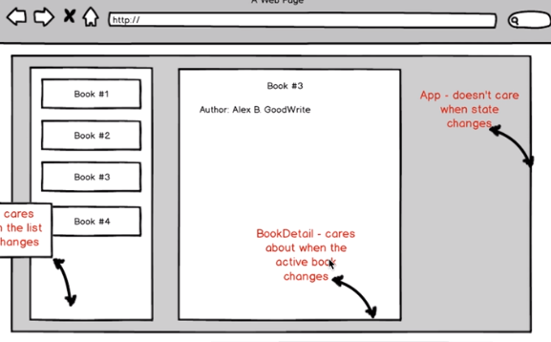

ACTIONS AND ACTION CREATORS
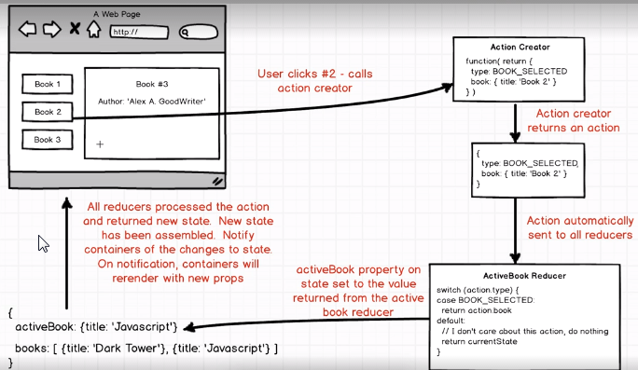
‘Book2’
‘Book2’
‘Book2’

