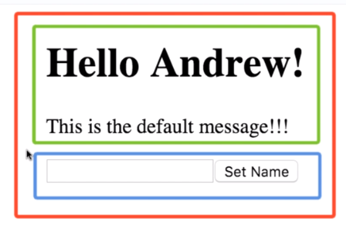

Red = Greeter component, which is main app and nothing above it.

It contains 2 nested components

Green = GreeterMessage component.
Blue = GreeterForm component.

WEATHER APP

