Jairun Diemert

Project 3

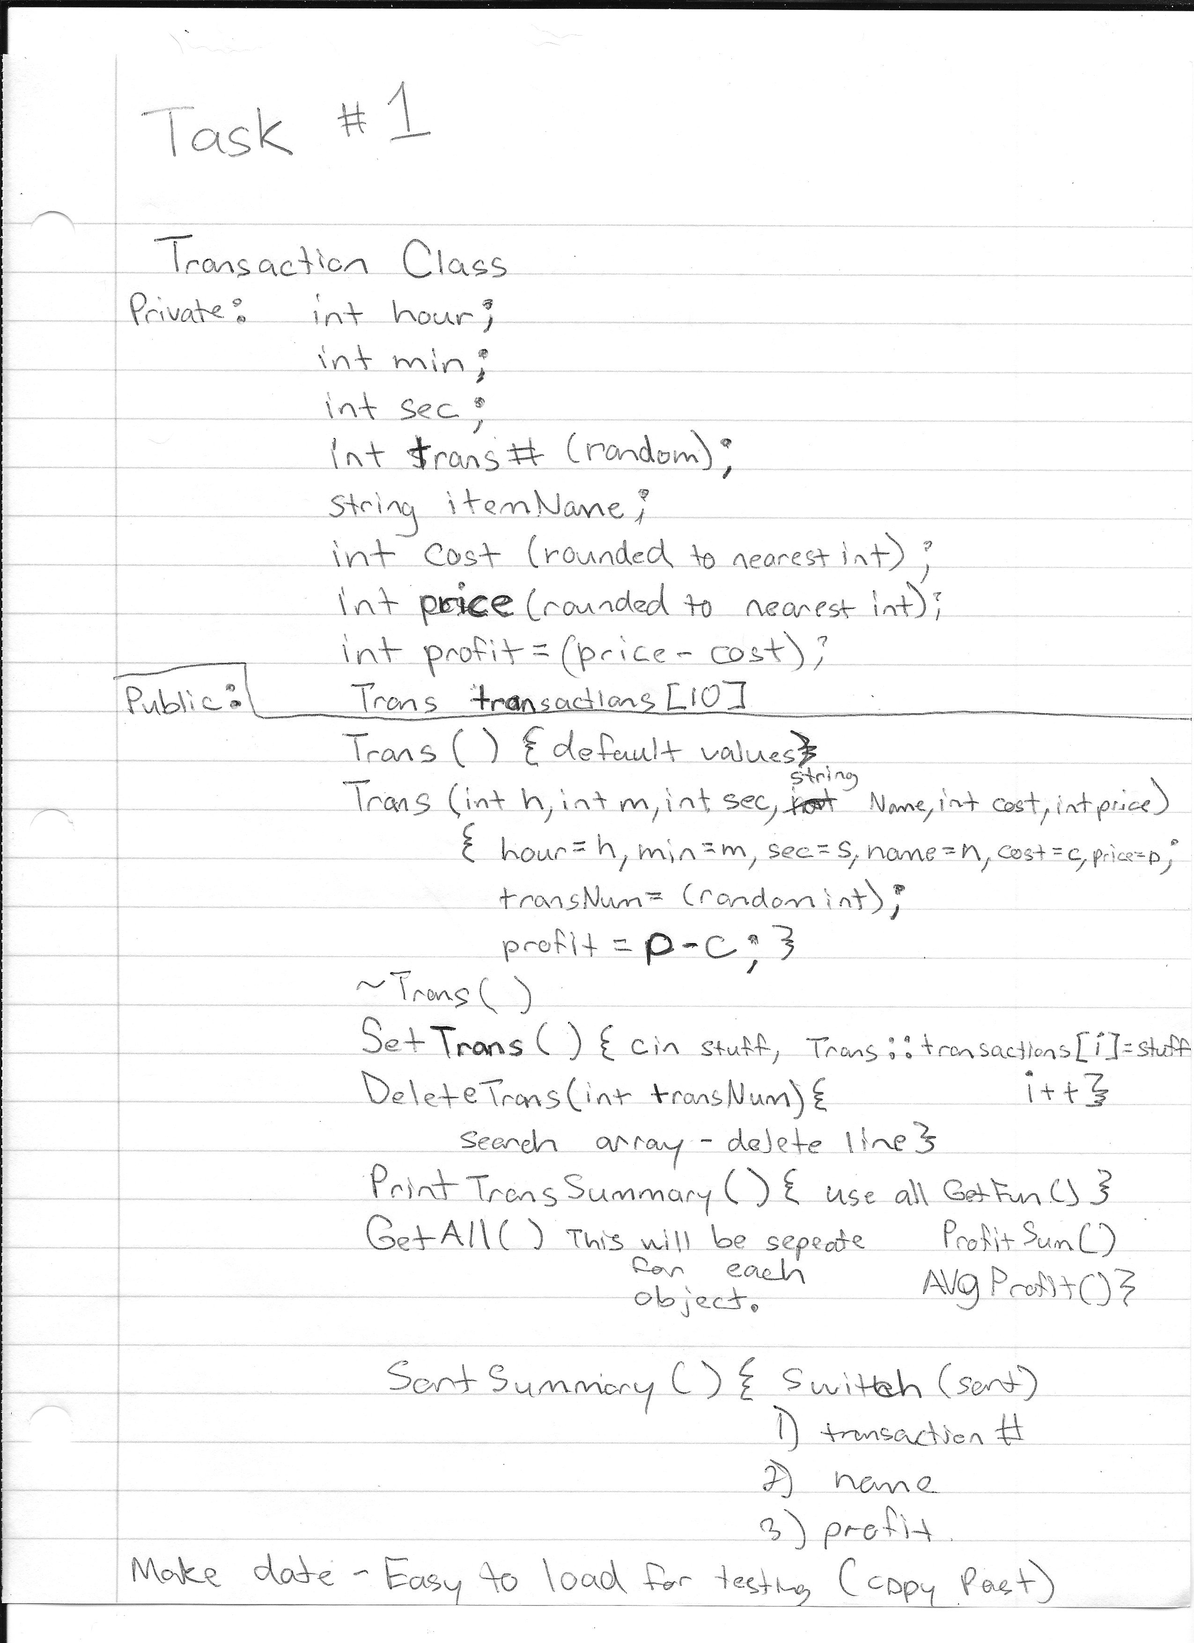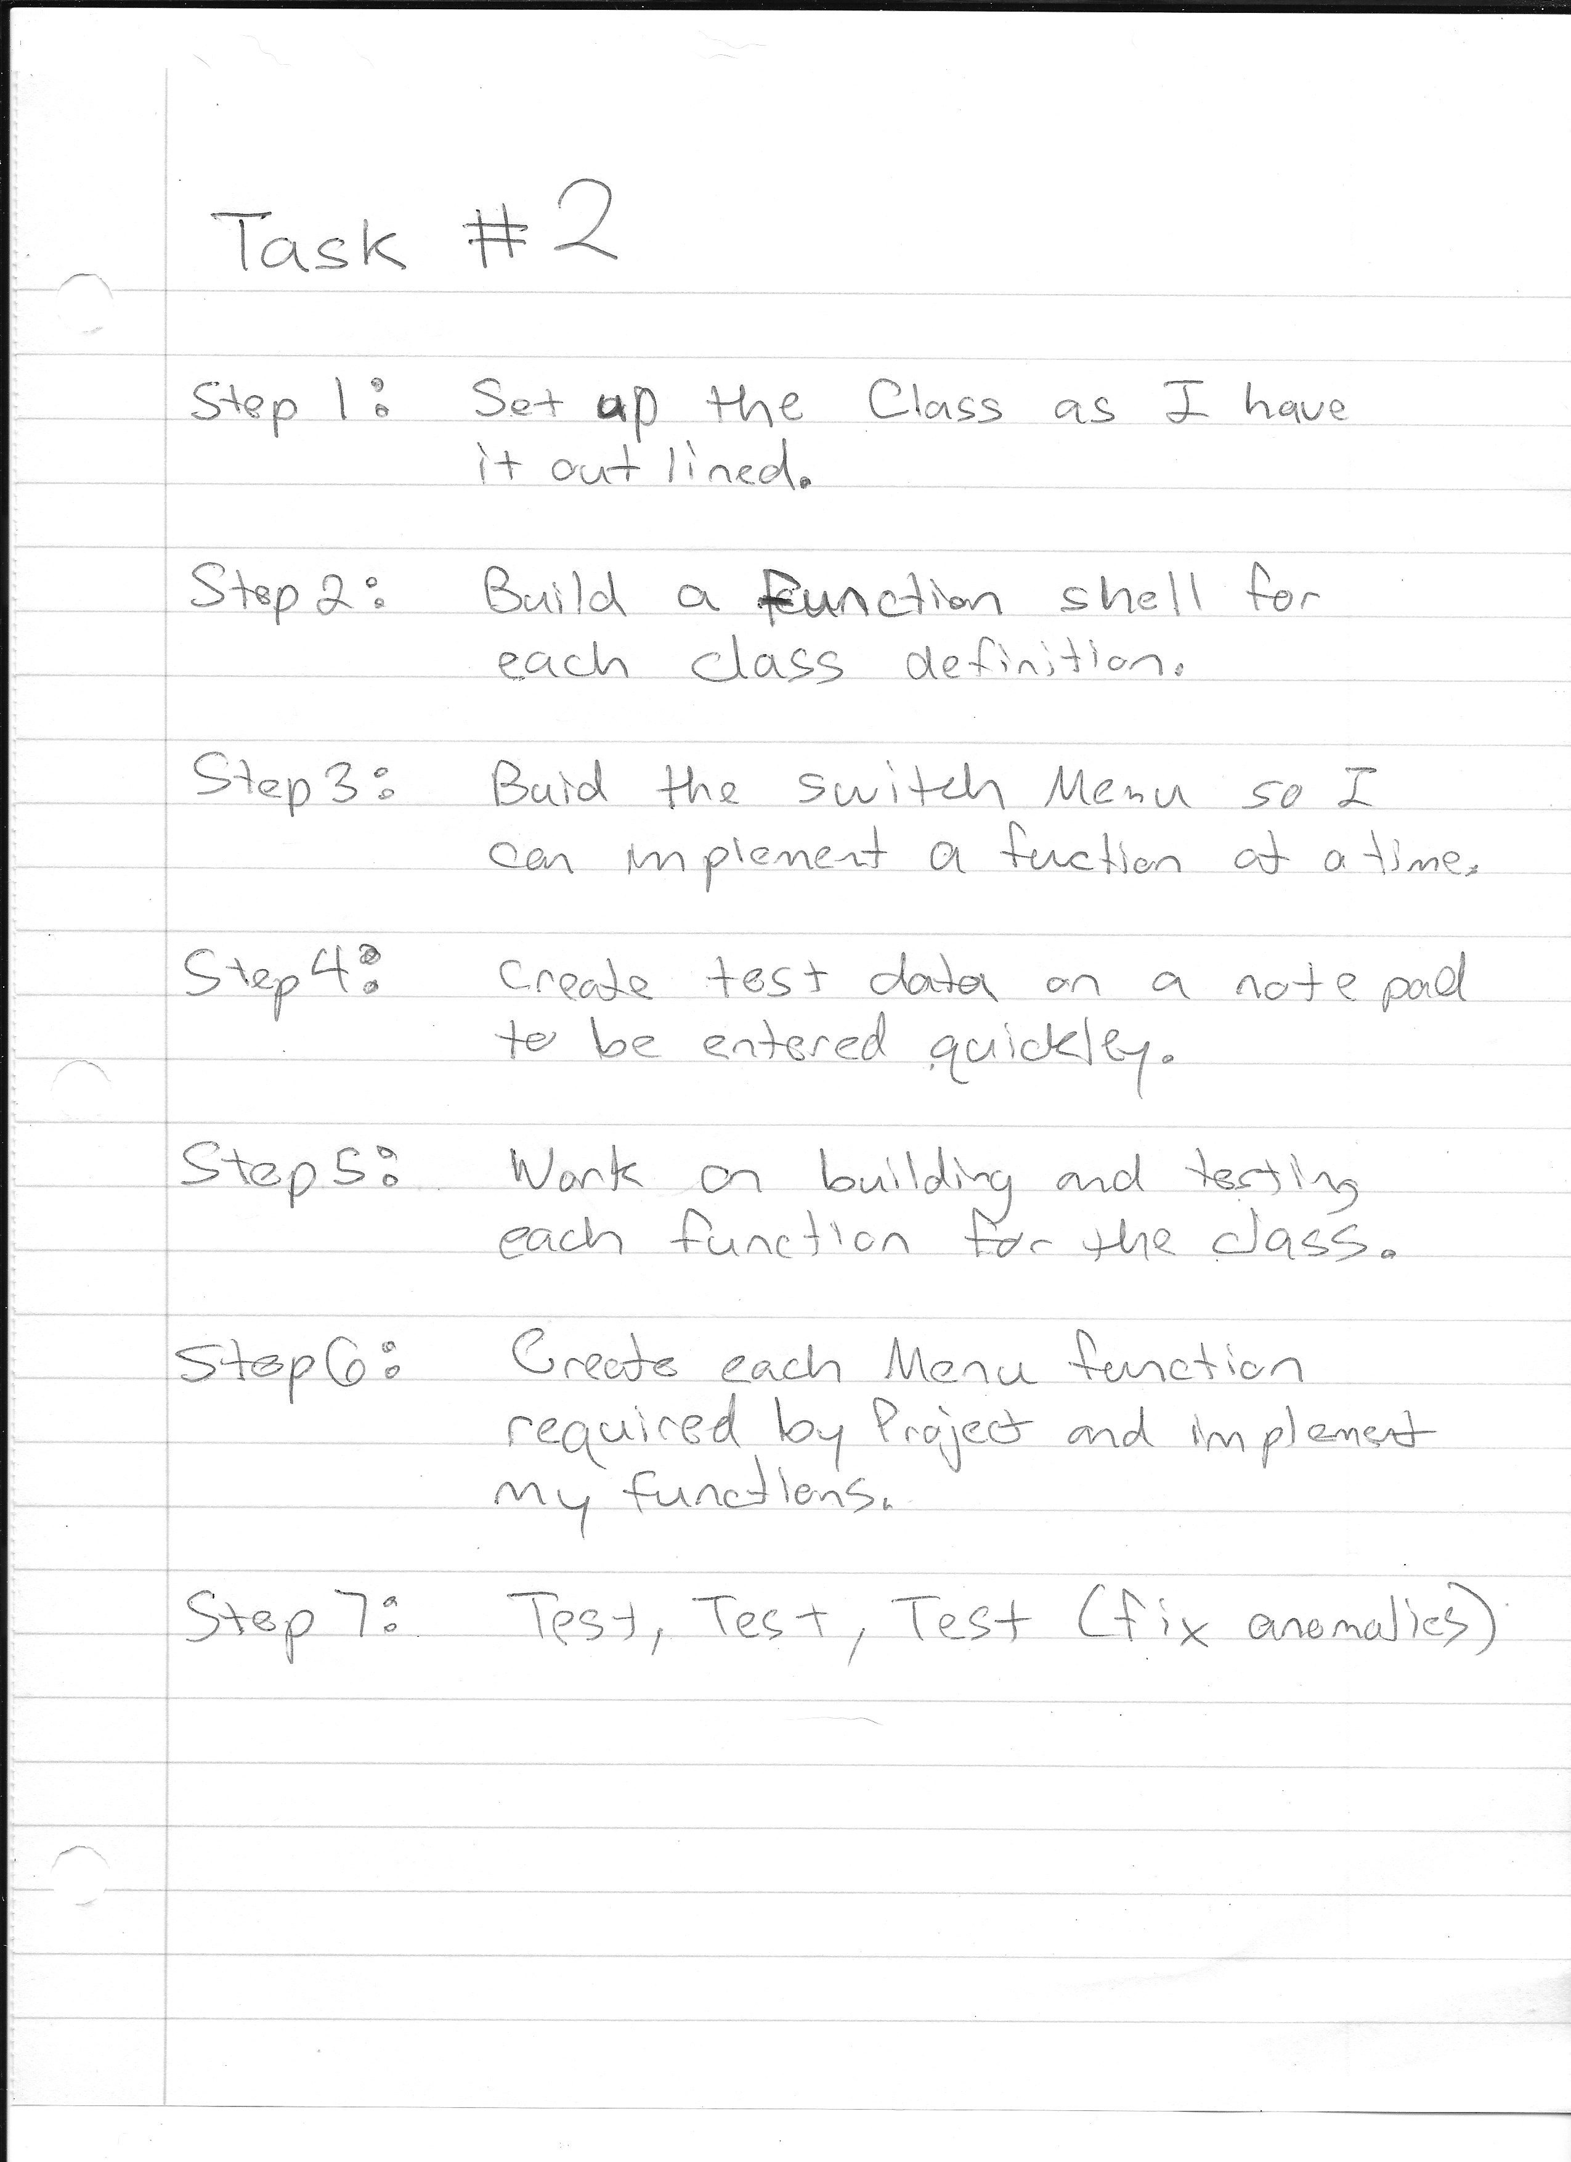

Task 4

In conclusion I did stick to my plan for the most part. I deviated from making separate functions inside the class for each switch do to an issue encountered when trying to pass the values into the functions. Over all I learned a bit about how pointers and arrays go hand in hand.