**DEVOPS**

**DAY-4 Kubernetes**

To create a one Directory

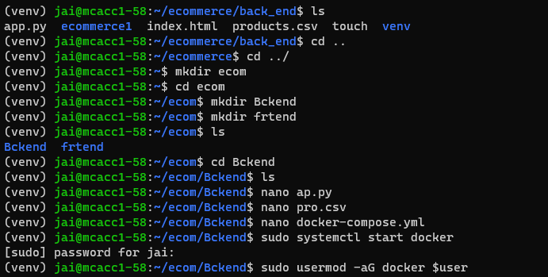

To install python:

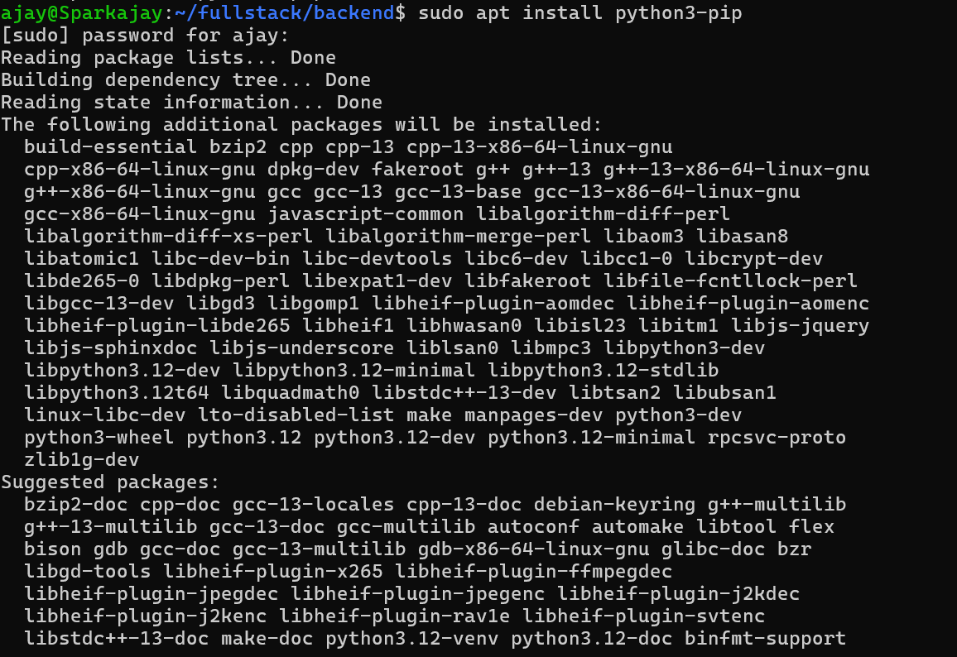

After Creating Python, Create an **Backend** to store the files,



then build Docker and Run the Docker

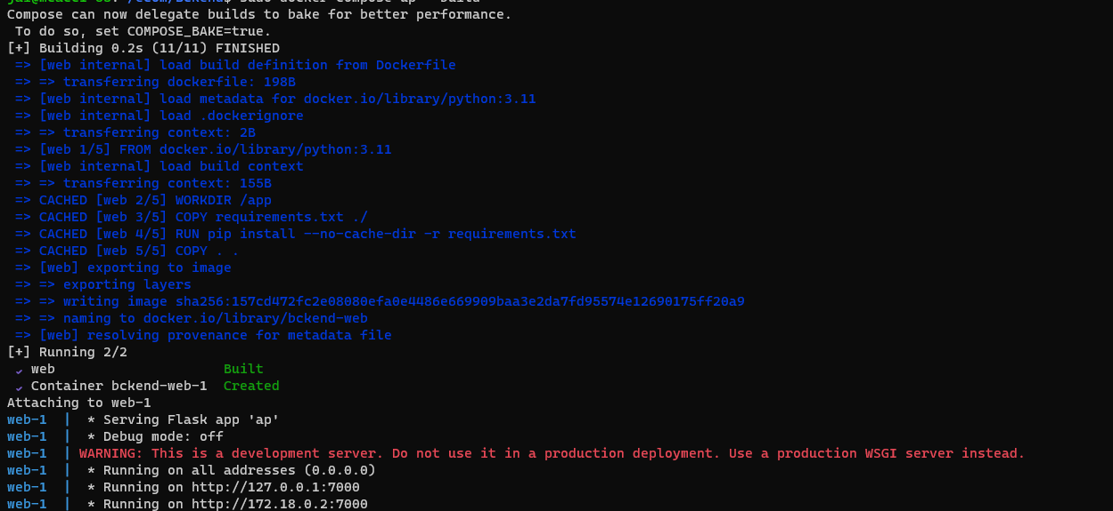

**To see the Output, goto the website and put the URL:**

then it will display the Json format in website

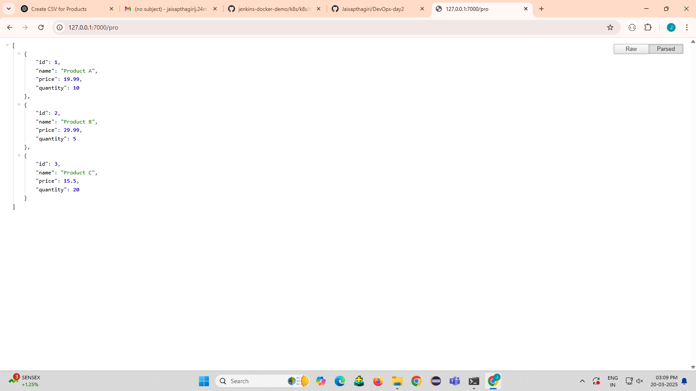

In **frontend**, Create the files like

**index.html**

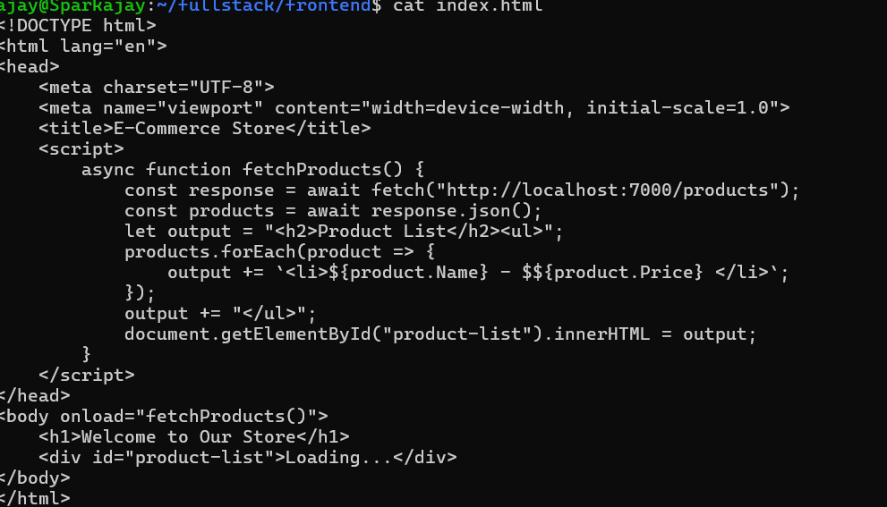

**Dockerfile**

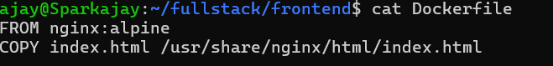

**Build the Docker image in Frontend**

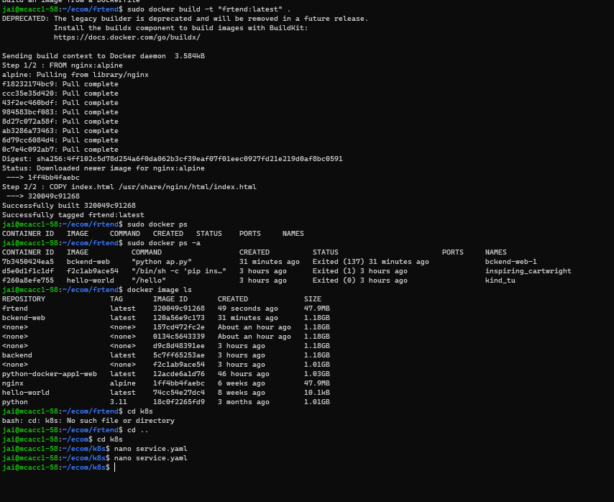

**To create an k8s folder in fullstack using mkdir command:**

**For deployment use Kubernetes**



**Deployment.yaml (for Backend)**

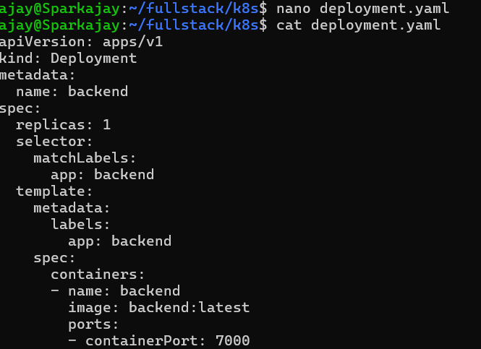

**Deployment.yaml (for Frontend)**

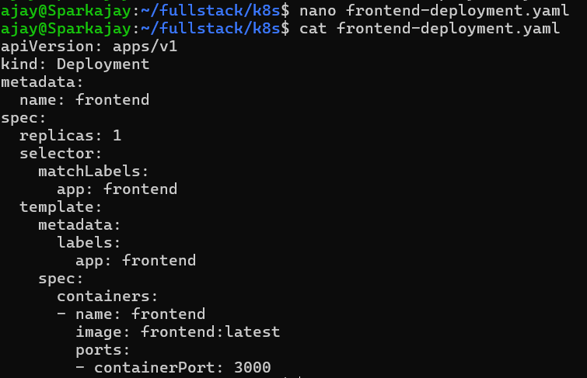

**Service.yaml:**

For **frontend-** nodeport **backend-**cluster IP

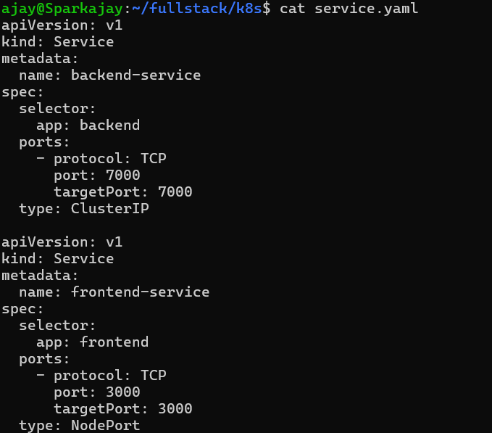

**Configmap.yaml:**

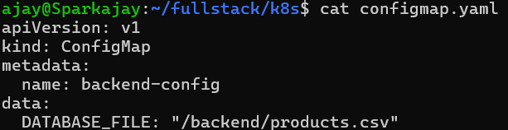

Install minikube

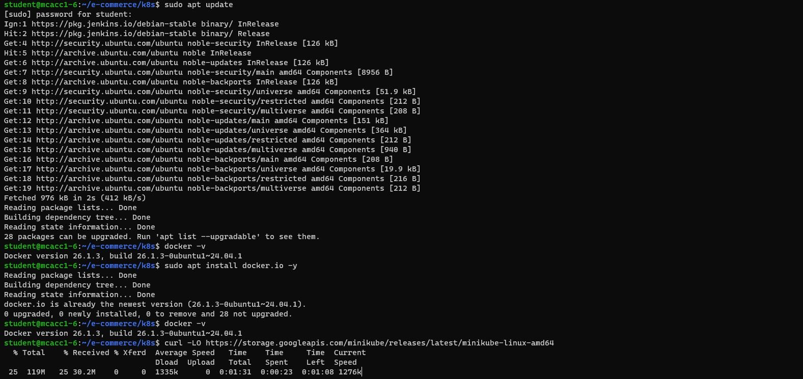Minikube is a tool that allows you to run a Kubernetes cluster locally on our machine. It is designed for developers who want to test and experiment with Kubernetes without needing a full-scale cloud-based cluster.

Install kubectl

kubectl is the command-line tool used to interact with a Kubernetes cluster. It allows you to deploy applications, inspect and manage cluster resources, and troubleshoot issues.

Grant permission for **kubectl chmod +x kubectl**

Move to kubectl to root

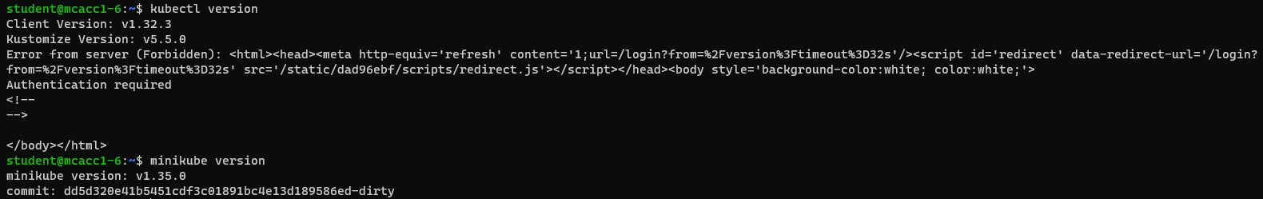Check the **minikube** and **kubectl** installed properly

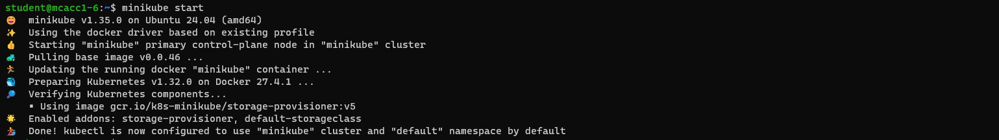Start minicube: **minikube start**

**Verify minikube is running**



**Load the image to the minikube Befor loading images**

**Perform this commend:** eval $(minikube docker-env) minikube image load frontend:latest

minikube image load backend:latest

**Check the images are loaded**

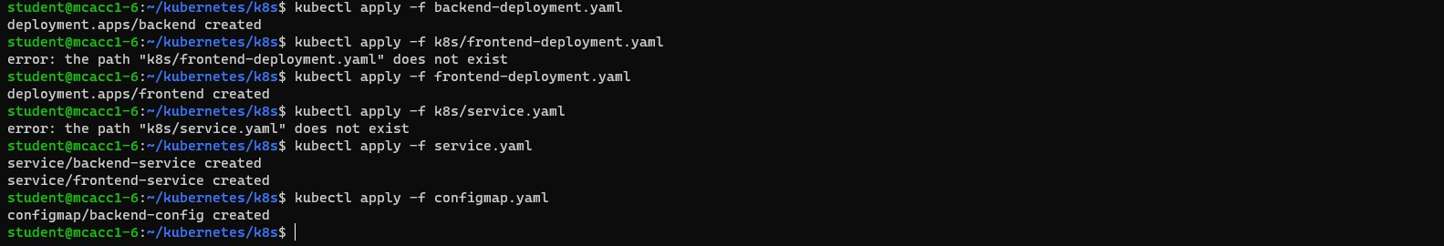Commands are used to deploy your application components (backend and frontend), expose them through a service, and provide them with the necessary configuration via a ConfigMap.

These commands are used to list and inspect the running resources in your Kubernetes cluster:

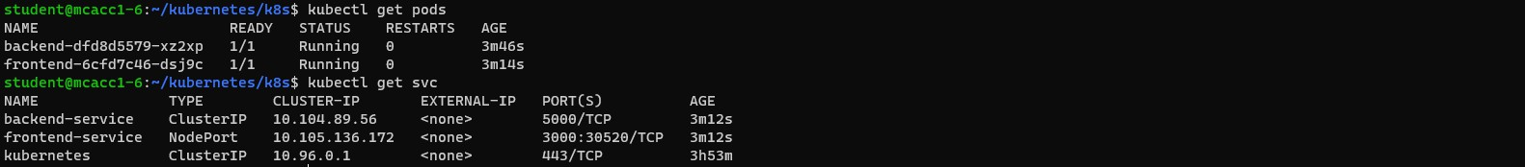**kubectl get pods kubectl get svc**

**To test Frontend**

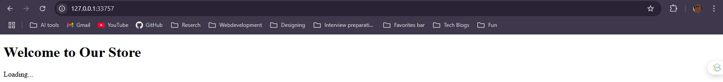

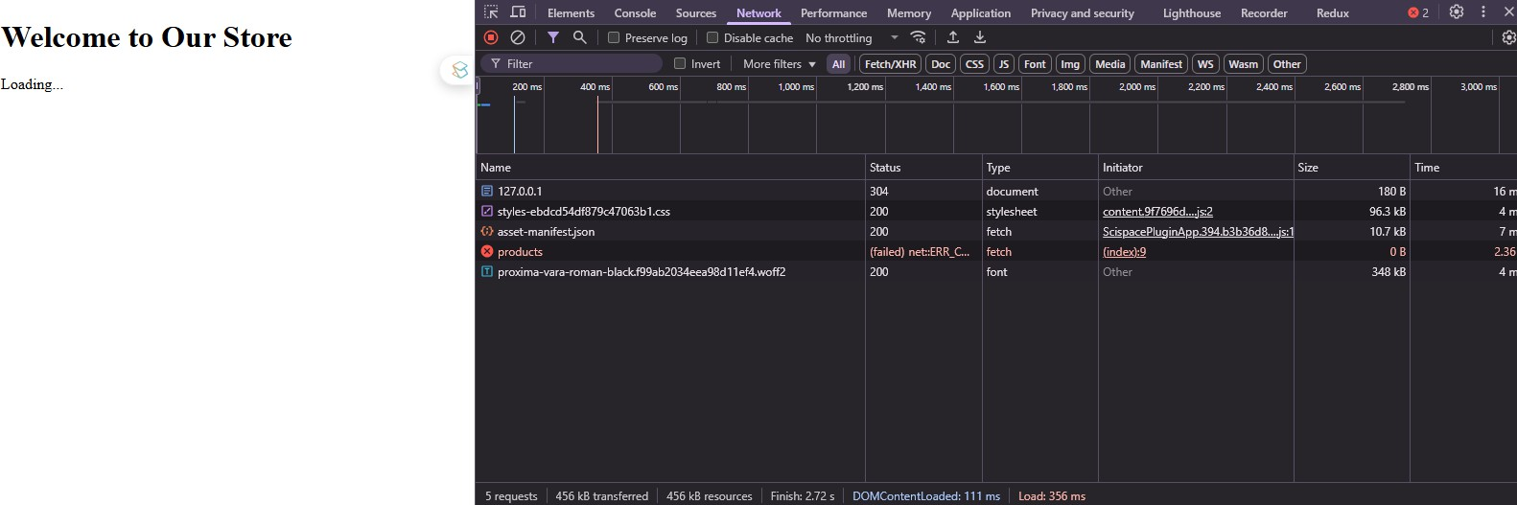**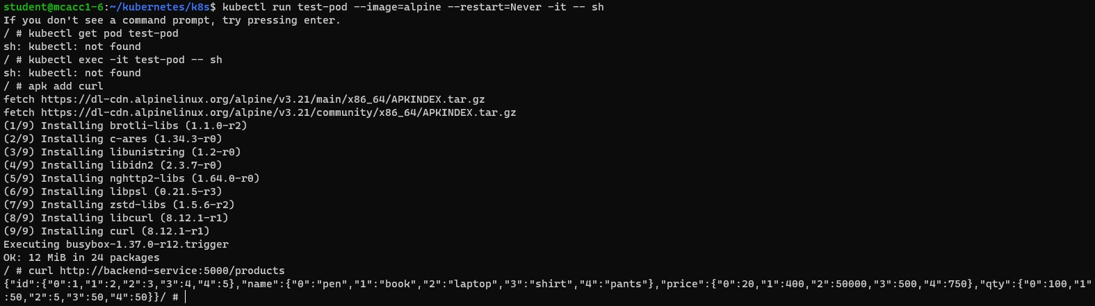To Test backend**

this kind of output because we are running this frontend on localhost.

this kind of output because we are running this frontend on localhost.