#include <stdio.h>

int main()

{

int ch;

do

{

printf("\t1.C\n2.Cpp\n3.Java\n4.Python\n5.Exit\n\n\nEnter your choice to know about the above language:\n\n\n");

scanf("%d",&ch);

if(ch<5 && ch>0)

switch(ch)

{

case 1:

printf("Founder- Dennis Ritchie in the year 1970\n");

break;

case 2:

printf("Founder - Bjarne Stroustrup in the year 1980\n");

break;

case 3:

printf("Founder - James Gosling in the year 1995\n");

break;

case 4:

printf(“Founder - Guido van Possum in the year 1991\n");

break;

case 5:

printf("Exit");

exit(0);

break;

}

}

while(1);

}

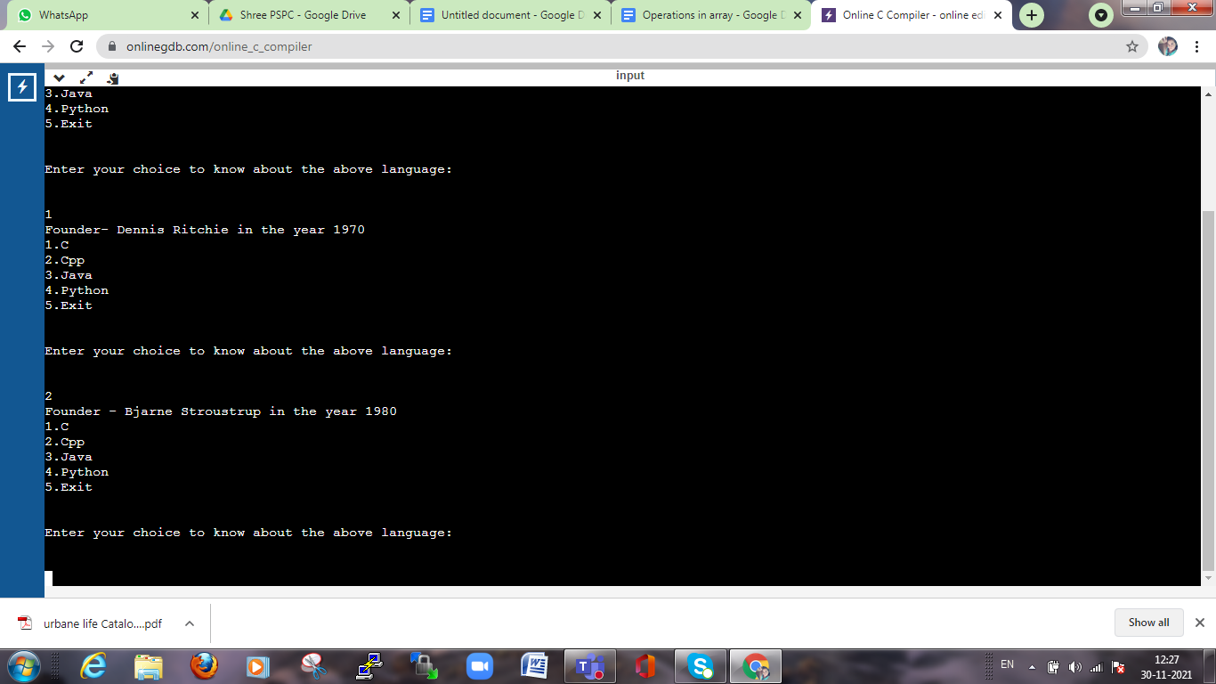

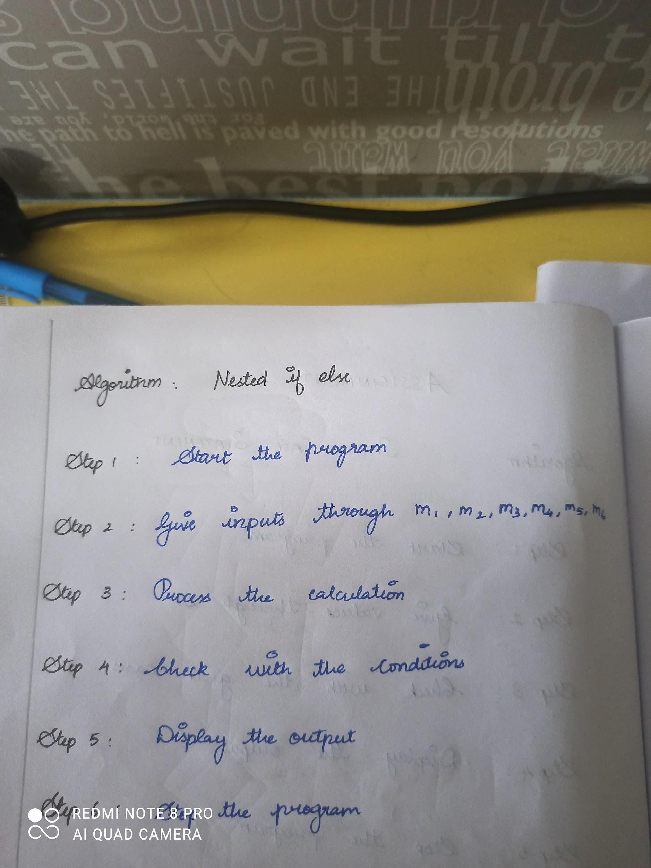

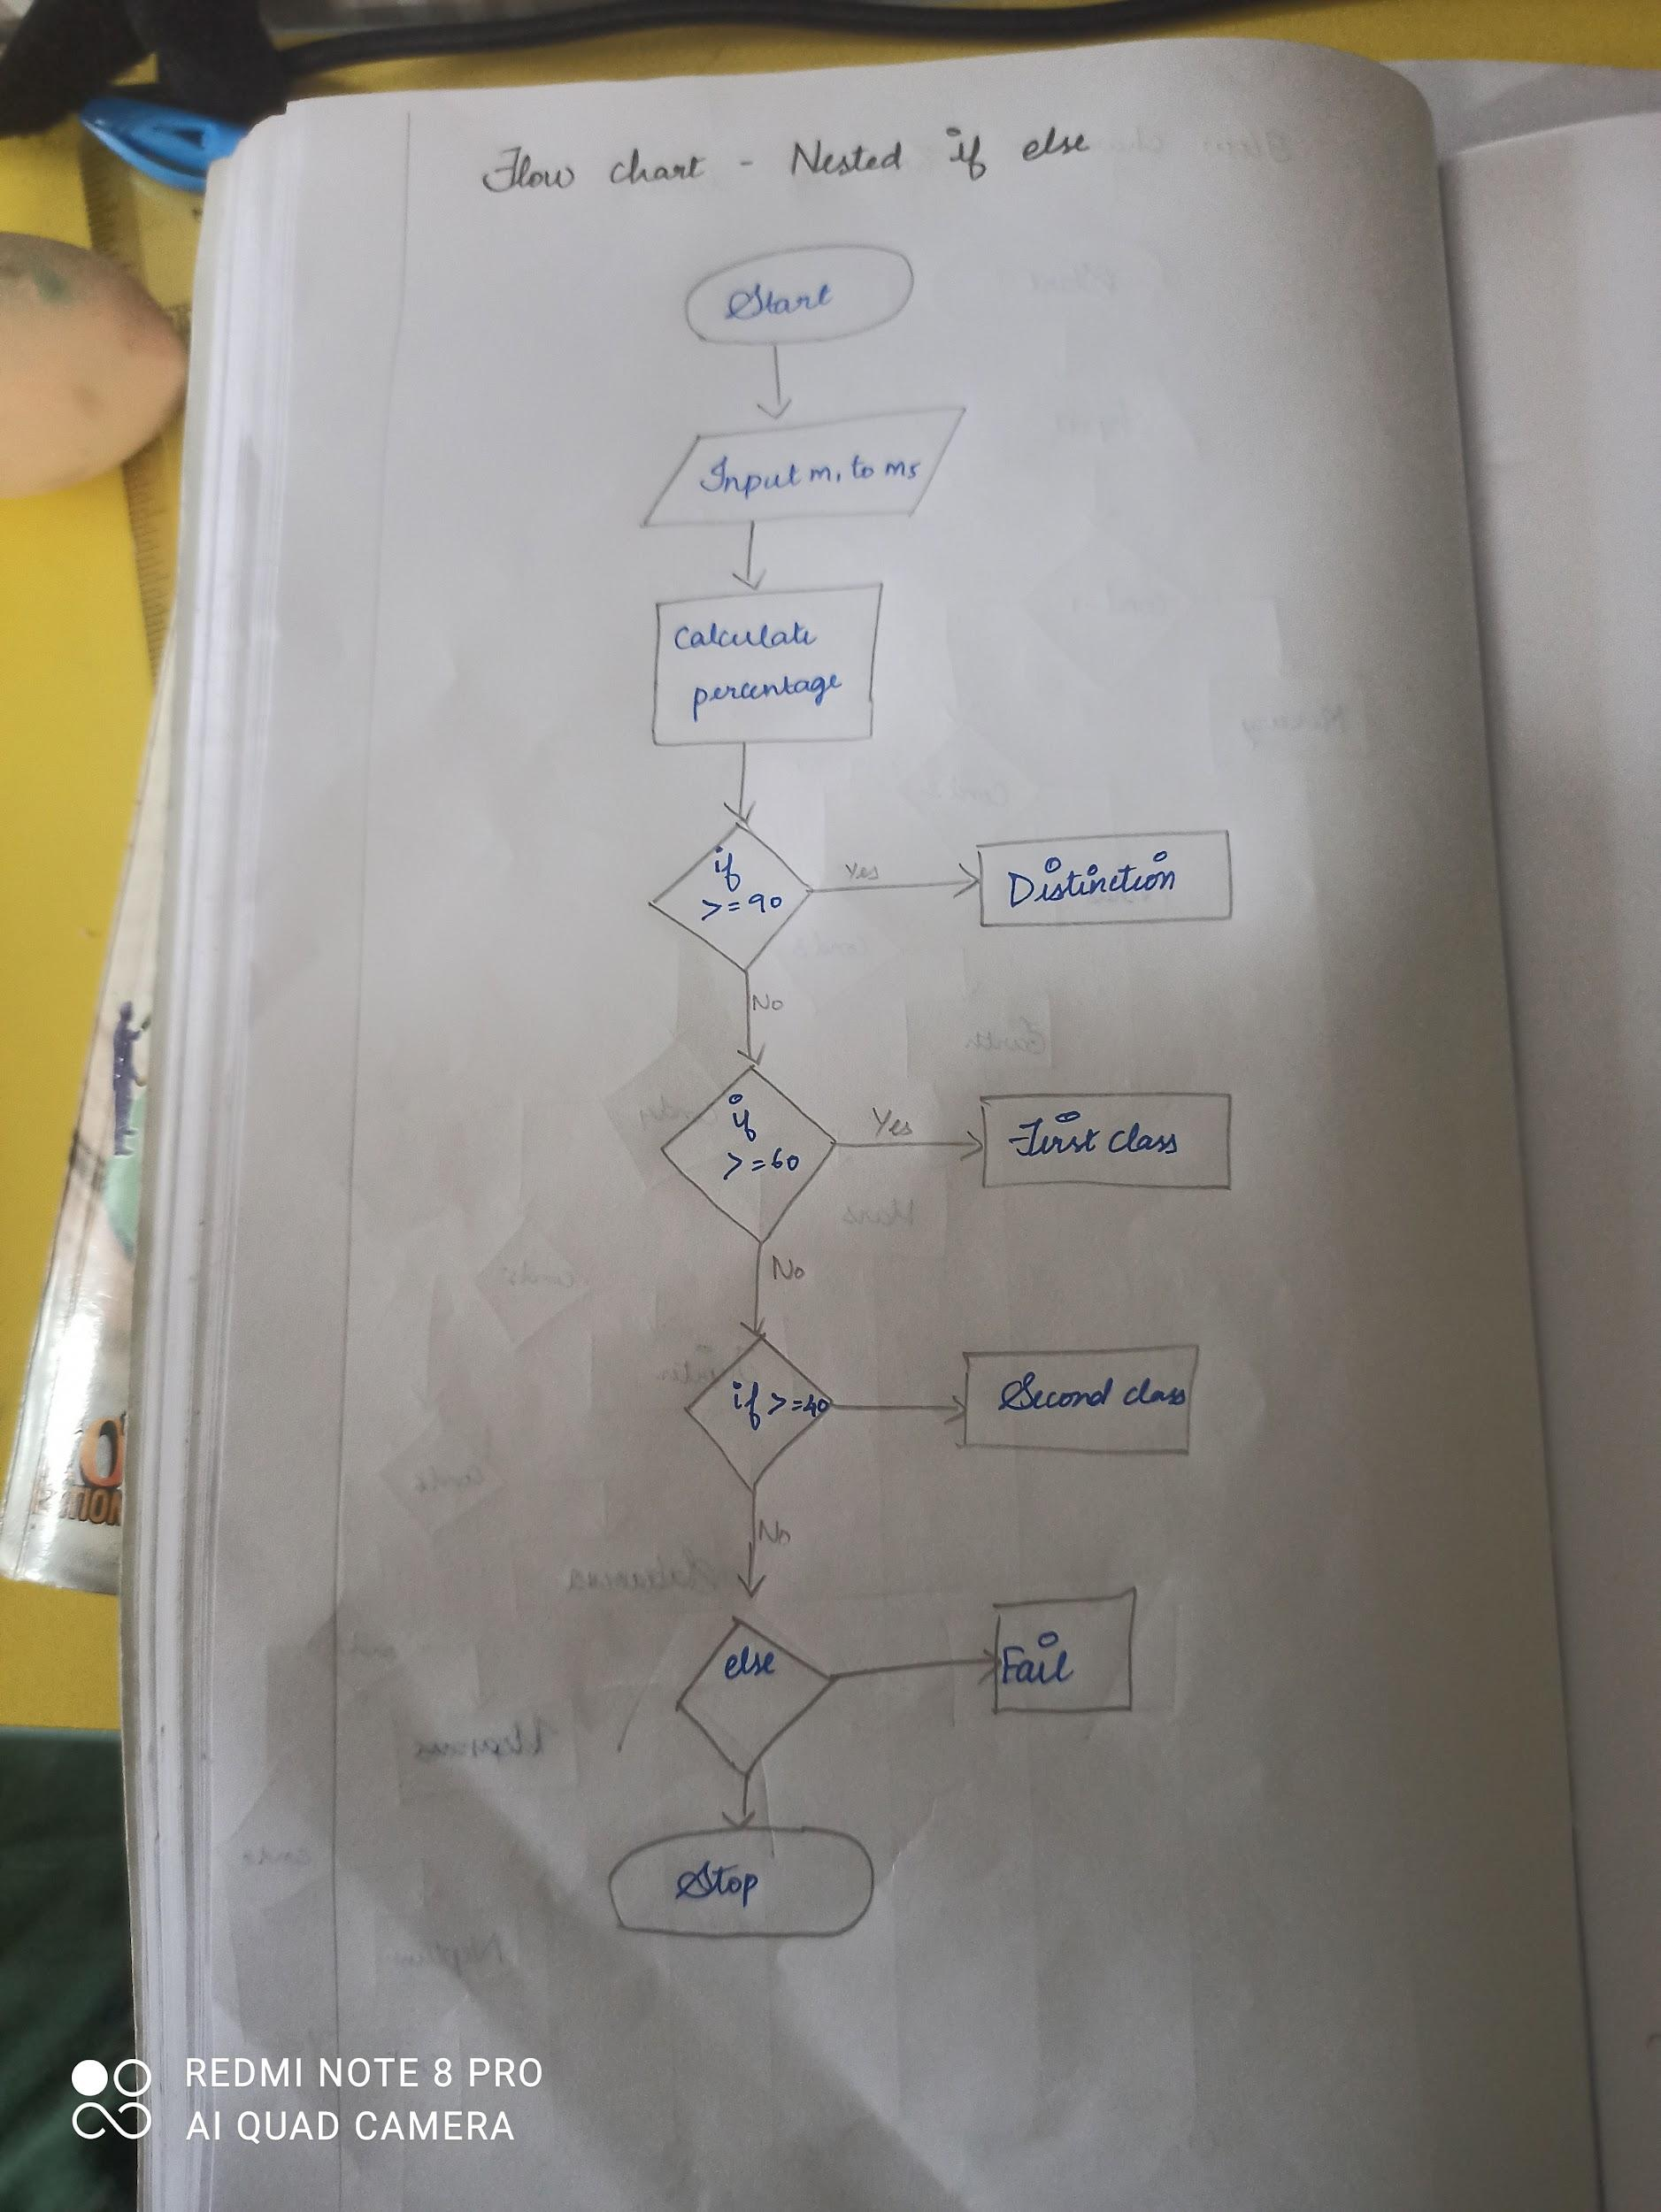

#include <stdio.h>

int main()

{

int m1,m2,m3,m4,m5,percent;

printf("Enter the marks in five subjects:\n");

scanf("%d%d%d%d%d",&m1,&m2,&m3,&m4,&m5);

percent=(m1+m2+m3+m4+m5)\*100/500;

printf("The percentage obtained is %d",percent);

if(percent>=90)

printf("Distinction");

else

{

if(percent>=60)

{

printf("First Class");

}

else

{

if(percent>=40)

{

printf("Second class");

}

else

printf("Fail");

}

}

}

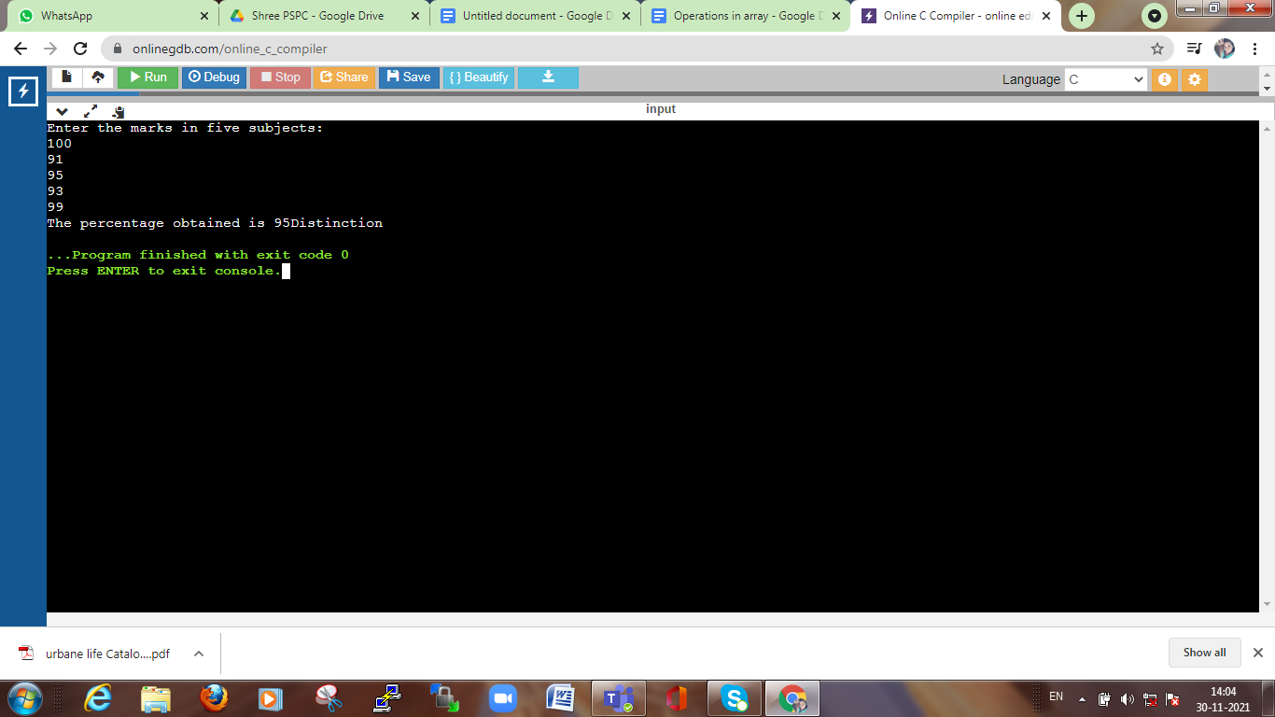

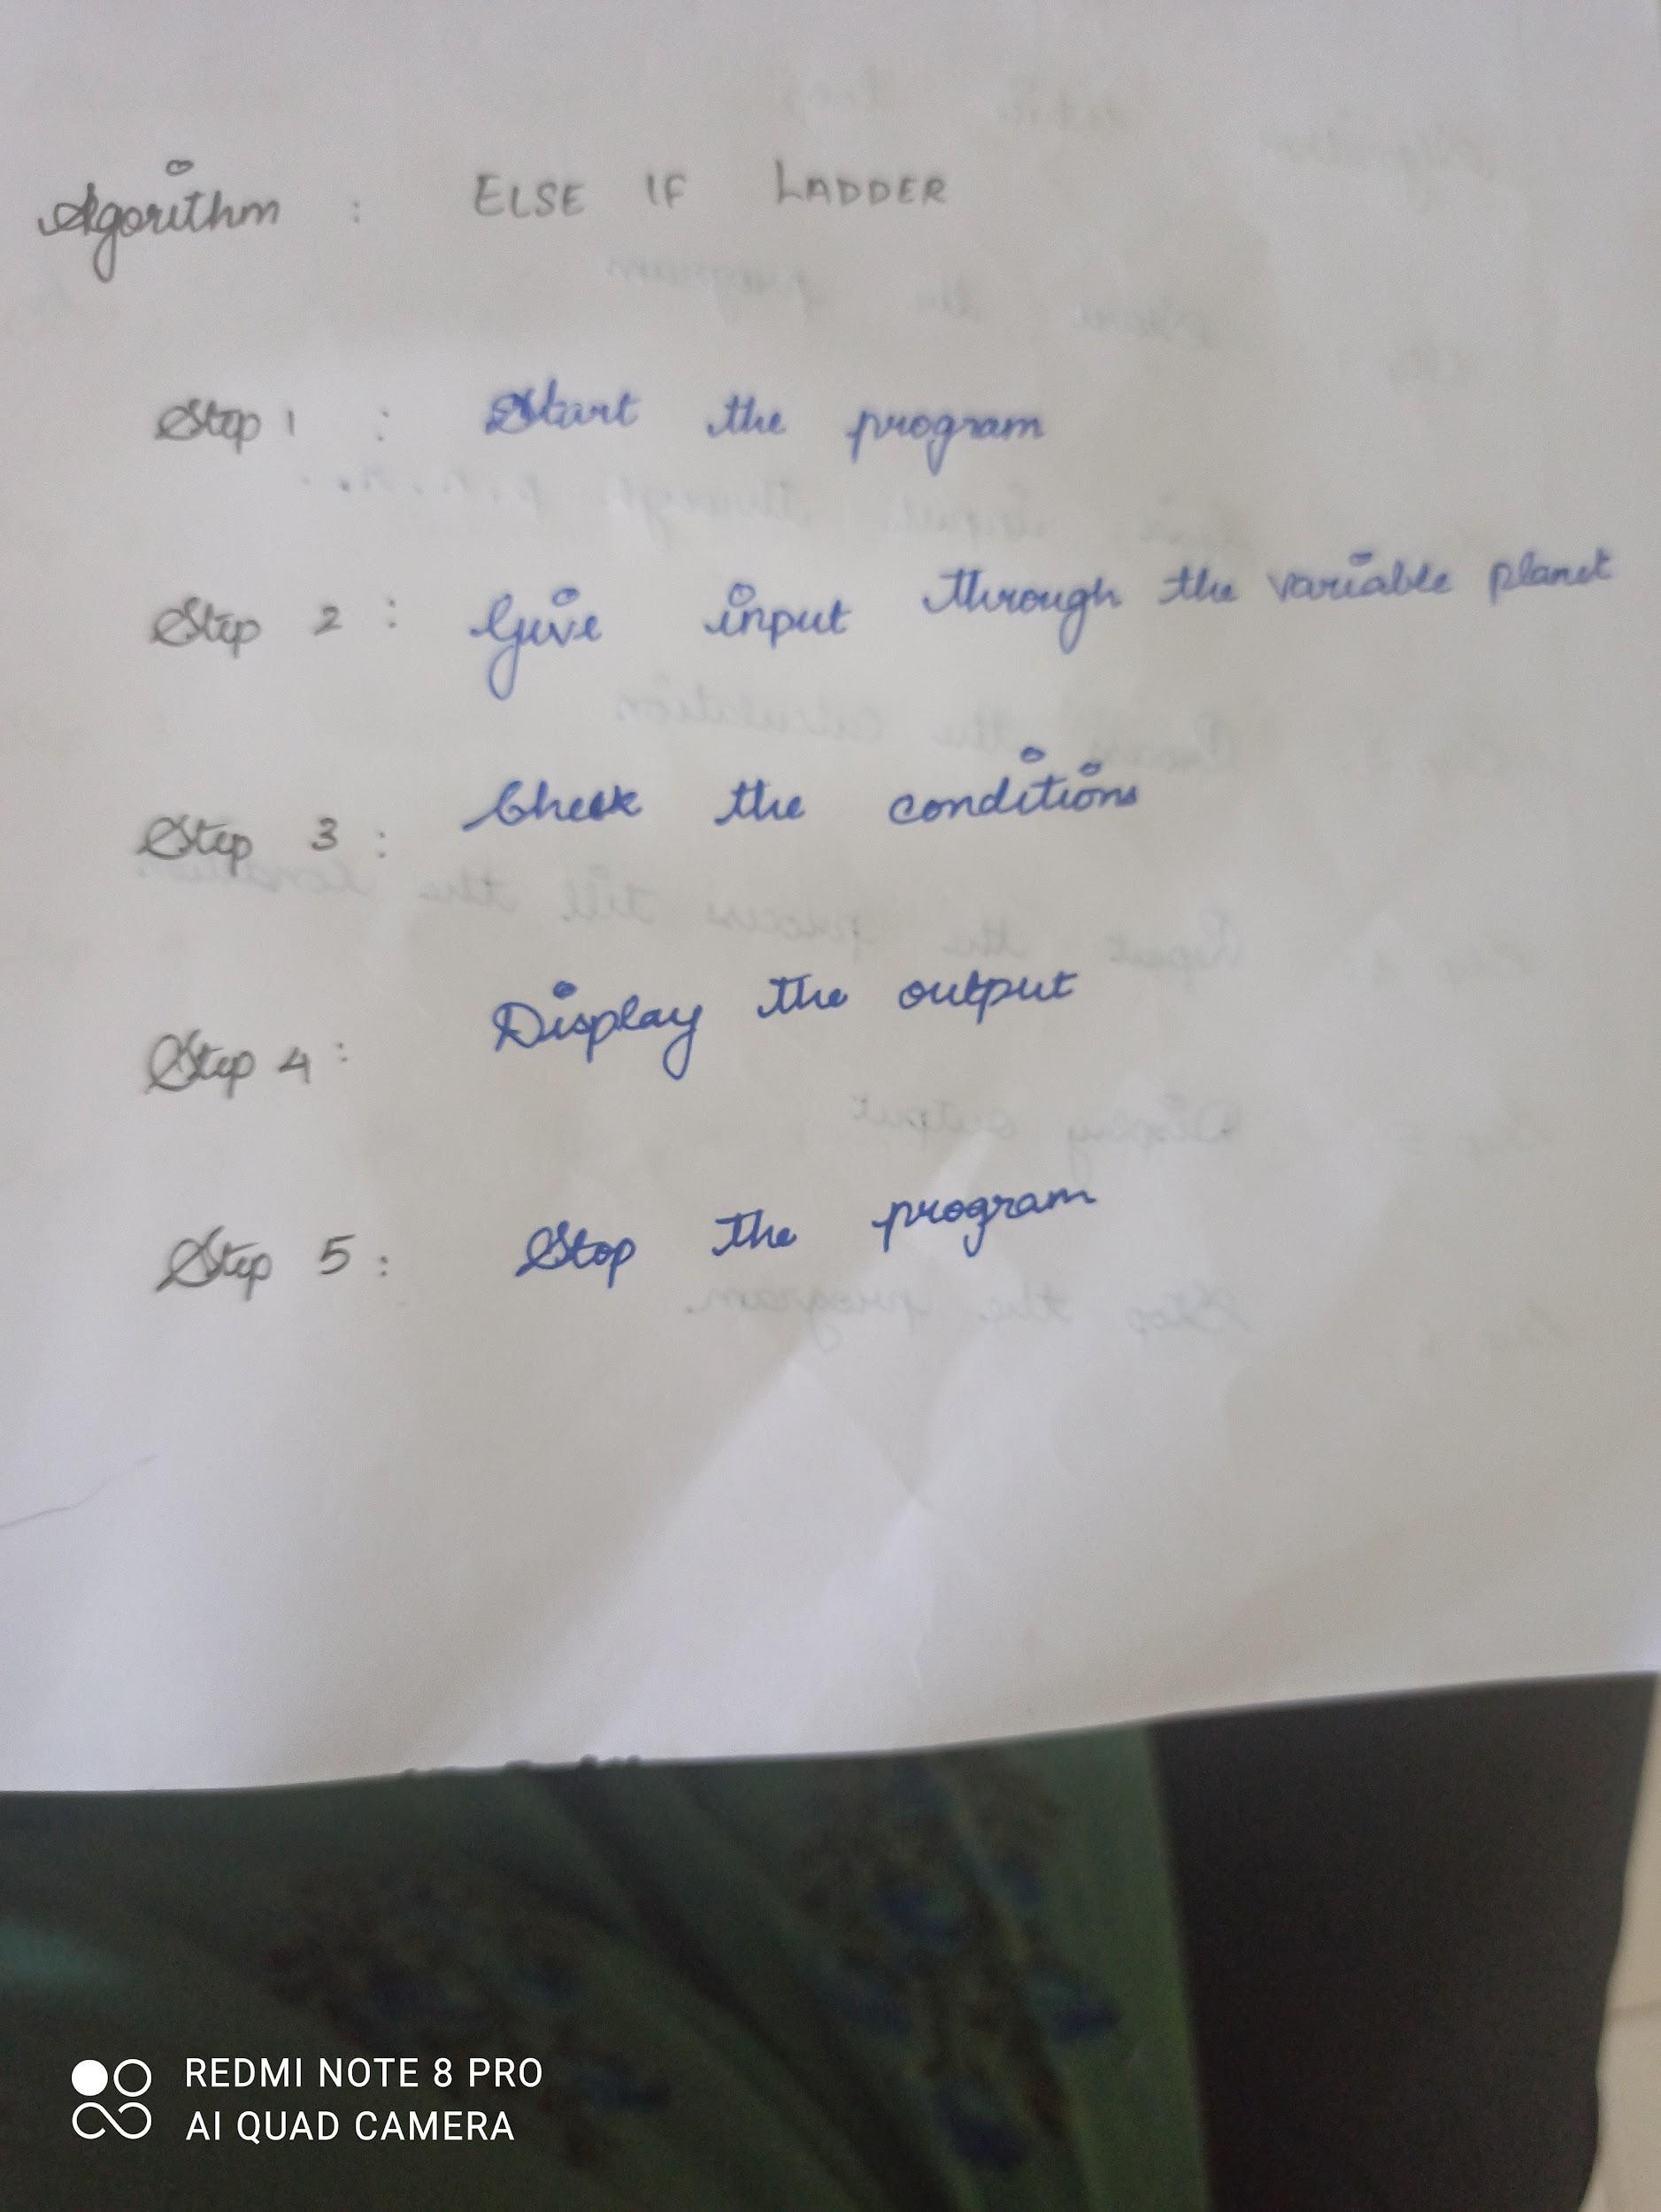

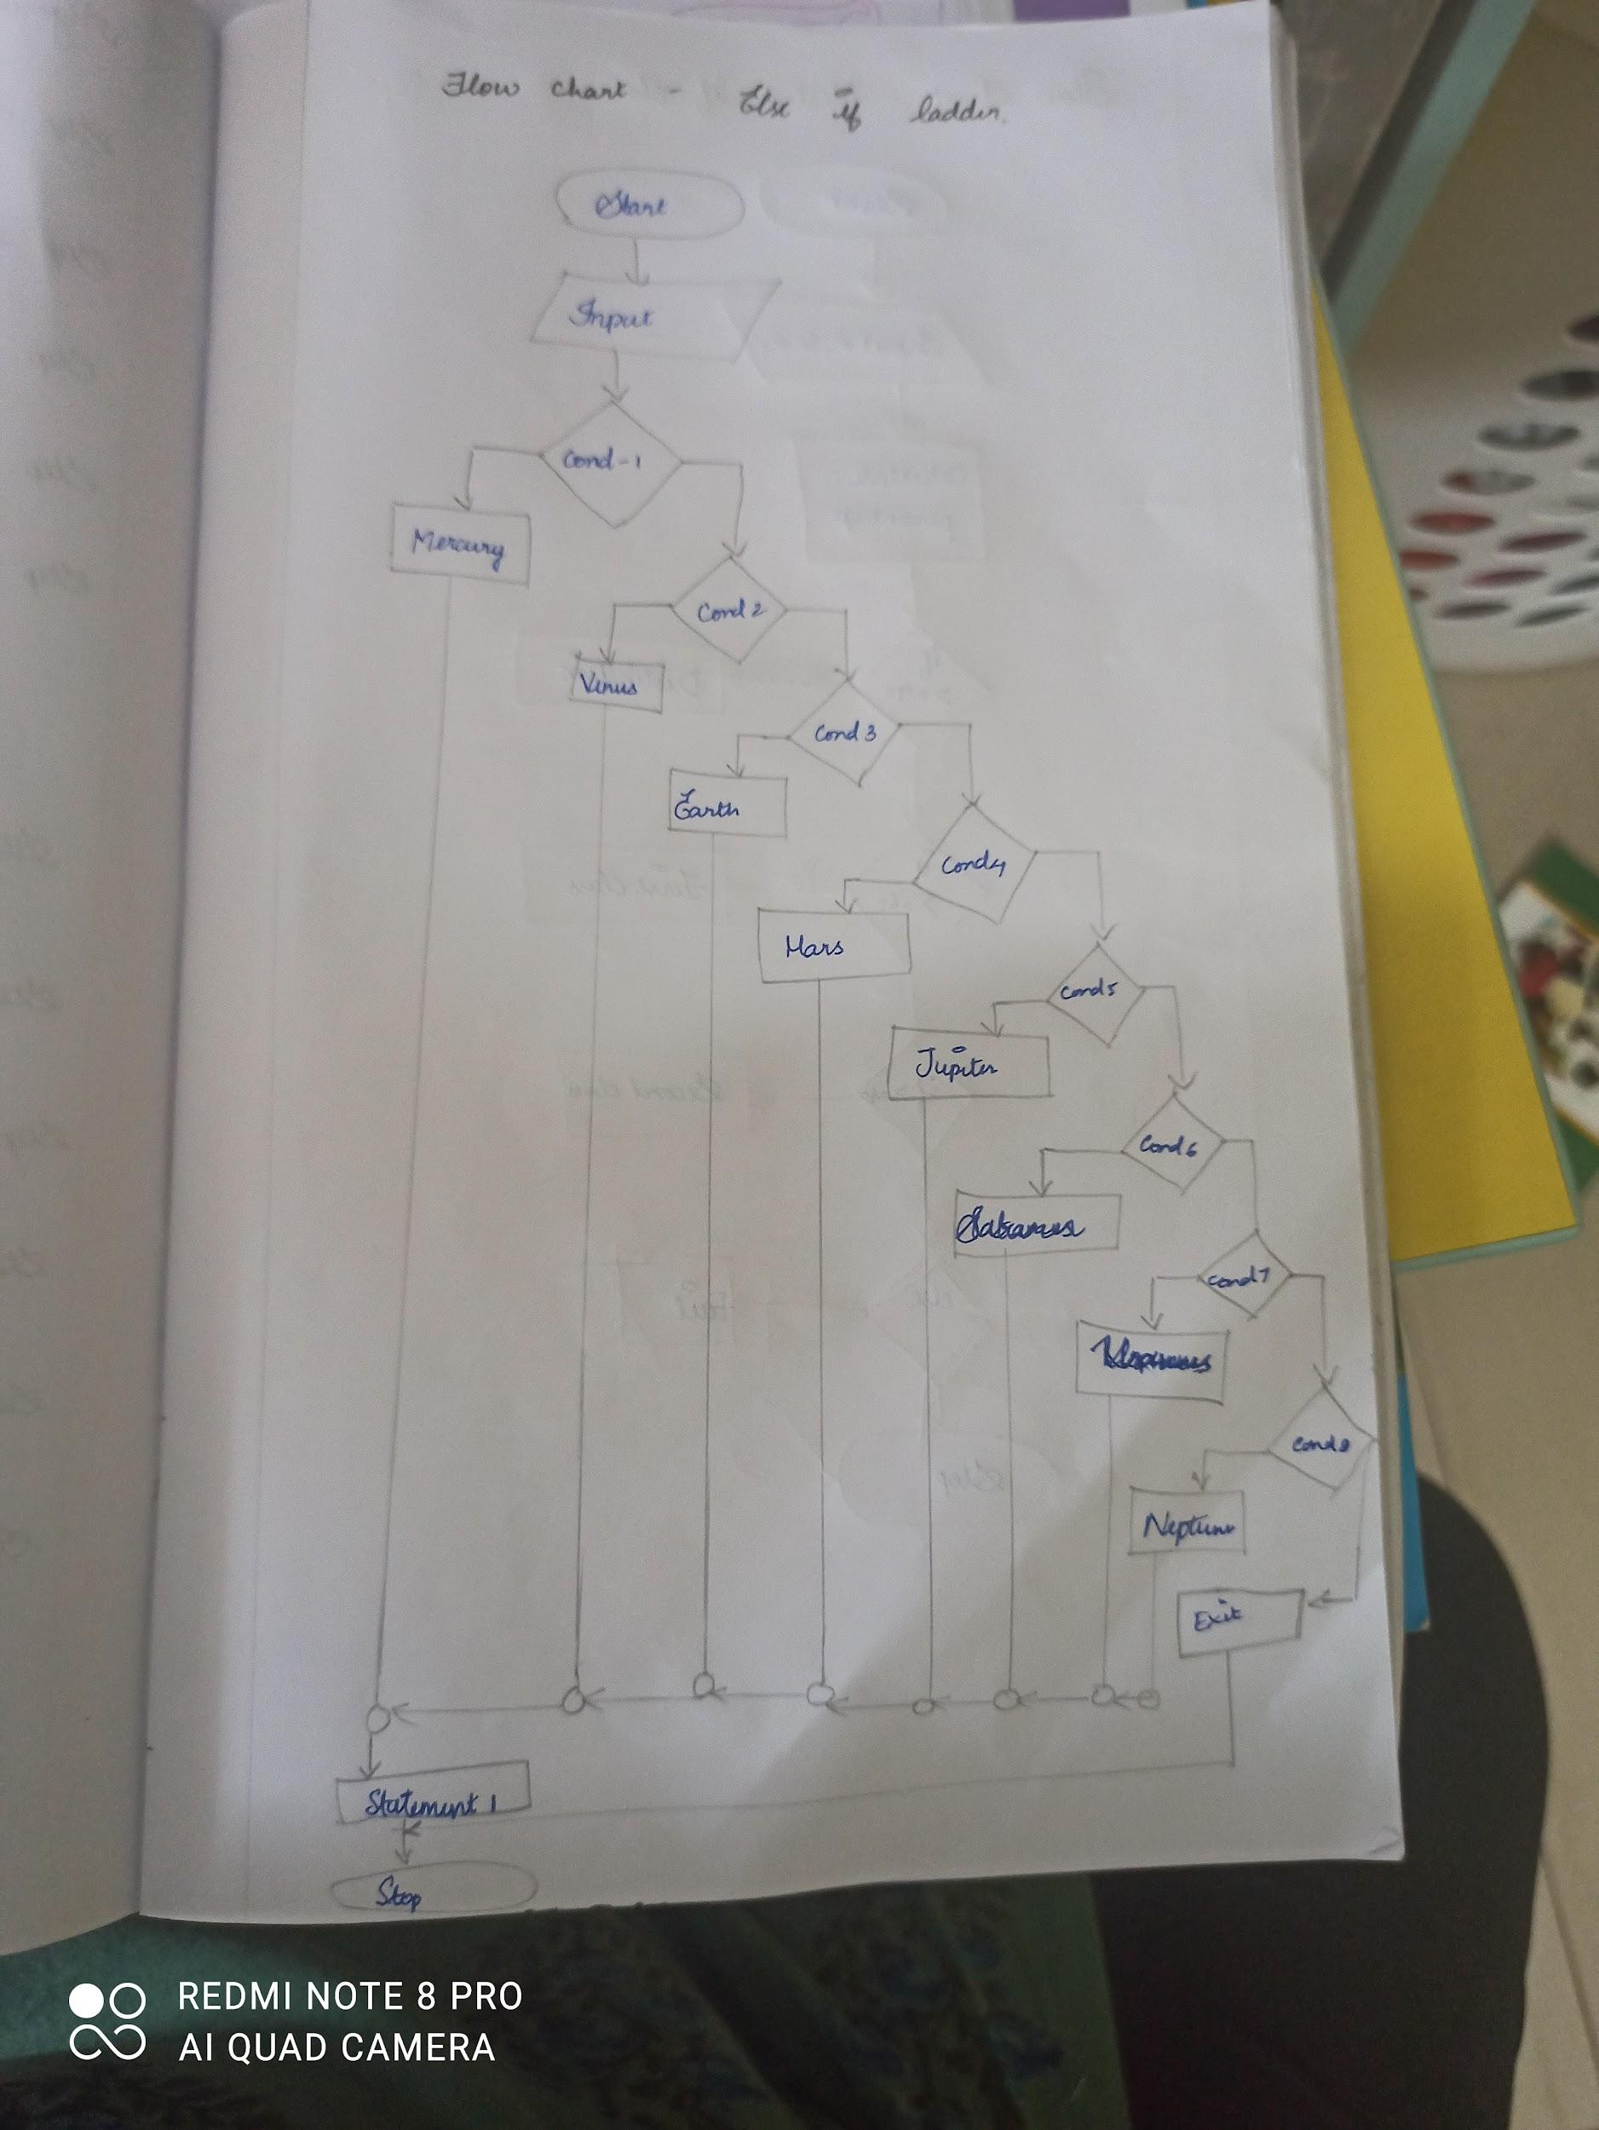

#include <stdio.h>

int main()

{

int planet;

printf("Enter the number between 1 to 8:\n");

scanf("%d",&planet);

if(planet==1)

printf("Mercury\n");

else if(planet==2)

printf("Venus\n");

else if(planet==3)

printf("Earth\n");

else if(planet==4)

printf("Mars\n");

else if(planet==5)

printf("Jupiter\n");

else if(planet==6)

printf("Saturn\n");

else if(planet==7)

printf("Uranus\n");

else if(planet==8)

printf("Neptune\n");

else

printf("Enter a valid number!\n");

getch();

}

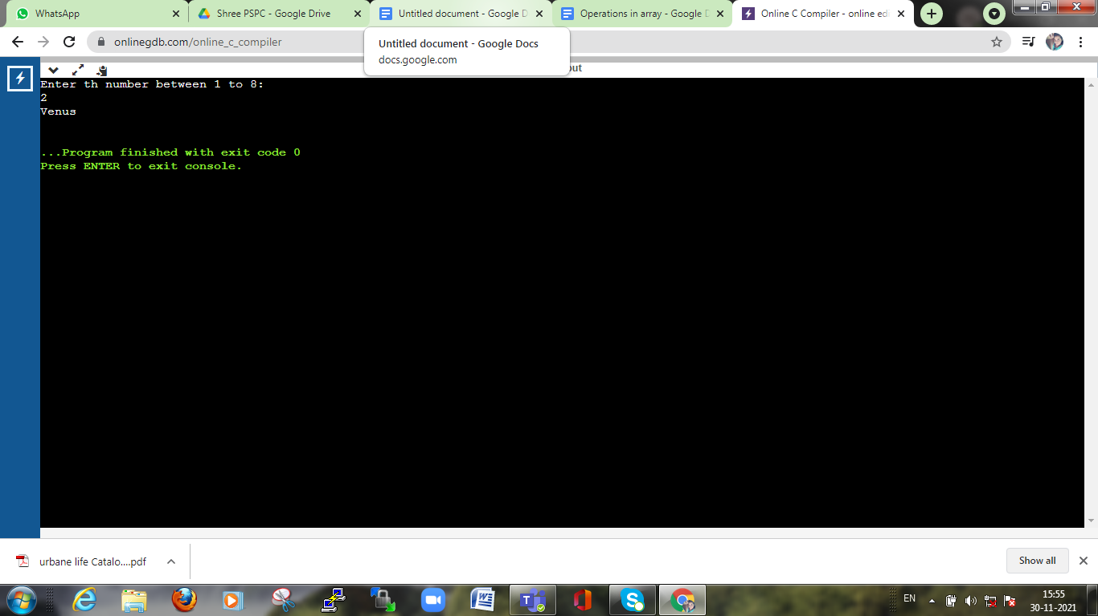

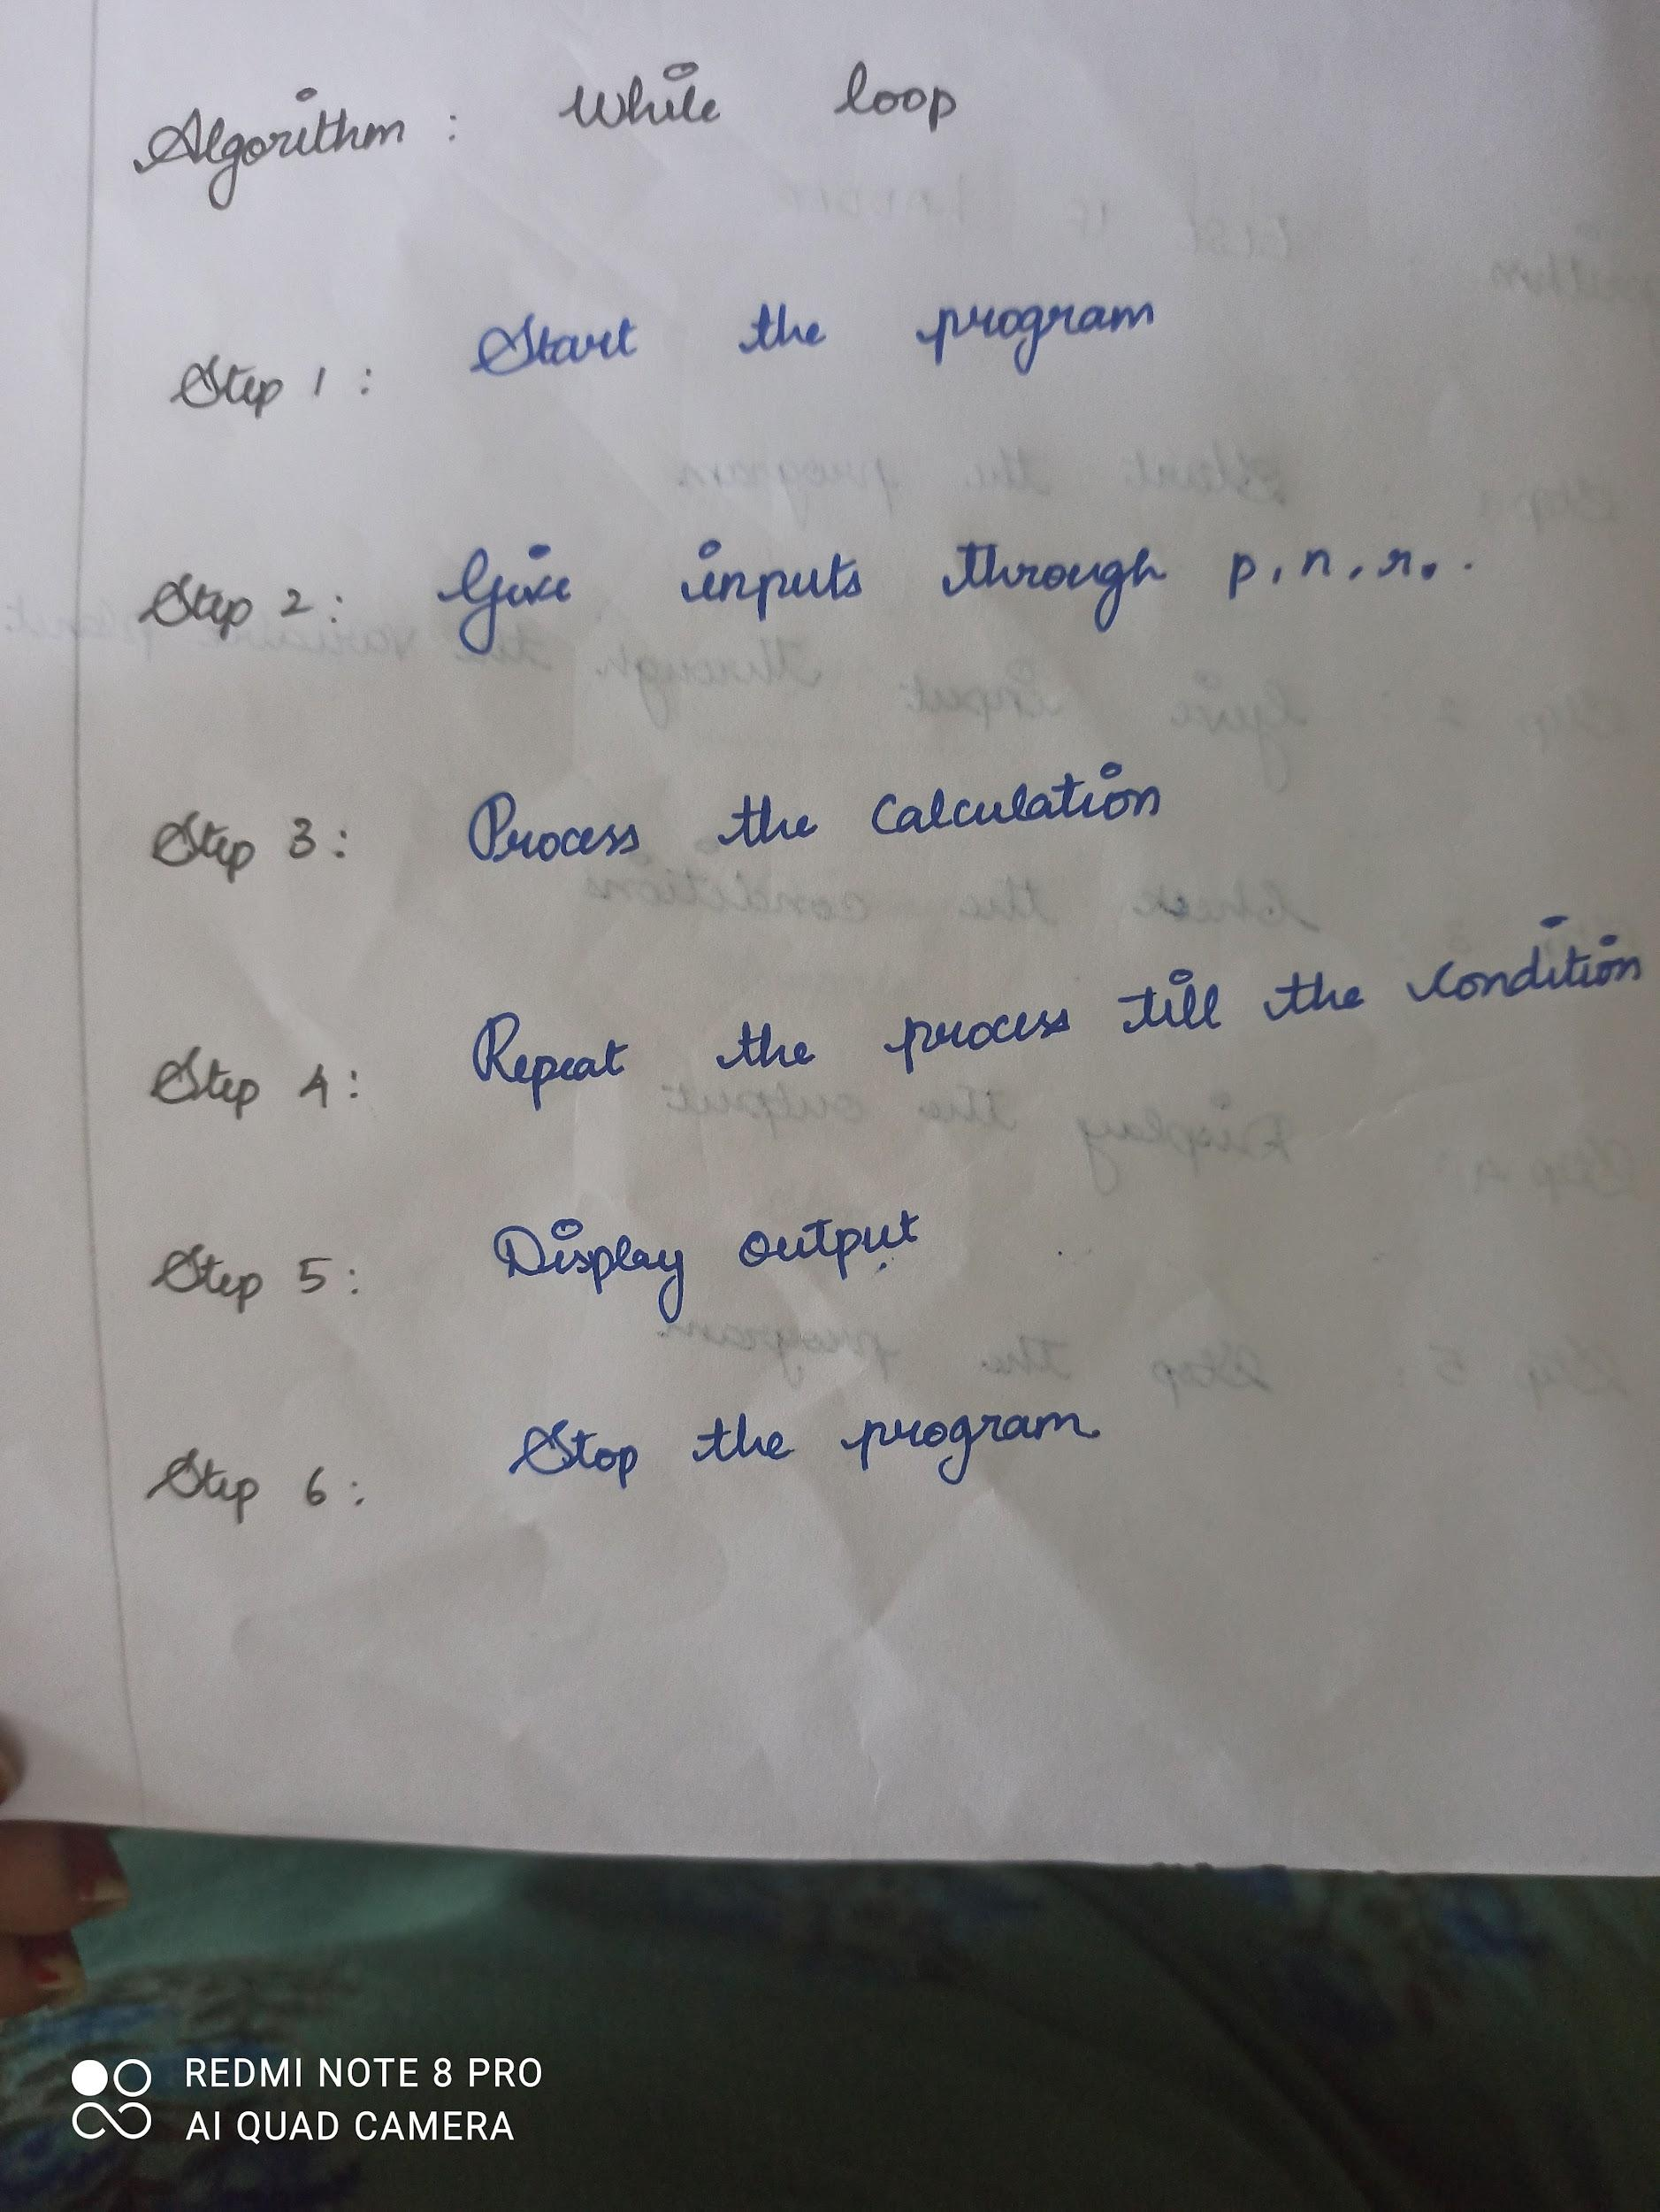

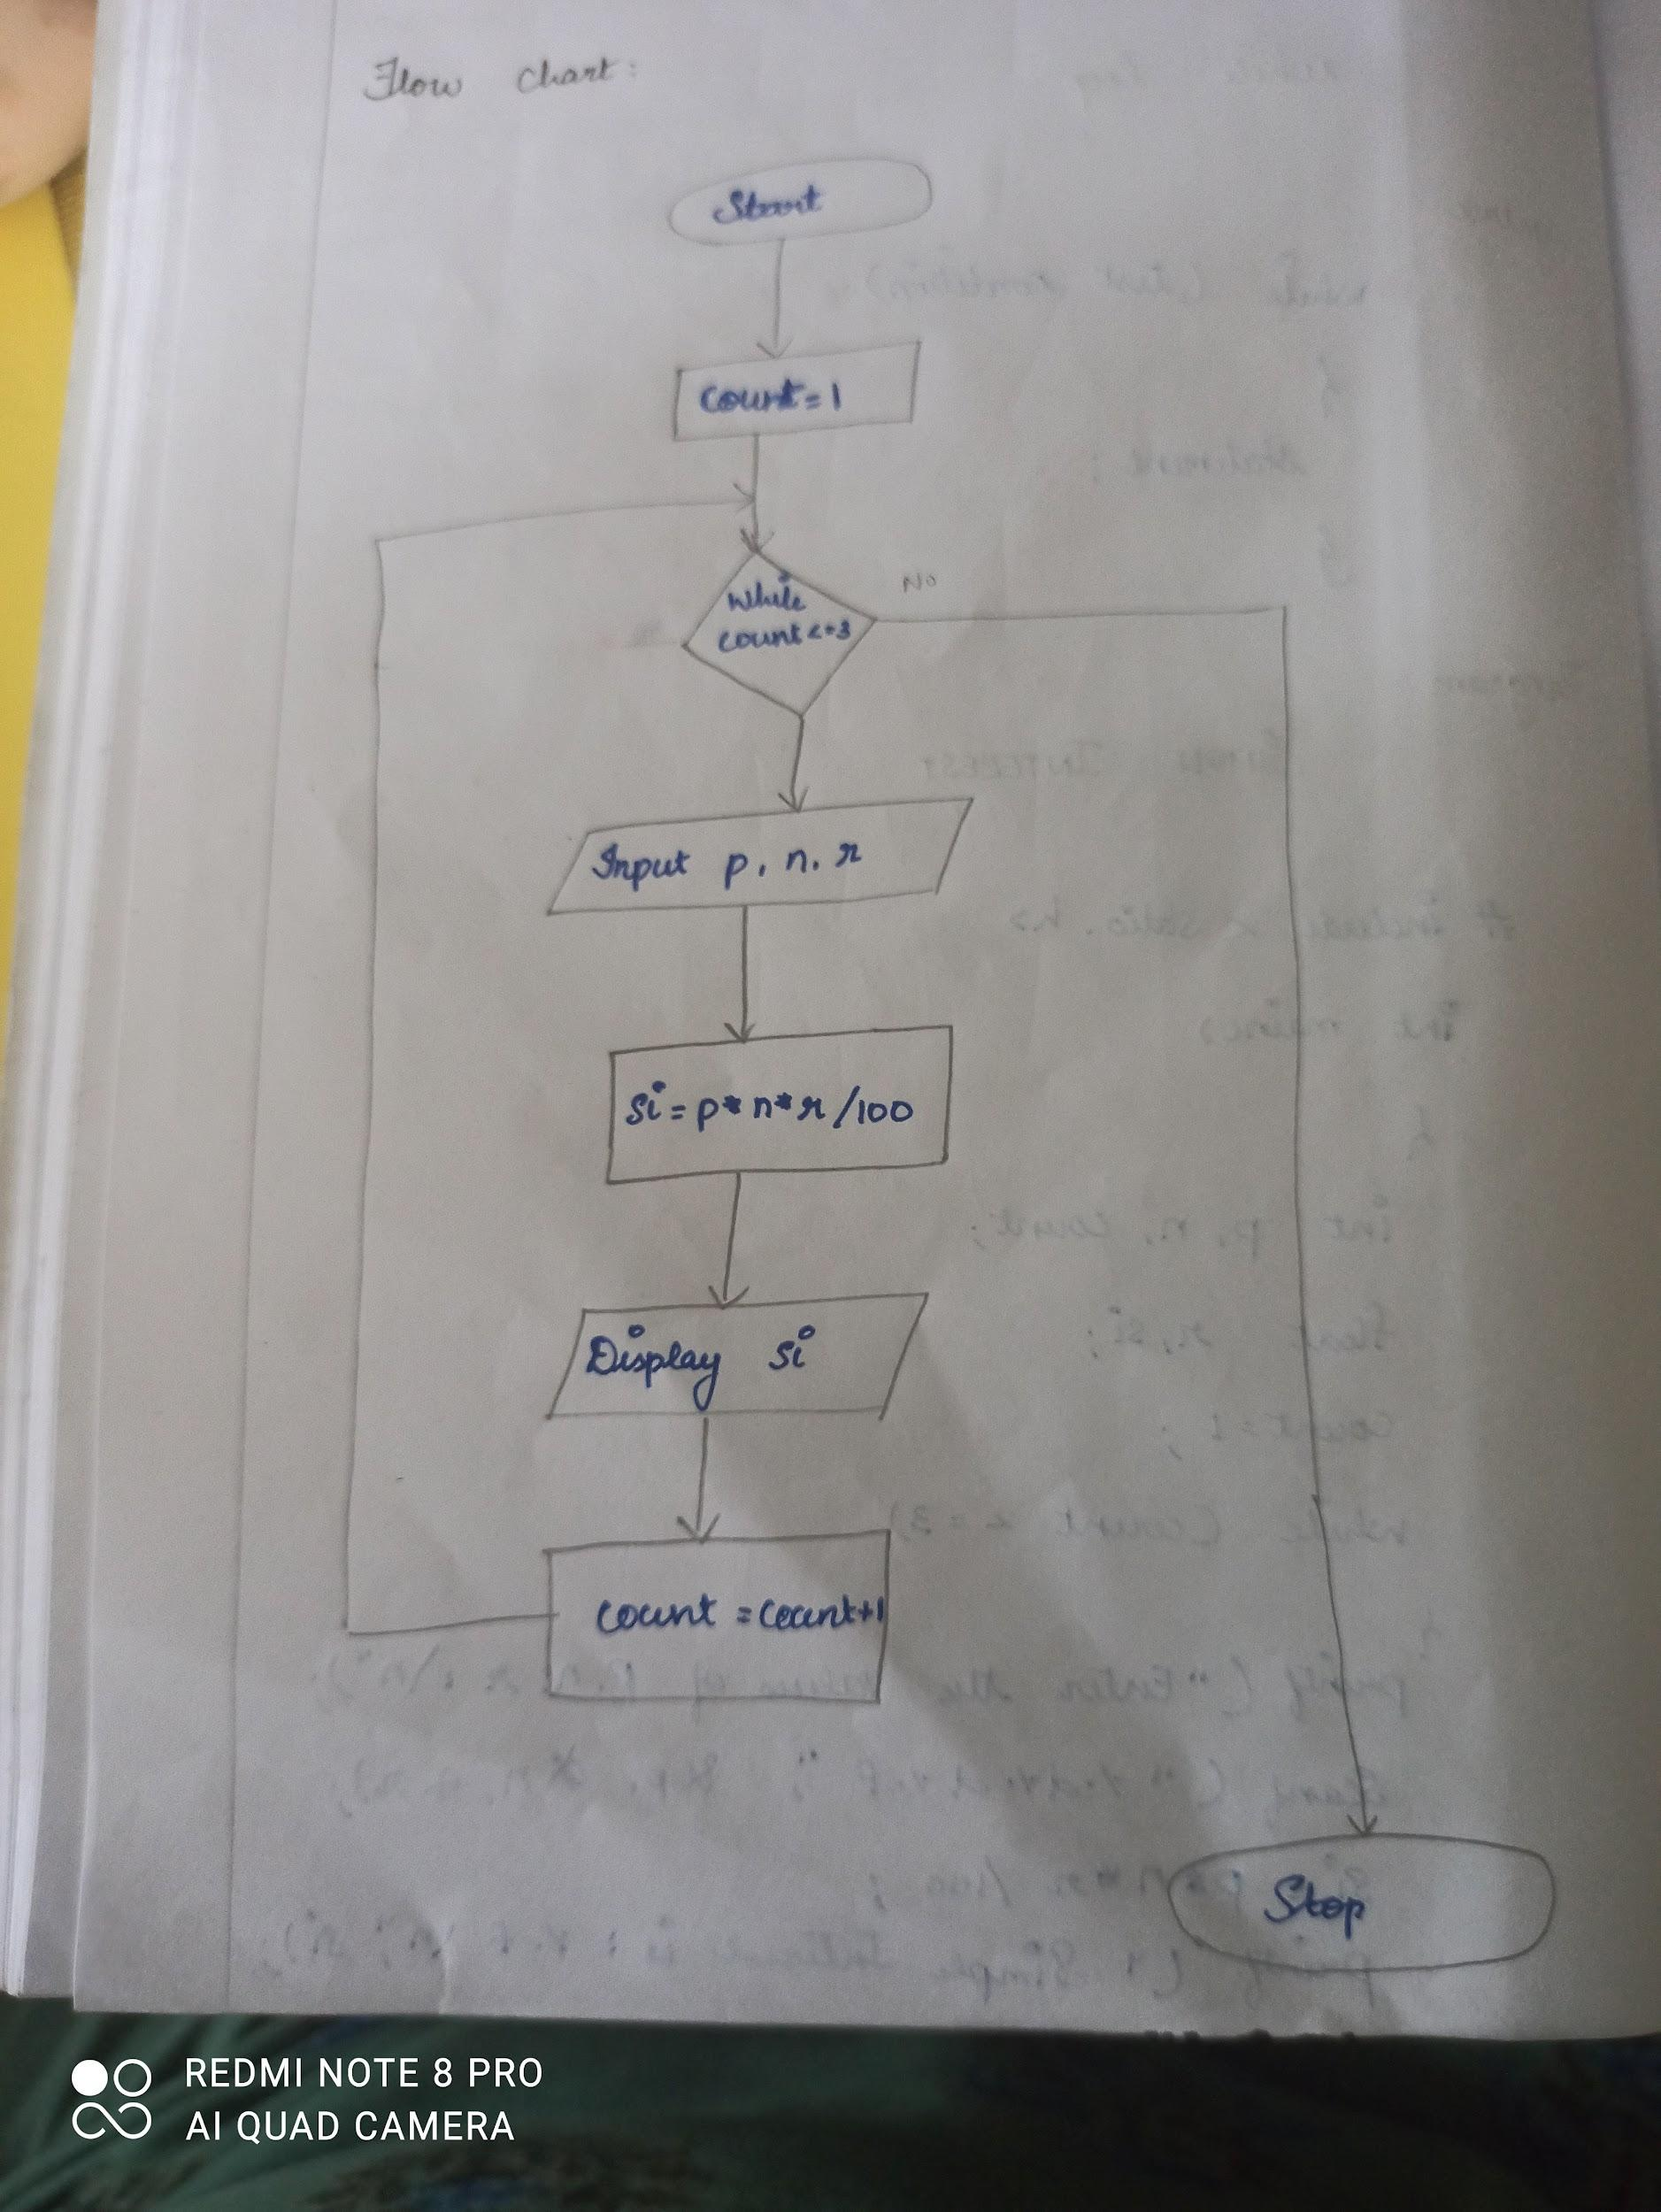

#include <stdio.h>

int main()

{

int p,n,count;

float r,si;

count=1;

while(count<=3)

{

printf("Enter the values of p,n,r:\n");

scanf("%d%d%f",&p,&n,&r);

si=(p\*n\*r)/100;

printf("Simple interest is %f:\n",si);

count=count+1;

}

return 0;

}

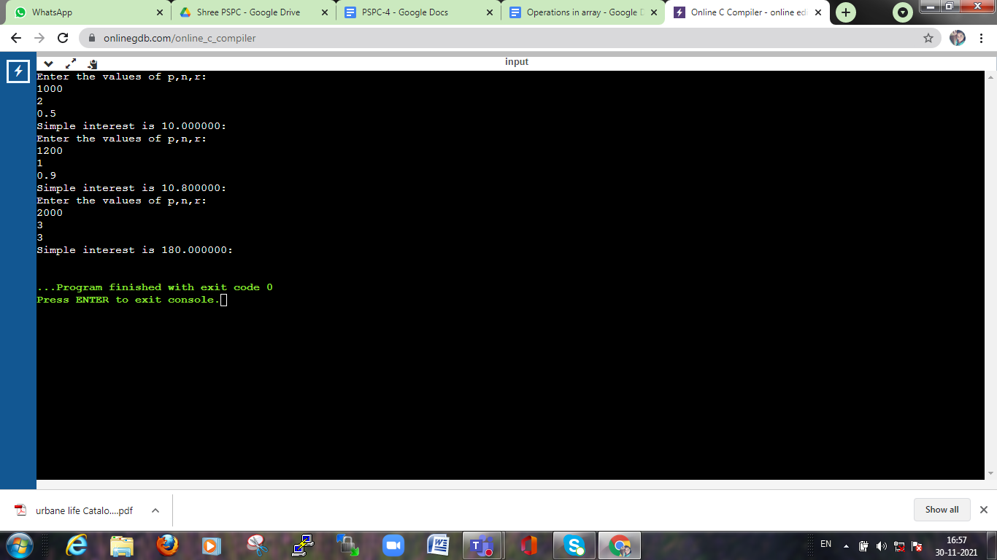

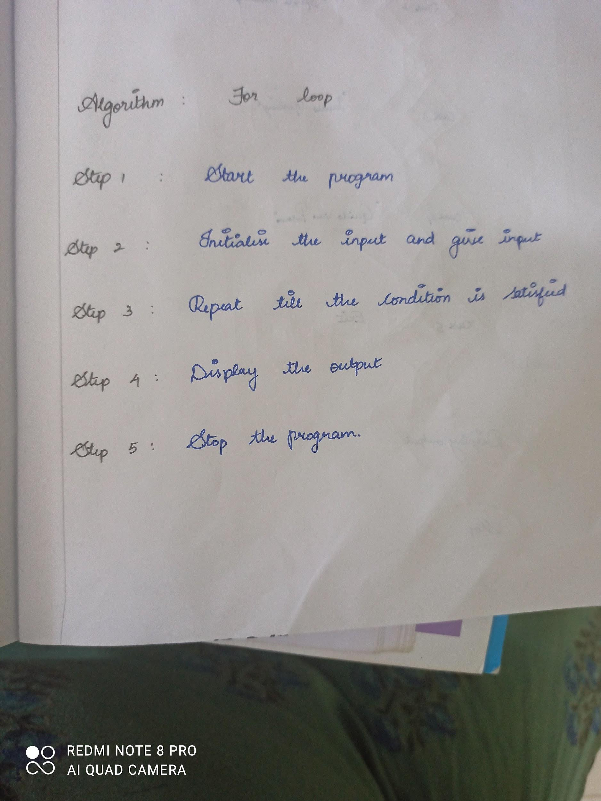

#include <stdio.h>

int main()

{

int i,j,array[10];

printf("0;

}

Enter the elements of the array:\n");

for(i=0;i<10;i++)

{

scanf("%d",&array[i]);

}

printf("The elements in the array are:\n");

for(j=0;j<10;j++)

{

printf("%d\n",array[j]);

}

return

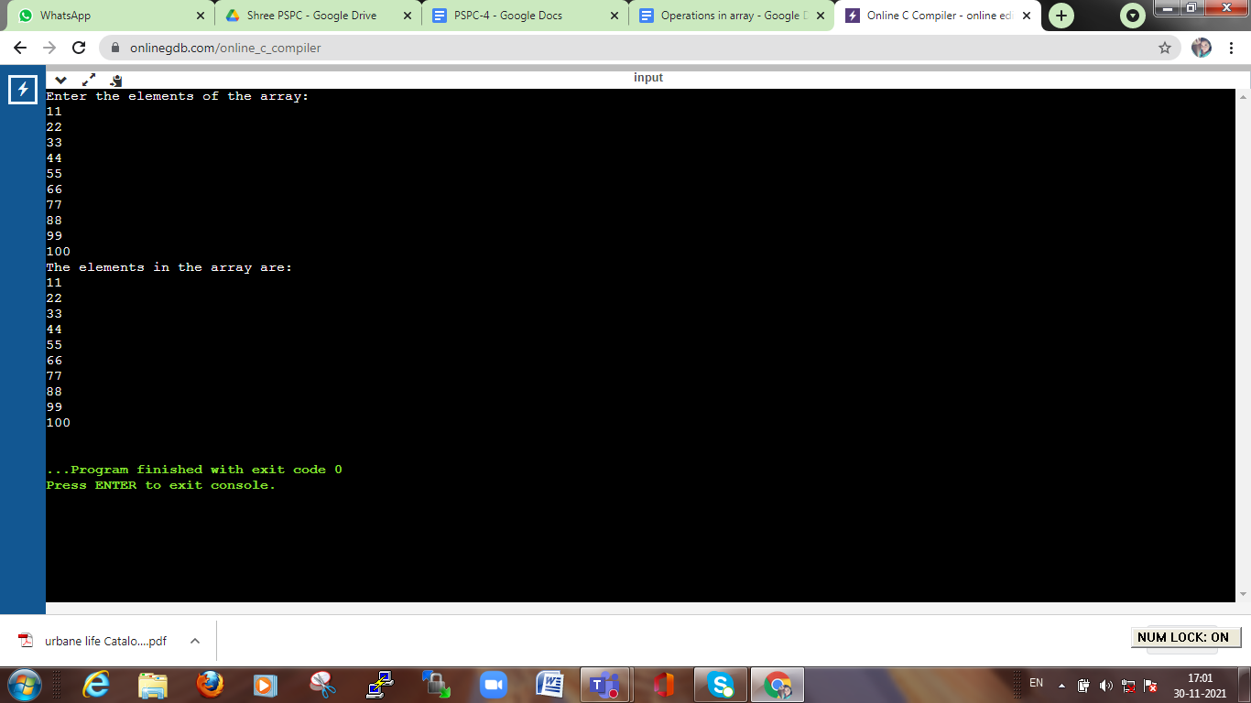

#include <stdio.h>

int main()

{

int i=1;

do{

printf("%d\n",i);

i++;

}

while(i<=10);

return 0;

}

