VISVESVARAYA TECHNOLOGICAL UNIVERSITY

“Jnana Sangama”, Belagavi – 590018, Karnataka.

A Mini Project Report (BIS586)
on

“Blood Donation and Emergency Connection”
Submitted in partial fulfillment for the award of degree of
BACHELOR OF ENGINEERING
in
DEPARTMENT OF INFORMATION SCIENCE AND ENGINEERING
Project Associates

- Namana.S 1DB23IS101
- Vanishree B.S 1DB23IS174

Under the Guidance of
Mrs. Chaithra A.S
Assistant Professor


Dept of Information Science and Engineering Don Bosco Institute of Technology

Department of Information Science and Engineering DON BOSCO INSTITUTE OF TECHNOLOGY

Kumbalagodu, Mysuru road, Bengaluru-560074
2025-26

Don Bosco Institute of Technology

Kumbalgodu Mysuru Road Bengaluru-560074 DEPARTMENT OF INFORMATION SCIENCE & ENGINEERING


CERTIFICATE

This is to Certify that the Project work on the topic “Blood Donation and Emergency Connection ” has been successfully presented at Don Bosco Institute of technology by Namana.S(1DB23IS101), Vanishree B.S(1DB23IS174) in partial fulfillment of the requirements for the V Semester degree of Bachelor of Engineering in Information Science and Engineering of Visvesvaraya Technological University, Belagavi during academic year 2025-2026. It is certified that all corrections/suggestions indicated for Internal Assessment have been incorporated in the project report deposited in the departmental library. The Project report has been approved as it satisfies the academic requirements in respect of Project work for the said degree.

Signature of the Guide Signature of the HOD Signature of the Principal
Mrs.Chaithra A.S Dr. B K Raghavendra Dr. Naghabhushana B S

Assistant Professor
Dept. of ISE
Professor & Head Dept. of ISE
Principal

DBIT, Bengaluru DBIT, Bengaluru DBIT, Bengaluru

EXTERNAL VIVA

Name of the Examiners Signature with Date

1.

2.

ACKNOWLEDGEMENT

The satisfaction and euphoria that accompany the successful completion of any task would be incomplete without the mention of the people who made it possible, whose constant guidance and encouragement crowned the efforts with success.

We would like to profoundly thank Management of Don Bosco Institute of Technology
for providing such a healthy environment for the successful completion of Project work.

We would like to express our thanks to Dr.Naghabhushana B S, Principal, Don Bosco Institute of Technology, Bengaluru for his encouragement that motivated us for the successful completion of Project work.

It gives us immense pleasure to thank Dr. B K Raghavendra, Professor and Head of Department, Information Science and Engineering for his constant support and encouragement.

We would like to express deepest sense of gratitude to our Mini Project coordinators Dr. Salma Jabeen(A Section) Associate Professor, Dr.Wahida Banu(B Section) Assistant Professor and Dr.Siva Kumar (C Section) Assistant Professor, Department of Information Science and Engineering for their constant support throughout the work.
We would like to express our deepest sense of gratitude to our guide Mrs.Chaithra A.S, Assistant Professor, Department of Information Science & Engineering for his constant support and guidance throughout the Project work.

Also, we would like to thank all teaching and non-teaching staff of Department of Information Science & Engineering who have helped directly and indirectly throughout the project work.

- Namana.S 1DB23IS101
- Vanishree B.S 1DB23IS174

ii.

ABSTRACT

.
The Blood Donation and Emergency Connection is a digital platform designed to bridge the gap between blood donors, recipients, and hospitals in emergency situations. The project aims to address the critical delays that occur while searching for suitable blood donors by providing real-time connectivity and automated notifications. Through user registration, donor profiling, location-based services, and request tracking, the system ensures that blood requirements are communicated instantly to nearby eligible donors. A centralized and secure database maintains donor health records, donation history, and request details, enabling efficient management and verification. By reducing manual effort, improving accessibility, and ensuring timely response, the system enhances the reliability of emergency blood supply. This project contributes to faster decision-making in critical scenarios, promotes regular blood donation, and supports healthcare institutions in managing blood availability effectively.

The direct contact donor and the recipient is not offered by many of the blood banks. This is critical when there is an emergency in need of blood. This aims to provide a direct link between the donor and the recipient. In this paper the Blood Donation and Emergency Connection which a web based application, which helps to manage the record of donors. Through web interface a blood bank database is created. In a central server the collected data is stored. Mobile application is used for sending notification via text message by using bulk message dispatch technique for providing the communication between the donor and the recipient. The recipient can also contact the donor with the help of the contact details available. Blood donors can also be searched from the mobile application, it is accessible only for registered members. The focus is to find the blood donors in an emergency situation and to provide direct link between the donor and the recipient

iii.

TABLE OF CONTENTS

Chapter No. Contents Page No.
Certificate i
Acknowledgement ii
Abstract iii
- Introduction 1-5
  - Preamble
  - Problem Statement
  - Aim and Objectives of the Proposed Work
  - Proposed System
    - Block diagram of the Proposed System
    - Advantages of Proposed System
- Literature Survey 6-9
- System Requirements and Specification 10
  - Hardware and Software requirements
- System Architecture and Implementation 11-15
  - Methodology
  - System Design
  - Data Flow Diagram
  - Pseudo code
- Results and Discussion 16-27
- Advantages, Disadvantages and Applications 28
  - Advantages
  - Disadvantages
  - Applications
- Conclusion and Future Scope 29
References 30-35

1.1 Preamble
Introduction
Blood transfusion safety is a critical public health concern, as the availability of safe and adequate blood products plays a major role in saving lives. However, many blood banks still rely on manual, paper-based systems that lead to errors, misplaced records, delays in blood availability, and inefficient blood bag inventory management. These issues can increase risks for both donors and patients. By implementing an online blood bank and emergency connection system, the entire process of donor registration, blood request, blood bag tracking, and inventory management becomes more organized, accurate, and transparent. Such a system helps reduce documentation errors, prevents the unavailability of required blood types, supports faster emergency response, and ultimately improves the overall efficiency and safety of blood transfusion services.

In today’s digital era, timely access to blood during medical emergencies is crucial, yet many individuals struggle to find suitable donors within a short span of time. The lack of a centralized platform often leads to delays in communication between hospitals, blood banks, donors, and recipients. The proposed Blood Donation and Emergency Connect system aims to bridge this gap by providing a unified digital platform where donors can register, update their availability, and respond quickly to emergency requests. Hospitals and recipients can instantly search for compatible blood groups, track requests in real time, and ensure quick coordination. By digitizing and automating the end-to-end process, the system reduces human errors, eliminates redundancy, improves accuracy of donor data, and enables faster decision-making, ultimately contributing to a more efficient and lifesaving healthcare ecosystem.

Problem Statement

- Despite advances in technology, nowadays, most blood bank systems are running in manual system.
- As such,there is a prevalent problem in the availability of needed blood types.
- For instance, when a person needs a certain type of blood and this type is not available in the hospital, family members send messages through social media to those who can donate to them and this process takes longer than the life of the patient to the most dangerous. In addition, it seems that there is lack of proper documentation about blood donors and its medical history.
- This may lead to blood bag contamination and may affect the blood transfusion safety.

Subsequently, this study seeks to answer the following specific problem:

- What is the level of perception among blood bank’s stakeholders on manual-basedsystem?

- What is the level of perception among blood bank’s stakeholders on online blood bankmanagement system?

- H0: Is there no significant difference in the level of perception among stakeholders between manual-based and online-based blood bank system?

- H1: Is there a significant difference in the level of perception among stakeholders between manual-based and online-based blood bank system

Aim and Objectives of the Proposed Work

Aim: The availability of blood products of all blood types and the provision of its safety ensure public trust of its excellent healthcare system.

Objectives:

This applied research aims to design, develop and implement online blood bank management system. This web-based application provides:

To ensure hospital to have good supply or inventories of blood bags.

To check the availability of blood bags anytime.

To manage the information of its blood donor. Function to check if the person donate blood for the last 3 months.

To allow good documentation about the donor and its blood donation activities.

Support fast searching to find match blood bags for the right person.

This research study covers the three (3) basic operations of blood banks, namely: donor registration, monitoring of blood bags or products’ inventories, and monitoring blood bags
or products’ issuance. Also, due to time-constraint, respondents will be from hospitals from near local area as fast as possible though the research study talks about blood banks in the near we can add concern. In addition, the study considers three (3) possible users of the ystem, namely: hospital administrator, doctors, and blood receptionists

Proposed System
The proposed Blood Donation and Emergency Connection System is a web-based platform designed to digitalize, organize, and automate the complete blood donation and emergency coordination process. The system provides a centralized database that stores donor information, blood group availability, hospital details, and emergency blood requests. Through this system, registered donors can easily update their availability, receive alerts for emergency blood requirements, and connect with nearby recipients in real time. Hospitals and blood banks can log in to request blood units, track their inventory, verify donor eligibility, and update blood bag availability instantly.

The system aims to eliminate the drawbacks of existing manual and paper-based processes by offering accurate record management, minimized human error, faster communication, and quick accessibility of donor and blood stock data. The platform includes essential modules such as donor registration, hospital/blood bank login, blood inventory management, emergency alert notification system, and search filters for identifying compatible donors based on location and blood group. With real-time updates and automated notifications, the system ensures that the right type of blood reaches the right patient at the right time, thereby improving the efficiency, transparency, and speed of blood transfusion services.

Block diagram of the Proposed System

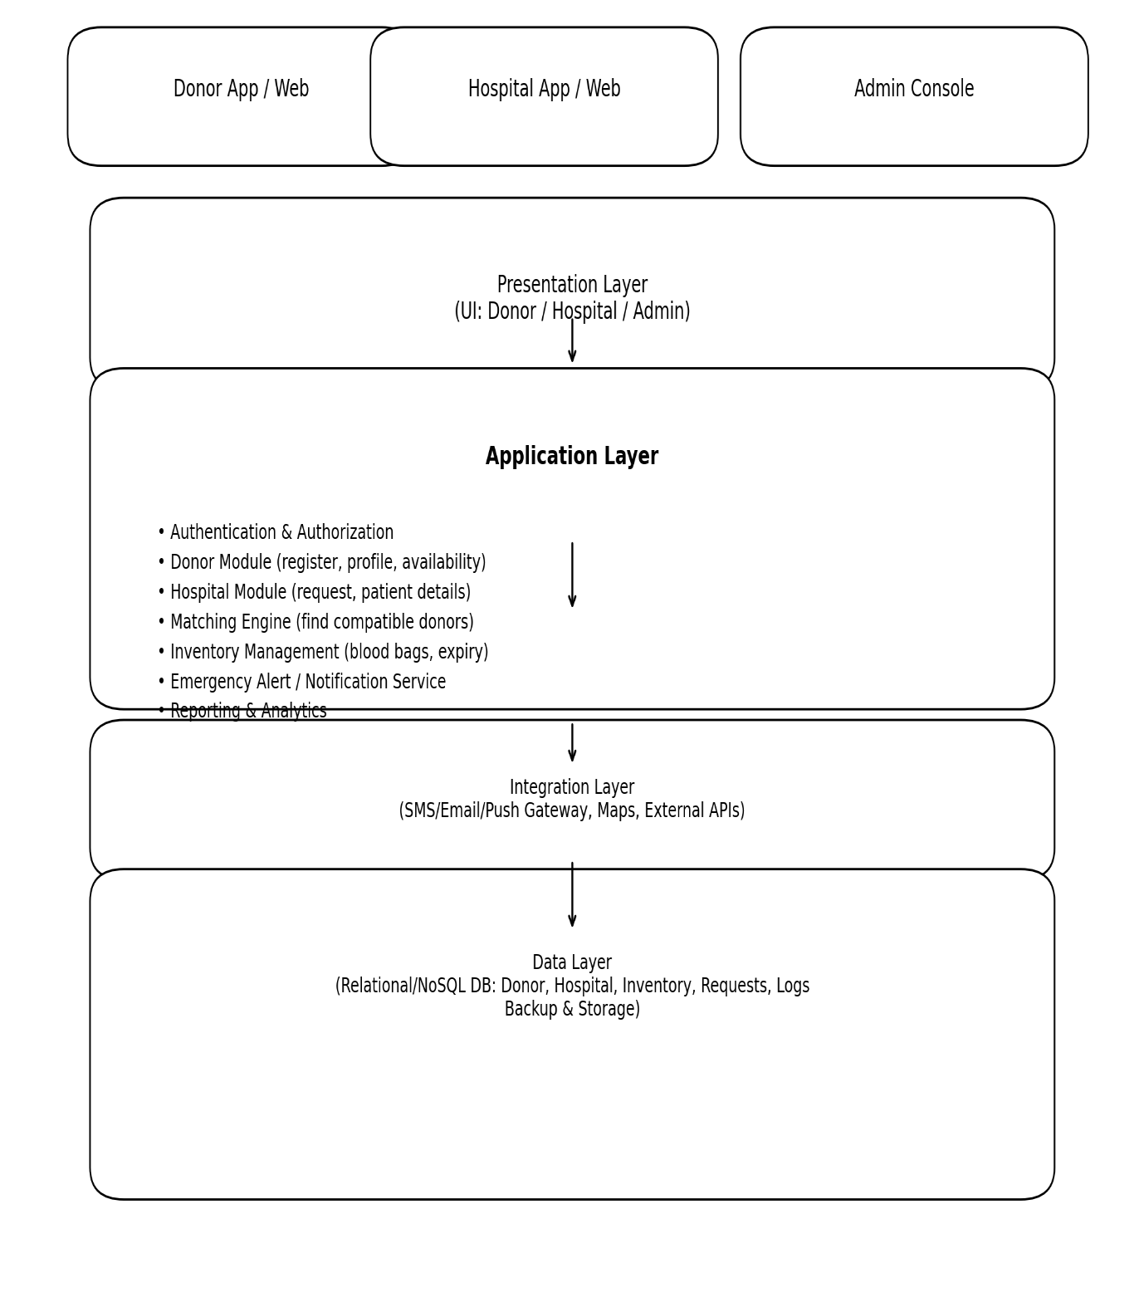

Figure 1.4.1

Advantages of Proposed System
• Real-time blood availability
Emergency blood requirements can be fulfilled faster because the system shows instantly who is available and which blood units are in stock.
• Quick donor–recipient matching
The system automatically finds suitable donors based on blood group, location, and eligibility, reducing delay in critical situations.
• Fast emergency alerts
Hospitals can send immediate notifications to multiple donors at once, saving precious time during emergencies.
• Accurate and error-free records
The digital database eliminates manual mistakes, misplaced files, and outdated donor information.
• Efficient blood inventory management
Tracks blood bag quantity, expiry, and usage, preventing wastage and shortage.
• Centralized and transparent system
All donor, hospital, and blood bank data is accessible from one place, making the process more organized and reliable.
• Time and resource saving
Reduces paperwork, phone calls, manual searching, and administrative burden.
• Increases donor participation
Regular reminders and an easy process encourage more people to donate blood frequently.

Chapter 2
Literature Survey

- G. Muddu Krishna & S. Nagaraju (2016) [1] SMS-based blood bank. They suggested a system that would allow users to access the blood bank's services through SMS. If someone needed blood, they would have to send an SMS requesting it. The system's packet count module would then check to see if there was any blood available, and the data processing module would respond.

- Muhammad Arif; S. Sreevas; K. Nafseer; R. Rahul (2012) [2] Automated online blood bank database. Using an asterisk, they devise a direct call routing method. Each blood bank in this case has a database, which is run by a central server. A donor will be contacted directly when a person in need of blood calls their toll-free number. The donor's name will be placed on hold for eight weeks following the donation.

- HIV transmission through donations that don't contain antibodies 13 individuals who tested positive for HIV and received blood from 7 donors who tested negative for HIV antibody at the time of donation are the subject of an investigation by Ward et al. (1988). According to available antibody tests, these donors were negative at the time of blood donation because they had reportedly only recently contracted the infection. study of European blood collection practices (Healy, 2000). Unlike state and blood bank systems, donations to the Red Cross are linked to religious activities and other volunteer work.

- Mohammad Ismail Z, Tukur Anas Mohammad, and Ibrahim Fawze Akar created the Centralised Blood Bank Repository. On the WWW platform, they have created a centralised web-based system with HTML5/CSS & JSP [6]. They use the H2 Database, which is hosted on Apache Web Server. This facilitates transactions for both the donor and the acceptor; the donor can be compensated for his services, and the acceptor can cover the transfusion fee and centre fees.

- These days, digital blood banks concentrate on files (data) that are kept in blood banks and hospitals, or data obtained through blood donation events. This guarantees that information about blood, donors, and recipients is kept in records and archives. This makes processing data and information challenging and time-consuming. Physical records of every blood donation and transfusion test are also kept. This renders information vulnerable to human error and mistakes, thereby endangering human lives. Destitute productivity is another fundamental issue with this framework. Blood recovery is a time-consuming process that requires a lot of work, whether it is donor or recipient information. Hospitals find it extremely difficult to rescue lives during life-threatening situations because the information retrieval procedure takes so long. Given how easily papers and records can be lost or stolen, information security and backup are also important considerations. It is therefore an unreliable framework.

Summary:

The reviewed literature highlights the evolution of digital blood bank systems and the challenges faced in traditional blood management methods. Muddu Krishna and Nagaraju (2016) proposed an SMS-based blood bank system that enabled users to request blood through text messages, with automated modules checking availability and sending responses. Muhammad Arif et al. (2012) introduced an automated online blood bank using direct call routing, where a central server connects donors and recipients through a toll-free number, and manages donor waiting periods after donation. Studies by Ward et al. (1988) and Healy (2000) emphasized the risks associated with inadequate donor screening, such as HIV transmission from donors in the early stages of infection, and highlighted how different organizations—including the Red Cross—manage donation practices. Further, Mohammad Ismail Z. and colleagues developed a centralized web-based blood bank repository using HTML5, JSP, and the H2 database, offering a platform for secure donor–recipient transactions. Overall, existing systems still face significant limitations, including reliance on physical records, slow data retrieval, risk of human error, and poor data security. These drawbacks make emergency response difficult and highlight the need for a more efficient, automated, and reliable digital blood bank system.

Chapter 3
System Requirements and Specification

Hardware Requirements

- System : Intel Core i5

- Hard Disk : Minimum 80 GB HDD / SSD

- Monitor : 15” LED / LCD

- Input Devices : Keyboard, Mouse

- Ram : 8 GB RAM (recommended), 4 GB minimum

Software Requirements

- Operating System : Windows 10 / Windows 11 / Linux

- Technology : MERN Stack (MongoDB, Express.js, React.jsNode.js)

- IDE : VS Code (Visual Studio Code)

- Tools : Postman (API Testing), Git/GitHub, NPM Packages

)

Summary:

Chapter 4
System Architecture and Implementation

Methodology
The life blood, the blood donation registration, and blood availability The all three are constructed in such a way, so that they can possible & able to access by any and all should stay in register & save a life by saving his own blood. This paper begins with a brief introduction that provides background information on the topic. Here's the process breakdown:

- The development of the “Blood Donor Network” website should start with the basic needs and requirements of the blood donors and blood recipients. This website would need to allow a user to register as a donor, register the blood type they have and ensure users can request blood from donors in their area. This part involved capturing the target audience and the core feature set of the website such as, user registration, blood type match, donor search, and emergency alerts.
- We decided to use a NoSQL database (MongoDB) for donor information. It consists collections for users (both Donor and the Recipient), users personal information like name & address, blood group & total donation count, and also their emails. MongoDB enables flexible data storage and retrieval − critical for efficient donor-recipient matching.
- Here we built the User Interface (UI) using React.js: the web development tool to produce dynamic, responsive and interactive web pages. React enables continuous user experience by efficiently rendering the UI as per the user's actions. The Frontend portion of the website consists of User Registration, Blood Type Selection, Donor Search, and Dashboard to manage user interaction.
- The website is tested, deployed to a cloud server, and continuously monitored for performance, bug detection, and updates to enhance user experience worldwide.
- The backend is written in Node.js and Express.js, allowing the server to receive requests and interact with the database. The backend is responsible for essential operations like validating user inputs, saving user info, processing blood donors’ requests, and reating notifications. APIs for registering new users, matching blood types, and querying the database for potential donors based on the recipient’s requirements were all created.
- Once both frontend and backend are developed, the integration stage takes place. They connected frontend and backend services together. To ensure that the system behaves as desired in production environments, unit tests, integration tests and user acceptance tests were performed.

Summary:

This project presents the development of an online “Blood Donor Network” system designed to simplify blood donation, registration, and availability for people in need. The platform is built to ensure that anyone can register as a donor and help save a life by sharing their blood. The system begins by identifying the essential requirements of both donors and recipients, focusing on critical features such as user registration, blood group matching, donor search, and emergency alerts. To store user details efficiently, a NoSQL database (MongoDB) is used, which provides flexible data handling for donor information such as personal details, blood group, and donation history. The user interface is created using React.js to ensure smooth, dynamic, and user-friendly interactions, enabling users to easily register, select their blood type, and search for donors. The backend is developed using Node.js and Express.js, where core operations like validating user data, processing blood requests, and sending notifications are handled through well-designed APIs. After building both frontend and backend components, they are integrated and thoroughly tested using unit, integration, and user acceptance methods to ensure reliability. Finally, the website is deployed on a cloud server and continuously monitored for performance, bug fixes, and updates, making the system accessible, efficient, and dependable for users across the world.

System Design

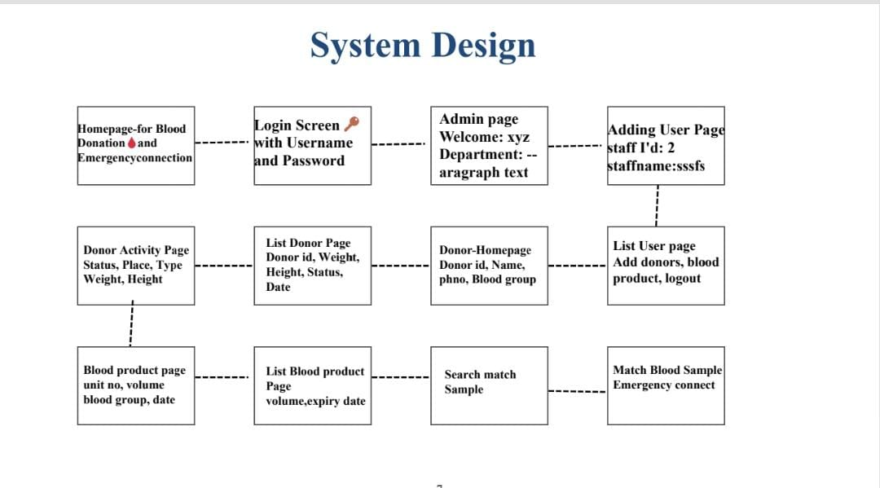

Data Flow Diagram

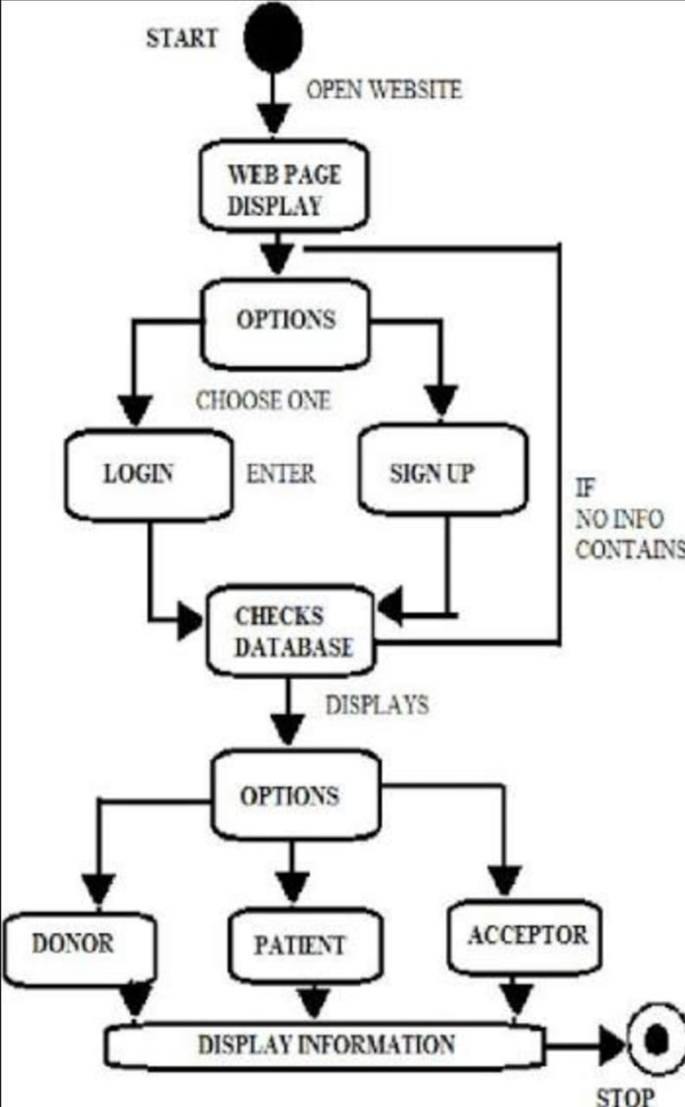

Figure 4.3.2 Data Flow Diagram – Level 1

Pseudo code

USER REGISTRATION MODULE

\ BEGIN UserRegistration
INPUT name, email, phone, blood_group, location, password

IF any field is EMPTY THEN
DISPLAY "All fields required"
EXIT
ENDIF

hashed_password ← HASH(password)

status ← INSERT INTO users (name, email, phone, blood_group, location, hashed_password)

IF status = SUCCESS THEN
DISPLAY "Registration Successful"
ELSE
DISPLAY "Registration Failed"
ENDIF
END

2. USER LOGIN MODULE

BEGIN UserLogin
INPUT email, password

userRecord ← FETCH user WHERE email = input_email

IF userRecord NOT FOUND THEN
DISPLAY "Invalid Email"
EXIT
ENDIF

IF HASH(password) == userRecord.password THEN
CREATE SESSION(user_id)

DISPLAY "Login Successful"
ELSE
DISPLAY "Incorrect Password"
ENDIF
END

3. SEARCH FOR DONORS

BEGIN SearchDonor
INPUT required_blood_group, location

donors ← FETCH FROM users
WHERE blood_group = required_blood_group
AND location = input_location

IF donors IS EMPTY THEN
DISPLAY "No Donors Found"
ELSE
DISPLAY donor_list
ENDIF
END

4. EMERGENCY REQUEST MODULE

BEGIN EmergencyRequest
INPUT patient_name, required_blood_group, hospital, contact_number, emergency_message

IF any field EMPTY THEN
DISPLAY "Fill all details"
EXIT
ENDIF

status ← INSERT INTO emergency_requests (details...)

IF status = SUCCESS THEN
DISPLAY "Emergency Request Posted"

donors ← FETCH users WHERE blood_group = required_blood_group

FOR EACH donor IN donors DO
SEND_NOTIFICATION(donor.phone, "Emergency blood needed")
ENDFOR
ELSE
DISPLAY "Error posting request"
ENDIF
END

5. DONOR PROFILE UPDATE

BEGIN UpdateProfile
REQUIRE SESSION(user_id)

INPUT new_phone, new_location, new_availability

status ← UPDATE users

SET phone = new_phone,
location = new_location,
availability = new_availability
WHERE id = user_id

IF status = SUCCESS THEN
DISPLAY "Profile Updated"
ELSE
DISPLAY "Update Failed"
ENDIF
END

6. ADMIN PANEL – MANAGE USERS & REQUESTS

BEGIN AdminLogin
INPUT username, password
IF credentials_match THEN
ALLOW ACCESS
ELSE
DISPLAY "Admin login failed"
ENDIF
END

BEGIN ViewUsers
users ← FETCH ALL FROM users
DISPLAY users
END

BEGIN ViewEmergencyRequests
requests ← FETCH ALL FROM emergency_requests ORDER BY timestamp DESC
DISPLAY requests
END

BEGIN DeleteUser(user_id)
DELETE FROM users WHERE id = user_id
DISPLAY "User Deleted"

END

7. DATABASE CONNECTION HANDLER

BEGIN DBConnect
connection ← CONNECT_TO_DATABASE(host, user, password, dbname)

IF connection FAILED THEN
DISPLAY "Database Connection Error"
EXIT
ENDIF

RETURN connection
END

Chapter 5
Results and Discussion

Chapter 6

Advantages, Disadvantages and Applications

6.1 Advantages:

- Real-time updates on blood availability.

- Easy accessibility through mobile/website.

- Time-saving in emergencies.

- Reduces manual search for donors.

- Improves communication between donors, patients, and hospitals.

- Encourages regular blood donation

  - Disadvantages:

- Requires active internet connection.

- Technical issues may slow down notifications.

- Verification challenges for new donors or fake profiles.

- Database maintenance is required.

- Privacy concerns regarding medical and personal information.
.

Applications:

- Connecting donors and patients: They create a channel for patients or their representatives to post blood requests, which are then broadcast to nearby registered donors.
- Real-time blood availability: These apps and portals display real-time stock levels in nearby blood banks, allowing users to check if the specific blood group they need is available.
- Donor management and history:
- Users can register as donors and create a profile.
- The system can track a donor's donation history.
- They allow for health screening and management of donor information.
- Data management and security:
- They store information about blood and donors securely.
- Administrative panels allow authorized users to manage the system and ensure the privacy of confidential data

Summary:

The Blood Donation and Emergency Connection System provides significant benefits by offering real-time updates on blood availability, ensuring easy access through mobile and web platforms, and reducing delays during emergencies. It streamlines communication between donors, patients, and hospitals, minimizes manual donor search efforts, and also promotes regular blood donation by keeping users engaged and informed. However, the system does have certain limitations, such as the need for a stable internet connection, the risk of technical issues affecting notifications, and challenges in verifying new or fake donor profiles. Additionally, continuous database maintenance and ensuring privacy of sensitive personal and medical data remain important concerns. Despite these drawbacks, the system has strong and valuable applications, including connecting donors and patients through instant request broadcasts, providing real-time blood stock information from nearby blood banks, managing donor profiles and donation history, and maintaining secure data handling through administrative controls. Overall, the system enhances accessibility, accuracy, and speed in the blood donation process, making it a vital tool for healthcare support and emergency response.

Chapter 7
Future Scope:
- The future of blood bank management systems (BBMS) involves integrating advanced technologies like AI and machine learning for predictive analytics, IoT for real-time monitoring, and enhanced location-based services for improved accessibility. These advancements will enable more accurate forecasting of donor needs, real-time inventory management, improved emergency response, and streamlined communication between donors, patients, and blood centers.
- These advancements will enable more accurate forecasting of donor needs, real-time inventory management, improved emergency response, and streamlined communication between donors, patients, and blood centers.
- Use machine learning to forecast blood demand based on historical data and trends,helping to prevent shortages

Conclusion:

- Based on results, this study concluded that online blood bank management systemis much better than the manual system
- Online blood bank management system rather than the manual system because it offers many advantages and benefits that lead to its effective and efficiency
- Because of the increased confidence on the users on the system, can be concluded that the online system enhances blood transfusion safety.
- This study recommends that system can be expanded by allowing donors to register online system user, and donors will be informed about planned blood donation activities through online

References

- Alfonso, E., Xie, X., Augusto, V., Garraud, O.: Modeling and simulation ofblood collection systems.
- Health Care Manag. Sci. 15(1), 63–78 (2012)
- Axsäter, S.: Using the deterministic EOQ formula in stochastic inventory control. Manag. Sci. 42(6), 830– 834 (1996)
- Bani, M., Giussani, B.: Motivation in Italian whole blood donors and the roleof commitment. Psychol.
- Health Med. 16(6), 641–649 (2011)
- Belien, J., Forcé, H.: Supply chain management of blood products: a literature review. Eur. J. Oper. Res.
- 217(1), 1–16 (2012).
- [5]Hossain, M. F. (2022, May). Digitalized Blood Bank. Designing and implementing a webbased application., 60.(Click me)
- [6]Keshari, P., & Maurya, P. (2024, June 05). Web Development Using ReactJS. 25-56. doi:10.110

