**Circuit diagram and connection**

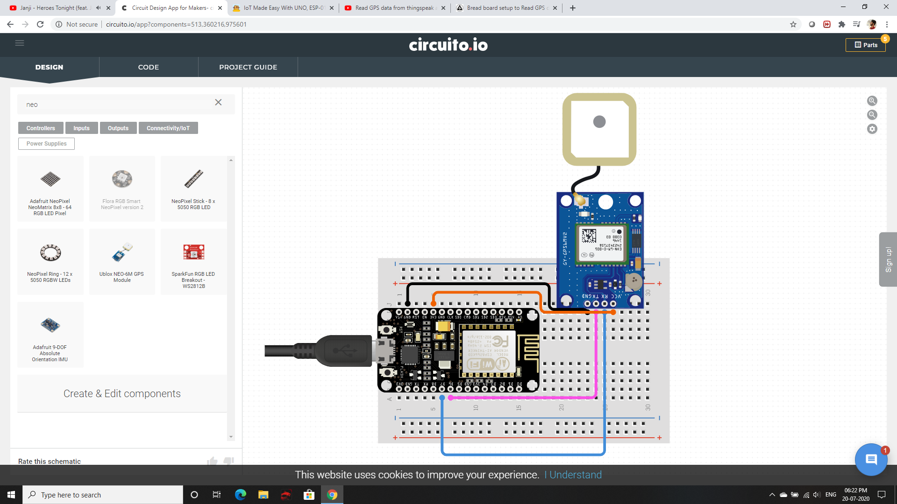

NodeMCU (ESP8266 board) Voltage input: 5V

For Neo 6m GPS:-

* Rx =D7 – GPIO 13
* Tx = D6 – GPIO 12

*For having female-to-female connector (jumper wires) we don’t need the breadboard.