1. **Daily Notes**

**For Loop**

For(initialization; condition; increment/decrement){

//statement

}

**Java While Loop**

Syntax:

while(condition){

//statement true

}

Do-while Loop

Do{

//statement

//increment or decrement true

}while(condition);

1. **Interview Questions**
2. **Difference**

**Programs**

1. Write a program to check the given number is positive

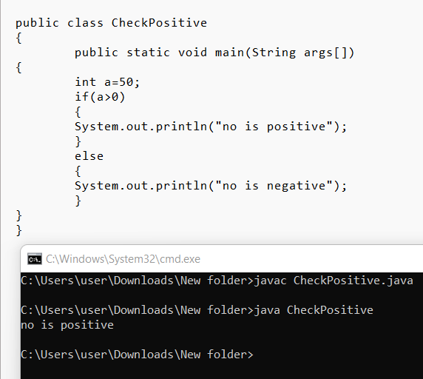

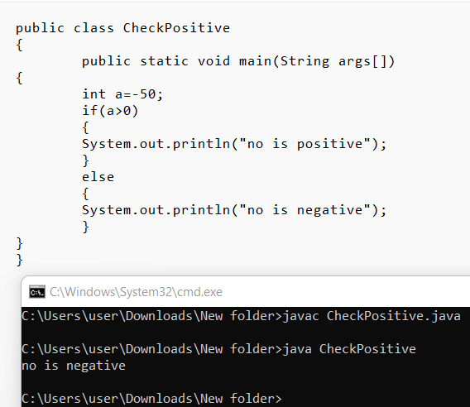

1. Write a program to check whether the candidate is eligible for driving license.

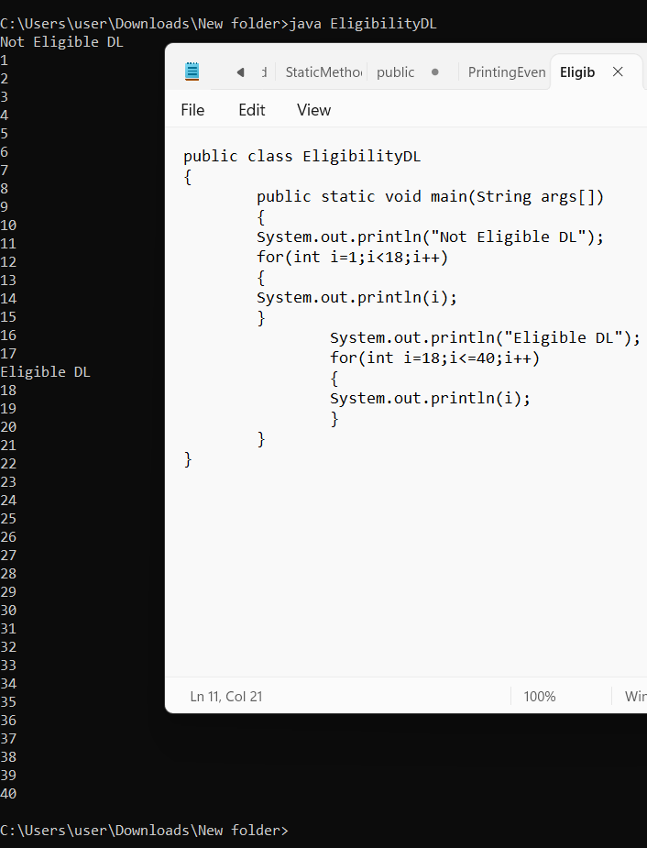

1. Write a program to check whether the given number is Odd/Even.

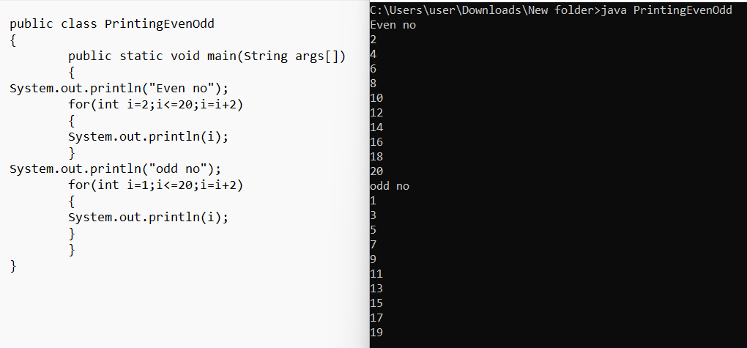

1. Write a program to find largest of three Numbers

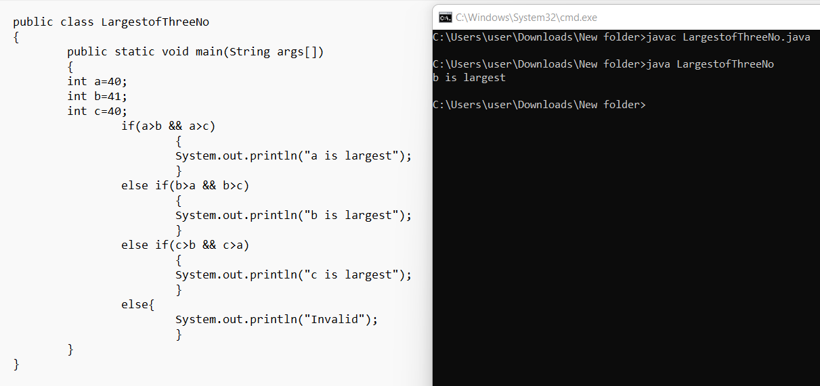

1. Write a program to find the grade of a Student based on total mark.

• Mark less than 40- Failed

• 40 to 60–Grade D

• 61 to 70-Grade C

• 71 to 80-Grade B

• 81 to 100-Grade A

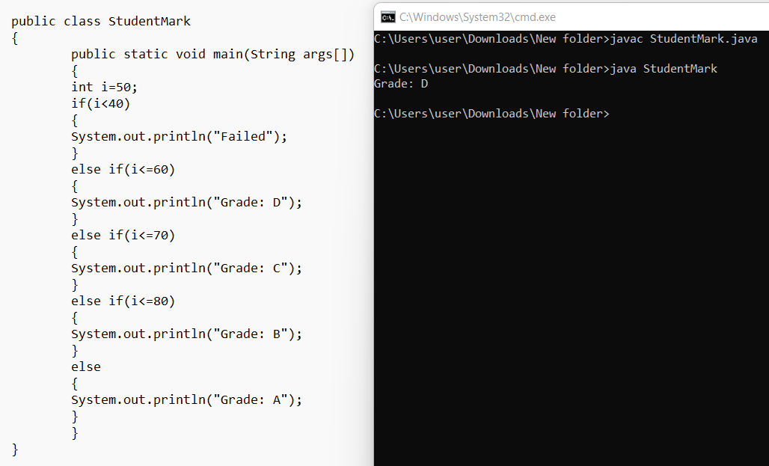

1. Write a program to check whether the given character is Vowel/not (Use switch-case)

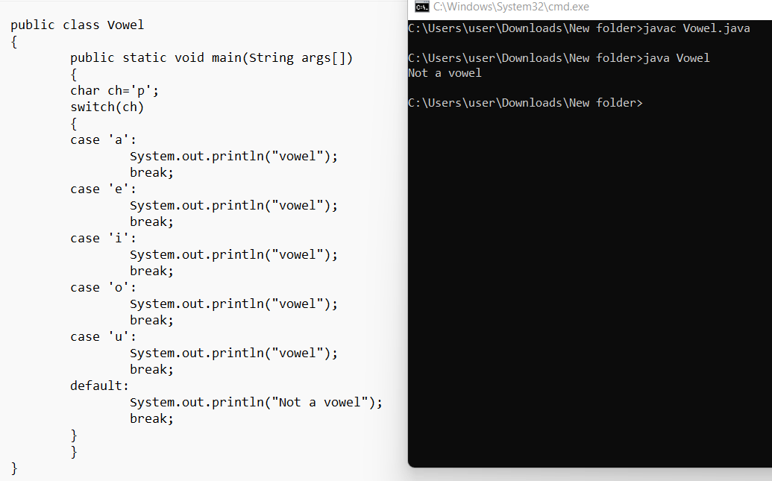

Switch clause

Switch(expression)

{

Case value1:

//statement

Break;

Case value 2:

//statement

Break;

Default:

//statement

Break;

}

1. Write a program to check month in a year(switch)

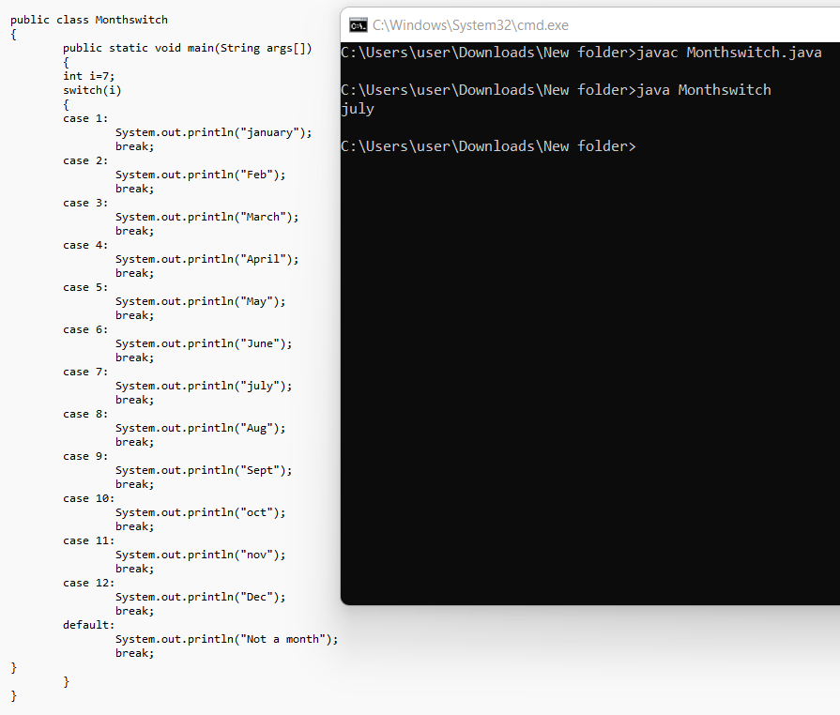

1. Write a program to check days in a week(switch)

