

Data Premier League

Formula 1 Driver Performance Prediction Challenge

CONTENTS
se
- STATEMENT OBJECTIVE
- TOOLS AND FRAMEWORK
- DATA PREPROCESSING
- FEATURE LEARNING
- ANSWERING QUERIES
- MODEL BUILDING AND EVALUATION
- DATA VISUALIZATION
- FRONTEND
- TEAM MEMBERS





Data

Visualization

and

Prediction
CHALLENGE

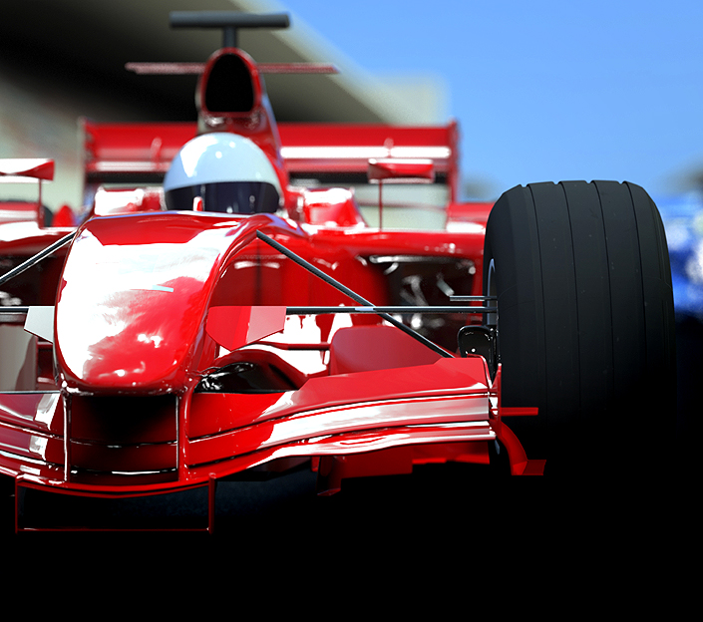

STATEMENT OBJECTIVE
ABOUT FORMULA 1:
Formula 1 is the highest class of single-seater auto racing sanctioned by the Fédération Internationale de l'Automobile (FIA) and owned by the Formula One Group. The FIA Formula One World Championship has been one of the premier forms of racing around the world since its inaugural season in 1950. The word "formula" in the name refers to the set of rules to which all participants' cars must conform. A Formula One season consists of a series of races, known as Grands Prix, which take place worldwide on purpose-built circuits and on public roads.
The dataset consists of all information on the Formula 1 races, drivers, constructors, qualifying, circuits, lap times, pit stops, championships from 1950 till the latest 2024 season.
"Races are won at the track. Championships are won at the factory." - Mercedes (2019)
With the amount of data being captured, analyzed and used to design, build and drive the Formula 1 cars is astounding. It is a global sport being followed by millions of people worldwide and it is very fascinating to see drivers pushing their limit in these vehicles to become the fastest racers in the world!
STATEMENT MOTIVE:
"Predict the finishing positions of Formula 1 drivers in an upcoming race using historical data and advanced analytics. The sponsors need clarity, and our strategy depends on it.

TOOLS AND FRAMEWORK
PROGRAMMING LANGUAGE
- PYTHON
- SQL
TOOLS
- GOOGLE COLAB
- VSCODE
- POWERBI
FRAMEWORK
- STREAMLIT
- WEBBROWER

LIBRARIES
- PANDAS
- NUMPY
- TENSORFLOW
- SCIKIT-LEARN
- Y-DATA-PROFILING
- MATPLOTLIB
- SEABORN
- PLOTY EXPRESS
- PLOTLY GRAPH OBJECTS
- NETWORKX
- PICKLE
- JOBLIB
- KERAS
- IMBLEARN

DATA PREPROCESSING
The data files have been preprocessed by handling missing values in both numerical and categorical columns, removing duplicate records, and generating detailed profiling reports using ydata-profiling.
Key Features of ydata-profiling:
- Automated EDA: Generates a comprehensive summary of the dataset.
- Missing Values Analysis: Identifies and visualizes missing data patterns.
- Duplicate Detection: Highlights duplicate records for potential removal.
- Statistics: Provides insights into numerical, categorical, and text data distributions.
- Correlation Analysis: Detects relationships between features using Pearson, Spearman, and other metrics.
SAMPLE
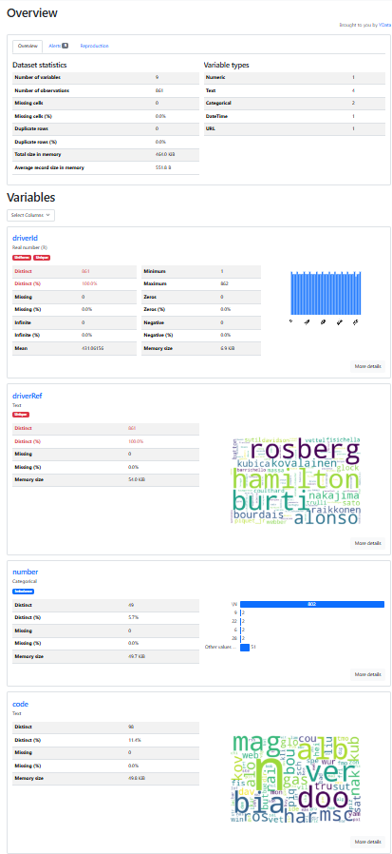
FEATURE LEARNING

- Driver Consistency – Evaluates the stability of a driver’s performance over a season.
Average Finishing Position: Mean of the driver's finishing positions.
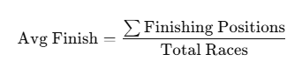
Average Qualifying Position: Mean of the driver's qualifying positions.
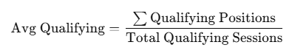
- Team Strength – Assesses the overall performance and reliability of constructors.
Total Constructor Points: Sum of all points scored by team drivers.
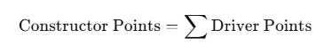
Reliability Rate: Percentage of races finished without mechanical failure.
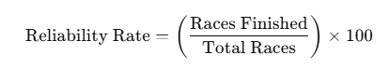
- Track Complexity – Reflects the overtaking difficulty of circuits.
Overtaking Opportunities: Average overtakes per race on a circuit.
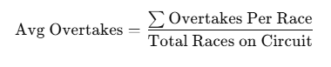.
- Win Ratio – Measures the driver’s winning efficiency.
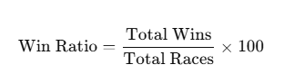
- Podium Percentage – Percentage of podium finishes relative to total wins.
Podium: Positions 1 to 3 are considered podium finishes.
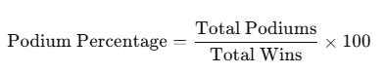
- Career Length Years- Duration of a driver’s career.
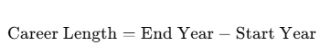
- Status Finished-the flag that represents whether the driver finishes the race
- Is Winner-the flag that represents is the driver finished the race first in the race
ANSWERING QUERIES

1.DRIVER AND CONSTRUCTOR PERFORMANCE

- Combines race results, driver details, constructor details, and race metadata into a unified dataset.
- Calculates for constructors and drivers
  - Total races, wins, podium finishes, and total points.
  - Win ratio and podium percentage to measure success
- For Career
  - Career start and end years, total races, and career length for each driver.

KEY INSIGHTS:
Driver & Constructor Performance
- Identify dominant drivers and constructors based on win ratios and podium finishes.
- Compare success metrics like wins, podiums, and points across different career spans.
Career Longevity vs. Performance
- Analyze whether a longer career correlates with more wins.
- Determines how career duration impacts race performance.

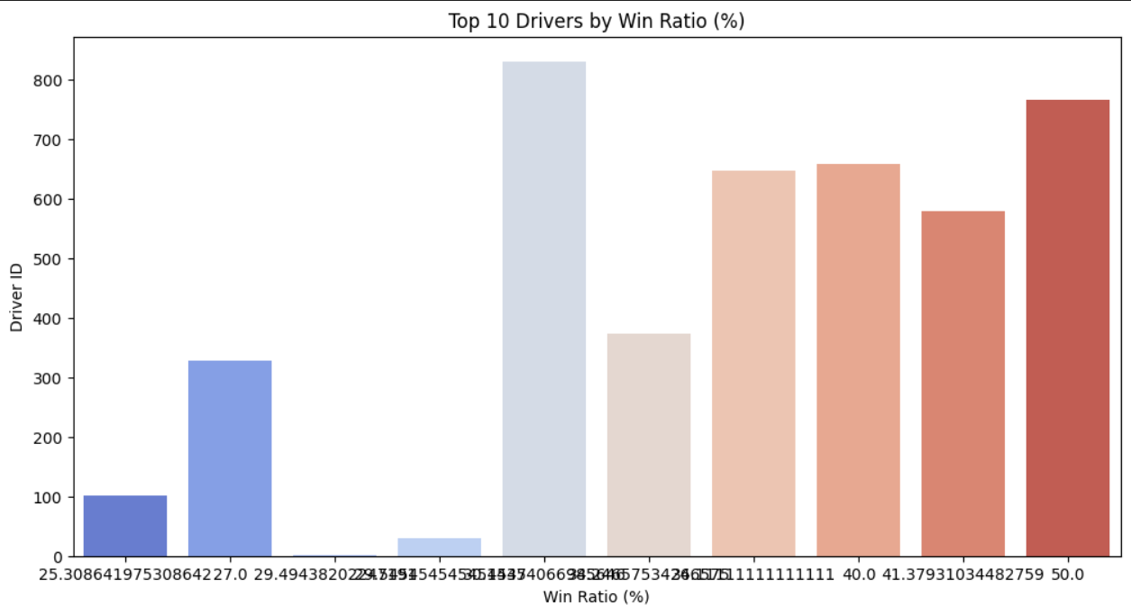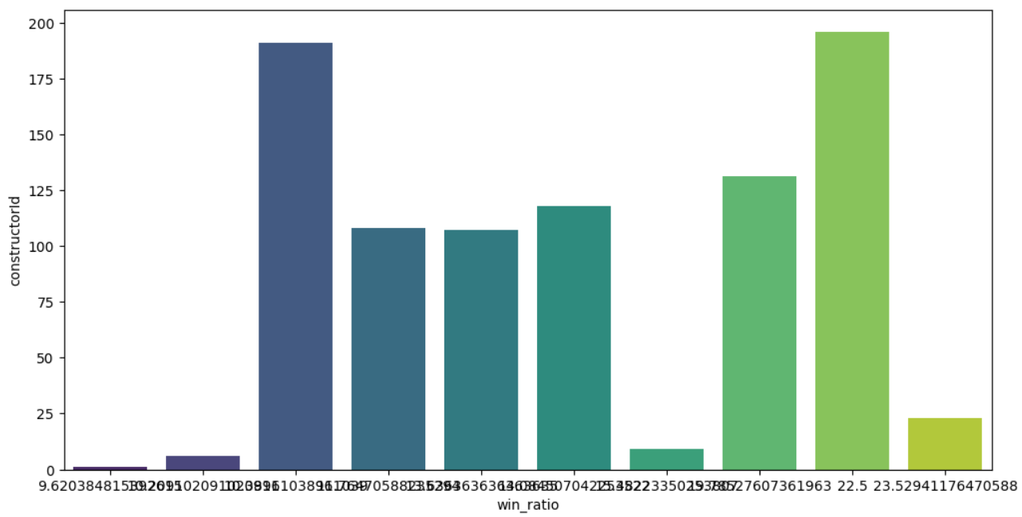

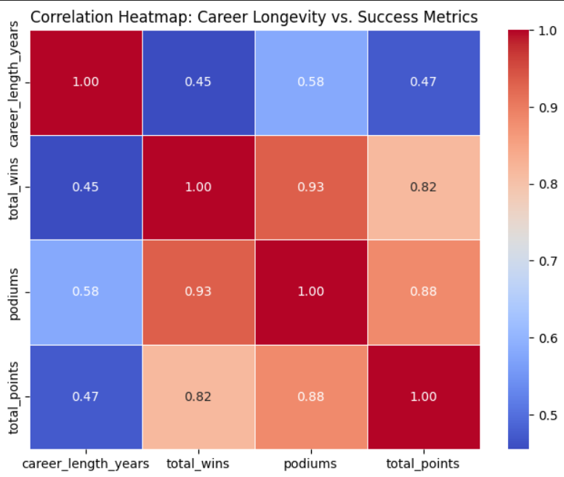
2.QUALIFYING VS RACE PERFORMANCE

- Convert positionOrder column to numeric to handle any non-numeric values.
- Calculate position change → position_change = grid - positionOrder (positive values indicate a driver gained positions).
- Merge driver names into the results dataset for better visualization.
- Scatter plot:
- X-axis: Starting grid position
- Y-axis: Final race position
KEY INSIGHTS:
- Do drivers who start in the front row typically maintain their position and finish at the top?
- Which drivers regularly improve or drop positions throughout a race?
- Are there specific teams or drivers that consistently perform better in race conditions compared to their qualifying results?

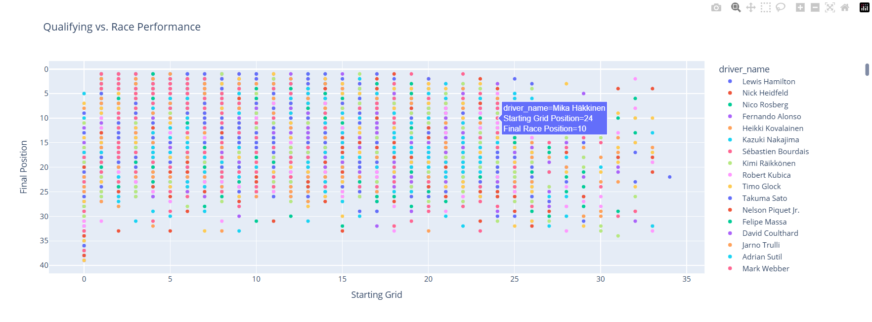

3.PIT STOP STRATEGIES

HYPERPARAMETER:
Pit Stop Threshold: Pit stops over 50 seconds are excluded to avoid outliers

- The analysis evaluates the relationship between pit stop timing, efficiency, and race performance by merging race, driver, constructor, and pit stop data.
- Merge race results with circuits, constructors, and drivers to get complete race details.
- Merge pit stop data with races and results to link each pit stop to a specific race, driver, and constructor.
- Remove extreme pit stops (over 50 seconds) to exclude outliers.
- Group data by constructor and year to compute mean pit stop times.
- Group by race and constructor to compare average pit stop duration in specific races.

KEY INSIGHTS:
- Evaluate how pit stop strategies impact final race positions.
- Identify teams that consistently have faster or slower pit stops.
- Compare yearly trends to see if pit stop times are improving over time.

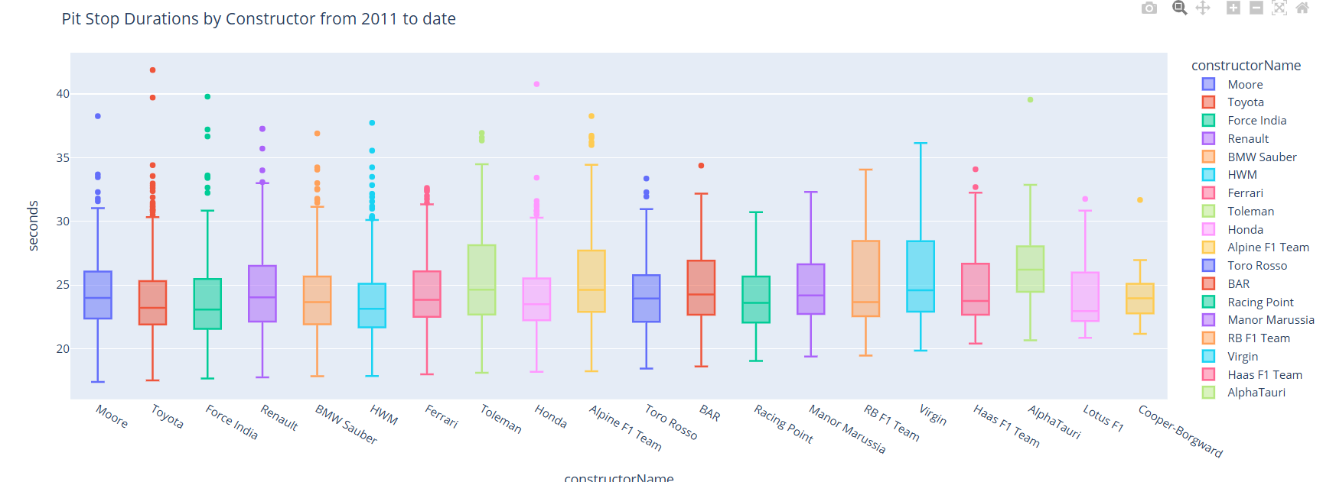

4.HEAD-TO-HEAD DRIVER ANALYSIS
- Combine race results with driver details and race year to create a dataset tracking driver performance per race.
- Perform a self-join on raceId to compare each driver against every other driver in the same race.
- Identify race wins in head-to-head matchups based on finishing positions.
- Group driver pairs to count the total races they competed in and the number of times Driver 1 finished ahead.
- Determine Driver 2 wins by subtracting from the total race count.
- Compute win percentages for both drivers.
- Filter rivalries to include only those with more than 10 races for meaningful analysis.
- Calculate the win percentage difference between the two drivers.
- Rank rivalries by the smallest win percentage difference to highlight the most competitive matchups.
KEY INSIGHTS:
- The closest rivalries feature drivers with nearly equal win percentages, indicating tight on-track battles.
- Some rivalries emerge from teammates in the same car, while others span different teams over several seasons.
- Analyzing win percentages over time can show shifts in dominance between two drivers.
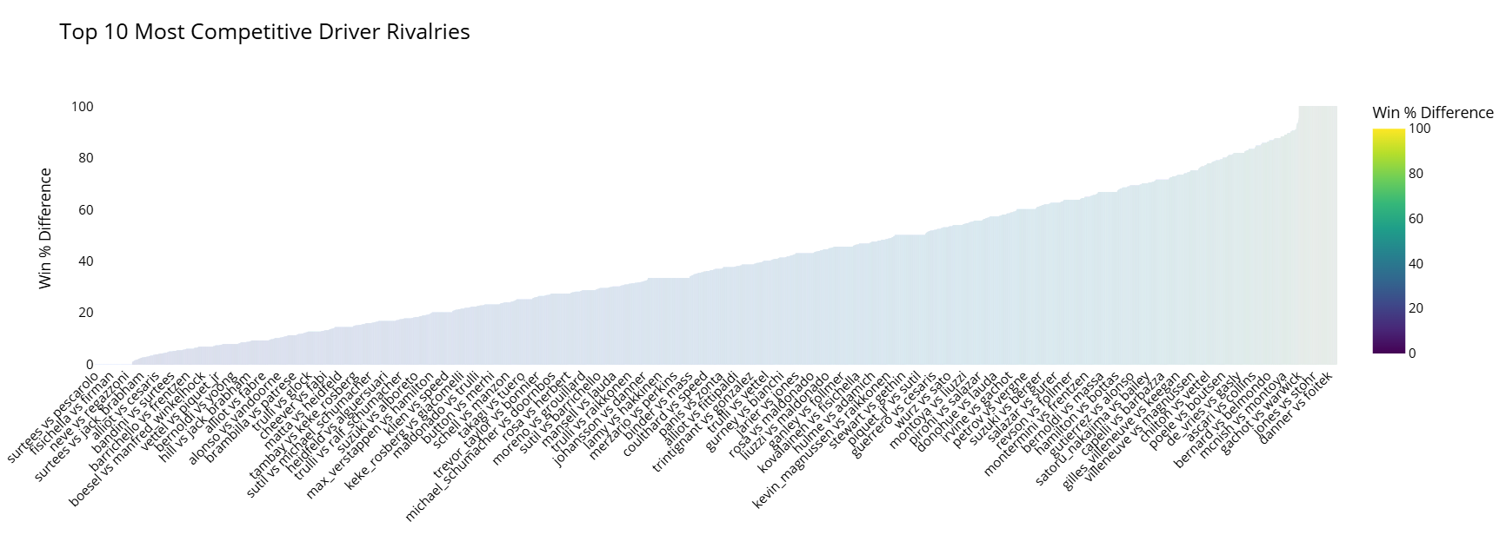

5. HYPOTHETICAL DRIVER SWAPS
- Identify two drivers to swap and retrieve their team assignments.
- Update the dataset to swap the drivers between their respective teams.
- Recalculate the total points for each team after the swap.
- Compare original and post-swap driver standings using bar charts.
- Compare original and post-swap constructor standings to analyze team performance shifts.
- Assess how the swap impacts individual driver rankings and overall team points.
- Analyze whether a weaker team benefits from gaining a top driver or if a strong team weakens due to the change.
- Evaluate how competitive balance and race strategies might shift due to the swap.
KEY INSIGHTS:
- Swapping drivers can significantly impact both individual standings and team performance.
- A top-performing driver moving to a weaker team can boost that team’s total points but may lower their own ranking.
- A strong team losing a top driver might see a decline in constructor points, affecting championship outcomes.
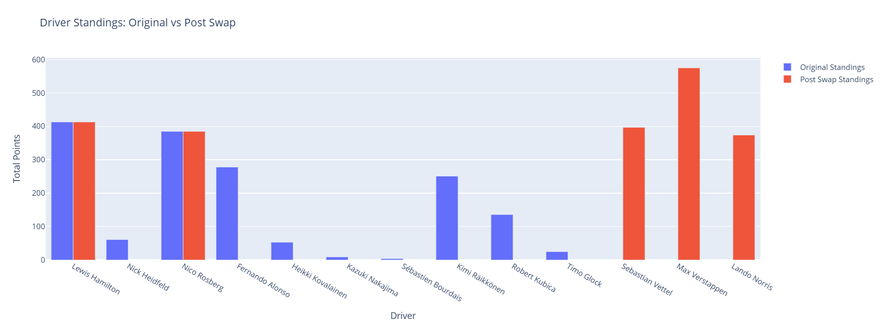
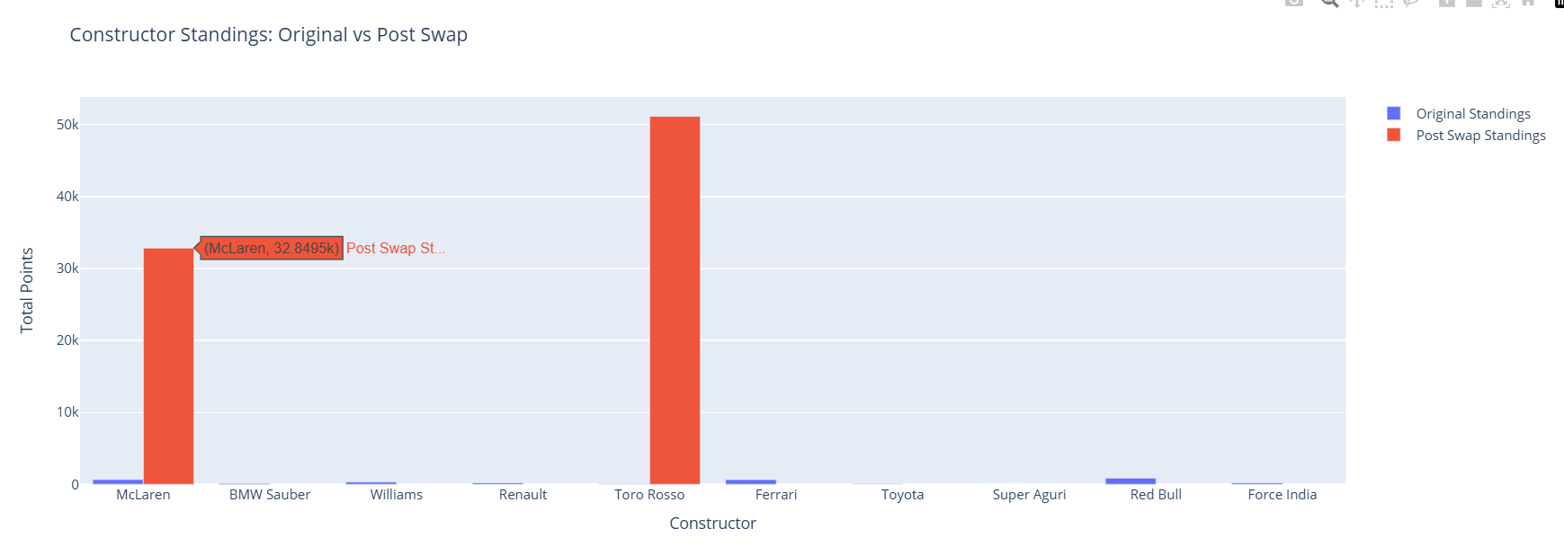
6. DRIVER MOVEMENTS AND TEAM NETWORKS

- Merge race results with driver and constructor data to associate drivers with teams for each season.
- Create a dataset of unique driver-team-season combinations and sort them by driver and year.
- Identify transitions by detecting changes in constructor names for each driver.
- Construct a directed graph where nodes represent teams and edges represent driver movements.
- Use a spring layout algorithm to optimize node positioning.
- Generate an interactive visualization using Plotly, where edges display driver transitions and nodes represent constructors.
KEY INSIGHTS:
- Frequent transitions indicate instability or strategic moves by drivers and teams.
- Stable drivers with fewer transitions highlight strong team retention.
- Top teams attract more drivers, showing dominance in the sport.
- The network structure reveals key talent shifts influencing team performance.
- Visual representation helps analyze historical trends in driver movements and constructor competitiveness.
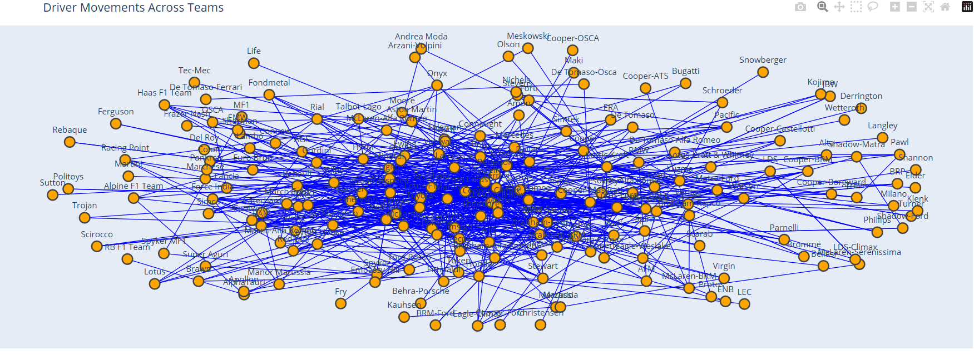

7. TEAM PERFORMANCE COMPARISON
- Aggregate total points per team to determine the best-performing constructor.
- Identify the top team based on accumulated points.
- Merge with constructor names for better readability.
- Merge race results with circuit data to analyze circuit-wise team performance.
- Group data by constructor and circuit to measure performance across different tracks.
- Visualize circuit-based team performance using a bar chart with circuits as a factor.
- Compare overall team performance using a separate bar chart without circuit influence.
KEY INSIGHTS:
- The best team is determined by total accumulated points over the seasons.
- Certain teams perform better on specific circuits, indicating track specialization.
- The overall performance comparison highlights dominant teams across all circuits.
- Circuit-specific analysis reveals teams' strengths and weaknesses in different environments.
- Visualizations provide clear insights into team dominance and consistency.
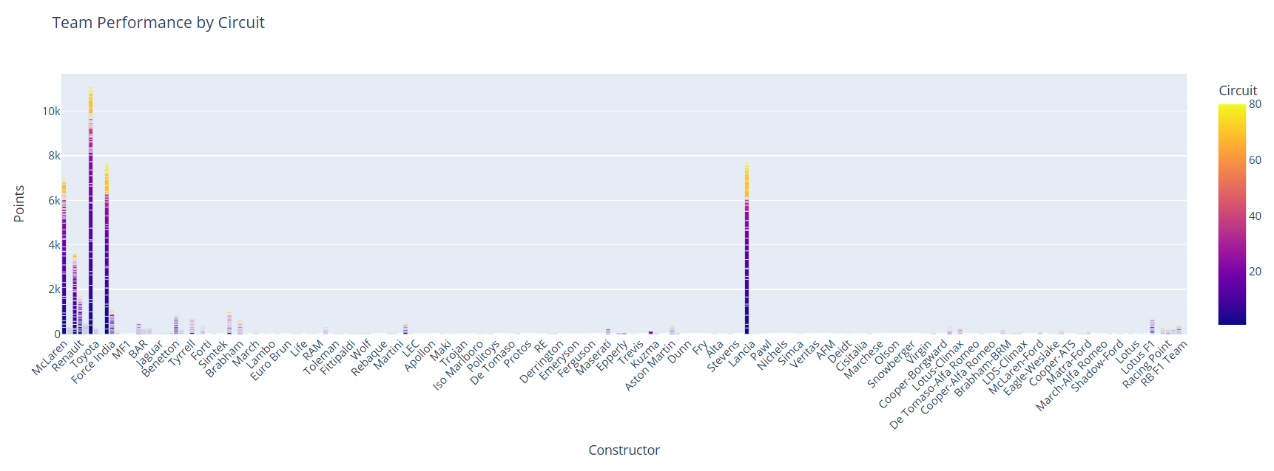
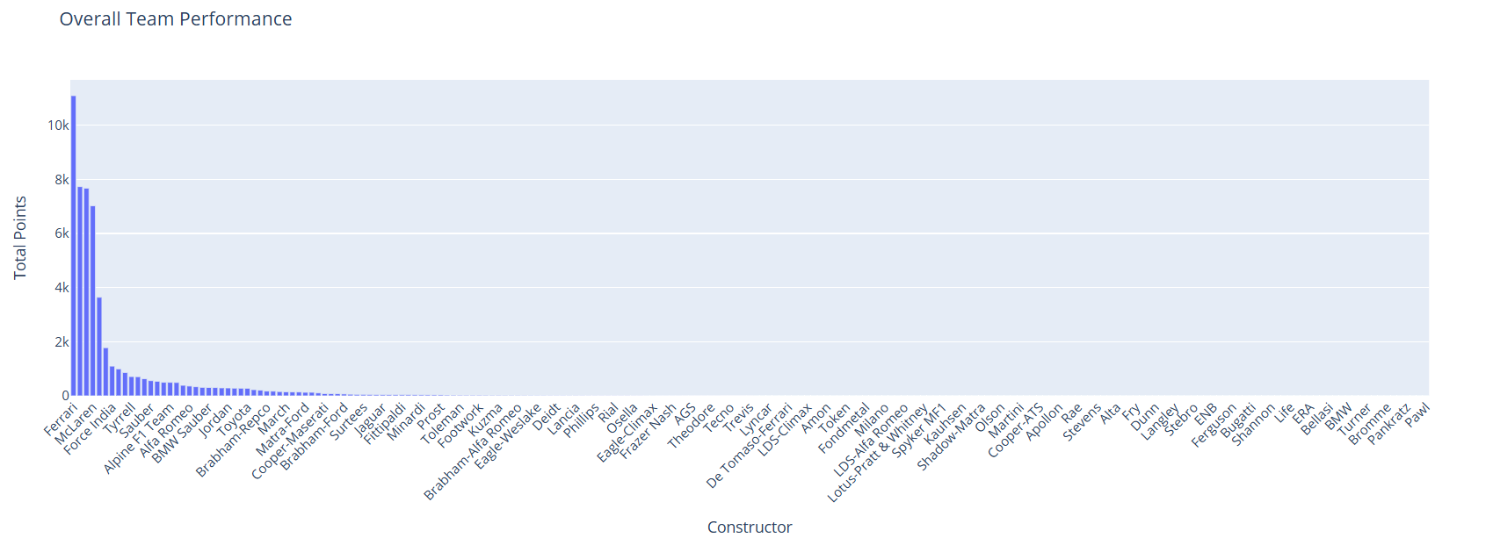
8. DRIVE CONSISTENCY IN RACE PERFORMANCE
- Gather comprehensive datasets, including race results, driver details, constructor information, and circuit specifics.
- Merge these datasets on common keys (e.g., raceId, driverId, constructorId) to create a unified DataFrame for analysis.
- Develop new features such as driver_name by combining first and last names, and calculate metrics like total points per constructor.
- Construct graphs to depict relationships and transitions, like driver movements between teams, using network analysis tools.
KEY INSIGHTS:
- Identified top-performing teams by aggregating total points, highlighting constructors with consistent success.
- Assessed drivers' average finishing positions and variability, pinpointing those with stable performances versus those with fluctuations.
- Highlighted drivers with the highest percentages of top-5 finishes, underscoring elite performers in the field.
- Mapped driver movements between teams over seasons, uncovering patterns in career progressions and team changes.
- Conducted direct comparisons between drivers or teams, providing a clear view of competitive standings.
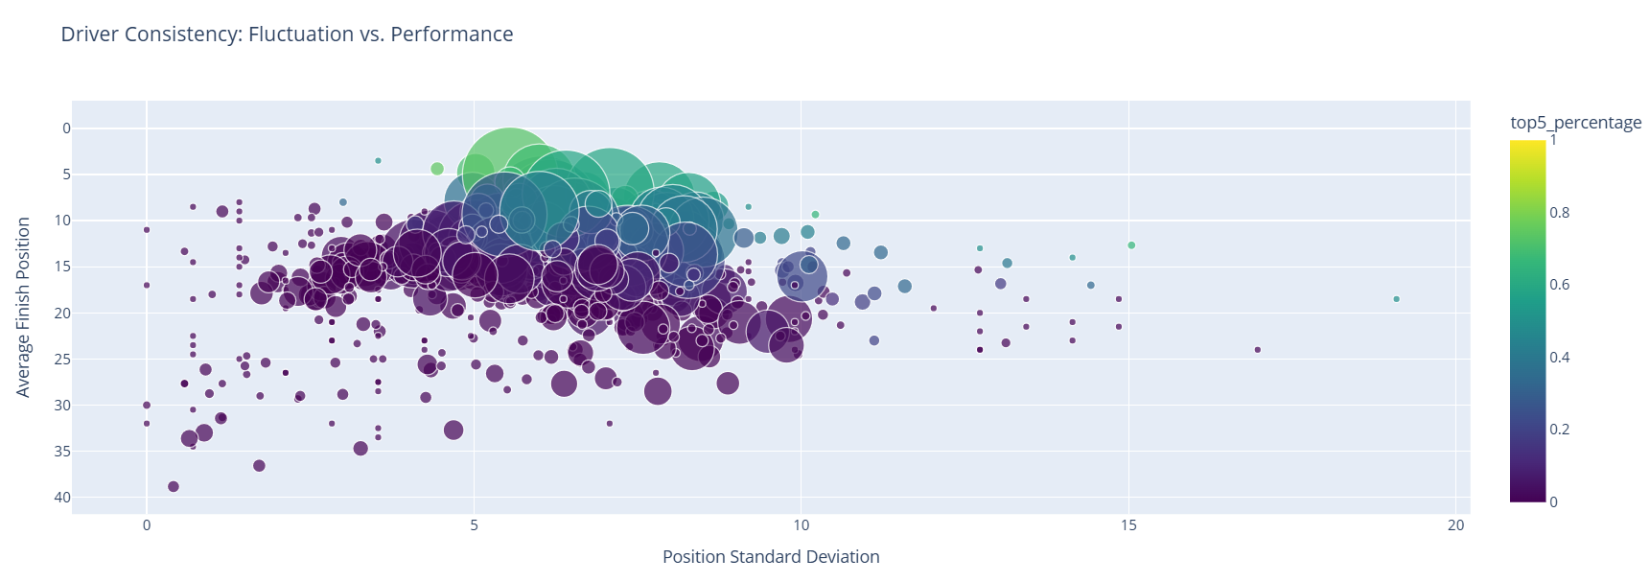
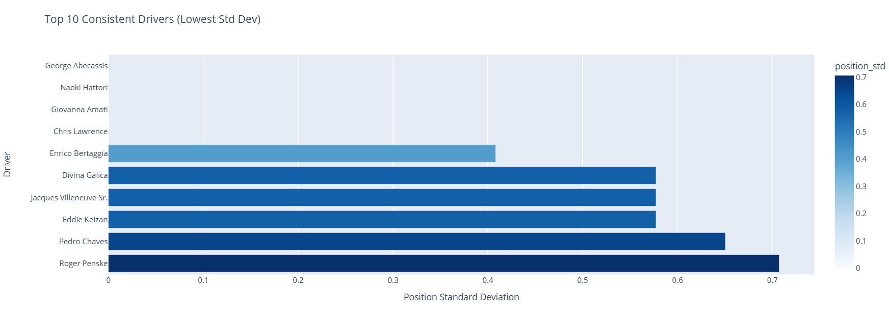

9. LAP EFFICIENCY

- Combine lap_times_data with results_data on raceId and driverId to obtain lap_results_df.
- Merge lap_results_df with constructors_data on constructorId, and with race_data on raceId to include circuitId. Then, merge with circuit_data on circuitId to append circuit names.
- Group the data by circuit name and constructor, computing the mean lap time in milliseconds for each group.
KEY INSIGHTS:
- Teams exhibit different average lap times depending on the circuit, highlighting strengths on specific track types.
- Analyzing average lap times helps teams pinpoint circuits where they excel or need improvement, informing strategic decisions.
- Understanding lap time efficiency assists teams in tailoring car setups and strategies to maximize performance on various circuits.
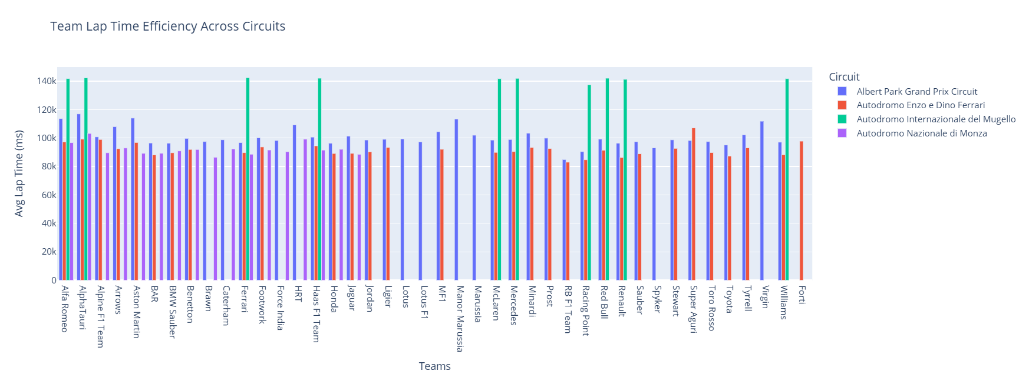
9. BEST TEAM LINE UP
- Merge lap_times_data with results_data to associate lap times with race results.
- Integrate constructors_data, race_data, and circuit_data to include team names and circuit details.
- Compute the average lap time per constructor for each circuit to assess team performance.
KEY INSIGHTS:
- Analyzing average lap times reveals which teams excel on specific circuits, highlighting strengths and weaknesses.
- Understanding lap time efficiency assists teams in tailoring strategies for different tracks, potentially improving overall performance.
- Identifying circuits where a team underperforms can guide targeted improvements in car setup and driver training.
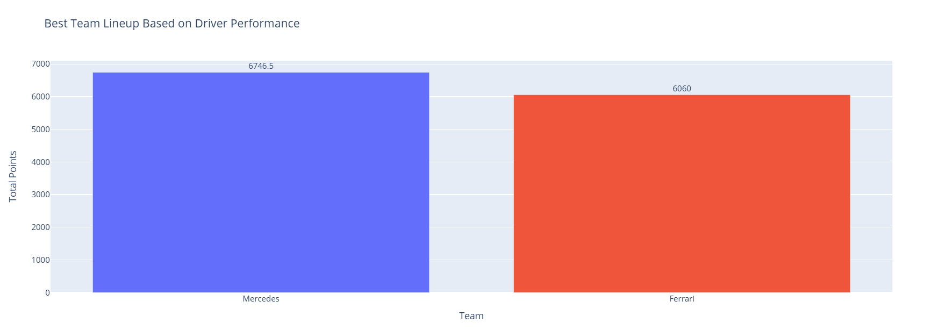
13. DRIVER SPECIFIC TRACK STRUGGLES
- Merge results_data with race_data to associate each race with its corresponding circuit.
- Merge the combined data with circuit_data to obtain circuit names.
- Merge with drivers_data to include driver references.
- Group the data by driver and circuit, computing the mean finishing position (positionOrder) for each combination.
- For each driver, determine the top 5 circuits where they have the lowest average finishing positions (indicating strong performance).
- Similarly, identify the top 5 circuits where they have the highest average finishing positions (indicating struggles).
KEY INSIGHTS:
- Certain drivers consistently perform better at specific circuits, showcasing their proficiency and comfort with particular track characteristics.
- Recognizing circuits where drivers struggle can inform teams' strategies and preparations, allowing for targeted improvements.
- Understanding these performance patterns enables teams to optimize race strategies, allocate resources effectively, and tailor training programs to enhance driver performance on less favorable tracks.
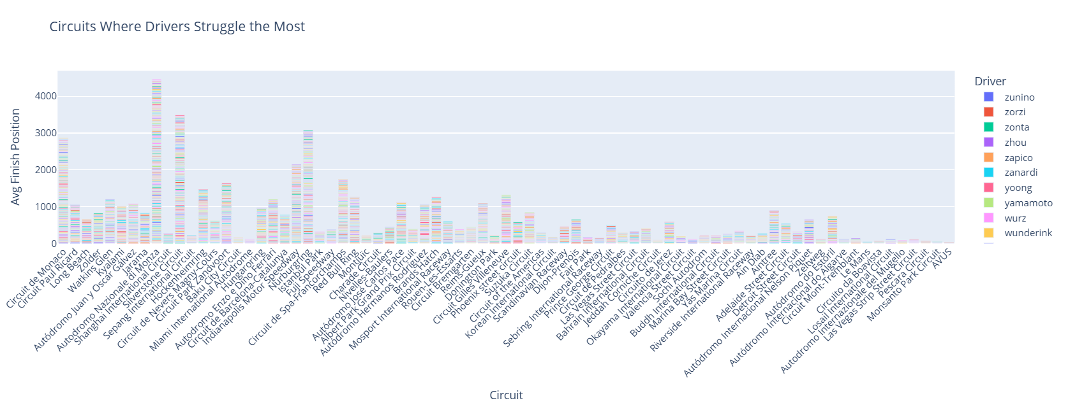
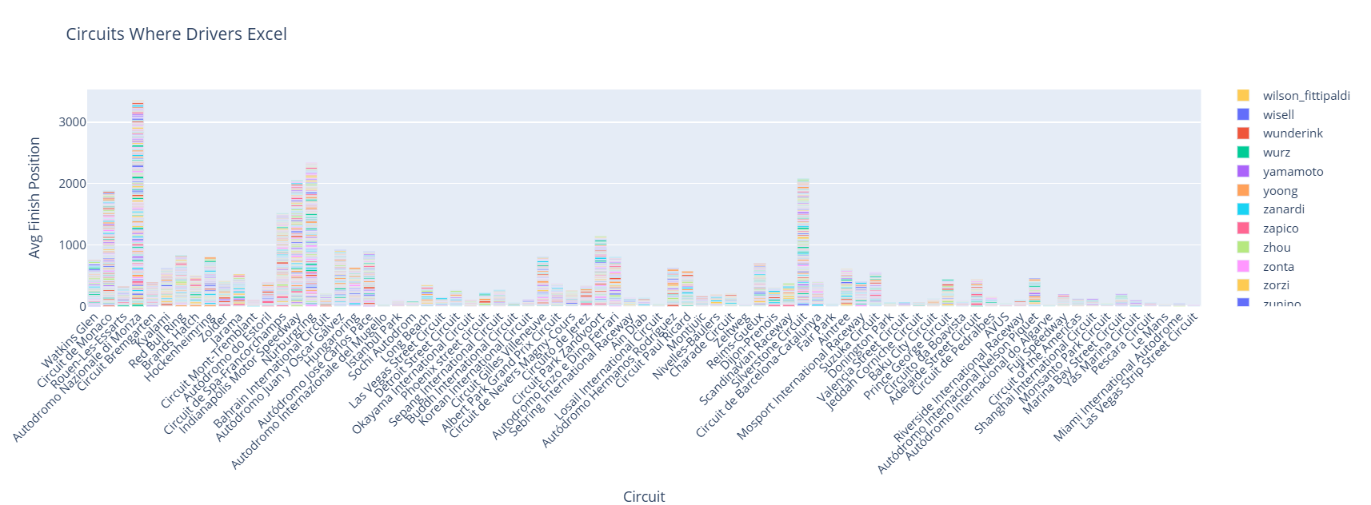
15. CHAMPION AGE TRENDS
- Merged datasets including race results, driver details, constructor information, and circuit data to create a comprehensive analysis framework.
- Analyzed driver movements between teams over seasons, constructing a network graph to visualize these transitions.
- Aggregated total points for each constructor to identify top-performing teams, both overall and on specific circuits.
- Calculated average finishing positions and standard deviations for drivers to assess performance consistency, highlighting those with stable results versus fluctuating ones.
- Evaluated average lap times of teams across different circuits to determine which teams maximize efficiency on specific tracks.
- Identified top drivers based on point accumulation and analyzed their contributions to constructors, determining the most effective team compositions.
- Assessed individual driver performances on various circuits to pinpoint tracks where they excel or struggle consistently.
- Examined the ages of championship-winning drivers over the years to identify trends and prevalent age ranges for peak performance.
KEY INSIGHTS:
- Visualizing driver transitions between teams reveals patterns in career moves, with certain teams acting as common stepping stones.
- Specific constructors consistently accumulate higher points, indicating sustained success and effective team strategies.
- Drivers with lower variability in finishing positions often contribute more reliably to team success, underscoring the value of consistent performance.
- Teams demonstrate varying lap time efficiencies across circuits, suggesting specialized strengths on particular track types.

