**UNIVERSITY OF PETROLEUM & ENERGY STUDIES**

**Lab Assignment : JOB TRIGGER**

Programme: B. Tech in Computer Science and Engineering with

Specialization in DevOps

Course: Continuous Integration & Continuous Delivery

Semester: V

Session: Aug-Dec 2022

Batch: 2020-2024

Faculty: Dr. Omkarendra Tiwari

**Submitted By:**

|  |  |  |
| --- | --- | --- |
| **Name** | **SAPID** | **ROLL NO** |
| **Rohit Kumar** | **500082652** | **R214220968** |

**Cybernetics Cluster**

**School of Computer Science**

**University of Petroleum and Energy Studies**

**Dehradun-248007**

Step 1: Create a new job.

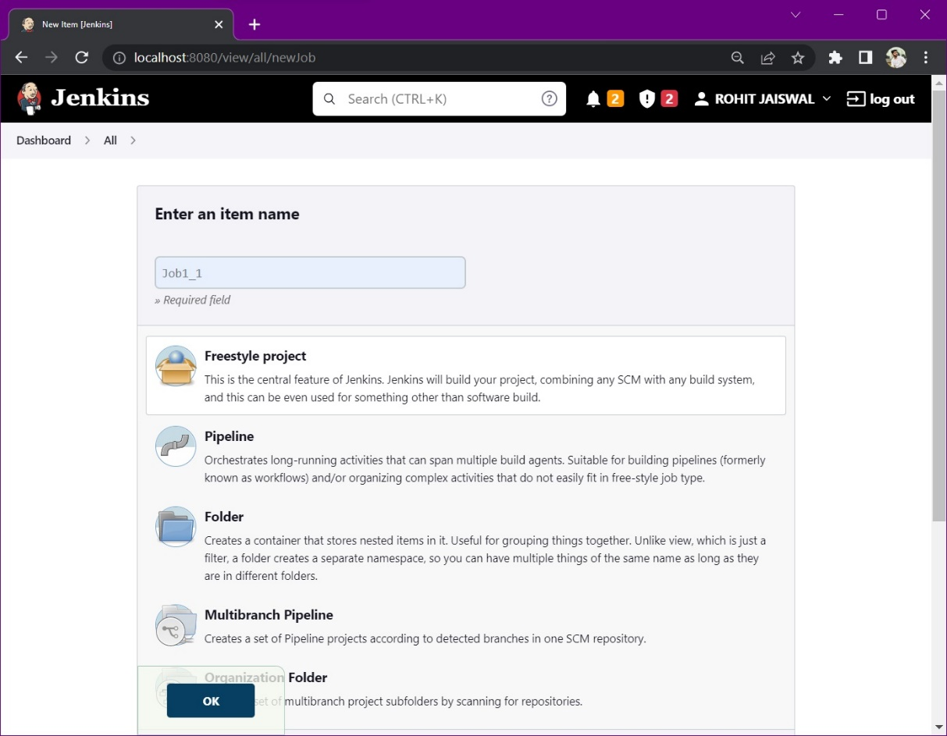

Step 2: Configure the build steps.

Select - Add build step > Windows batch command

Write some sample commands as follows.

Press Save.

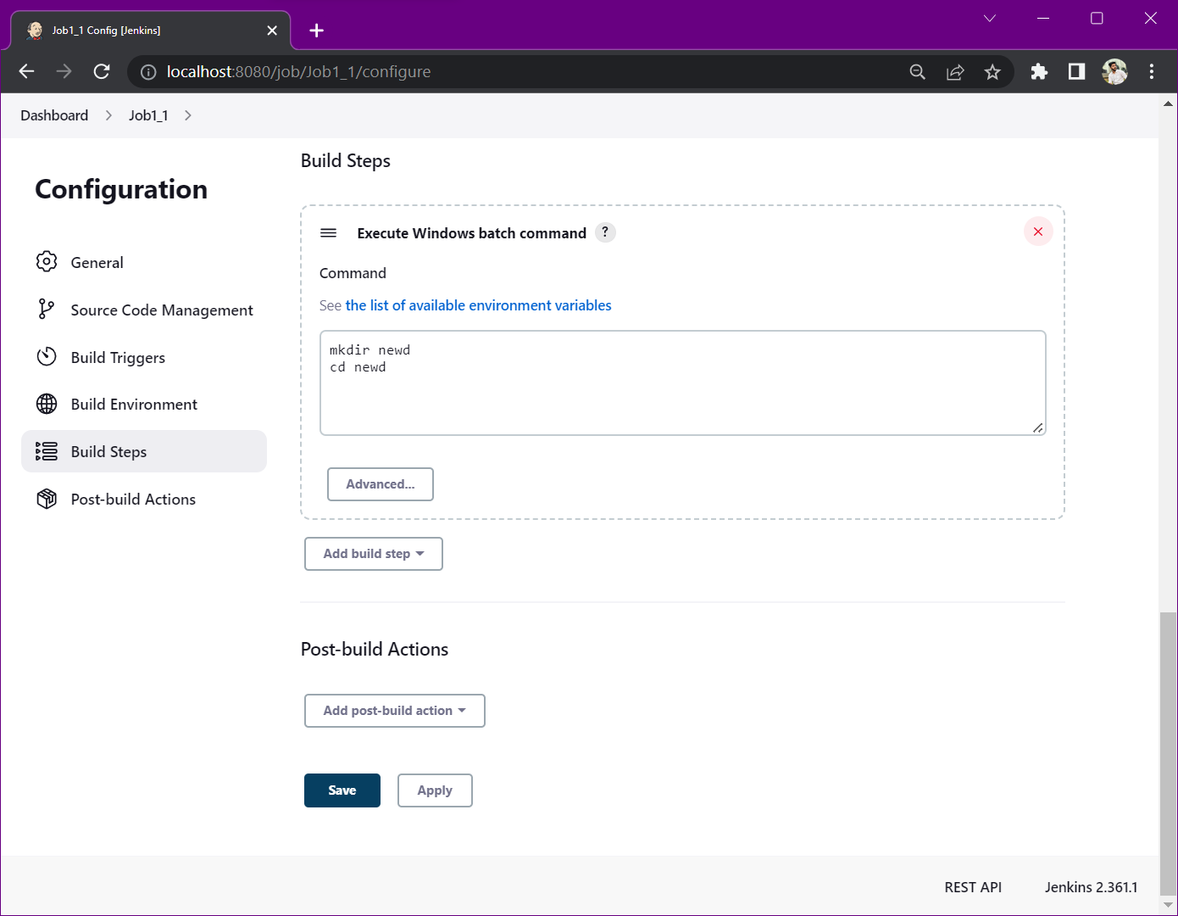

Step 3: Press Build now. And then click on Console Output.

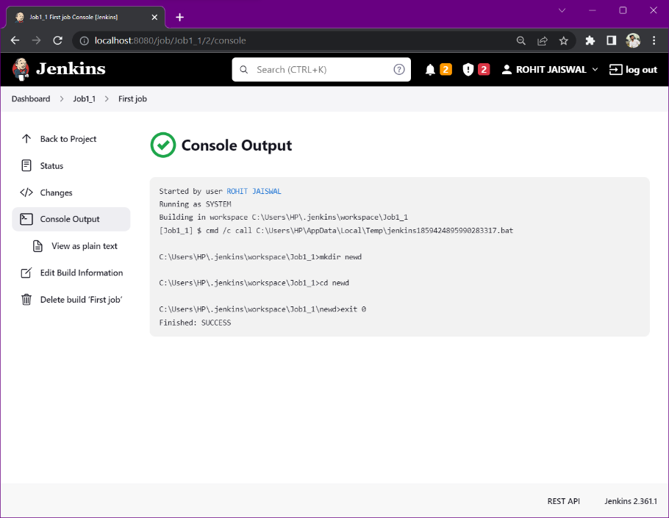

Step 4: Create second job.

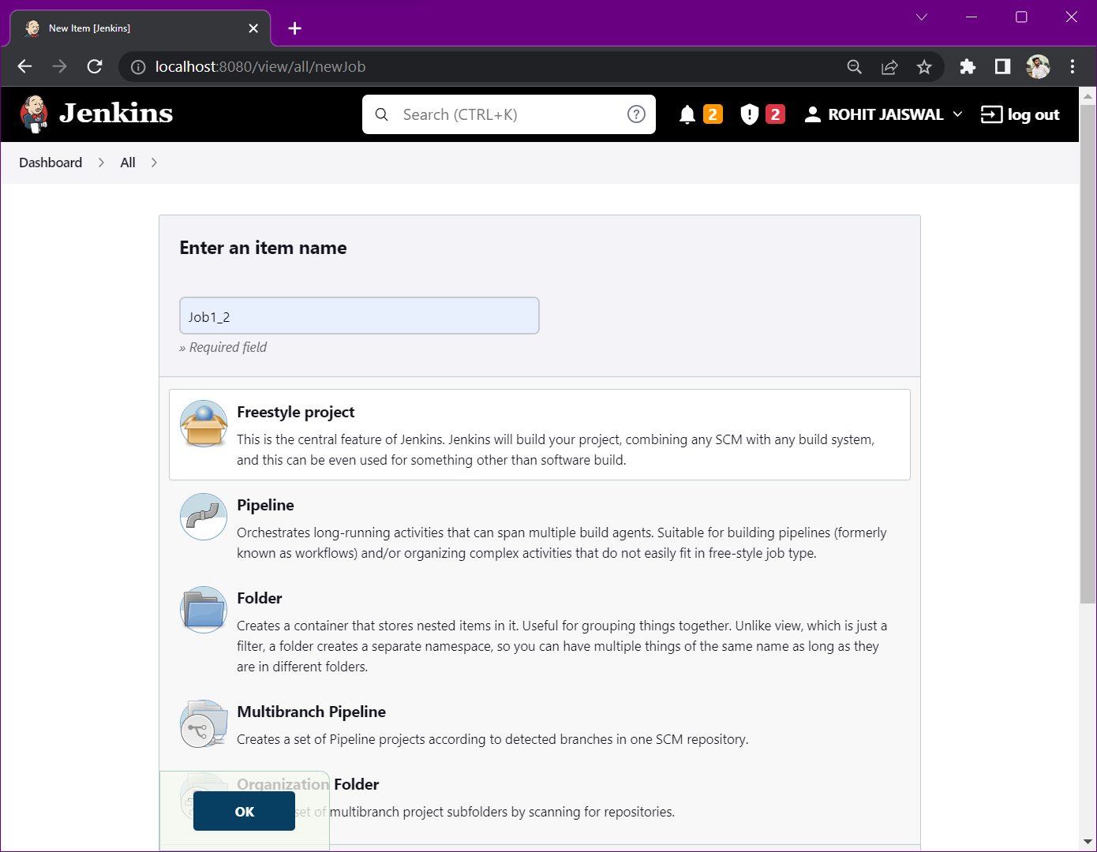

Step 5: In build trigger section, tick the check box which says – Build after other projects are build.  
Select the first job in “Projects to watch” section > Trigger only if build is stable.

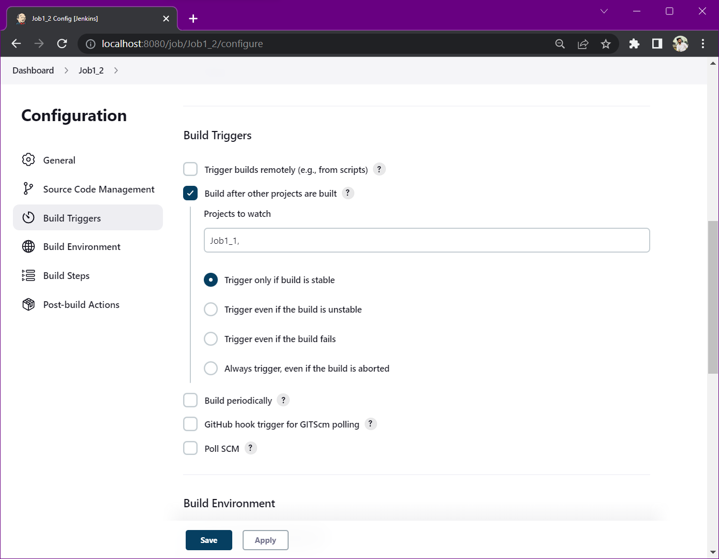

Step 6: Configure the build steps.

Select - Add build step > Windows batch command

Write some sample commands as follows.

Press Save

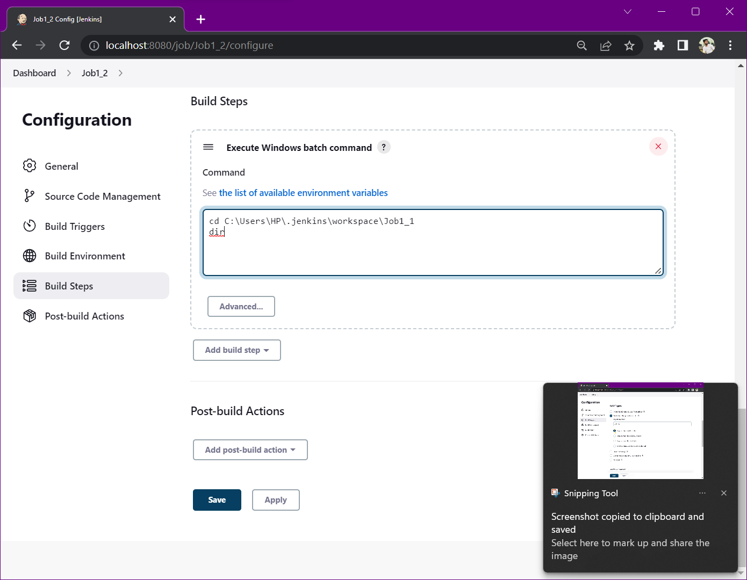

Step 7: Create third job.

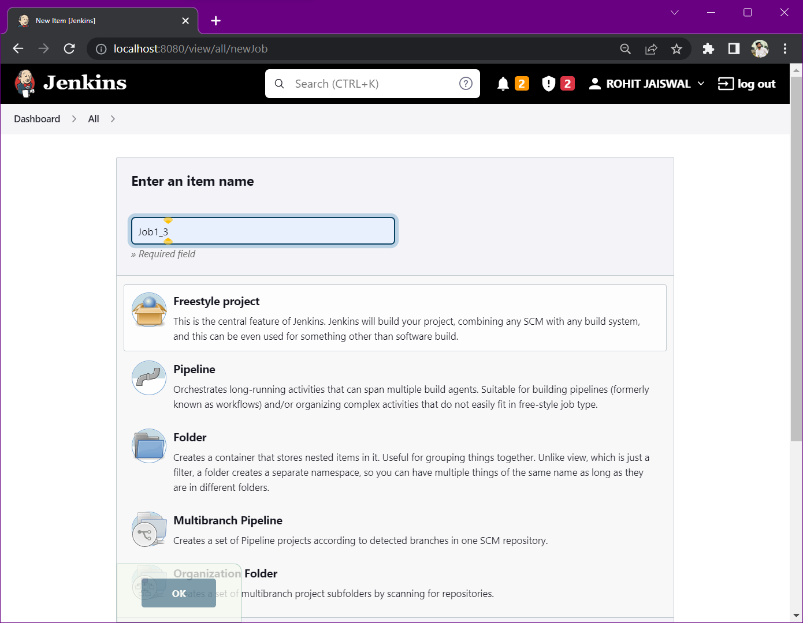

Step 8: In build trigger section, tick the check box which says – Build after other projects are build.  
Select the second job in “Projects to watch” section > Trigger only if build is stable.

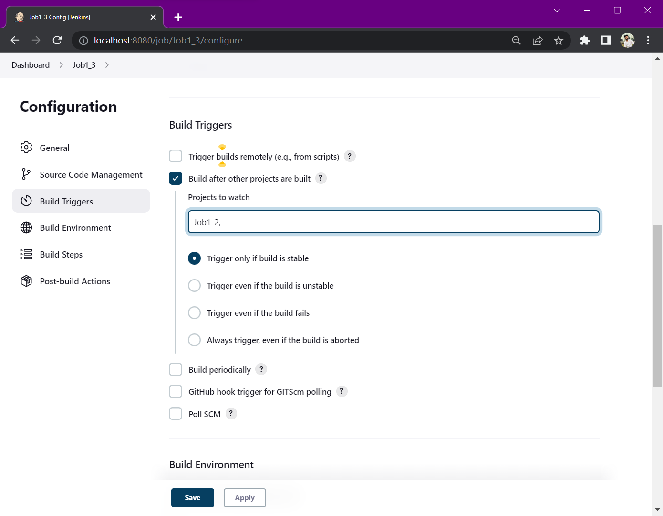

Step 9: Configure the build steps.

Select - Add build step > Windows batch command

Write some sample commands as follows.

Press Save

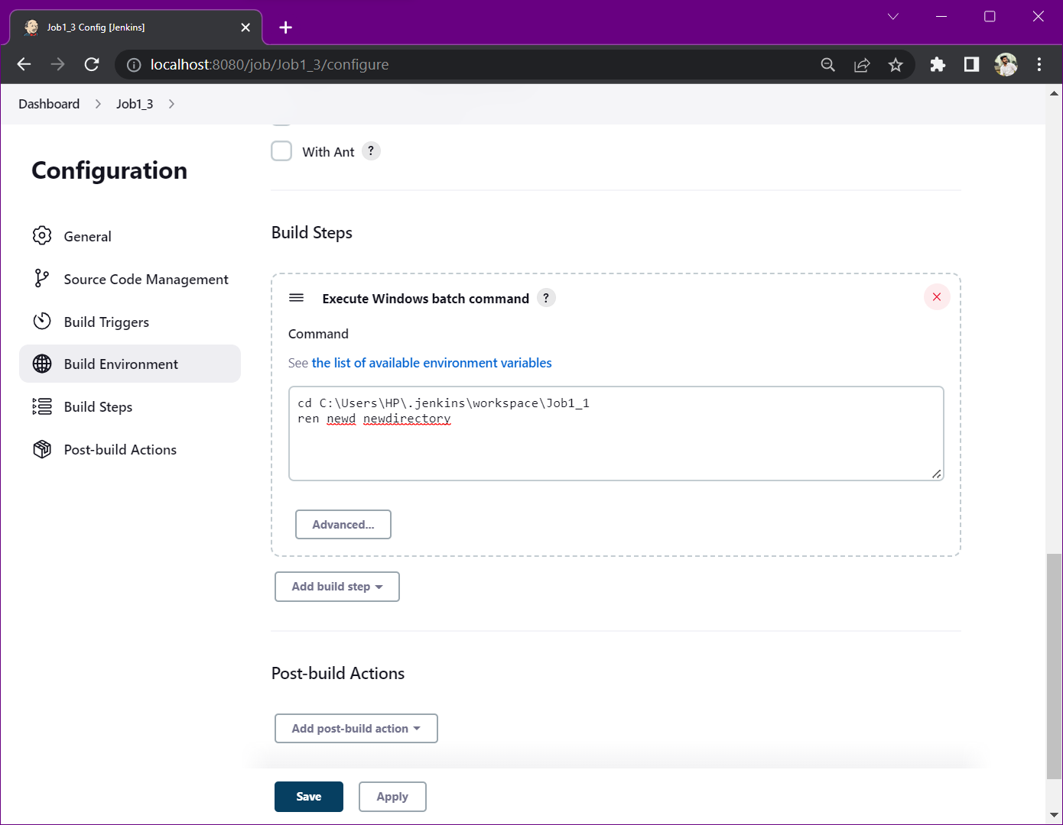

Step 10: Create fourth job.

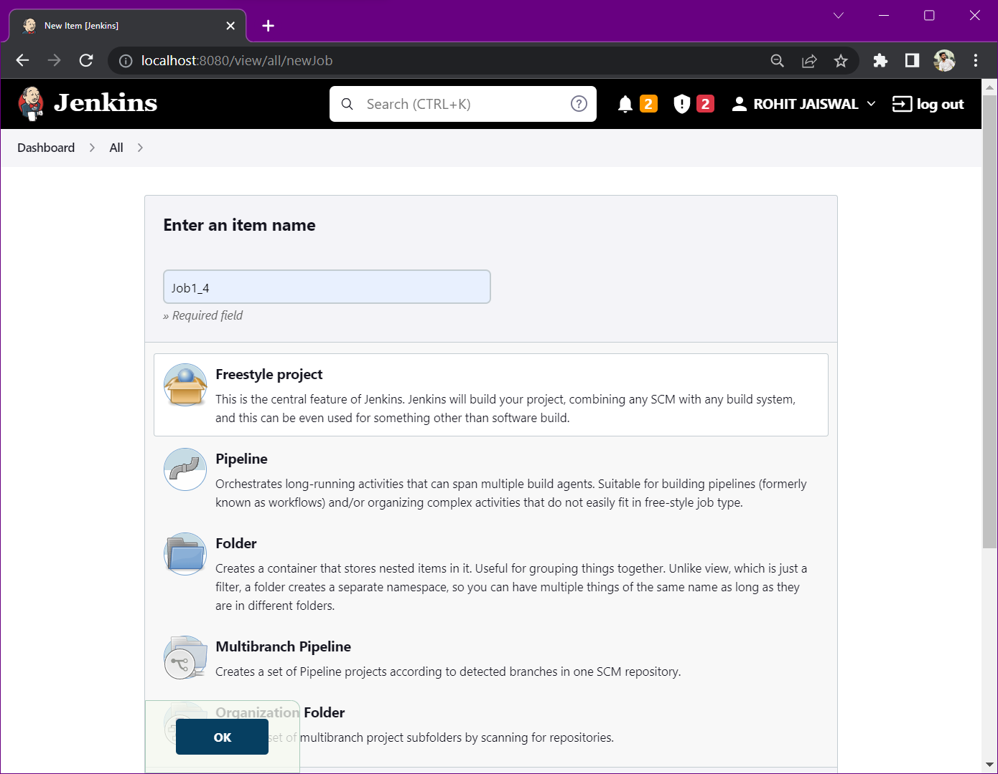

Step 11: In build trigger section, tick the check box which says – Build after other projects are build.  
Select the first job in “Projects to watch” section > Trigger only if build is stable.

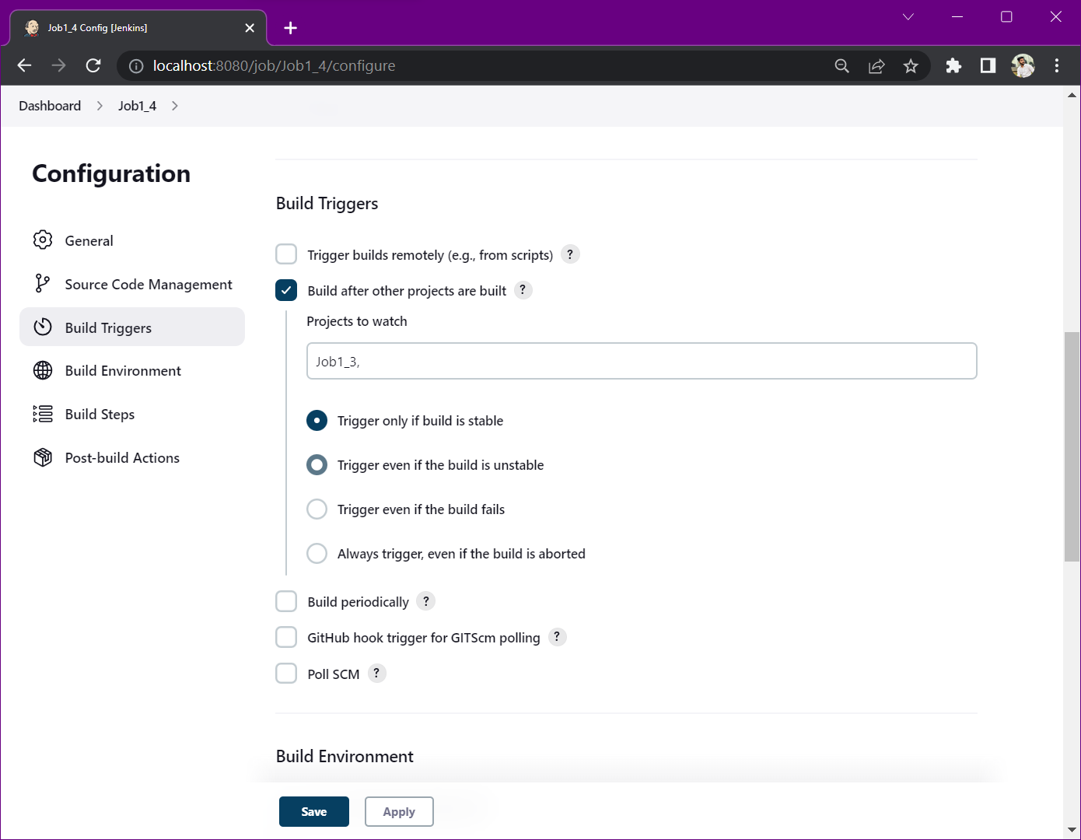

Step 12: Configure the build steps.

Select - Add build step > Windows batch command

Write some sample commands as follows.

Press Save

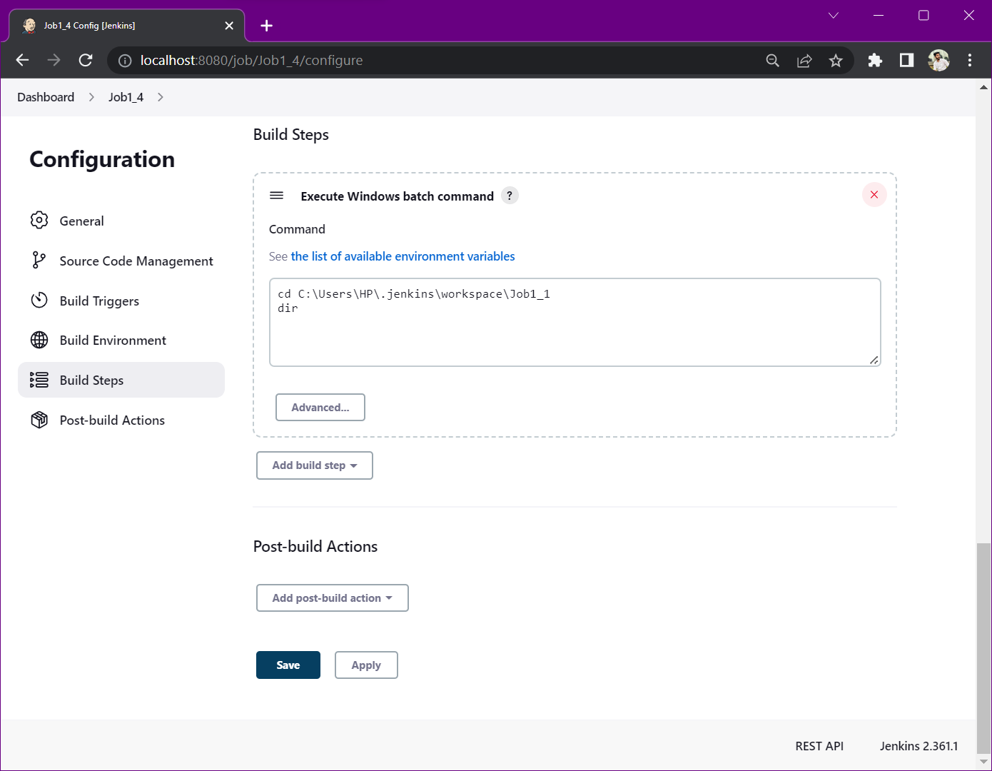

NOTE: We can see that build of Job 1 has been successfully created. Whereas, for 2nd, 3rd & 4th job, we have not created any build.

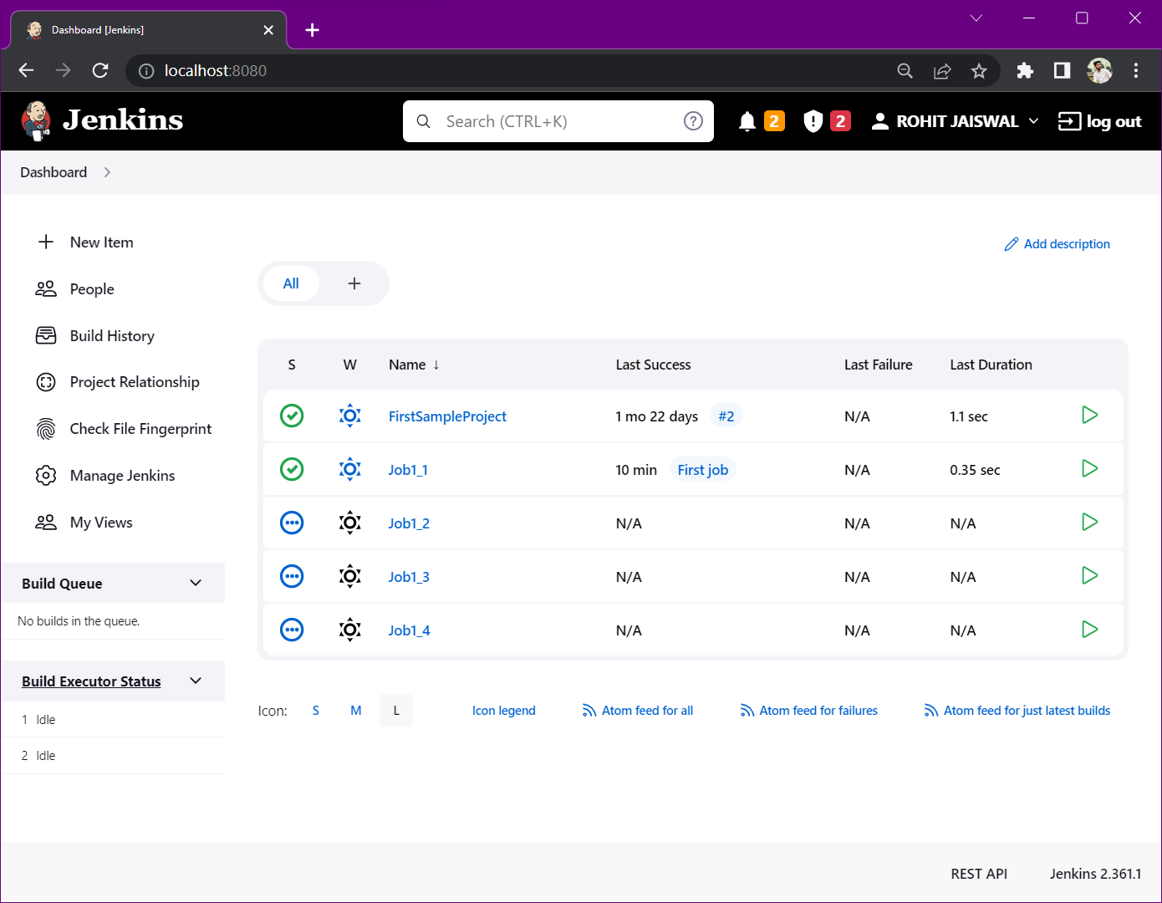

Step 13: Move to job 2 & create a build for this job.

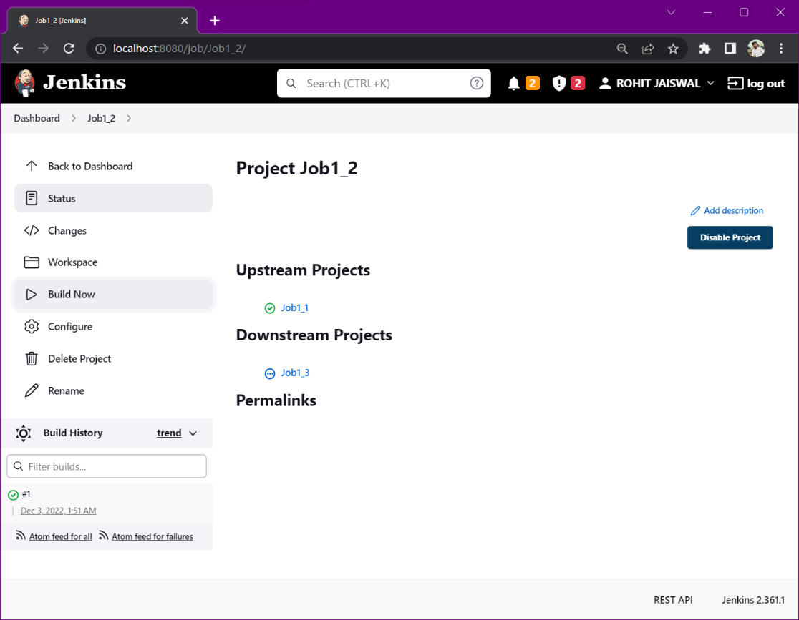

NOTE: Build of 2nd, 3rd & 4th job has been created just by creating the build of Job 2.

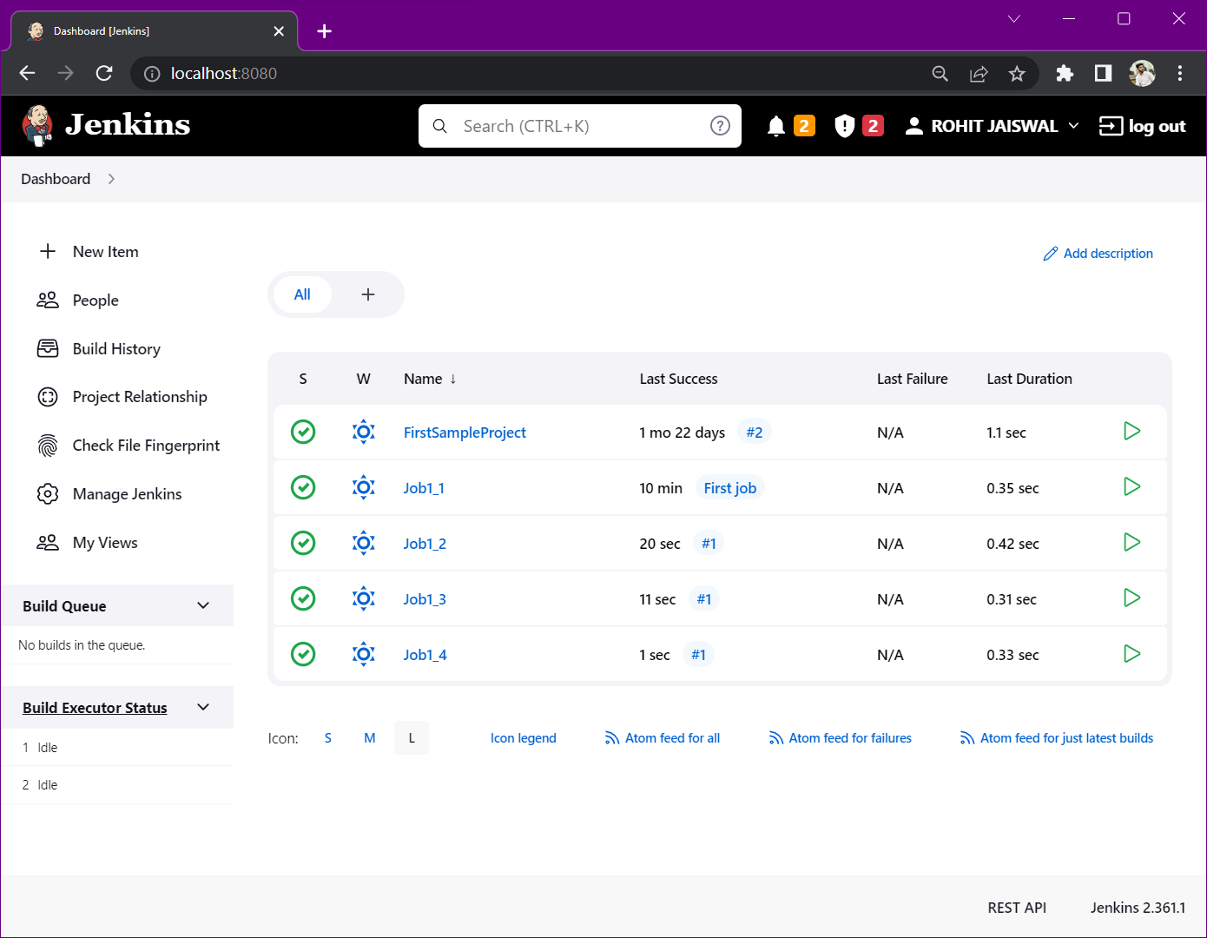

Step 14: Open the console output for 2nd, 3rd & 4th job’s build and check if the task specified in the commands has been performed correctly or not.

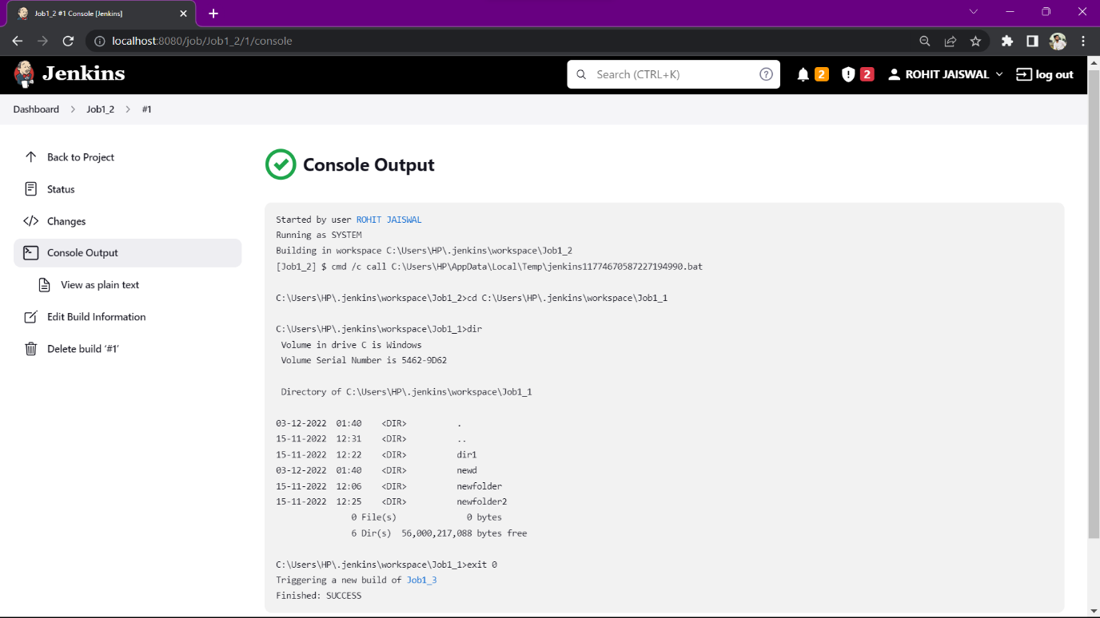

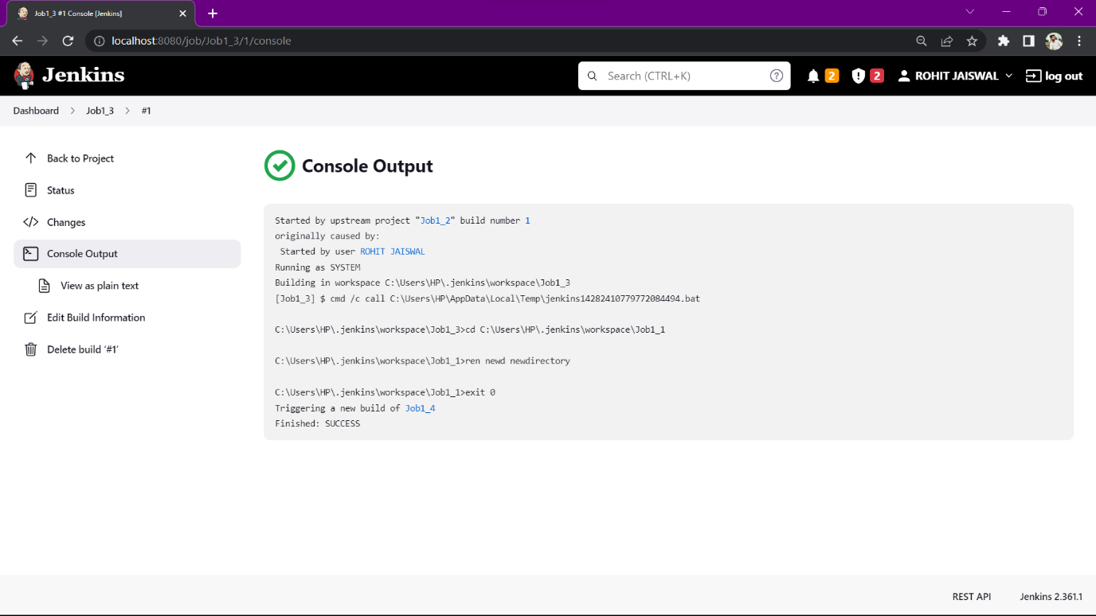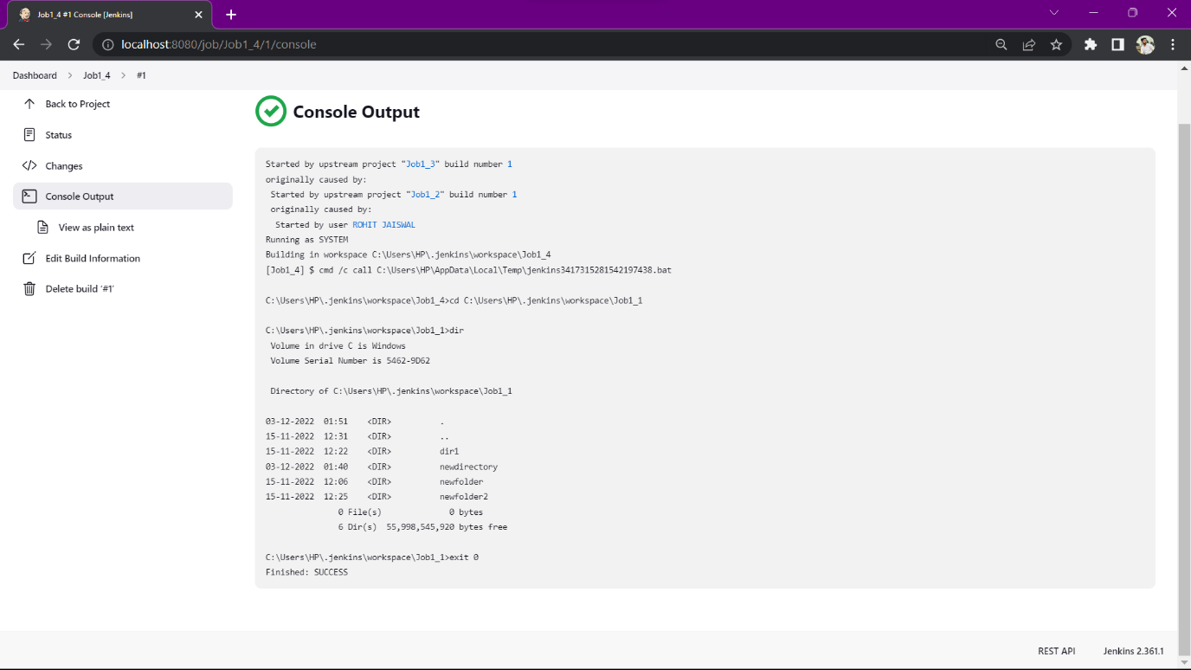

**CONCLUSION: *On a successful and stable build creation of Job 2; Job 3 and Job 4 got triggered automatically leading to creation to their builds as well.***