TEAM - 3  
   
 JAITEJ VAKKALAGADDA  
 (21B21A4652)  
  
 GIT & GITHUB

**GIT Introduction :**

**Git is a free, open-source version control system (VCS) that helps software developers manage and track changes to source code.**

**Git is a distributed version control system that tracks versions of files.  
  
Git is a Version Control System(VCS). VCS is basically software designed to record changes within one or more files over time.**

**GITHUB Introduction :**

**Github is a website that developers store, manage and share their code.**

**Uses Git, an open-source version control system, to track changes to files.**

**GIT & GITHUB USES :**

**Git and Github are tools that developers collaborate on software projects.**

**Storing code: Developers can store code in GitHub repositories**

**Sharing code: Developers can share code with others in GitHub repositories**

**Allows multiple people to work on the same code simultaneously.  
  
Provides tools to manage conflicting changes from multiple developers, includes access control, bug tracking, and task management.**

**Reviewing code: Developers can use GitHub to review code, report issues, and merge changes.**

**Common Basic Commands of Git :**

**1. Git Init :   
 Git init command creates a new repository and also convert an existing project to a Git repository.**

**2. Git add :   
 Git add command stages files for the next commit in git.**

**3. Git commit :   
 Git commit command moves files from the staging area to local repository.**

**4. Git Remote :   
 Git remote command connects Github repository to the Git and lets user create, view, delete connections to other repositories.**

**5. Git Push :   
 Git Push command upload local repository content to a remote repository.**

**6. Git Rebase :   
 Git rebase command move commits around a git repository and also rewrites commit history.**

**7. Git fetch :   
 Git fetch command retrieves latest information from a remote repository.**

**8. Git Clone :   
 Git Clone command copies a Git repository from a remote location to the user local machine.**

**The Operation associate between Git & GitHub:**

**Step-1:Creating a folder**

**Creates a new folder and open it in the VS Code. and create any file in that folder to work.**

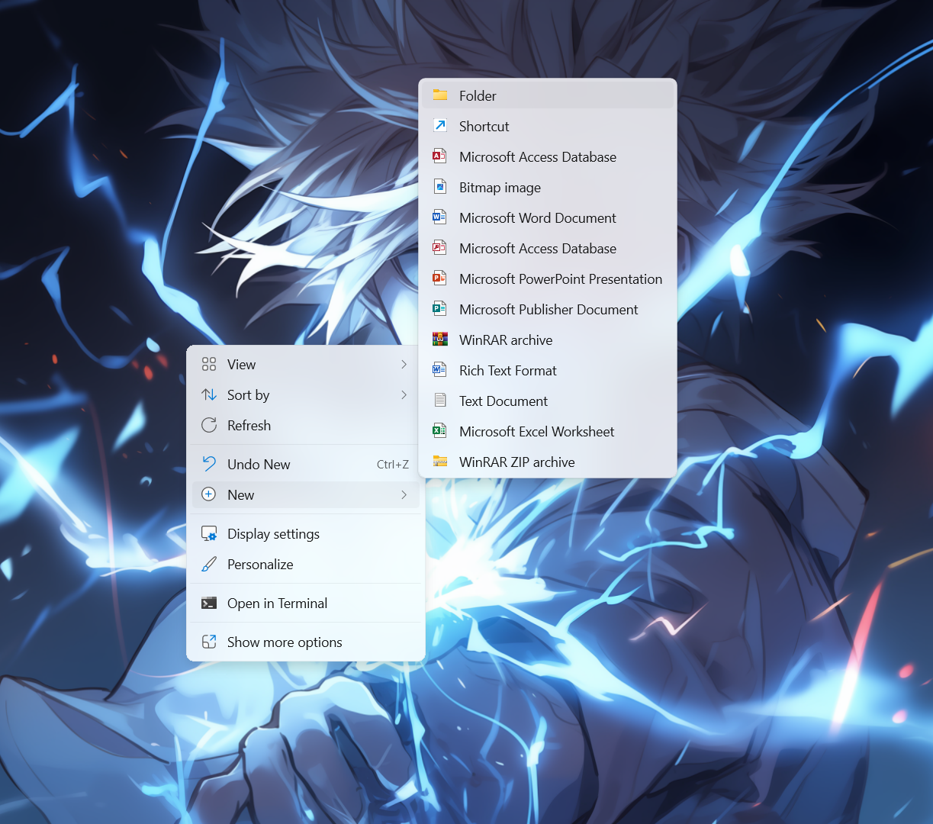

**Step-2:Initializing git in the Folder**

**Open terminal in VS Code and navigate to the folder where the file is located and run the command below.  
>> git init**

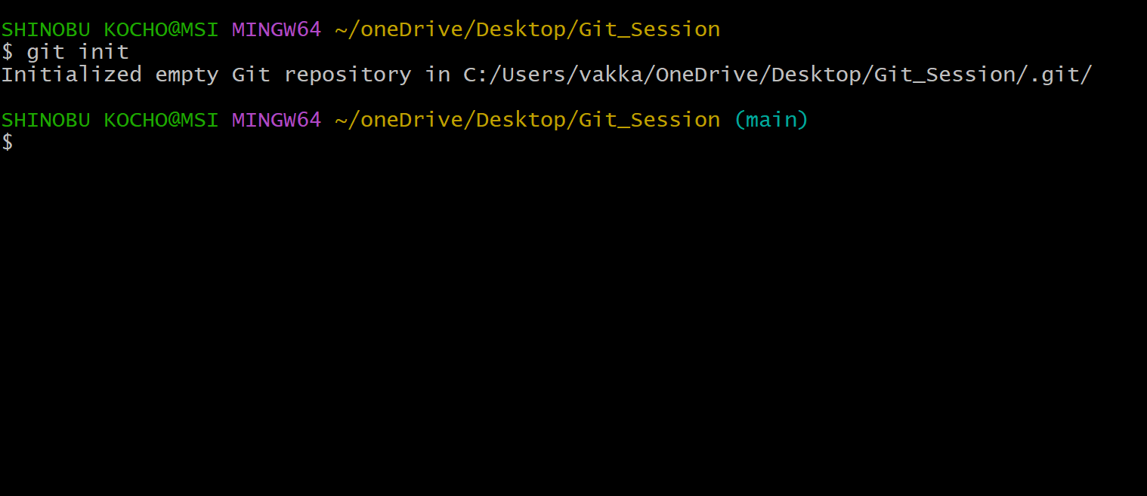

**Step-3:Adding files to the staging  
To add files to the staging run the below command in the terminal.   
>> git add .**

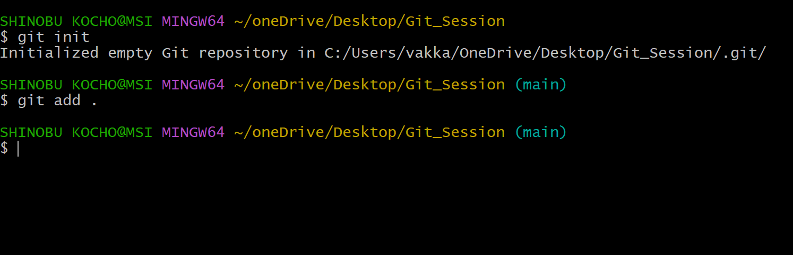

**Step-4:Commit the changes**

**Commit the changes made in the file so that we can track of it.Run the below command to commit the changes.  
  
>>git commit -m “commit string”**

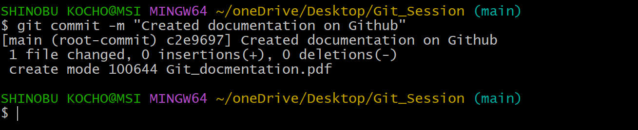

**Step-5:Create a GitHub repository**

**Open GitHub and login to your account and create a new repository and name it.**

**Step-6:Link Local repository to GitHub**

**Copy the remote repository URL from GitHub and type the following command in the terminal.**

**>> git remote add origin**

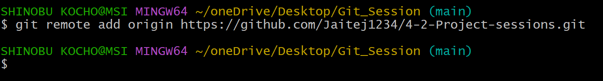

**Step-7:Push Changes to GitHub**

**Now you can push the changes made in the file to the Github repository to do that type the command below in the terminal.**

**>> git push origin main**

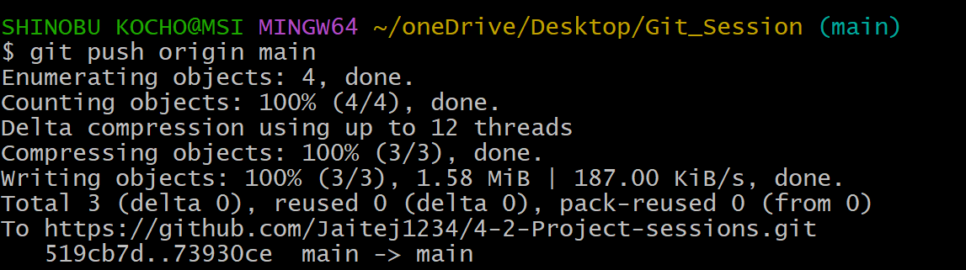

**📞 Contact**

**For any inquiries, feel free to reach out: -**

**📧 Email: vakkalagaddajaitej@gmail.com**

**💼 LinkedIn: https://www.linkedin.com/in/vakkalagaddajaitej/**