TOPIC

USING AI TO TO REDUCE MANUAL LABOUR WITH RESPECT TO GLOBAL TRADE AND SUPPLY CHAIN MANAGEMENT

BY-Jaival Shah

19BCE0552

Under

PROF. Rajkumar R.

ABSTRACT-

The administration of duties and global business undertakings represents a alive function for trades that significance and export merchandise about the world. To be even with an changing worldwide trade supervisory countryside in an era of growing supply chain safety concerns, a company endure occupy strong and pliable all-encompassing business compliance and preparation processes. Robust processes are necessary to address the intersection of significance requirements, ship controls, and opportunities accompanying added vital projects of killing, containing supply chain and transportation administration. The correct payment of assignments, taxes, and accounts, from an significance perspective, in addition to the direct management of transport controls, are owned by the economic, operational, and reputational comfort of associations engaged in the evolution of merchandise and wealth across borders.

In many arrangings, duties and global business undertakings are usually either managed by a stand-unique function or by possessions entrenched inside other trade functions. Also, this working region has historically been seen as a cost center at which point many arrangements dedicate only restricted money. Such a understanding typically constrains trade accomplishment when it yields duties and global work administration programs that are understaffed, underfunded, and easily systematized.

Introduction-

The system for Global Trade Services (GTS) lets you mechanize your global work undertakings, manage big numbers of trade partners and documents, and guarantee that your association always gives up accompanying constantly changeful international allowable managing. This solution supports your all-encompassing work activities accompanying the finishes you need to participate in the remodelled structures and electronic way of communication secondhand by management agencies and duties experts. GTS helps you avoid priceless delays and commercial risks involved accompanying imports and exports, permissive you to react to worldwide business moment fast.

SAP Global Trade Services helps parties better accomplish all-encompassing trade movements, guarantee continuous work compliance, and enhance the cross-border supply chain. The resolution gives industrialization and comprehensive performance to speed profession functions and exaggerate accomplishment. With direct unification throughout the supply chain, consumers can wish diminished costs, lean trade punishments and fines, and faster duties go-ahead, two together outbound and ingoing. The far-reaching functions contain the following:● Export procedures

● Import procedure

● Customs procedures

● Free trade agreements

● Restitution

● Sanctioned party list screening

Litertature Survey-

|  |  |  |  |  |  |  |
| --- | --- | --- | --- | --- | --- | --- |
| S.No | Author | Year | Title | Methodology | Result | Conclusion |
| 1 | Thomson Reuters and KPMG International | 2016 | GLOBAL TRADE MANAGEMENT SURVEY | Case studies  (6) | 1.Lack of automation is the top challenge.  2.FTA underutilization.  3.Complexitiy with classification of goods.  4.Centralisation of trade process. | Manual work exponentially high due to lack of automation and complexity with classification. |
| 2 | Mohammad Reza NORUZI | September 2010 | A literature Review of Global Economy and Globalization Era |  |  |  |
| 3 | Sunanda Sen | November 2010 | International Trade Theory and Policy: A Review of the Literature | Scholarship and economic research . | The unequal power connections betwixt the rich and poor countries with its own government of the realm permits a continuation concerning this uneven combination of procedures, to which profession belief unfortunately has provided much | Concluding, seemingly the development of work belief, from traditional business doctrines to the NTT, has jolted tactics at two levels. The first has connection with the ongoing support of the capitalism principle to decide tactics for evolving fields. As is anticipated, the push arises the advanced countries with its own government, two together at the intergovernmental level and at multilateral organizations like the IMF and the WTO |
| 4 | Eukeria Mashiri and Favourate Y Sebele-Mpofu | · January 2015 | Illicit trade, economic growth and the role of Customs: a literature review | Case studies | Eight per cent and fifteen per cent of national GDP is through illicit trade due to complexity in classification of good, import duties,etc. | Findings show that the criminal frugality accounts for middle from two points eight per insignificant value and fifteen per cent of domestic GDP, falsifying local frugalities, reducing authentic trade revenues and revenue calm through taxes. Illicit profession also weakens the public cohesion and socioeconomic welfare of societies, as long as preventing the impartial giving of public merchandise as revenue that maybe used to expand and improve foundation. |
| 5. | Yanfen Wang | : November 8, 2019 | A Literature Review of Empirical Research on Trade of Cultural Goods | Empirical Research Literature of Western Cultural Goods | How cultural goods have been transported, problems faced by certain nations due to agreements. | setting many quota entries to limit the import of foreign (mainly American) film, television, radio, and other cultural goods |
| 6. | By Roszel C. Thomsen II | November,2018 | Artificial Intelligence and Export Controls: Conceivable | Research based analysis using a sample size. | Putative controls on AI data. | AI Controls based on end users and end use . |
| 7. | Christopher Nelson | 2019 | Machine learning for detection of trade in strategic goods: an approach to support future customs enforcement and outreach | Machine learning for detection of trade in strategic goods. | . Neural network algorithms are more complicated than decision trees but can handle a wide range of input variables and have the ability to create non-linear and complex 128 Volume 14, Number 2 International Network of Customs Universities relationships between variables. This approach could be explored to train more accurate models in predicting strategic trade transactions | Given the data-dense nature of international trade transactions, customs authorities around the world are in an excellent situation to exploit advances in machine learning to improve risk analysis, enforcement and outreach. |
|  |  |  |  |  |  |  |

PROPOSED METHODOLOGY-

WHAT IS ECCN

An Export Control Classification Number (ECCN) is a five-individuality number accompanying alphanumeric designations secondhand under the Commerce Control List (CCL). This list, that the Department of Commerce understands, helps trades decide either an transport license is necessary to smuggle merchandise from the US to different parts of the planet.

An ECCN virus in classifying commodity established ability’ character, type, mechanics limits, and the program/electronics secondhand.

**Purposes and Uses of ECCN**

An ECCN allows the government to anticipate the level of control required for a particular product, not only during the export process but also after its manufacturing.

### ECCN Code Format

All ECCNs are filed in the Commerce Control List (CCL) that is before detached into ten broad classifications, and each classification is further subdivided into five brand groups. The first figure of the ECCN recognizes the fuller classification at which point it belongs and the second type labels the merchandise group.

• Category Group: This group forms various activities varying from 0 to 9.

• Product Group: The group facilitates the number into five various amount traits.

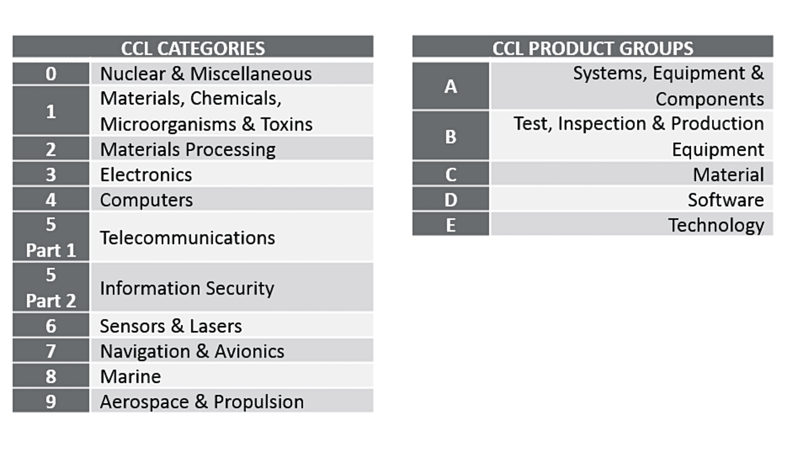

Although the ECCN classification and code format is fairly straightforward to understand, it can be better explained with the help of an example.

Example the ECCN code to re-export Riot Helmet is **0A979**.

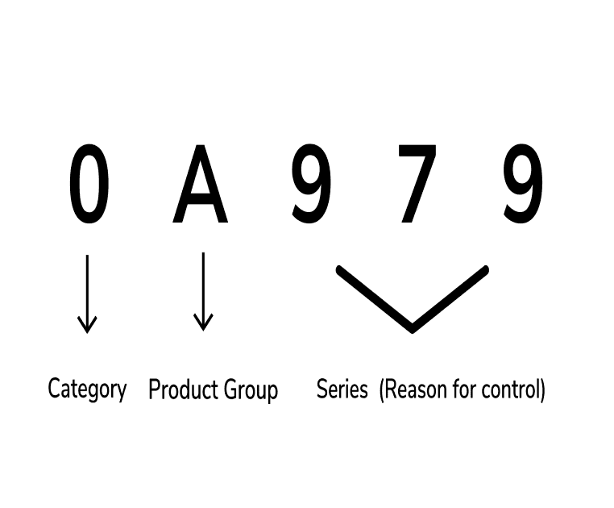

Algorithm(METHODOLOGY)-

Product classification-

To predict classification codes for new products

Identify anomalies by comparing existing tasks with ml generated predictions

Classify and scale effectively

How the algorithm, shall work-

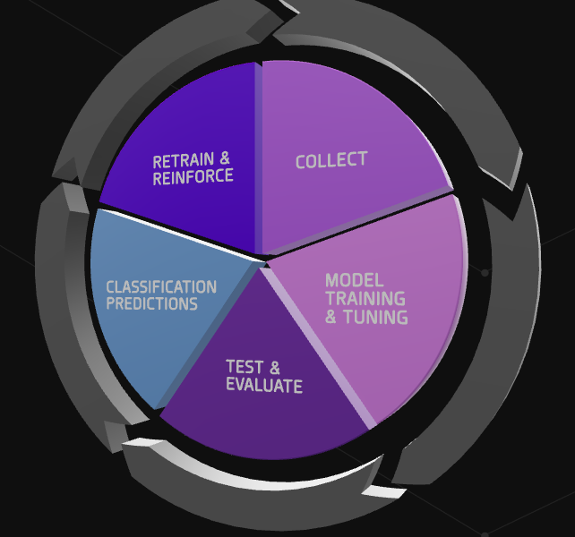

If something goes wrong(health check for algorithm based upon model)-

Healthcheck can support you a modernized solution through robotic reasoning so you don’t have to influence supplementary headcount to stay compliant. This duty will guarantee you have accurate, compatible business data across your trade to support resumed compliant movements in all-encompassing trade.

We will specify a report emphasize erroneous or inconsistent dossier utilizing AI. Use the report to reclassify or delete old-fashioned, wrong, redundant, or unfinished dossier from classification databases.

Basic code for testing-

import dash

import dash_core_components as dcc

import dash_html_components as html

import pandas as pd

from fuzzywuzzy import fuzz

df=pd.read_csv('consolidated.csv')

df["FirstName"] = df["name"].apply(lambda x: x[0:x.find(",")])

df["LastName"] = df["name"].apply(lambda x: x[x.find(",")+2:])

def generate_table(dataframe, max_rows=100):

return html.Table(

# Header

[html.Tr([html.Th(col) for col in dataframe.loc[:,['name','title','citizenships','addresses','source_list_url','source_information_url']]])] +

# Body

[html.Tr([

html.Td(dataframe.iloc[i][col]) for col in dataframe.loc[:,['name','title','citizenships','addresses','source_list_url','source_information_url']]

]) for i in range(min(len(dataframe), max_rows))]

)

app = dash.Dash()

server = app.server

app.layout = html.Div(

children=[html.H4(children='Denied Party Screening'),

dcc.Dropdown(

id='dropdown',

## extend the options to consider unique Fund values as well

#options=[{'label': i, 'value': i} for i in df['Investor'].unique()] + [{'label': i, 'value': i} for i in df['Fund'].unique()],

options=[{'label': i, 'value': i} for i in df['FirstName'].unique()] + [{'label': i, 'value': i} for i in df['LastName'].unique()] + [{'label': i, 'value': i} for i in df['name'].unique()],

multi=True, placeholder='Filter by Name(FirstName or LastName)...'),

html.Div(id='table-container')

])

@app.callback(dash.dependencies.Output('table-container', 'children'),

[dash.dependencies.Input('dropdown', 'value')])

def display_table(dropdown_value):

if dropdown_value is None:

return generate_table(df)

## add an 'or' condition for the other column you want to use to slice the df

## and update the columns that are displayeds

#dff = df[df.name.str.contains('|'.join(dropdown_value)) ]

#dff = df[df['name'].str.find('|'.join(dropdown_value)) != -1]

def get_ratio(row):

name = row['name']

return fuzz.token_sort_ratio(name, '|'.join(dropdown_value))

dff = df[df.apply(get_ratio, axis=1) > 60]

dff = dff[['name','title','citizenships','addresses','source_list_url','source_information_url']]

return generate_table(dff)

if __name__ == '__main__':

app.run_server(debug=True, host="0.0.0.0", port=8080, use_reloader=False)

Visualisation-

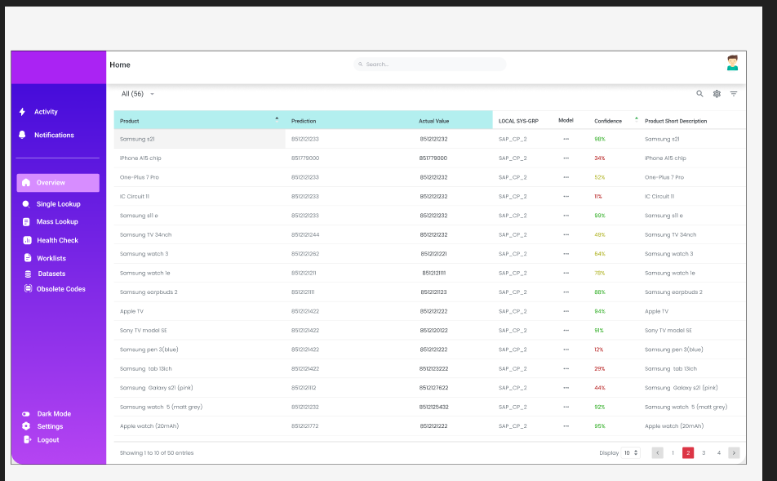

**AI ARCHITECTURE**

AI can be thought

Of as consisting of four distinct layers, each with its

Own challenges and related technologies: (1) the per-

Ception layer, (2) the learning layer, (3) the decision

Layer, and (4) the action layer.

The perception layer includes the sensors (hard-

Ware and software) that collect data. For example,

It can include sensors for detecting the proximity of

Objects or optics used to capture facial features for bio-

Metric uses. According to Professor Dubrawski, the

Technologies at the perception layer are considered

Mature technologies, developed largely independent

Of AI. The learning layer includes data science and

Machine learning algorithms, which he also considers

To be mature technologies. Access to large data sets

Also is required in order to have AI systems that learn

Quickly. The United States, Europe, and China are

Currently the main players in developing technology

For the learning layer.

By comparison, the decision layer and action

Layer are still in the early stages of development. The

Decision layer is where planning occurs and where

The software chooses a path to take based on the data

Available. The action layer is where the AI system

Realizes autonomy and takes an action based on its

Decision. Important research in this layer also includes

Human–machine interfaces.

For example, consider the application of AI to

Autonomous vehicles. The perception layer would

Be represented by the sensors on the vehicle. The

Learning layer would be represented by the software

Which analyzes the surrounding environment using

The data from the sensors. Here humans would have to just check and verify the functuioning of the algorithm by using SAP.

Algorithm-

Machine learning with random forest

Once prepared, the **information** **is prepared** **for use** to create a **version** for classifying transactions **related to** Strategic goods.

A minority **part of** the **gathered** dataset **need to** be set **apart** for **impartial** **trying out** of the Model **as soon as** **it's miles** **skilled** **at the** **information**, **with the intention to** **offer** a **degree** of performance.

This **have a look at** proposes **using** the random **wooded area** **set of rules** to **are expecting** **whether or not** a transaction **includes** a Strategic **suitable**. Originally proposed **through** Breiman (2001), this **version** creates many **choice** **bushes** **primarily based totally** on Randomly **decided on** **functions** and **information** samples to **decide** the **class** of a transaction. A **choice** Tree **assessments** one **function** at **every** **choice** node, splitting into sub-nodes **so that it will** maximise the homogeneity

Of the **ensuing** groups. It **keeps** splitting **till** **it may** **positioned** the **information**, with a **excessive** probability, into a Leaf that identifies the **class** of the record. Decision **bushes** have the **benefit** of being more

Easily visualised and interpreted than **different** **class** algorithms. Random **wooded area** expands this **version** By **developing** **masses** or **hundreds** of randomly generated **bushes** **the use of** **extraordinary** **functions** and subsets of Data. In our case, **every** tree **might** generate a prediction for **every** transaction and the **very last** **class** Would be **determined** **through** a majority vote does not, **consequently** **the general** prediction is that **there may be** a strategic **suitable** involved.

Next step I plan to add is

This algorithm has many advantages. By utilising random samples of features and data over many

Trees, it can help prevent overfitting the model. Individual decision trees, unless pruned or controlled,

Can continue splitting the dataset in increasingly specific ways, creating a very specific model that

Cannot generalise to new data. In addition, random forest is very versatile, handling categorical and

Numeric data. Many machine learning algorithms require workarounds for categorical data. Applications

Of this algorithm also provide an ability to identify the importance of individual features to the final

Classification. This would allow the identification of which aspects of transactions, such as destination,

HS code or value, are most valuable in predicting whether a transaction involves a strategic good. By

Utilising a multitude of trees, no individual test of the data will predominate, increasing confidence in

The ultimate classification. Random forest can be computationally expensive; however, parameters of the

Algorithm may need to be adjusted for the amount of data involved.

The algorithm would be trained on the data and performance would be measured against the reserved

Test set, which has a known classification. Based on the test, parameters or features could be changed

To increase performance. This model would apply to a particular strategic good. After the approach

Has been tested, it can be used iteratively to create models for a broad portfolio of strategic goods

Based on a state-level risk or priority assessment. Also, once these models are created, they could be

Applied as new data arrives. Pre-shipment data or shippers’ export declarations would be inputted into

The models to determine if the transaction is likely to contain a particular strategic good. The creation of

Multiple models has the advantage of taking into account the characteristics of particular commodities in

Addition to providing a prediction of which particular strategic good may be involved. A general model

Identifying if any strategic good was likely involved in a transaction would mix a multitude of very

Disparate commodities that have varying levels of risk or priority.

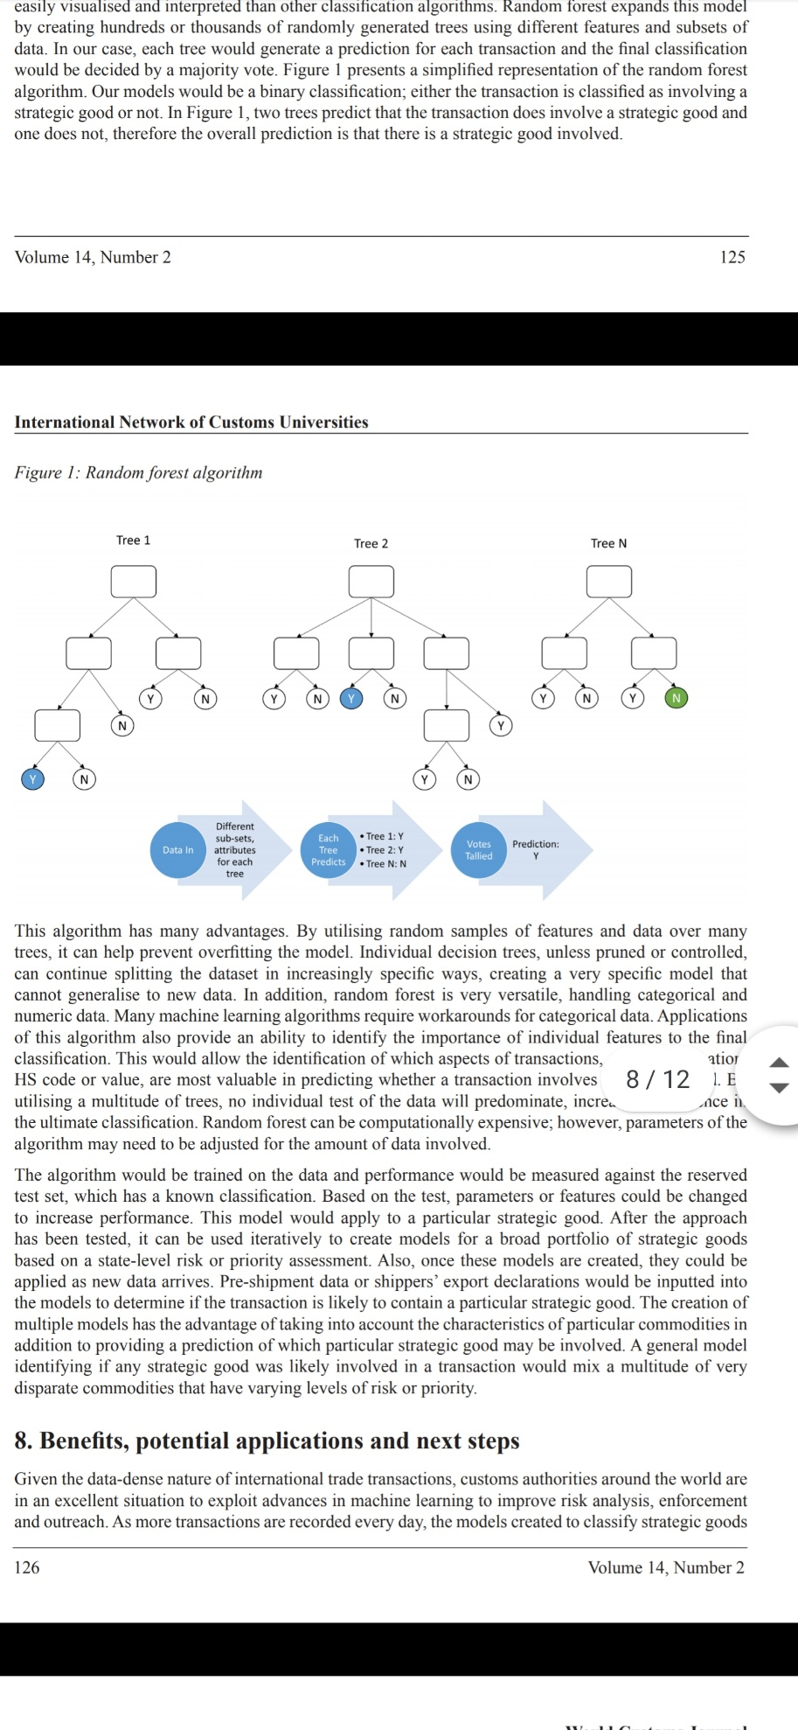

**Future propositions and improvements-**

Given the statistics-dense nature of worldwide change transactions, customs government round the arena are in an super state of affairs to take advantage of advances in gadget studying to enhance threat analysis, enforcementand outreach. As greater transactions are recorded each day, the fashions created to categorise strategic itemscan enhance, be adjusted and remodeled below the identical methodological construct. In addition, since this technique proposes using country-centric statistics, the fashions will inherently be designed to become aware of strategic items within side the context of that country, deliberating geography, buying and selling companions and industrial capabilities.

.The latest growth of disbursed computing and cloud-primarily based totally offerings permits for country government to examine and create fashions for a miles large part of statistics that might be treated even five to 10 years ago. Beyond higher managing of statistics, the continuing advances in gadget studying algorithms and techniques keeps to push the bounds of category predictions. The random wooded area set of rules turned into first delivered in 2001 and similarly refinements to it and different fashions preserve constantly (Breiman, 2001).

Random wooded area turned into selected for this notion due to the fact it could take care of a extensive variety of statistics sorts and may additionally become aware of the maximum crucial capabilities to the category of a transaction as concerning or now no longer concerning a strategic suitable. Practical trying out may also locate different techniques to offer higher overall performance or efficiencies, however that is exploration and can be very fruitful in lots of customs analyses.

The category of transactions concerning strategic items has a extensive style of beneficial packages for states. From an enforcement perspective, this technique could permit for higher profiling of transactions concerning strategic items the usage of real-international statistics. Reliance at the accuracy of licence packages and right HS code declarations is frequently misguided for a number of reasons. Training a random wooded area version on transactions declared to be a strategic suitable and people that aren't can permit for identity of patterns that delineate the transaction sorts. Once educated and refined, those fashions can be carried out to incoming transactions, thereby improving threat profiling and ability documentation or end-use checks. Modelling primarily based totally off a choose set of high-precedence strategic items may want to decorate aid allocation and offer statistics-primarily based totally justifications for inspections. This technique could additionally permit for states to higher understand not unusual place change flows for strategic items and become aware of ability transshipment factors. The random wooded area version can keep in mind the origination and vacation spot factors of the transactions. If a selected buying and selling point seems as a key node within side the version, it is able to help in enforcement concentrated on or outreach efforts.

In addition to enforcement, this technique can be used to layout outreach efforts that could cyclically enhance universal customs efficiencies. First, primarily based totally at the fashions educated via present statistics, it could be feasible to become aware of transactions that match the profile of a strategic suitable, however have been now no longer licensed. The entities concerned in those transactions can be recognized for schooling on export manipulate regulations and destiny end-use checks. Since this technique makes use of a basket of HS codes to become aware of how entities are delivery strategic items, it can additionally be used to enhance the manner states and entities classify which HS codes are utilized in exercise and which have to be used within side the change of a strategic suitable. This may want to offer a baseline for the way entities in a country are working and the way customs government may paintings with them and their worldwide companions to make greater powerful use of the HS. If this technique proved powerful, over the years the statistics gathered through customs government could be greater complete and accurate, thus enhancing the modelling over the years. In addition, the trade of strategic suitable transaction fashions with different buying and selling companions may want to enhance detection of applicable imports and sharing of great practices.

**References-**

References Breiman, L. (2001). Random forests. University of California. https://www.stat.berkeley.edu/~breiman/ randomforest2001.pdf Cariolle, J.,

Chalendard, C., Geourjon, A. M., & Laporte, B. (2018).- Measuring and improving the performance of customs valuation controls: An illustration with Gabon. The World Economy, 42(6), 1850–1972. Chalendard, C. (2017). Using internal and external sources of information to reduce customs evasion.

International Centre for Tax and Development. ICTD Working Paper 62. Chatelus, R., & Heine, P. (2016). Rating correlations between customs codes and export control lists: Assessing the needs and challenges. Strategic Trade Review, 2(3), 34–67.

Chawla, N., Bowyer, K., Hall, L., & Kegelmeyer, W. (2002). SMOTE: Synthetic minority over-sampling technique Journal of Artificial Intelligence Research, 16, 321–357

Chawla, S., & Chandola, V. (2011). Anomaly detection: A tutorial. Theory and applications.

University of Sydney & Oak Ridge National Laboratory. https://webdocs.cs.ualberta.ca/~icdm2011/downloads/ ICDM2011_anomaly_detection_tutorial.pdf Chermiti, B. (2019). Establishing risk and targeting profiles using data mining: Decision trees. World Customs Journal, 13(2), 39–57.

Dictionary of International Trade. (n.d.). Pre-shipment Inspection (PSI). https://www.globalnegotiator. com/international-trade/dictionary/pre-shipment-inspection-psi/ Digiampietri, L., Roman, M., Meira, L., Filho, J., Ferreira, C., & Kondo, A. (2008).

Uses of artificial intelligence in the Brazilian customs fraud detection system. Proceedings of the 9th Annual International Conference on Digital Government Research, pp. 181–187

. European Commission (EC). (2020). Correlation list between TARIC and the Dual-use Annex of the Regulation 428/2009, EC, Brussels. https://trade.ec.europa.eu/doclib/html/155445.htm

Kim, H. (2017). Enhancing the interface between the harmonized system and strategic trade controls.

Laporte, B. (2011). Risk management systems: Using data mining in developing countries’ customs administrations. World Customs Journal, 5(1), 17–28.