Character device driver code( Kernel module): (user space to kernel space communication)

Aim: Using dev file → user can read and write a message stored in buffer (small storage space created on kernel )
1) character device driver (Kernel module):

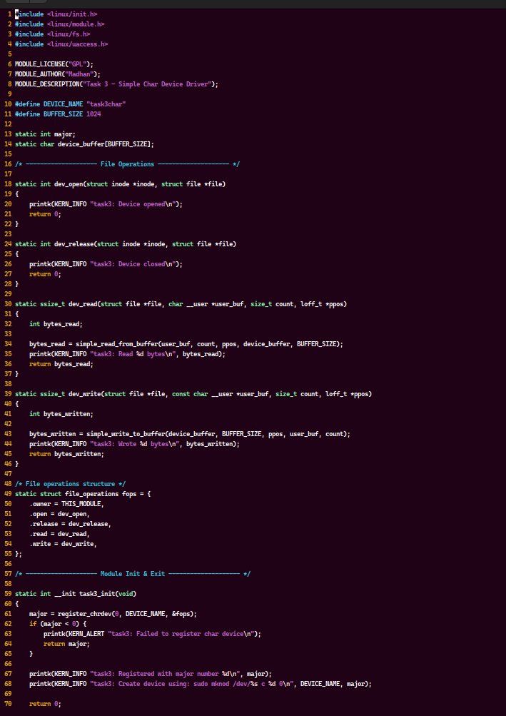

In this code:

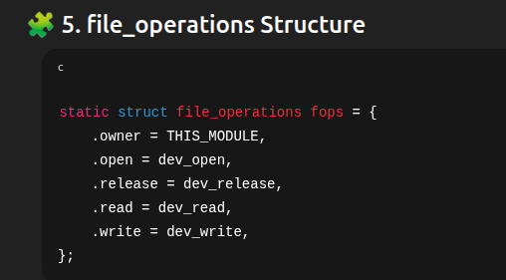
read () →

read() → read data from the buffer and gives to usersapce
write () → data from userspace is stored in buffer
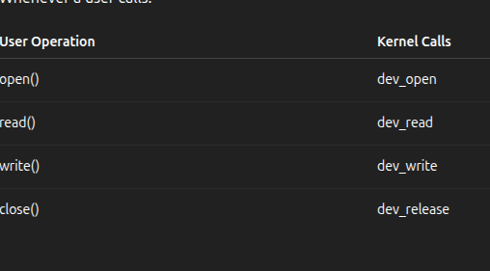

Module _int :
register the file as char device driver
Kernel dynamically will assign a major number for this char driver

xxxxxxxxxxxxxxxxxxxxxxxxxxxxxxxxxxxxxxxxxxxxxxxxxxxxxxxxxxxxxxxxxxxxxxxxxxxx
Create .ko file:
using makefile run this .c file → and get .ko kernal file

xxxxxxxxxxxxxxxxxxxxxxxxxxxxxxxxxxxxxxxxxxxxxxxxxxxxxxxxxxxxxxxxxxxxxxxxxxxxx
Insert a kernal module & create a dev entry:

insert a .ko file in kernel → now kernel gives major number for this char driver

manually create dev entry using mknod
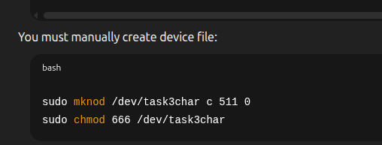
mknod → create a entry in dev path
chmod → grant access to read , write files

xxxxxxxxxxxxxxxxxxxxxxxxxxxxxxxxxxxxxxxxxxxxxxxxxxxxxxxxxxxxxxxxxxxxxxxxxxx

User space:
