Patent Strategy & Research Report: VAVE AI System
Prepared for: JSW MG Motor India
Project: VAVE AI (Value Analysis Value Engineering) System
Purpose: Intellectual Property Protection for Internship Project

1. Executive Summary
This report outlines the strategy for patenting the VAVE AI System. The system introduces a novel 'Physics-Informed Generative AI' approach that solves the critical problem of AI hallucination in engineering contexts. We recommend filing a 'System Patent' to cover the entire workflow, securing the invention as a corporate asset for JSW MG Motor India.

2. Scope of Protection: The "System" as a Product
While computer programs 'per se' are excluded from patentability under Section 3(k) of the Indian Patent Act, a 'System' that utilizes software to achieve a technical effect is patentable. We define the VAVE AI not just as code, but as a specialized engineering system.
Instead of Claiming... | We Claim...
Code for resolving car parts | A Physics-Informed Context Resolution System comprising a data matrix and constraint enforcement module.
AI checking if ideas are good | A Deterministic Autonomous Validation Engine utilizing vehicle-weight physics logic.

3. Detailed Patentable Inventions

A. The Physics-Informed Matrix (Context Resolver)
Technical Problem: Generic LLMs do not understand engineering constraints (e.g., suggesting fuel tanks for EVs).
Technical Solution: A pre-processing module that strictly defines the 'Ground Truth' based on a Vehicle x Component Matrix.
Key Code Reference: `_resolve_engineering_context`

B. The Autonomous Validation Engine (The Gatekeeper)
Technical Problem: Generating ideas that are physically dangerous or illegal (e.g., thinning brake discs beyond safety limits).
Technical Solution: A deterministic post-processing filter that applies hard-coded physics rules to validate AI outputs.
Key Code Reference: `_validate_and_filter_ideas`

4. Process & Timeline
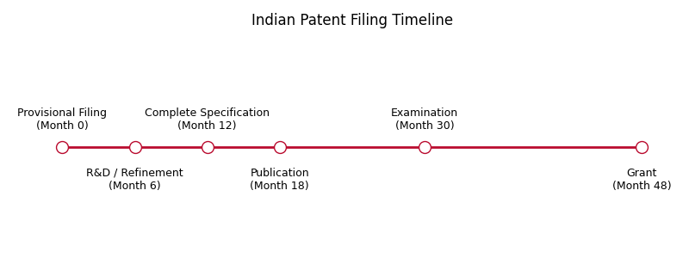
Figure 1: Standard Indian Patent Filing Timeline

5. Cost Analysis (Estimated in INR)
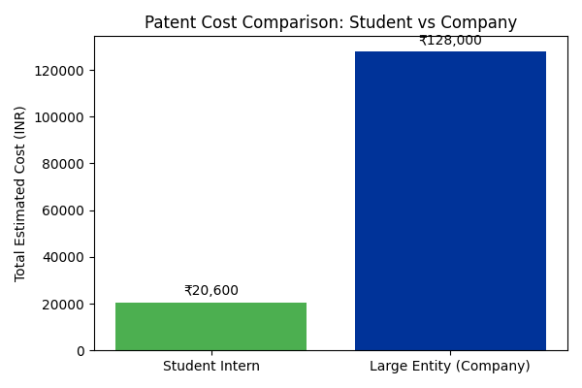
Figure 2: Estimated Cost Breakdown (Official Fees + Legal)
Note: As a corporate filing, JSW MG (Large Entity) fees apply. While higher than student fees, this ensures full corporate ownership and commercialization rights.

6. Conclusion & Next Steps
1. File Provisional Application immediately (Month 0).
2. Refine the 'VLM Engine' and gather experimental data (Months 1-11).
3. File Complete Specification (Month 12).

